# Table of Contents

|  |  |
| --- | --- |
| **List of Figures List of Tables**  **1 Negotiating researcher and participant relationships** | **vii****ix**  **1** |
| 1.1 Introduction . . . . . . . . . . . . . . . . . . . . . . . . . . . . . . . . . . . . | 2 |
| 1.1.1 Taking a situated knowledge approach . . . . . . . . . . . . . . . . . . | 3 |
| 1.2 Learning from people living with dementia . . . . . . . . . . . . . . . . . . . | 4 |
| 1.3 Designing VR environments . . . . . . . . . . . . . . . . . . . . . . . . . . . | 8 |
| 1.4 Returning to Silverline Memories . . . . . . . . . . . . . . . . . . . . . . . . | 10 |
| 1.5 Understanding researcher-participant relationships . . . . . . . . . . . . . . . . | 13 |
| 1.6 Relationships that were forgotten . . . . . . . . . . . . . . . . . . . . . . . . . | 20 |
| 1.7 Designing the Moment Boxes . . . . . . . . . . . . . . . . . . . . . . . . . . | 22 |
| 1.7.1 Designing for eclipsing realities . . . . . . . . . . . . . . . . . . . . . | 22 |
| 1.7.2 Honouring the individual’s choice . . . . . . . . . . . . . . . . . . . . | 24 |
| 1.7.3 Nurturing caring relationships . . . . . . . . . . . . . . . . . . . . . . | 25 |
| 1.8 Handing over the moment boxes . . . . . . . . . . . . . . . . . . . . . . . . . | 27 |
| 1.9 Summary . . . . . . . . . . . . . . . . . . . . . . . . . . . . . . . . . . . . . | 30 |
| **2 DemVR: Public Engaged Hackathon** | **33** |
| 2.1 Introduction . . . . . . . . . . . . . . . . . . . . . . . . . . . . . . . . . . . . | 33 |
| 2.2 Related work . . . . . . . . . . . . . . . . . . . . . . . . . . . . . . . . . . . | 34 |
| 2.2.1 Learning about dementia through design . . . . . . . . . . . . . . . . . | 34 |
| 2.2.2 Dementia and public engagement . . . . . . . . . . . . . . . . . . . . | 36 |
| 2.2.3 Design events and public engagement . . . . . . . . . . . . . . . . . . | 38 |
| 2.3 Event context . . . . . . . . . . . . . . . . . . . . . . . . . . . . . . . . . . . | 39 |
| 2.3.1 Recruitment . . . . . . . . . . . . . . . . . . . . . . . . . . . . . . . . | 40 |
| 2.3.2 Pre-hackathon engagement . . . . . . . . . . . . . . . . . . . . . . . . | 42 |
| 2.3.3 Team formation . . . . . . . . . . . . . . . . . . . . . . . . . . . . . . | 45 |
| 2.3.4 Hackathon . . . . . . . . . . . . . . . . . . . . . . . . . . . . . . . . | 45 |
| 2.3.5 Participants’ final ideas . . . . . . . . . . . . . . . . . . . . . . . . . . | 48 |
| 2.4 Methodology . . . . . . . . . . . . . . . . . . . . . . . . . . . . . . . . . . . | 51 |
| 2.4.1 Positionality . . . . . . . . . . . . . . . . . . . . . . . . . . . . . . . | 52 |
| 2.4.2 Ethics . . . . . . . . . . . . . . . . . . . . . . . . . . . . . . . . . . . | 52 |

## Table of Contents

2.4.3 Data and Analysis 53

* 1. Findings 54
     1. Participants’ approaches to engagement and design 54
     2. Reworking participants’ conceptualisations for design 60
  2. Discussion 65
     1. reification, experience & designing with and for stereotypes 65
     2. Facing actual reality: Unplatforming and participant disinterest 68
     3. Towards a new economy of collaboration for design events 72
  3. Conclusion 75

1. Learning from Ethics in Dementia Research 77
   1. Introduction 77
   2. Related work 79
      1. Design & ethics in HCI 79
      2. Ethics in context: Dementia and HCI 80
   3. Methodology 82
      1. Participants and recruitment 82
      2. Ethics 82
      3. Data collection 84
      4. Data and analysis 84
   4. Findings 85
      1. Guidelines vs situated practice 85
      2. Emotion and everyday experiences 89
   5. Discussion 94
      1. What can researcher’s and ERB’s do? 94
      2. Designing for peer-led research 94
      3. Designing for impact 96
   6. Summary 98
2. Dialogical Dementia Design (D3) Toolkit 99
   1. Introduction 99
   2. Related work 100
      1. Representing the experiences and views of marginalised communities in

HCI 101

* + 1. Resources for designers and developers doing participatory HCI work . 102 4.3 Methodology 104
    2. Participants & Online Setting 105
    3. Ethics 105
    4. Data collection 107
    5. Data and Analysis 109
  1. Developing a design rationale for dementia design toolkit 110

iv

## Table of Contents

* + 1. Empathy and appreciation for a diversity of experiences 110
    2. Putting dementia into dialogue with design 111
    3. Integrating with existing workflows 112
    4. A collaborative and unfinalisable toolkit 112
  1. Dialogical Dementia Design (D3) Toolkit 113
     1. Inspiration phase 115
     2. Ideation phase 117
     3. Implementation phase 118
  2. Reflections on D3 Toolkit 119
     1. Barriers to online co-creation with people with dementia 119
     2. Sharing the designer role 121
     3. Incentives for sustainable participation 123
  3. Discussion 124
     1. Future directions for co-design toolkits between designers, developers,

and people with dementia 125

* + 1. Limitations of the work 129
  1. Chapter summary 129

**Appendix A Documents** **131**

* 1. Information Sheets 131
  2. Consent Sheets 131
  3. Thematic Analysis Example 131
  4. DemVR Schedule 131
  5. DemVR Recruitment Advertisement 131
  6. Ethics Semi-structured interview 131
  7. Affinity Diagramming 133
  8. Workshop materials 134

**References** **135**

v

# List of Figures

* 1. Thesis Map showing the relationships between data chapters to research questions 1
  2. Silverline memories community room (taken from Silverline Memories Facebook) 6 1.3 Content zones in VR . . . . . . . . . . . . . . . . . . . . . . . . . . . . . . . 9
  3. Park environment including an Irish castle 10
  4. Beach and park moodboards 10
  5. Framed family photo 21
  6. Moment box 22
  7. Different ways to view the captured footage 23
  8. Dioramas created for Lauren and Sarah 25
  9. Walkthrough experience of Wallington Trust 26
  10. QR codes VR activity 27
  11. Optional ways to access bespoke moments 27
  12. Subsequent chapters 31
  13. Timeline of the event 40
  14. Ideaboard features 44
  15. DemVR hackathon event schedule 45
  16. Howard’s Zoom Q&A 46
  17. Inspiration packs 47
  18. DemVR final prototype ideas 49
  19. Day one of DemVR 55
  20. Denis commenting on shared ideas on Ideaboard 56
  21. MindfulForest influences from Sweden dementia forest research 58
  22. Change in Sensory Tide’s VR technology 59
  23. Garden Life VR dog companion 61
  24. VRHallucinate educational game on hallucinations 61
  25. Chatter Bench shared VR locations 63
  26. World Share’s UI interactions 64

3.1 Workshop at DIS’19 78

* 1. Data chapter overview 99
  2. Stage one, two, and three Miro boards (from left to right) 107

vii

## List of Figures

* 1. Stage Two Category Examples: storytelling about dementia, reflection, and journaling, and directing the conversation (left-right) 108
  2. Final Affinity Diagram for our design rationale 109
  3. Different components that create D3 Toolkit 113
  4. Navigating Our Shared Story page 115
  5. Platform for ’Dementia Friends’ 116
  6. Foresight checklist example on VR and dementia 116
  7. Flow cards 117
  8. Guiding topic cards (blueprint design on the right) 118
  9. Suggestive guidance pack to reflect on best practices 119

viii

# List of Tables

2.1 DemVR participant table 43

2.2 . . . . . . . . . . . . . . . . . . . . . . . . . . . . . . . . . . . . . . . . . . 53

2.3 Data collection 53

* 1. Participant demographics 83
  2. Recommendations for ERBs and researchers for ethical research 95
  3. Designer and developer demographics 106
  4. People with dementia demographic 107
  5. Data Collection (audio) 110

ix

# Chapter 1. Negotiating researcher and participant relationships

Before you get into the good bit, In the introduction, I will have a clear description of what chapter tackles what for the research questions and this diagram below. I will then return to the research questions in more detail in the discussion.

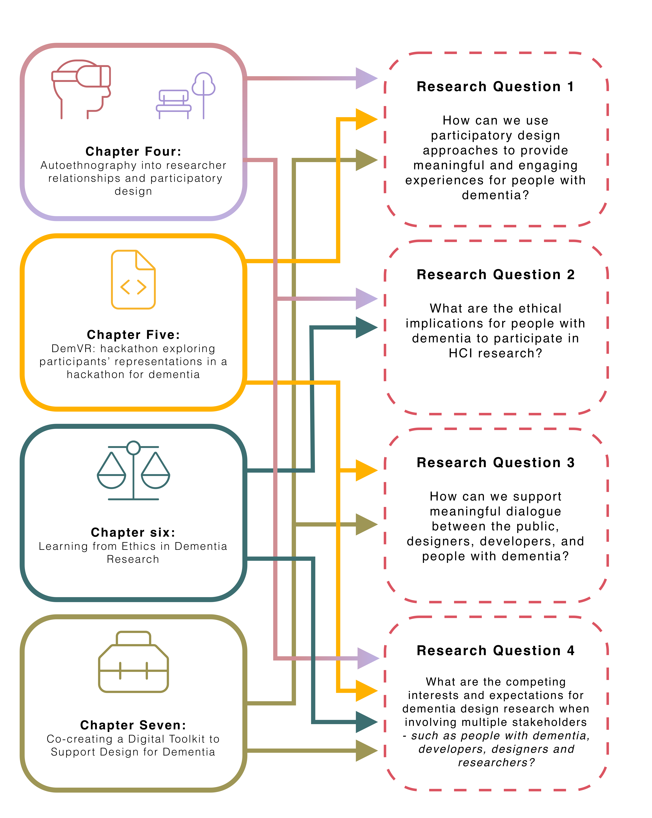

**Figure 1.1** Thesis Map showing the relationships between data chapters to research questions

1

## Negotiating researcher and participant relationships

* 1. **Introduction**

In the previous two chapters, I described the relevant literature to the context of dementia and HCI that emphasises involving people with dementia in technology design processes. Within my methodology, I highlight the ways researchers and designers have tailored participation for people with dementia - that I adopt and adapt to suit the needs of my participants within this chapter. As discussed in the two chapters, the relationship between the researcher and participant is an important one that mirrors the ethics of care in dementia research Hamington (2019). Robertson and Wagner (2012) describe the four ethical aspects of PD that influence the research partnership:

* + - Who do we engage with in a Participatory Design project?
    - How do we engage with participants?
    - How do we represent participants and their work?
    - What can we offer participants?

To explore these broader ethical questions, researchers have proposed approaches to reflect on their experiences working within these sensitive spaces to explore how design decisions play a role in the research partnerships. This chapter describes a three-year auto-ethnography that explores my path into designing in dementia and HCI research. Through two studies, I reflect on guidance into designing media and VR experiences *for* and *with* people with dementia. As I recall the prior three years, there is a gradual shift from VR technology being a critical part of the research, to placing importance on the broader concerns about ethics in the community of practice. For example, how does short-term memory, need for care, orientation, and a culture of ethical ’protectionism’ impact the involvement of people with dementia in research. This chapter covers two- and half-year engagement with a dementia café in Newcastle known as Silverline Memories. This local registered charity prides itself on its activities, organising celebrations for members’ birthdays and other special occasions. With designing for creativity becoming an essential shift in design research in dementia (John Killick Claire Craig, 2012; Morrissey and McCarthy, 2015; Wallace et al., 2013), the potential for VR for people living with dementia may come hand-in-hand with ways to experience and express creativity. In the first study, I explore designing tailored VR experiences, which leads to exploring how we design for media capture of meaningful experiences to support families living with dementia.

With this in mind, this chapter reveals reflective insights into how power differences shaped collaboration; the sharing of personal stories that are perhaps irrelevant to the research questions; technology appropriateness vs novelty in technology; and building of trust participants had towards myself (the researcher). Furthermore, the insights that I share in this chapter are significantly influential in the trajectory of where this thesis goes. As mentioned earlier, my work

2

## 1.1 Introduction

in dementia originally started with an interest in VR. However, through personal experience in conducting research, my interests lie in understanding the broader concerns of ethics in practice and how relational approaches can be structured between people with dementia and technologists who ultimately make design decisions through design and development roles.

The two studies covered in this chapter were peer-reviewed and published at the CHI Conference on Human Factors in Computing Systems (Hodge et al., 2018, 2019). Both papers were co-authored by Dr. Kellie Morrissey and Sandra Hastings, with additional co-authorship from Dr Madeline Balaam for the 2018 paper, and Dr Kyle Montague for the 2019 paper. While this chapter expands on the auto-ethnography data that was not used for either publications, I acknowledge that ideas and arguments in the chapter are influenced by the publications. Furthermore, section 1.7 acts as a set of design decisions that are described in a published book chapter for ’HCI and Design in the Context of Dementia (Hodge and Morrissey, 2020) that I co-authored with Dr Kellie Morrissey who provided feedback on the paper’s writing and contribution.

### 1.1.1. Taking a situated knowledge approach

Given the ’outsider’ perspective I have within the dementia community, I drew from Kaomea (Kaomea, 2001), which describes the importance of recognising and respecting participants’ views and what they share, mainly when acting as an ’outside’ researcher. While someone living with dementia may describe their experiences and reflect on diagnostic stigma, I can only make sense of the experiences I may identify with as an outsider. For example, I can think about what it is like to have family or friends distance themselves from me. However, the experiences are confined only to thought, as I can never experience what a participant has said. Crucially, this does not mean I cannot be influenced by what I heard from others. By considering the experience *"in the context of a past, and a future, we may give it a meaning that is more personal to us"* (McCarthy and Wright, 2007) that may open up new questions and understandings into the area of research. Additionally, McCarthy and Wright describe how narratives are interpretations and do not mirror what *’actually’* happened. As the researcher constructs the narrative, they have a responsibility to *"position ourselves in the story. By expressing ourselves to others, we show something of how we feel about the experience being described and how we feel about ourselves in that experience"* (McCarthy and Wright, 2007). Through relfecting on the *’inward’* perspective of the researcher’s identity, this auto-ethnography takes a wide-angle lens (Ellis, 2016) to consider what the research means to the *’outside world’*.

3

## Negotiating researcher and participant relationships

* 1. **Learning from people living with dementia**

In November 2016, I started my final undergraduate year in the School of Computing at Newcastle University. Given my interests in the HCI and developing technology around dementia, Dr Madeline Balaam and Dr Kellie Morrissey were suggested to supervise my final year project. Given my family history, I was interested in exploring how I could build nuanced technology for people living with dementia. My Grandpa was diagnosed with Alzheimer’s in his early 50’s, and my Grandma took care of him until he passed away when he was 67 (2001). I wanted to know more about the neurodegenerative condition and understand what my Grandpa and Grandma went through. My Grandpa was only around till I was five, and from those five years, I remember very little of seeing any changes in him through those years. From what I remember, he was less physical and verbal than others around him, but my memory is rather patchy and is now filled with stories from my Grandma’s view instead. My Grandpa lived with dementia for about 10-15 years, but my Grandma always said the *"toughest times he faced were the first few years"*. The diagnostic labelling of dementia can have a detrimental effect on those living with dementia and their social group around them. In dementia writing, this labelling is often represented as a *’loss of self’* or *’non-person’* or an *’un-becoming of self’* (Fontana and Smith, 1989; Kontos, 2005).

Often in society, the view of dementia has been criticised as a "medicalization of deviance" (Bond, 1992) over prioritising maintaining a sense of self. For my Grandma and others, friends and family often abandon or become almost strangers to the person living with dementia. It’s common for those who have experienced dementia in some way to have experienced or heard stories of friends or family members abandon or socially exclude themselves from the person living with dementia’s lives. As this social exclusion continues, this can deprive the person living with dementia of their personhood and quality of life Taylor (2008). My Grandma told me of the time when she had got ’fed up’ with my Grandpa’s attitude: *"all he was ever doing was staying in his shed and feeling sorry for himself. I couldn’t handle it anymore. I couldn’t deal with seeing him like this, nor could I deal with feeling so lonely. I told him to stop feeling sorry and take a walk with me"*. The progression of dementia also has social ramifications within the family structure, as family or friends become the caregiver, and the person living with dementia becomes the care-receiver. In particular, social activity can decrease, which entails several *’knock-on’* effects such as a decline in emotional well-being, and increased social isolation and depression.

With no current cure for dementia, technology fitted how it could have improved my Grandpa’s and Grandma’s more quality of life. The shift from medicalisation towards the quality of life attracted research that leveraged creativity (John Killick Claire Craig, 2012; Lazar et al., 2017a) and evoked emotion (Morrissey and McCarthy, 2015; Wallace et al., 2013) to allow creative communication. All the readings above had clear influences from person-centred care (Brooker, 2003; Kitwood and Bredin, 1992) where the person living with dementia is treated as an individual; by including the person living with dementia in the research process and acknowledging *"changing individual strengths and vulnerabilities"* (Suijkerbuijk et al., 2019).

4

## 1.2 Learning from people living with dementia

In the area of HCI and dementia, a wide range of technology had already been considered. For example, PlayStation moved controllers to encourage group dancing (Morrissey et al., 2016) to touch screen displays that display music, video, and photos to support general reminiscence (Astell et al., 2010). However, one technology that had been underexamined was VR. As VR technology was growing commercially in 2016, it had its fair share of considerations on the impact on healthcare, such as treatment of PTSD, pain management and cognitive processes (Hoffman et al., 2000; Schultheis and Rizzo, 2001; Slater, 2013). While several studies seemed promising, prior work did not consider the technology as an expressive and creative medium for people living with dementia.

From the very start of my project, there was a significant difference in the work I’d be doing compared to my colleagues on my course. While many of us decided on working with different communities and groups, rarely did any of them have to fill in such an extensive ethical form to conduct their research. At the time, it didn’t feel that out of place or obtrusive. Over time, as I spent time working with people living with dementia, I became conflicted over how a researcher can conduct sensitive research when following a set of ambiguous and generic principles. Comparing my ethics form to the outcome of the study didn’t align at all. By expressing the study through tick boxes and linear questions, researchers have to attempt to foresee the research and what may go wrong. Filling risk assessment forms help to give the ethics reviews an indication of how the researcher would act in particular situations, but what about moments that could not be considered? Could an act of trying to ’help’ end up causing harm? As Lichtner describes below:

"He kept falling asleep on the chair. And when awake, tried to get out of the chair. I told him to wait and went looking for somebody to help him. At the nurses’ station, the clerk said there is a risk of falling, not to let him get out of the chair. When I explained that I was not authorised to intervene, she said she isn’t either but that better to intervene than to have a fall. So, I went back to the patient and thought that if I engaged him in conversation he would stop trying to get up" (Lichtner, 2014)

Lichtner discusses the difficulties of reducing their presence in the ward but found them- selves either intervening or explicitly being asked to help. Acts of ambiguity are ordinary in socially-oriented research but challenge the ethical complexities of conducting research. Often, researchers are placed into an ethical dilemma, where they have no time to ask for another’s advice and make a split-second decision. Similarly, they are times where I’ve taken an ethical’ snap decision’, and I have felt guilty for it. But spending time outside the field, learning by reading other people’s accounts in socially-oriented research, not only normalised my decisions but helped me prepare for the next ethical dilemma to be faced. By reading other researchers acts of ambiguity in the field, many of the conflicts centred around a lack of understanding from the ethical review boards (ERBs) for the research being conducted. Perhaps, if ERB’s engaged with the community, review boards would gain insight into the type of ethical practices that should be

5

## Negotiating researcher and participant relationships

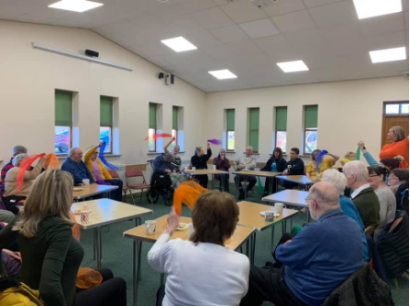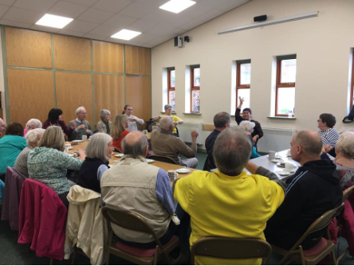

**Figure 1.2** Silverline memories community room (taken from Silverline Memories Facebook)

in place for that particular community. Furthermore, working with the community would also allow those affected to articulate their interests and priorities at the building block stages of the research study.

Throughout December and January 2017, I started to consider what it meant to create workshops that encouraged engagement, particularly within socially-oriented research. Guided by the network of collaborators Open Lab had, I conducted a series of workshops at a dementia café on the outskirts of Newcastle city centre. For the first workshop, I wanted to find out what participants may wish to see in a VR experience and know anything about VR. Working alongside Dr Kellie Morrissey, we set out to Silverline Memories dementia café, and I felt nervous. I felt so out of place. Apart from my experience with my Grandpa when I was a child, I had never really experienced being around people living with dementia. Kellie and I arrived at the dementia café a little earlier than Sandra (who runs Silverline Memories). Sandra came later than us with bags full of snacks and drinks for their dementia café session. As we approached the dementia cafe, it was apparent this was a community room attached to a church. We helped Sandra carry the bags into the boxed room that, while felt outdated, had its uses. On the left side was a kitchen area for volunteers and to hand out tea, coffee and biscuits throughout the session – while this was for volunteers/staff, if members walked in, no one was told to leave. Instead, volunteers would ask what they would like. They had an unlocked door opening up into the church to the very back of the kitchen, which was used for sessions when they split carers and people living with dementia into different activities. To get used to the room and distract me from the nerves, I helped set the space up seen in Fig.1.2.

With the community room being shared across many different groups, Silverline memories had never had the chance to make space their own. Instead, you had a sense of ’home’ or ’community’ through the interactions with the volunteers and members. As I had set up the room, I got my notebook out, VR headset, and a recorder and consent/information sheets. As the first couple entered the café, Sandra and the other volunteers came over to them with open arms

– similar for everyone who walked in on that day. They caught up, got them a cuppa tea and biscuits and got them sat down. Sandra was immediately welcoming and had created a space that focused less on the diagnosis and more on creating social interactions through creativity,

6

## 1.2 Learning from people living with dementia

music, entertainment and shared experiences. Sandra introduced the couple – Philip and Kate, to Kellie and I, and they were so appreciative and warm. They asked about the research, what we did, and showed such enthusiasm for why we were there. As I would find out in the study, the initial few minutes of signing consent, and reading information sheets and explaining the research are uncomfortable for all those involved. At that moment, it went from an informal conversation and into a formal study where two of us would be analysing and studying what was said. As we described the study, both were very happy with taking part in the conversation about the types of VR experiences they’d like to see. They were okay with quotes being used as long as they were anonymised.

The workshop was my first experience working with people living with dementia, but more importantly, the first time I would be seen as a ’researcher’. Although looking young, and of course, getting sarcastic comments from the participants about my age and that I’m too young to be a researcher, I didn’t know how to conduct myself in conversations with this new title. Each conversation felt like an interview, and there was a sense of power imbalance. In some instances, power imbalance came from both sides, with members of Silverline Memories having been a part of the cafe for some time. Members didn’t have to talk to us or take part in the study, and if they didn’t, they had nothing to lose. On the other hand, Kellie and I were the only ones walking around with that title of ’researcher’ who were here to interview and record participants. It was so unnatural to me, but why would it be natural? I don’t start my conversations with friends or family with consent forms and placing an audio recorder on the table. Yet, the methodologies I was told to follow focused on the importance of researcher-participant relationships.

From our conversation, I was surprised to see such common links with other papers I had read around HCI and dementia - people wanted an experience and ’fun’ with the technology. Thomas wasn’t interested if VR could help reduce care or anything focused on medicalisation, just how technology could be used as a form of entertainment. Thomas expressed Janet’s passion for *"listening to music and playing"* and that when she was younger, *"she used to be in a choir... so it’s been a big part of her"*. Regularly, the couple would explore YouTube videos looking for performances, which is why Thomas suggested a virtual theatre as he thought it’d be an *"effective way of allowing her to experience something approaching live music once more"*. As our workshop ended, we had gained an overview of what may and may not work with the environments we would be creating. I then returned in a month with three different VR environments - a beach, park and a tailored Shania Twain concert hall for Janet and Thomas.

As I sat down writing, I felt a strain of being a ’researcher’ or an ’outsider’ in this perspective’. Akindes says that *"through reflection, the meaning becomes visible in the process of writing"* (Akindes, 2001). In this case, I’m talking about my privilege. As a white British male, I had never taken on any particular title that may place me as an ’outsider’ throughout my entire life. Many of the members were warm and welcoming to myself, but I will always remain as an outsider to some degree. Although we share some aspects of experiences with all the

7

## Negotiating researcher and participant relationships

members of Silverline Memories being from the UK, based on their stories and mine, they are drastically different. Throughout my life, I’ve remained in education and had the opportunity to go to university. At the same time, many of the participants I talked to discussed stories of their working-class upbringings that I had no perspective to draw upon. Therefore, I remain to question am I a good fit to research into the area of dementia. Christine Bryden discusses how by living with dementia *"[she] ha[s] complete member research status and can provide an insiders perspective"* (Bryden, 2020). However, while this gives Bryden an insider perspective to her own experiences and an understanding in the similarities that are present with a diagnosis with dementia, as ethnographers, *"we are never fully outside or inside the "community"* (Naples, 2003). Naples argues that during research, *"we negotiate and renegotiate our relationship to the community through particular and ongoing everyday interactions"* (Naples, 2003). Even if I had been part of Silverline Memories for numerous years, the addition of the ’research’ title would have shifted my identity within the group. If we consider gender, race inequality, and class divisions as part of the outsider phenomenon, then we must acknowledge the *"powerful role we play in shaping what can be seen"* (Naples, 2003). While as a researcher, we are not the only ones creating the academic knowledge nor can we control its effects, we must be aware that it plays an essential role during and after the research (Irwin, 2006). Whether we believe we have an outsider or an insider perspective, our research is to make changes to the research population, not ourselves.

## Designing VR environments

Over the next month of creating the VR experiences, I felt immense anxiety and stress about creating something interesting. Even though expectations may have been low from the partici- pants, the pressure to make a well-researched project from my final year project and that I didn’t want to let Sandra or the participants down was on my mind. Over that month, conversations with my Grandma consisted of sharing our experiences of dementia. While we had different understandings and experience, I realised the challenges she faced as a caregiver—mine from a research perspective and hers from a caring one. Pursuing dementia research not only was a personal endeavour from prior family history, but it also opened up conversations I had always been afraid to ask of my Grandma. Selfishly I know, but asking more about my Grandma’s relationship with dementia, I thought, would give me a clearer perspective of how I may design for people living with dementia. I’m not sure if it did, but it gave me a sort of connection and empathetic feeling to the topic. I continued to be interested in the area, and during that time, I got to connect in a way to my Grandpa; I never thought I would have. Listening to my Grandma’s stories about the challenges that came from his diagnosis influenced my perspective on dementia research. The influence and relationship I have with my Grandma is a significant one in my research. While her stories painted a picture of their relationship that had its ’ups and downs’, it was relatively a positive story of living with Alzheimer’s. Over time, I began to realise and

8

## 1.3 Designing VR environments

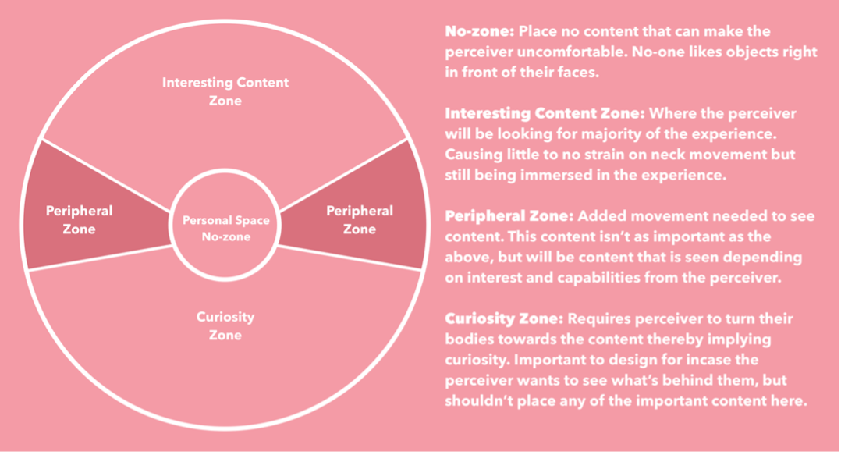

**Figure 1.3** Content zones in VR

acknowledge that I overlooked the challenges and complexities that people with dementia may face - either the individual or carers. Only by spending more time in Silverline Memories – with other people living with dementia, would I gain a more in-depth understanding of the vastly different experiences people have had.

With around four weeks to develop the VR environments, I enrolled in a VR online course by Udacity. With VR development being relatively new and not an area the university specialised in, I contacted the online course representative at Udacity to consider myself for a scholarship for their VR course. In early February, they got back to me and found the study of personalised VR for people living with dementia "innovative" and "novel" to the area. They sent me an online access code, and throughout February, I started to juggle learning VR game development with the rest of my university modules. The course gave me invaluable experience in building VR environments in Unity (a game engine). However, what it didn’t describe was the importance of the particular placement of objects within the environment. For this project, I applied Mike Alger’s (Alger, 2015) concept of content zones that I describe in fig.1.3 that helped reduce risks of sickness or disorientation and improve the individuals’ overall experience. Another limiting factor in deciding to use VR was anything that could create photo-realistic environments was expensive and bulky. Instead, I had to rely on taking a more stylised and abstract view of reality by exploring ways that low-poly art would portray the participants’ desires.

From the data collected from our first workshop, we created moodboards (shown above) based on the ideas and desires that individuals expressed. While we could not develop each participant’s individual experience, participants’ ideas were combined into one environment. For example, one participant asked for us to ’take [her] back to Ireland, to see the beautiful castles again’. While we couldn’t get any 360 footage from the castles the participant asks for, we did create 3D objects of a traditional castle from Irish medieval architecture. We placed it in the park environment that many participants expressed interest in (see Fig.1.4).

9

## Negotiating researcher and participant relationships

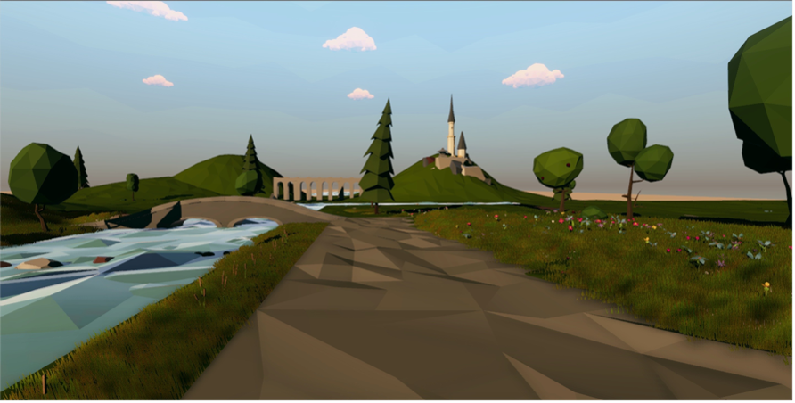

**Figure 1.4** Park environment including an Irish castle



**Figure 1.5** Beach and park moodboards

During the workshop, many participants expressed the particular environments of going to the beach or the park, following conversations of intricate details of Jesmond Dene Park or Whitley Bay Beach (both popular locations in the North East). Aspects would often resemble participants saying "I love the chirping of the birds", or explicitly remembering particular structural details such as "I love the bridges over the lake", and telling me stories of the Whitley Bay lighthouse. As I had written in my reflection in 2017, "I’m building a product to create positive experiences and potentially create some sort of reminiscence, I want to find those key objects that run through the [particular environment]". Back in 2017, reminiscence was a significant influence on the way the VR experiences had been designed. While, to some extent, they had an abstract style not to represent a particular location, adding in specific objects or sounds was done to provide familiar experiences for people living with dementia. While reminiscence has its promising evidence base and can provide opportunities of engagement, designing to attempt to ’cast back’ to earlier positive moments may burden the person living with dementia by the past and relies on their perceived cognitive deficits.

## Returning to Silverline Memories

A month later, I went back to Silverline Memories to conduct the second workshop. Given that the charity had recently won a lottery fund, the Monday session I held my workshop in was

10

## 1.4 Returning to Silverline Memories

in parallel with their celebration activities. The celebration put less pressure on me, holding the room entertained. It’s not surprising to anyone who has used VR before, but it’s rarely a shared experience that would have caused difficulties when dealing with a room of 30 people. Fortunately, having the entertainment of a magician that was part of the ongoing celebrations and offering people to try the VR experiences ensured that everyone in the room was being entertained and not just waiting around for the VR experiences.

Multiple partners/carers tried the park and beach experiences and adored it. I remember thinking about how well the workshop was going but trying to think about how I can evaluate this? How can I say someone was emotionally happy or that they remembered something from the past? I didn’t have any guidelines, but maybe that didn’t matter. Surely my observations and the way I talk about it is enough? What I did know is this workshop felt very ’authentic’. I thought the workshop felt part of the dementia cafe this time around. I took the lead more in the research aspect, participants that we met a month ago asking how I’ve been and what I had been up to since the last visit. The research activity fits into the celebration, and people found the park and beach experiences beautiful.

As mentioned before, I had my doubts about VR not being interesting enough for the wider group, given it’s a very isolating technology. During participants use of VR, participants and their caregivers expressed a wish to share in the same live VR experience as their partner or parent. Participants indicated that meaningful shared experiences with their loved ones with dementia had changed recently or decreased in frequency when asked about this. For example, Linda, whose husband Michael is living with dementia, mentioned that the couple no longer drove and used public transport. This meant that the two could not visit favoured locations together. So, they indicated that the VR park and beach could be used to supplement their recreational activities and allow them to experience a semblance of the sorts of activities that used to mean very much to them. Having the carers experience the environment first allowed carers to help direct their loved ones around the environment by probing specific interactions in the environment that the person living with dementia may have missed. For example, one carer started asking questions about what they could see or if they saw the horse walk past on the beach.

Near the end of the workshop, I sat down with Thomas and Janet to show them their personalised Shania Twain concert hall. With the current room where we were getting relatively loud, we asked them to sit down in the church attached to Silverline Memories. The room was more private with just Kellie, myself and Thomas and Janet. However, with the VR environment being personalised, and I had spent more time developing it only for the one couple, there were this expectation and pressure to make sure I captured the experience and data collection. Similar to other participants in the workshop, Thomas and Janet saw VR as a novelty and a technology that they had never had the opportunity to experience.

11

## Negotiating researcher and participant relationships

Janet’s reactions to first trying VR echoed that of prior participants – with concern and uncertainty. As Janet started to hear Shania Twain singing, she began to *’hmmm’* to the song and held the headset that Thomas was holding up for her. While Thomas has initial concerns with Janet having the *"patience to hold the [headset] for a long time"*, Janet was engaged entirely through her body movement and was "*start[ing] to sing. She was singing to the tune and attempted to repeat the lyrics"*. While I had a minimal conversation with Janet through the workshops as her verbal abilities are limited, other ways of communicating became apparent through the way she explored the VR experience. As Janet finished the 5-6-minute experience, she passed the headset back over to me and had a broad smile on her face gave us a wave goodbye. As we ended the workshop, the celebrations for Silverline didn’t stop. As I was leaving, we said our goodbyes and I remember Janet looking back at me and giving me a big wave to say bye.

As I left, I didn’t reflect that this was maybe the last time they’d experience the environments I had created. In my mind, I had developed some very rough prototypes that were prone to breaking. This holding onto the prototypes did create frustrations between Sandra and me over the continued relationships we had with Silverline Memories over the next couple of years. These frustrations could have been from me not setting out clear expectations, or Sandra was expecting a lot from the project and having an ’app’ that the dementia café could use. Over the past ten years, digital health apps have dominated technological solutionist approaches and mainly gained interest through the suggestion that with young people being ’tech-savvy’, apps could connect particular populations (Byron, 2019). ’AppMovement’ is a platform that encourages collaborative design and development of mobile applications (Garbett et al., 2016). AppMovement gained popularity and has shown apps can be successful and valuable through developed apps such as FeedFinder (Balaam et al., 2015) and Safe Places to fly your drone. However, they rely on the uptake and participation of users, and they are designed in a particular manner. They may not necessarily be well suited for specific communities, such as people living with dementia. Sandra’s expectation for a fully-fledged out app questions a sociotechnical knowledge barrier between us. With little to no resources and little time, an app was out of the question to have ever been developed. Eventually, in 2019, I recreated the environments and gave them to Sandra alongside other objects and technology we developed through the ongoing collaboration. While it was not an ’app’, it was workable prototypes of the three experiences. Towards the end of this chapter, I break down particular moments that created a complicated working relationship between myself and Sandra. Looking back, was it unethical to take away the experiences? The group never had the opportunity to try the experiences again. Of course, the time frame was concise, with it being an undergraduate dissertation. However, without learning from these ethical mistakes, I would have unlikely understood the importance of what defines ’impact’ or ’legacy’ of the relationships and technology you create in socially-oriented research.

12

## 1.5 Understanding researcher-participant relationships

* 1. **Understanding researcher-participant relationships**

Through the first six months of my Digital Civics MRes, I had the opportunity to learn about a range of topics and areas of research that seemed foreign to me during my undergraduate. From learning qualitative research methods to how, as researchers, we can engage in socially-oriented approaches. A core part of Digital Civics is *"how our digital research could be of use and value to local councils and local citizens"* (Olivier and Wright, 2015). To some extent, I had done a similar take on my undergraduate research when working with Silverline Memories. A key theme through learning about Digital Civics was the idea of ’empowerment’. How do you design to empower the citizens that use the technology? With Open Lab being a leading HCI lab in the field, particular examples of Digital Civics created spaces for both citizens and local government through digital participatory platforms such as ’App Movement’ (Garbett et al., 2016) and ’Make Place’ (Peacock et al., 2018). Similarly, in a less socio-technical perspective, a determination by governments and Alzheimer’s societies promote dementia-friendly communities that bring groups of people living with dementia to influence services and policies or create spaces to share experiences or to have a place that is rid of the societal complexities that someone living with dementia may experience with a diagnosis. In 2017, Morrissey et al. explored an app created through App Movement called ’Care and Connect’ to identify and rate public spaces on their ’dementia friendliness’ (Morrissey et al., 2017a). The study reported that while people living with dementia were *"interested and comfortable in using the app, it is mostly used by carers at the moment"*. Of course, App Movement was not specifically designed for any particular community but demonstrated that members of the community wanted to meaningfully express their thoughts and to be involved on a level that saw fit to their desired engagement.

In a similar fashion, although people living with dementia have been involved in planning, decisions and discussions of ’dementia-friendly communities’, Swaffer reports that in the UK, approximately 350 people with dementia had been directly engaged in the work. . . that is an unacceptably low number" (Swaffer, 2014). A lack of involvement of people living with dementia contributes to the stigma and discrimination within society. While we have seen recent research in HCI and gerontology research into the area place significant importance in engaging with people living with dementia, the extent to which we involve people living with dementia and the implications remains a contested and under-examined issue. As a community of researchers, we should be echoing similarities in the Dementia Enquirers group that are developing new design approaches to research led by people living with dementia (Diaries, 2020). By involving the community during grant stages, identifying research priorities, and planning research, we can ensure research agendas are more closely aligned to the needs of that given community. While I must admit, I have not achieved in full the scope of what I have discussed above. Still, as I moved from my undergraduate where I designed for people living with dementia, in the study that follows, I move a step further by considering ways we engage with not only the person living with dementia but working closely with families to co-plan days out, and to facilitate

13

## Negotiating researcher and participant relationships

active participation through the study. While I was reading up on the breadth of literature around involving families and carers in dementia care, the same attributes of relationship-centred care can be followed in how we should engage families living with dementia in HCI research:

Good communication will contribute to a good-quality relationship by helping each party to understand the other party’s perspective and enabling differences to be discussed and, where possible, resolved. It will be respectful, recognising the expertise of the family member and that each party has much to learn from the other. A good relationship will improve the quality of care, by helping relatives to act in an advocacy role for the resident, and by ensuring that the important information that the relative has (which can make such a difference to the individualisation and personalisation of care) is shared with those staff involved in hands-on care. (Keady et al., 2007)

Keady et al. highlight the benefits of involving the person living with dementia and their relatives and care home team. Although each situation of working with people living with dementia is individualistic, the emotional ’burden’, guilt, and overwhelming feelings that those around the person living with dementia may be feeling, should be considered and explored. To continue and build from the prior VR exploration, I worked with Silverline Memories to work with three families who explored how they could capture meaningful experiences using photography, audio recordings, and more contemporary technologies such as 360-degree video cameras support families living with dementia.

Reflecting on what didn’t work and what did in my undergraduate research, I wanted to focus on three differences to the prior work: 1) designing for moments, not memory, 2) insider-outsider relationship, and 3) the act of giving. My first point – designing for moments, not memory, is a move away from designing for reminiscence and considers the philosophy of *"[if] the present is all that person has, [then] that is their reality"* that Silverline Memories support group follows (Hodge et al., 2018). While the VR experiences had an art style that enacted as ambiguity and created space for people to reminisce on their own lived experiences of beaches, and parks, through developing the three environments, my design approach was to represent participants memories through the environments such as one participant asking to *"take [her] back to Ireland, to see the beautiful castles again"*. While reminiscence was apparent and effective in the study, I began to question if relying on the person’s ability to recognise or articulate past events is an appropriate activity to enhance emotional connection (Lazar et al., 2014). Another notable concern I had was the tensions that arise from the insider-outsider relationship. Through the workshops, I initially got to know some of the members of Silverline Memories, but there was a strong presence of ’researcher’ title and power imbalances, and perhaps they always will be. I’m still going to be the ’researcher’, and I am researching them, but how can I improve this? Researching under a culture of ethical ’protectionism’ already caused significant tensions about formally acknowledging participants as co-creators, I sought to recognise and acknowledge

14

## 1.5 Understanding researcher-participant relationships

participants as individuals who will contribute to the research and ensure that their knowledge, experiences and time are appreciated through compensation that is meaningful to the participants.

Furthermore, compensation leads to the act of giving. The exploration of VR experiences resulted in three prototypes that were never developed for continued use or different hardware while positively appreciated. This caused tension in the relationship between Sandra and I, which I didn’t want to happen again. Instead, the study with the families would present the members as co-creators who would be working towards developing a final product for them. I wanted to ensure that the families felt appreciated and that the ’meaningful experiences’ they created on the days out would be in their hands forever. I hoped this would acknowledge and appreciate the time and effort they would put into the research and be a way to consider the ’ending’ of the project ethically.

Working with Silverline Memories again, I went to one of their activity days to ask families if they would like to be involved in the study. Each family would engage in a piece of research through design (RTD) (Zimmerman et al., 2007) work to explore the opportunities and challenges of designing enriched personalised multimedia experiences. The families would choose a ’day out’ where we would go and capture meaningful moments through photography, audio and 360-degree videos that were to be deployed in VR headsets. After their days out, families would be invited to a series of design workshops, whereby families would work with researchers and designers to curate personalised media experiences from their meaningful moments. As I arrived, Sandra welcomed me back again and was looking forward to working together still. Unaware of this, Sandra said I’d be running the Silverline Memories session for the entire group. Remarkably unprepared and put on the spot, I felt expected to do what Sandra was asking. Sanghera et al. discusses the relationship between the ’gatekeeper’ and researcher, is an important one, "yet it is a relationship that is fraught with inconsistencies and instabilities" Sanghera and Thapar-Björkert (2008). Crucially, gatekeepers have control over who is recruited and the refusal of participation. While Sandra, cannot refuse permission for members of Silverline to be recruited, information about the study went through Sandra which she could withhold. Arguably this relationship is important one to keep reciprocal to ensure access within the community. Furthermore, Coffey argue through the study: researchers, participants and gatekeepers have their own interests and needs and are likely to differ from one another. Expectations can be perceived clearly or implicitly through research, and in my own work, I perhaps didn’t reciprocate Sandra’s needs or expectations in the right manner.

As I discussed in the prior sub-chapter, it took two years for Sandra to get the VR experiences with a fault on my part. Still, throughout these years, I had placed significantly more time on respecting the interests of the participants as opposed to Sandra’s. What I failed to recognise was Sandra wanting me to volunteer and support Silverline Memories. Researchers who work with non-profit organisations (NPO’s), may get emails or texts asking to help run activity sessions, and in turn, the research acts as a volunteer instead of being a research. Researchers who have

15

## Negotiating researcher and participant relationships

experience in sensitive settings or have committed time in a marginalised community have invaluable skills for NPO’s. In more deprived areas, non-profit organisations (NPO’s) tend to have an abundance of skills, volunteers, and cash. Marshall et al. discuss findings of volunteer effort to be not only preferred compared to donations but that its *"important from a funding standpoint"* (Marshall et al., 2016). NPO’s ability to quantify the number of volunteers and how they contribute to research studies, can be seen as an invaluable addition to their NPO. The difficulty from my work was a miscommunication between Sandra and me. The research was focusing on the families and not necessarily to benefit Silverline Memories. However, looking back, navigating how my time could have helped Sandra by volunteering, writing blogs about Silverline Memories partnership with Newcastle University would have benefitted the relationship more than creating replicas of what was created for the families for Sandra. Going through a gatekeeper among the challenges of relying on level reciprocity also led to potential ethical challenges. Sandra, as the gatekeeper between the researcher and the Silverline members, Sandra had the opportunity to control who I spoke to and who I may conduct research with. While I believe Sandra suggested the particular families that ended up being participants was for my benefit and not hers, the control split the members towards those who may be ’good’ fits for the research and those who may not create ’interesting’ or ’useful’ research findings that Sandra foresees.

Through the project, I wanted to work with at least two families but on a more intermediate level compared to the previous study. Sandra had recommended that Kate and Philip take part in the research, but another family or two families that Sandra suggested were Lauren, Michael, and Sarah and John. Both couples had recently joined Silverline Memories and created a bond between one another. Sarah and Lauren were both diagnosed with dementia about two-three years ago. Through the relational context, Michael and John bonded over particular situations and over time, so have Sarah and Lauren. As I approached the four and introduced myself and why I was here at the dementia café, Michael seemed somewhat sceptical of my reasons and the research. He initially started to make jokes about am I going to "spy on them", or that I "look awfully young to be a researcher". At the time, their jokes were on the line of them trying to be defensive and welcoming that I was around them. My identity was being challenged, and, at this moment, I had to *"prove that [I was] worth of their time"*. It isn’t that often that many members of Silverline get to take part in research, and for some of them, the attention from outsiders is remarkably welcomed. I don’t necessarily fit into the space that the families or members co-exist in. What I’m doing is maybe obscure to them. I’m not necessarily supporting care, and I have a lack of lived experiences to pull from – which is apparent from comments about my age. As soon as they saw me, they knew I wasn’t apart of Silverline Memories or that I was not a volunteer either. We got talking, and both couples wanted to take part in the study as a group. Michael and John took the lead on where the group would like to go, and they decided on a national trust park in Northumberland.

16

## 1.5 Understanding researcher-participant relationships

A few weeks later from the initial recruitment process, I picked up Michael, John, Sarah, and Lauren, excited and ready to go on their day out. The families filled in the consent forms, and it went pretty smoothly, even if it did make the start of the day a little awkward. Lauren and Sarah both can still read and write, so they signed their consent sheets, and we went on our way. Throughout the day, I had a set of semi-structured interview questions to ask the family. Given the nature of the day out being co-designed by the family, and that they decided on what to do throughout the day, the questions came out very naturally in conversation. Through particular discussions with each member, I was able to drive the conversation into specific questions. For Michael, the day out allowed him to let his guard down his caring duties and socialise with others. Quite often, Michael would be asking about my life and telling me stories of his past – less about his current situation and more conversation around non-dementia related topics. He found solace in this, to the extent that later through the study, he told me *"this felt very much like therapy. Thank you so much for listening"*. However, particularly with Michael and Keith, they would often share stories of challenging encounters they have had while caring for their partner. They would then reiterate sayings similar to *"is that the type of things you want us to talk about?"* or "*would x be useful for the study?"*. Wang echoes problems with the authenticity of qualitative data that may occur in researcher-researcher relationships (Wang, 2013). Similar to Michael and Keith, Wang discusses students who would ’act’ differently and emphasise particular moments by saying "you should write this down in your report". On these occasions, I wondered at what point are these conversations not only ’valid’ in my analysis, but with some conversations being particularly open and to some extent, over-sharing, where is the line drawn? Michael was very aware that he would be recorded throughout the day, but during the spur of the moment conversations, would he want some of the topics of guilt, grief and his internal struggles be published in publications, or was it more a call for help.

Thinking back to the day, the change in tone from the families was noticeably different from what it was when I first met them. As we sat down for lunch, Michael commented on the ’change’ in what he thought of me. At first, he thought I was relatively ’shy’, while now he saw me more confidently. The comments from other participants that align with my personality, character, or even referring to the research title such as Michael saying ’are you going to be spying on us’, they are comments that still bother me. Not because I’m offended or felt ’picked on’, but because I wondered why were these comments made? Similarly, Rose et al. discuss during an interview, "another worker at the centre, walked past us, he laughed and said, *"’look, I’m being interviewed for Radio 4’"* (Rose, 1997). Rose again, is bothered by the comments but reasons of the uncertainty of what do the comments represent. In parallel to Rose, I wondered if these comments a reference to my note-pad with scribbled down notes alongside my audio recorder? Maybe it’s a comment of my ’shyness’ because I’m not acting like myself under the representation of a ’researcher’ for Newcastle University – Am I representing a different version of myself? I found that there is a lot of uncertainty in what participants say and that it’s difficult to position ourselves in these particular ambiguous situations. While reflecting on these particular moments, I questioned how I could answer comments that are so uncertain in the

17

## Negotiating researcher and participant relationships

analysis. But perhaps, not every quote or ’data’ has to be analysed to understand its meaning. Again, returning to Rose’ work on personality, and situated knowledge, as researchers we should *"inscribe into our research practices some absences and fallibilities"* (Rose, 1997), and through discussing to some extent, a failure in how to analyse this uncertainty in my position through the comments of the participants, perhaps by sharing these particular accounts, contribute to the overall narrative of other well-defined analytical pieces through this written account of the past three years.

Another narrative that has been discussed very little in my prior publications is the second family that went on the days out. Kate, Philip and their two daughters were invited to go to Seahouses – a particular Beach that held a place in the family’s history. On the arrival of the planned day out, we went over the initial consent and information sheet details. As each family member signed and consented, we got to Philip. Philip, who is rarely verbal, and can no longer read or write, had some difficulties in partaking to the institutional ethics I had to follow. Despite the growing literature of people living with dementia participating in research, many researchers have accounted for moments where they had to exclude particular people from satisfying the ethical review boards processes. The makeup of an ethical review board (ERB) often consists of other academics who are unlikely to have experience in your field – and this can lead to a biomedical view. ERB’s will try their best to have varying experience in particular areas. Still, due to the specialisation of research, it is not always possible to have a committee with expertise in dementia from both a person-centred and design angle. Based on my ethics approval I had gained for the study, I knew if any participant couldn’t at least verbally communicate consent, then they could no longer be part of the study.

Consequently, I had an option to either walk away or continue with the day out but not count this as research. It felt unfair to walk away, and I would be contributing to that of older people living with dementia being excluded from being involved in research. While I couldn’t continue with Philip being a participant, the day out was already set up. It would be morally wrong not to ’give’ back to the family who had already spent time invested in pre-study preparations.

To my surprise, I had a sense of relief and my anxiety of conducting the research had gone. I no longer felt this pressure to attain ’interesting data’ or apply the ethical principles that controlled, corrected, and structured the research. Of course, with the family signing up to take part in an RTD approach where they would get something at the end that expressed the meaningful experiences they created, we still took pictures, and videos during our day out, but it was vastly different. No more did I feel the need to place a recorder on every table where I sat down with the family, I wasn’t overthinking every word that came out of my mouth, or how this will apply to my analysis. This echoes Irwin, who describes ending an ethnography of a tattoo shop where one of the participants became her ex-boyfriend (Irwin, 2006). To her surprise, she found comfort in moving her identity of being a researcher, to a friend of those she had become close to through the research. To Irwin, letting events naturally evolve paralleled the feeling

18

## 1.5 Understanding researcher-participant relationships

of ’authenticity’ that had been discussed by other feminist researchers who had tensions arise where their commitment split between the research participants wants and their research goals. As the day went by, Philips interaction between all of us radically changed. After we took a break at the local Fish and Chip shop, Kate commented on that she was "shocked at how much Philip had ate today. . . I’ve been struggling to get him to eat over the past few days". On our return journey Philip started to tickle his daughters’ necks who were in the seats in front of him. He even prodded me in the side to amuse me and we all started to laugh. He turned to look at Kate and said "I love you". These acts from Philip that Kate and his daughters rarely had seen over the past year and cherished every second of them. Since my interactions with the family, I’ve been continuously frustrated with following the ethical principles in place. Philip could only consent at the start of the project, and in particular with that consent – it was cognitively informed. Dewing discusses a method for consent that is ongoing. It enables more significant and meaningful involvement from participants who may otherwise have been excluded from studies similar to mine (Dewing, 2007). As I write this and reflect back on experiences, my interactions with the ERB were rather limited. If I could have sought support, advice and had a more open collaboration through the ethical process, perhaps Philip’s involvement in the research would have changed radically.

As I had finished the days out, and captured content with the families, I ran individual workshops with each family as a way to consolidate the personalisation and storing of the created moments from their days out. In the workshop, we shared pictures of VR videos in each workshop to give participants a perspective of the day out and to see the digital moments they had co-created. The families discussed how moments could be translated into technological media to be relieved or experiences with others. I shared some of the videos and images to the participants in the workshop and we iterated numerous ideas of how the families wanted to be able to access, experience and display their moments they captured. With deadlines being accounted for, once I had finished the workshops I had very little time to create any of the media experiences for the families for either my MRes deadline or the CHI deadline. Through my conduction of my analysis of the days out, it was apparent this would heavily side on Sarah, Lauren, Michael and John with not being able to gain consent from Philip in the other family day out. The analysis delved deeply into the idea of experiences of being in the moment as opposed to designing for reminiscence. Through this, it raised questions of in particular Michael and Laurens relationship. In many instances, Michael expressed frustrations of Lauren no longer having the capacity to reminisce a particular history of their lives, which brought him great grief. In my CHI publication about this study, I use many examples of the challenges that arised between Lauren and Michael to present the idea of how we design for *’eclipsing realities’* (Hodge et al., 2018). At the start of the subchapter, I discussed how community members should be part of the entire process of the research and while I think that may be true, I imagine if I had done that with involving Michael and Lauren in paper writing or even giving them the opportunity to review the paper, the relationships may have turned sour. Returning to Wang, who discusses a participant who disagreed with the way she was portrayed in Wang’s work. Wang battles

19

## Negotiating researcher and participant relationships

with this dilemma in that *"If I followed her suggestion to reconstruct the image that she had of herself, my research would lose its critical edge, and I might become a ’mouthpiece’"* (Wang, 2013). My fear of sharing the paper to Michael portrayed similar dilemmas that Wang had faced. While I didn’t hide the publication from any of my participants, as when I offered the paper to them, all participants shrugged it off and state they aren’t bothered in reading the paper. As I look back, should have I been more open about what I was writing about in my work with the participants? Would they understand that the analysis isn’t aimed at questioning the participants care or relationship, would they understand this when reading quotes of their interactions, but also, as the researcher, am I contributing to the exclusion of the community in research that I have discussed through my work.

## Relationships that were forgotten

I officially started my PhD in September 2019 and found myself surrounded by many other tasks that took most of my time, delaying finishing the prior project. By leaving the field with little to no repercussions, researchers can leave the study behind and return to their academic position (Abu-Lughod, 1990; Gottfried, 2016; Irwin, 2006). Researchers get to continue their academic lives through conferences, presenting work, planning and conducting new studies. This privilege represented clear power distinctions between researchers and participants, particularly between researchers and caregivers who cannot leave if the caring role becomes too heavy. Irwin shares insights into her complexities of research relationships when they are attempted to be carried on after the end of the fieldwork. While my study didn’t end after the workshops, the finishing of the moment boxes continued to be delayed creating frustrations by the participants as they would occasionally text saying *"hope you haven’t forgot us lol."*, or *"are we still going to be getting the boxes?"*. The participants had been promised something and didn’t want to feel led on. Despite my dedication to other projects, I attempted to keep the families up-to date with what was going on. With my original date of delivering the research through design prototypes to the families by Christmas not being possible, I sent personalised Christmas cards with photos and a photo frame with the group family pictures.

During the time away from the families, particular comments from Michael stuck with me. He would pull me to the side and express his gratitude for being part of the study and post workshop - *"Thank you so much. . . this felt very much like therapy to me"*. During the workshop, he opened up a lot about his struggles with the different realities Lauren would be co-existing through. Michael’s comments could be seen as a cry for help and the appreciation of being involved in the study calls to the considerable societal challenges associated with living with dementia. Swaffer expresses people living with dementia "*want to access services and to participate in the community the way everyone has a right to expect, and to have our disabilities respected with acceptance, support and enablement"* (Swaffer, 2014). By taking a more person-centred approach to the study by including and respecting the participants’ desires

20

## 1.6 Relationships that were forgotten

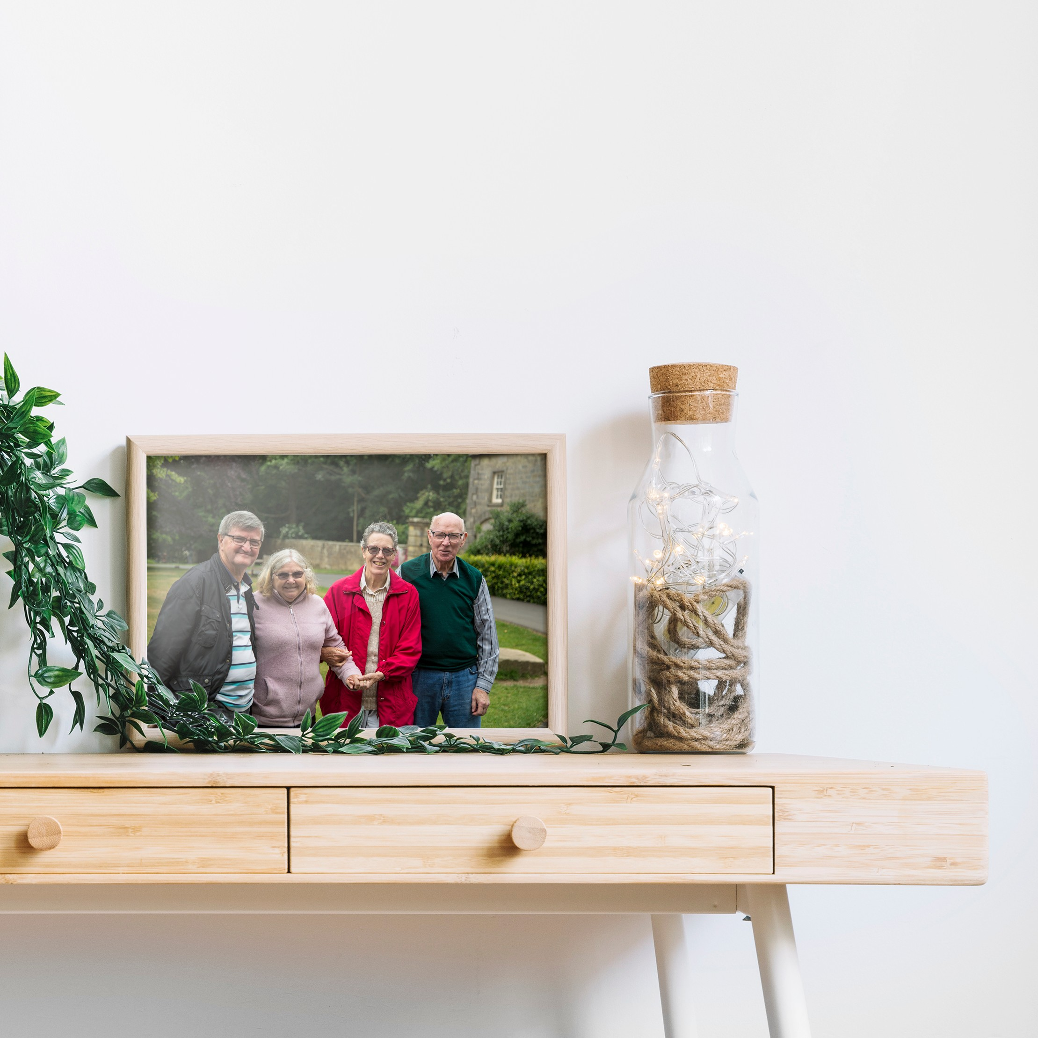

**Figure 1.6** Framed family photo

21

## Negotiating researcher and participant relationships

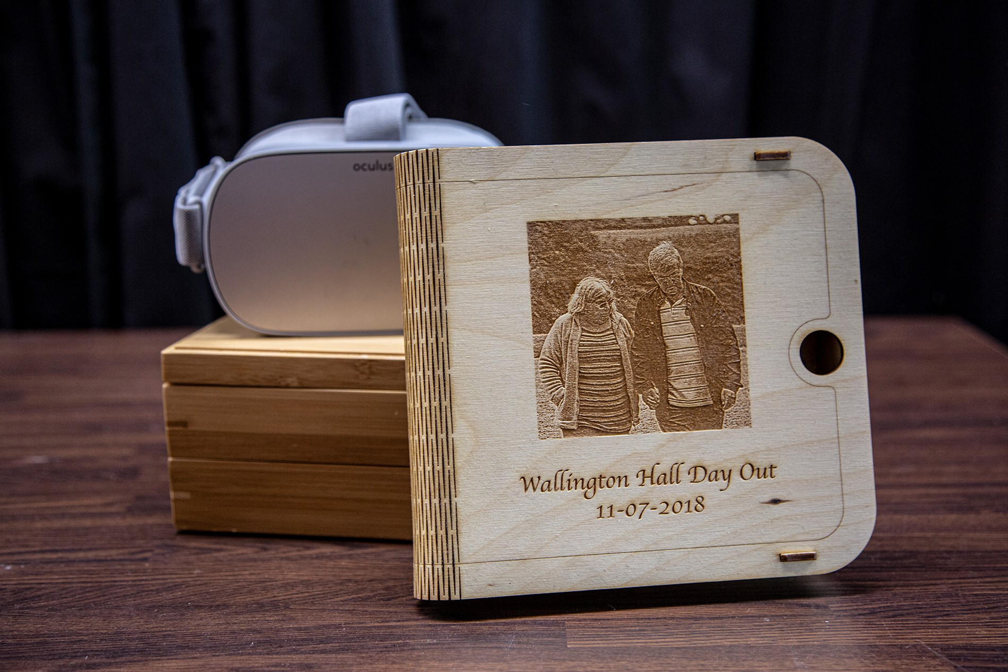

**Figure 1.7** Moment box

by co-planning where the research would take place, the research involvement promoted a more inclusive space and meaningful engagement for the families.

## Designing the Moment Boxes

From the days out, workshops and analysis, the boxes represented each participant’s desires and needs instead of focusing on the individual living with dementia. The final version of the moment boxes was developed in late March, with families receiving in early April. Design choices took influence from ways for realities to eclipse one another, to honour the individual’s choice, and nurture caring relationships that are outside of the caregiver and care receiver’s relationship. Each moment box came with an Oculus Go Virtual Reality headset, a personalised wooden picture box, and a bamboo wooden box filled with physical objects from the days out, or specific requests from the participants such as the dioramas.

### Designing for eclipsing realities

During our days out, it became apparent that the person living with dementia may slip in and out of realities which could be contested by those around them, who may struggle with these conflicting accounts of reality. In particular, Michael expressed his struggle to orient his wife, Lauren, to reality. Michael shared a repeating act of telling Lauren her mother had passed away and would be coming over to see her. While this may place Lauren into the reality Michael sees, we must question if this is an effective way of care. When one cannot recall and recount memories, we should consider other ways to eclipse realities briefly rather than conflict with

22

## 1.7 Designing the Moment Boxes

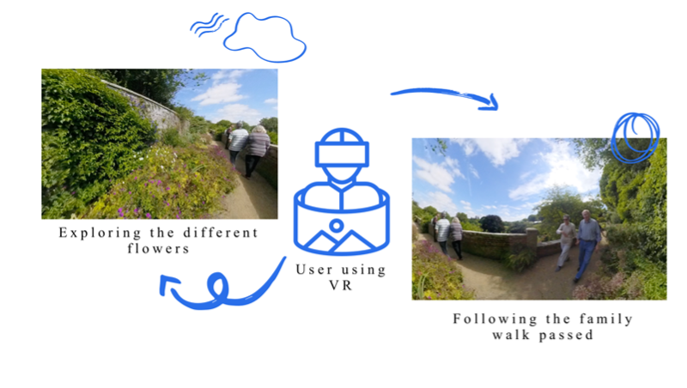

**Figure 1.8** Different ways to view the captured footage

each other entirely. To do so, we may consider the use of lying or being deceptive as a way to eclipse one another’s realities. Unsurprisingly, therapeutic lying is somewhat questioned in what context it is being used (Elvish et al., 2010; Lorey, 2019). Some researchers suggest that by lying, there becomes a sense of dishonesty, and once occurs, trust is broken, which significantly moves away from person-centred approaches. While it’s easy to engage in debates concerning what is morally wrong, many researchers are not the ones dealing with the challenging situations in care. Lying and orienting the person living with dementia towards the ’right reality’ will remain controversial, but it comes entirely down to the situatedness of the moment. With this in mind, in the design of the moment boxes, I considered ways the media experiences could be shared and experienced in multiple ways by considering each individuals desire, wants and possible levels of engagement.

Using 360-degree video capture meant that when the user would be playing it back, they would be the focal point driving along with the experience in all its richness. By placing the user as the centre of the moment they had captured, the 360 experiences could be interpreted in different ways. For some, the moments would be less about revisiting past, and instead foster emotional connections of the beautiful scenery in the video. Accompanied in the moment boxes, I placed tactile, scented artefacts, such as pine cones taken from the forest on the days out. While the families directed myself to take the videos and photographs through the day, by capturing the entirety of the space in 360 degrees, it means for Michael, he can watch and reminisce on these particular moments and watch as the family walk by the cameras and explore the national trust park, while for Lauren her gaze may focus on the trees, the birds, and flowers that were captured that surrounded the space instead. In the example below, we have Michael, Lauren, Sarah and John walking through the National Trust Gardens, where the viewer is given freedom to focus on the flowers and scenery, or the family.

23

## Negotiating researcher and participant relationships

For Philip and Kate, their daughters expressed they wish they could capture further meaning- ful moments for the family. Kate and Philip would spend time on evenings looking over images and videos that the daughters posted and shared on Facebook. Aligned with Philips interactions on the day out, his experiences and interactions strongly rely on the family that surrounds him, and demonstrates an importance of designing for supported family moments. In our moment box for Philip and Kates family, we created a set of tutorial guides to create 360-degree videos for their family gatherings. The tutorial explains how the families can place the videos on YouTube and create QR codes, which individuals can scan onto their phone and place into a VR cardboard headset to share and experience their 360-degree video moments. While I must stress that the use of media experiences is no substitute for going outside, or to replace nature walks, gardening with virtual reality versions, we must consider that these experiences are alternatives for engagement and immersion when the person decides not to go outside – or in a situation particular to as I’m writing this thesis, during periods when social isolation is a priority for all and social interaction is limited.

** Print out tutorial guide and take picture – Post Covid **

### Honouring the individual’s choice

Nolan et al. argue that people living with dementia have reported a lack of confidence when going out (Nolan et al., 2006). As we age, our cognitive abilities are likely to change. By creating opportunities to communicate oneself, such as getting their hair done, dancing, and choosing the way to dress, we start to consider how we honour the individual’s choice in respectful ways that represent their personhood and individuality (Twigg and Buse, 2013). Through the days out, I got to know the families and some participants were more explicit than others. Michael expressed his needs such as asking for a VR guided experience. But for Lauren, it was apparent that at times, Lauren would lack a sense of individuality. As we followed the larger group, Lauren said:

**Lauren:** "You take note because I forget which way I come from, where I’m going to."

**Researcher:** "Don’t worry. No problem. if we get lost, we’ll get lost together. That’s fine. It’s so beautiful. You’ve been here quite a few times, Is that right?"

**Lauren:** "Yes, Yes."

Throughout getting to know Lauren, her expressions ranged from moments of anxiety similar to above to confident chat about hobbies and interests, from wildlife to the carefully modelled miniature figurines she admired in the national trust site. To honour Lauren’s choices and preferences, I created a set of personalised Dioramas placed in the top-tier section of the moment box (see fig.1.9). The Dioramas are inspired by particular locations we spent significant time at Wallington National Trust, and yet they remain abstract enough to be enjoyed by others.

24

## 1.7 Designing the Moment Boxes

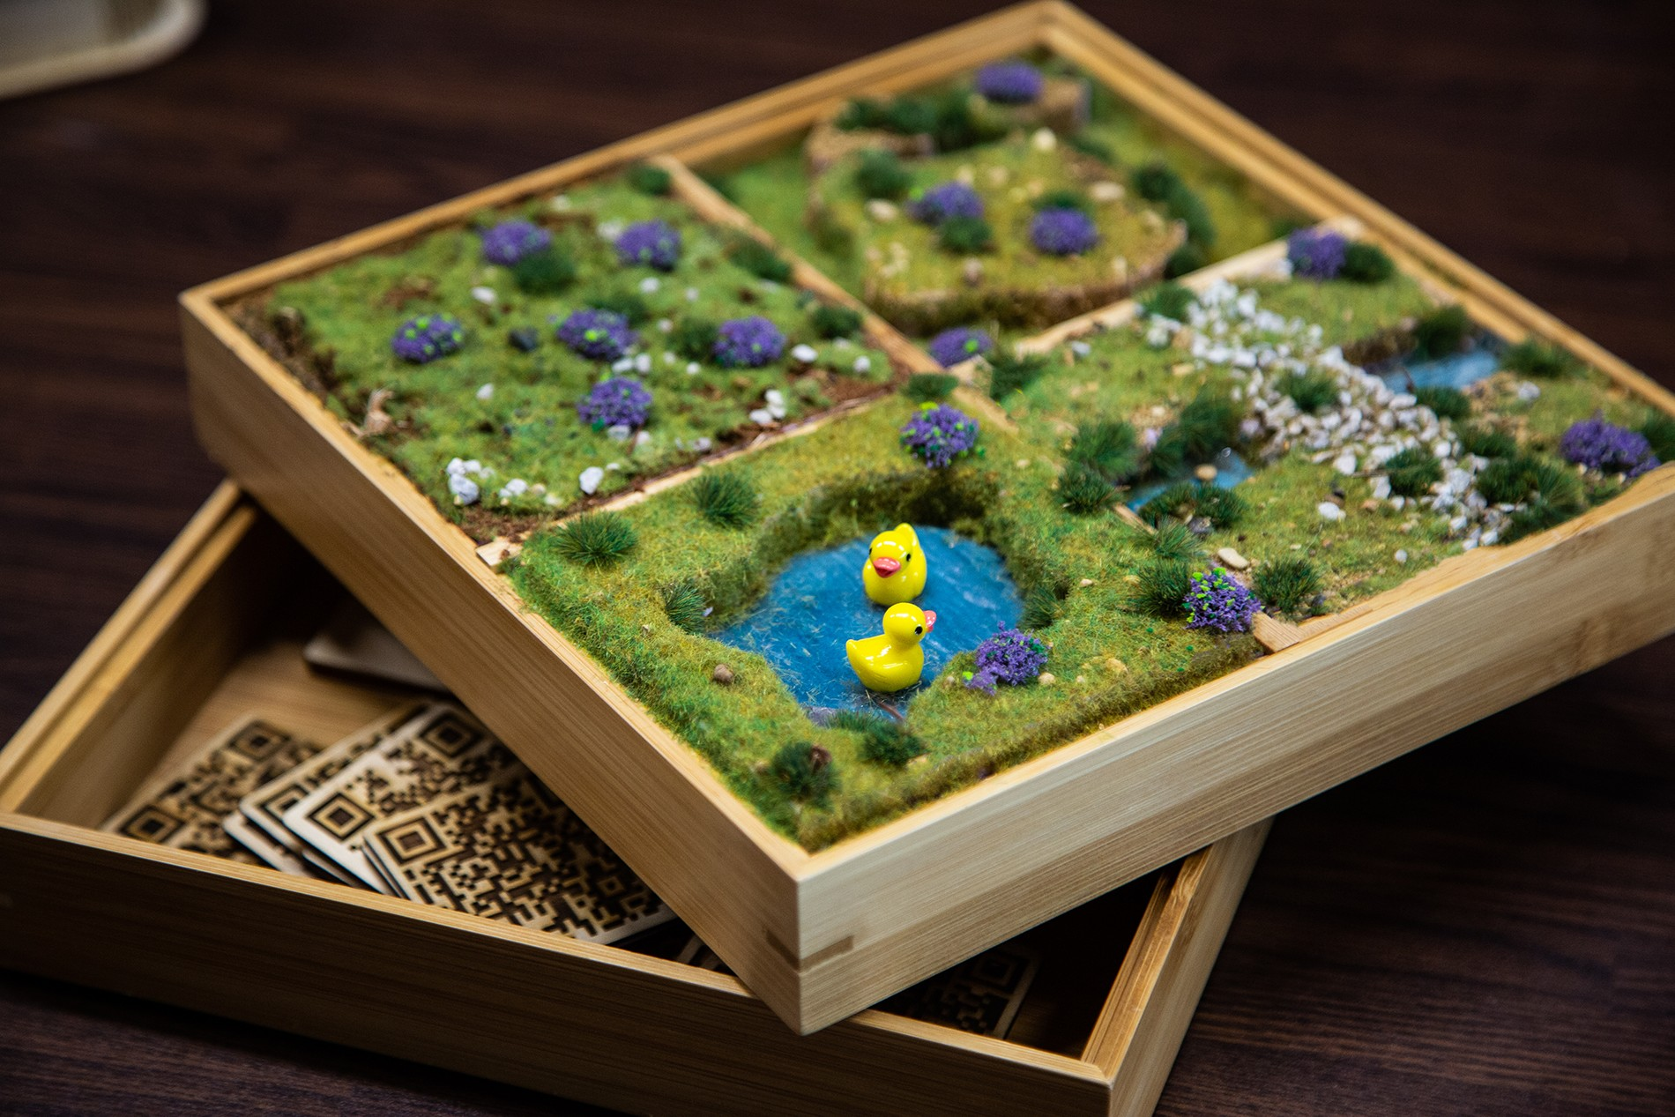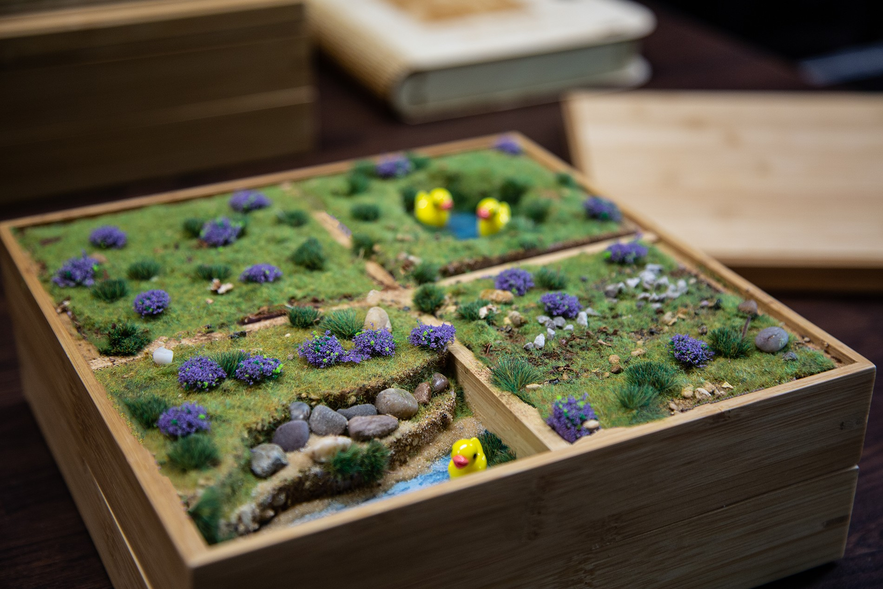

**Figure 1.9** Dioramas created for Lauren and Sarah

To honour the relationships between different family members, Sarah and Lauren’s relation- ship became evident through our interactions and conversations. Michael recalled their family holiday with the four of them, and Michael mentioned that Lauren and Sarah *"walked up the seafront hand in hand all the time chatting away"*. In designing for their relationship, each of them got a set of ’Lauren and Sarah’s moment’s which was particular snippets of videos of the two together and photos that are focused on their relationship solely.

Family members also expressed the types of material for the moment boxes. Through a couple of iterations and engagement with family members, bamboo was decided to be light and sturdy for the box. While this limited the customisability that the cardboard boxes offered, they remained sturdier and would last longer. In one of the workshops, Kate shared *"Philip likes to pick at things or pull at corners of card. . . I think the boxes would have to be wooden or made out of something more solid so it can last longer"*. With more time, I could have perhaps created a more personalised box with a custom-made handle and lock on the sides to make the item more portable. Still, given the time frame and overdue handing the boxes over to the families, I had to sacrifice particular design decisions.

### Nurturing caring relationships

From early on, I aimed to design the media experiences with not only the person living with dementia, but to include their family members and friends. Traditionally, studies often separate carers and people living with dementia as previous work expected different needs from one another. When carers are designed for/with, technologies typically have a focus on duties of care with direction towards assistive technology (Bennett et al., 2017; Bharucha et al., 2009; Gibson et al., 2015). Spending time with the ecology of care, and with a focus on memorable and pleasurable activities, the overall technology or activity tends to include a variety of interests and interactions that the ecology of care desire. With many carers reporting high levels of burnout and burden (Takai et al., 2009), targeting carers as research participants worthy of digital interventions focusing on personhood (as much as we target those with dementia) means treating them with respect, and as whole persons, rather than defining them by their roles.

25

## Negotiating researcher and participant relationships

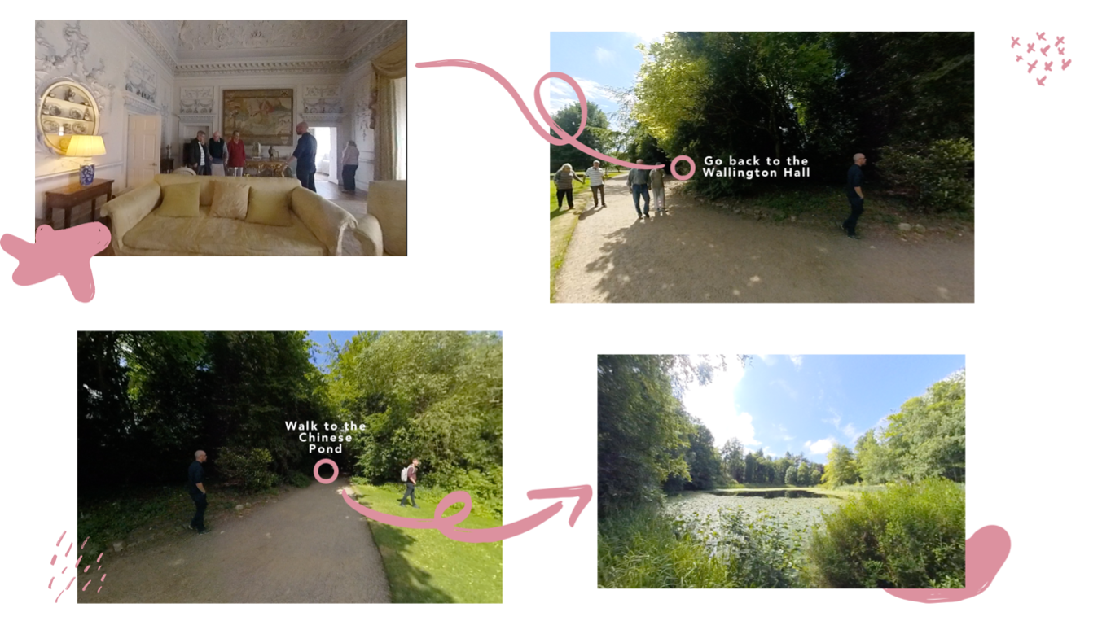

**Figure 1.10** Walkthrough experience of Wallington Trust

As discussed before, Michael wanted to share experiences that would place Lauren in experiences that required to articulate past events as their history held significant importance to him. For this reason, our 360-degree experiences tailored for them can also be used on a phone or tablet. With some ambiguity in what families exactly wanted in how to access the experiences and given their recent introduction to VR technology, I created multiple ways for families to explore the media experiences they captured. The first, was a ‘walkthrough’ experience where the user can navigate to different areas of their day out by clicking on pink circles on the video (see fig1.10). For example, clicking ‘Walk to the Chinese Pond’ from the entrance video will take you to the Chinese Pond video. For Michael, the video walkthrough gave him the ability to explore the estate and history through the day out and for him to be able to express his experiences through recognition, if Lauren chooses to do so, she can join the experience through the same exploration too.

Our second way to explore the day outs was to create an activity that Lauren, and Sarah to take part in and potentially with others from the dementia friendly communities they are a part of. The experience attempts to encourage shared, meaningful interactions. Through a set of ‘random’ QR codes, users would select a QR code that resembled a random moment that the family captured on the day out. Users then place it into the square (shown in fig.1.11 and scan the QR code on their tablet, or phone – which in turn, would open the video up onto their phone.

This interaction while could be used between any of the couples who took part in the study, I wanted to create a way to interact with the experiences that could not be influenced by other people’s needs. With the ambiguity of the QR codes, the choice of the moment was selected by random by whoever decided to pick up the QR square from the box. As the media is designed for shared experiences, this leaves it open as an experience that both partners can interact with solely, as a couple, or together with other loved ones to enrich their lives and provide comfortable, evocative experiences. Finally, families expressed share their experiences with others such as

26

## 1.8 Handing over the moment boxes

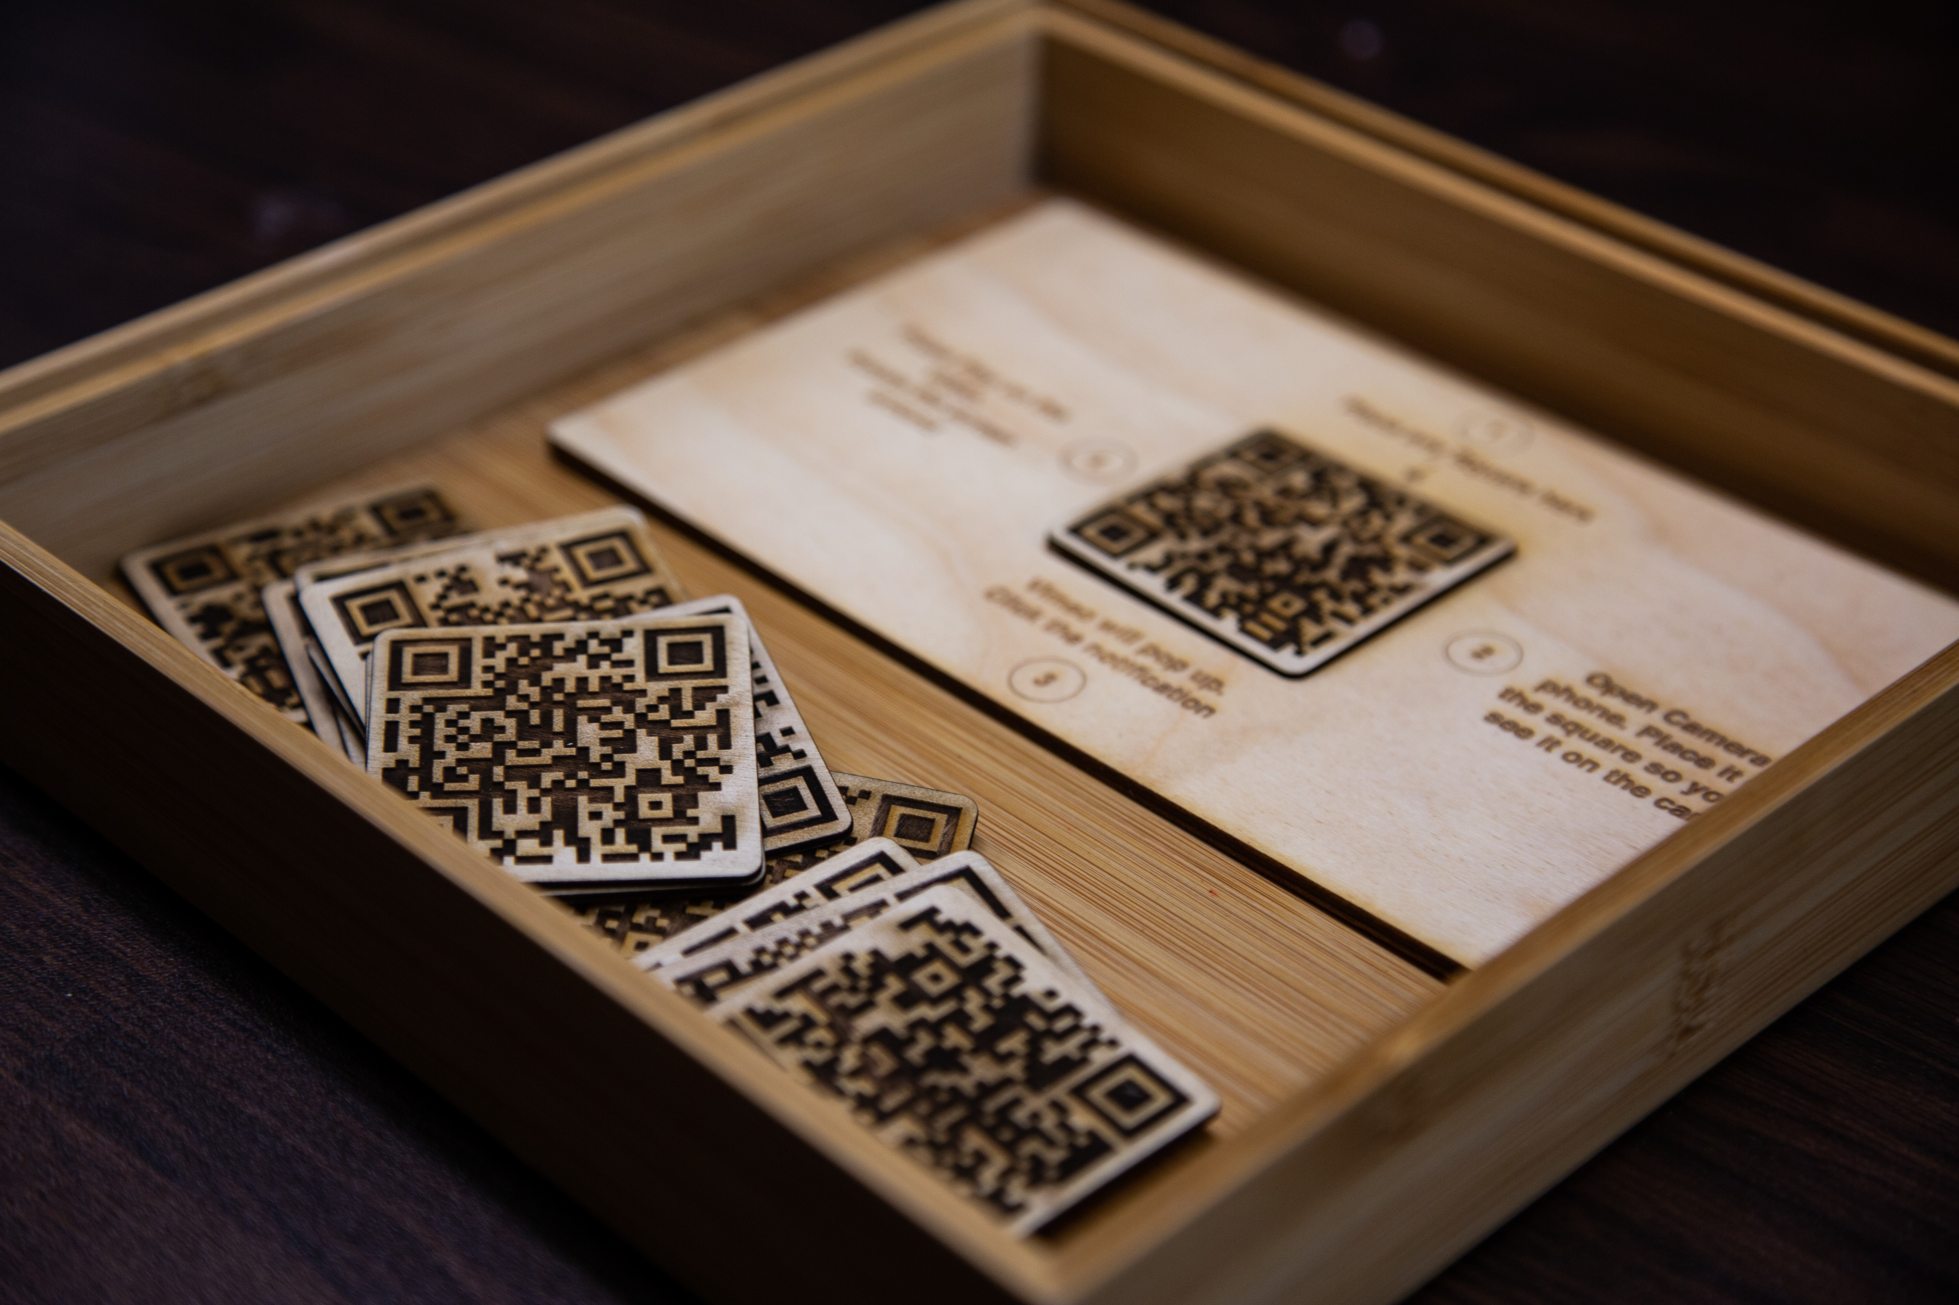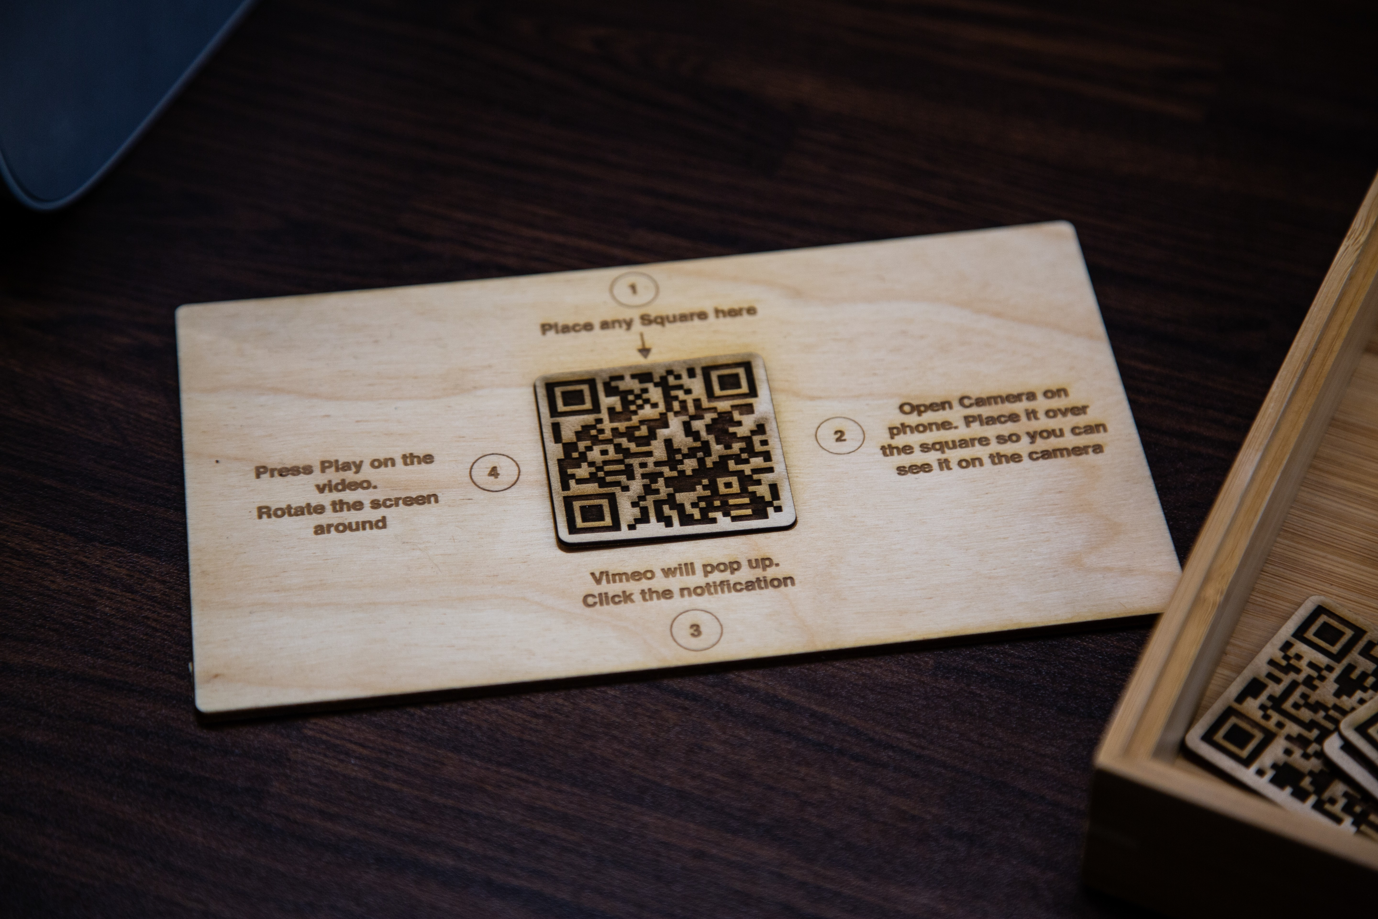

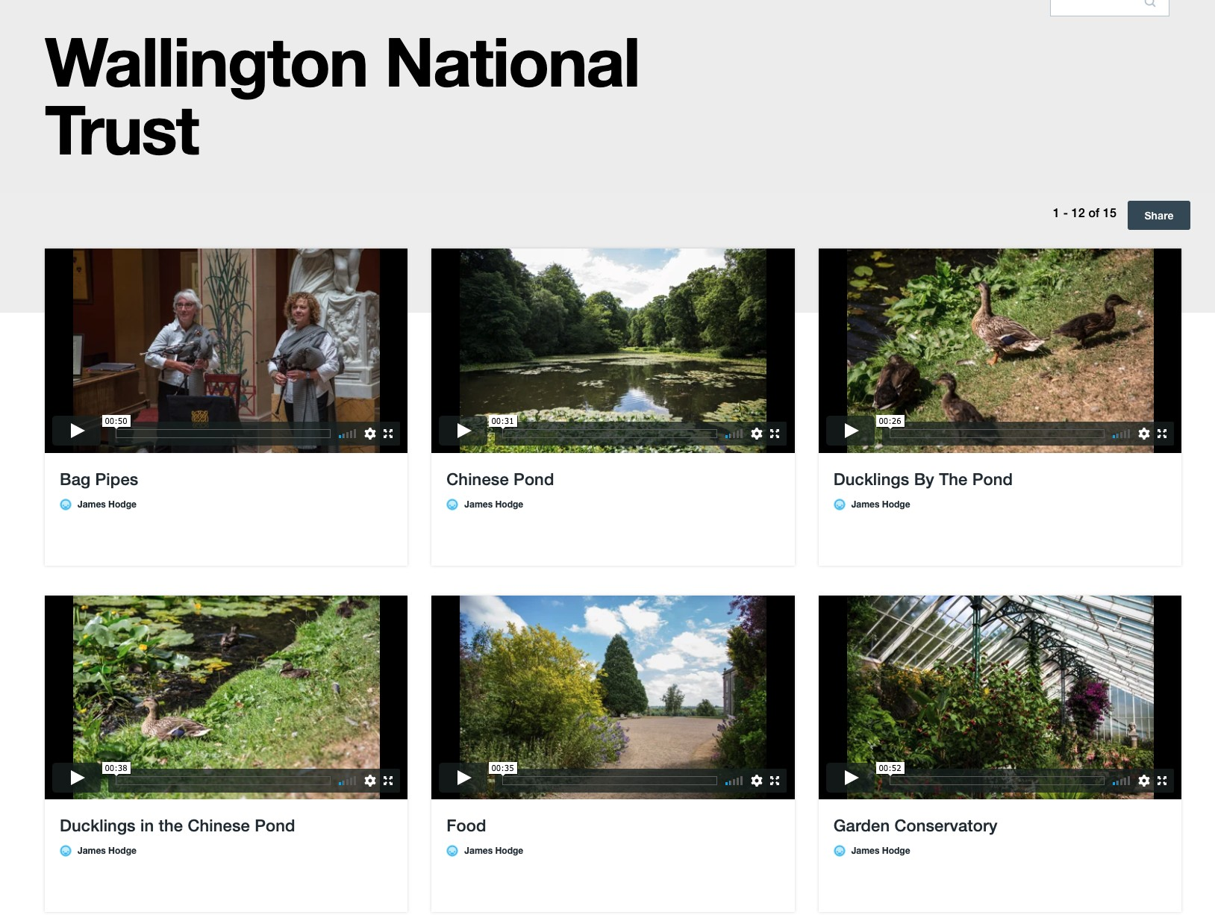**Figure 1.11** QR codes VR activity

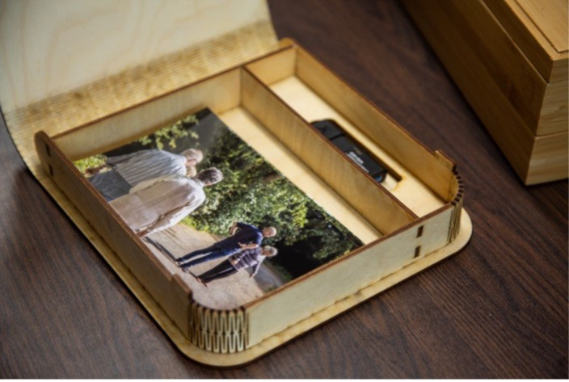

* + - 1. Online archive on Vimeo **(b)** Album box with USB Stick

**Figure 1.12** Optional ways to access bespoke moments

other family members who did not have the chance to get part in the day out. Through Vimeo, I curated a showcase with an archive of all the videos taken from the days out (see fig.1.12a). In the boxes, I printed out multiple different small cards that families could share with others with a bit.ly link for others to watch the videos. Furthermore, each album box had a space for a USB drive with all the data collected from the days out and workshops. The data was theirs to keep and if they ever needed to print out multiples of the images, or use the videos and audio for other reasons, they had the data to do so.

## Handing over the moment boxes

In early April, I contacted Sarah, John, Lauren, and Michael to suggest a meeting for coffee and hand over the moment boxes. I tried to contact Kate and Philip through their daughters’ email, but no luck in reaching out to them – later on, I found out they were going through some family problems. In mid-April, I arrived at Michael’s house where I’d meet the four again. Michael and John were both at the door and welcomed me with open arms. I asked where Lauren and Sarah were, and they told me, "they’re just chatting in the living room. . . We won’t disturb them". With many carers reporting high levels of burnout and burden, John and Micheal’s relationship was more than just a friendship, but also a distraction from their caregiving role. As we sat down and had a catch-up, I asked John how he was doing, and although I expected it, I was still sad to hear that the situation was no longer "we’re lucky" or "life changing" as he had said just nine months

27

## Negotiating researcher and participant relationships

ago. Instead, John echoed similarities to Michael’s struggles that he was facing. John shared a story about how respecting Sarah’s reality and going along with it as opposed to orienting her towards the ’right’ reality: *"It was about 2am couple days ago and I started to hear some banging downstairs. . . I walked downstairs and saw Sarah trying to open the front door. She told me she wanted to go home and I tried to get her to come back to bed but she wouldn’t have any of it. Instead, she kept insisting this wasn’t her home. I told her I’d take her home and we got in the car and I drove around for a bit and then we came back home and all was fine."* John acted in a way similar to the idea of eclipsing realities that has been discussed in this chapter but what I had not understood before, was some of the structural challenges of acting upon the ’dreamlike’ state that someone living with dementia may be experiencing (Bryden, 2015). Although John often follows the ’Butterfly method’ that focuses more on being in the moment as opposed to the ability to recall and recount memories (Hodge et al., 2019), he shared *"it’s tiring James... I’m constantly tired and was completely out of it the next day"*. Going along with what is classed as best practices do not necessarily make it any easier on the caregiver or the person living with dementia. Through the studies, I’ve seen participants change in personality and expression. After only nine months, I saw John’s go from coping to expressing problems of finding self-care for himself. John’s practice of care and Michael’s may have differences when it came to orienting the person living with dementia or co-existing between realities, but as I write this, saying "Orienting the person with dementia towards the "right" reality has very little effect. . . It is also considered to be poor practice" (Hodge et al., 2019) is easier said than done. Spending time in the area of dementia over the past few years, as I’ve had the luxury of being able to leave and reflect on the lived experiences of the participants, I’ve had a more in-depth understanding of how it may be challenging to see someone go through a diagnosis of dementia.

Later on, I asked if Lauren and Sarah could come and see what I had made for the four of them. We all sat down together, and I got the boxes out and heard many expressions of excitement from the four. I placed the boxes between couples – one for Michael and Lauren and another for Sarah and John. They took the tops of the moment boxes, which revealed the personalised dioramas. Both of them expressed that they "love it" and started to feel and play with the grass and ducks in the ponds. After showing the album box with the photos from the days out, Michael asked, *"What about the VR? I’m dying to try it"*. I took the VR headsets out, and we went over how to set them up and what the headset can do. John and Michael grabbed the headsets and placed them on together. As I directed them through the range of settings, they both started to talk and interact with one another as they explored the 360 experiences:

**John**: "here..Michael, are you seeing this? I see the house and you chatting to our James *laughter*

**Michael**: "Hang on a sec. . . I’m at the Ponds. Come to the ponds. How does he do that James?"

28

## 1.8 Handing over the moment boxes

**James**: "Flick the top button of the controller in your hand and you’ll start moving between the different 360 videos.

**John**: "Ah this is canny James"

**Michael**: "Look at the little chickens"

At the time, Sarah and Lauren didn’t seem too interested in the headsets. They were laughing at John and Michael’s interactions alongside me. Unsurprisingly, this was expected from the prior study where participants mentioned a fear of looking foolish or looking silly when wearing the VR headsets (Hodge et al., 2018) the 360 videos, I placed them on Vimeo – a video streaming service similar to YouTube. Michael and John had expressed earlier in the study that they had iPad’s and would like to see the experiences using non-VR technology. I introduced the QR code activity and described it to the four. As Lauren and Sarah grabbed a random QR code albeit looking slightly unsure on what would happen, Michael and John scanned the code on their tablets and it opened a different 360 video. Lauren and Sarah could still drive the experience by rotating the camera with finger gestures on the screen. With the tutorial guides I had place in the box and my introduction of the technology to the families, I had hoped for the families to return to the future experiences. A couple of weeks later, I had a brief call with John and Michael about their interactions with the moment boxes. Sarah and Lauren both had spent very little time experiencing any of the VR experiences but would sometimes sit down and play with the dioramas, the photos and playing with the QR code ’lines. Sarah found the burnt lines into the plywood to create the QR code interesting to feel and hold. For Michael and John, they felt guilty that what I had made wasn’t being used as much. As we discussed that this would be the end of the study, both thanked me for all the work and said, "*if you are ever doing this again. . . we’d be more than happy to go on another day out"*.

While the families were thankful, their comments suggested that VR wasn’t a technology they felt comfortable with or were wanting to explore anymore. A key issue discussed in the HCI community is a push for innovative projects. Meurer et al. discuss the problems of innovation and its impacts on sustainability (Meurer et al., 2018). Involving VR from a research perspective and Sandra’s for the dementia café put pressure on time and resources to explore a technology that may not be appropriate for the community. VR technology has come a long way but still isn’t quite there. Personally, I’ve seen rapid development of VR headsets becoming more user-friendly. As Facebook has started to develop headsets that the families used, they have become far more accessible and useable since 2017. Vine et al. describe ethical difficulties in using Google Glass, supported by Google, which still had bugs typically found in prototypes ((Vines et al., 2017). Although the Oculus Go Headset, and Google Glass – both supported by large corporations, their user interfaces and uses are continued to be designed for the majority instead of the marginalised. Michael expressed a struggle to navigate the system after I wasn’t there to direct him through the step-by-step guide. Even though I had written them down, a paper tutorial is far more difficult to use while you’re navigating a VR interface. Despite failures of longevity in the families wanting

29

## Negotiating researcher and participant relationships

to use VR, they remained thankful and would be more than ’happy’ to participate in any similar study. The families expressed to take part in similar studies resonated with the impact being less about the technology, but rather the involvement and opportunities for meaningful engagement. Wallace et al. expresses the impact through the relationships and involvement created between the study and the participant. Wallace discusses how involving her participants as the driving point, the study itself became important to them. Furthermore, documenting the process with photos for the family, the images held significant value to the participants (Wallace et al., 2013).

## Summary

In this chapter, I have provided reflective insights into three years worth of research where I worked closely with people with dementia and their family members. The focus of the reflection aimed to shed light on the implications of conducting participatory design within this space. In turn, the chapter raises conflicting problems in balancing study expectations with research partners; ’ ethical protectionism’ employed by Ethical Review Boards preventing later stages of dementia participating; and the value of the researcher-participant relationship. Although, as researchers in the field, we may understand that every person has personhood, this doesn’t always seem apparent in the real world. As researchers, our next steps are to consider what it means to be an inclusive society, what it means to do inclusive research and to question the infrastructures that surround and often hold up our work. For instance, as researchers, how can we ensure ethical review boards are reflexive and dynamic when they are evaluating research that seeks to design in sensitive settings? Likewise, while HCI and dementia has explored the nuances and importance of relational approaches in developing technology with people with dementia, understanding how these interactions may scale between people with dementia and designers and developers remains underexamined.

Finally, when we consider our impact, it is essential to note that technology offers opportuni- ties for meaningful engagement as well as create challenges relating to robustness and longevity when the project ends. Typical strategies to overcome these challenges could be to ensure a longer lifespan and technology support if anything goes wrong. Alternatively, we can aim for technology to become a part of a community and create meaningful relationships with our participant groups and research ecologies. This pertains to participatory and community-based research, personalisation, recognition and meaning. In this way, it’s clear that technology alone does not hold any value; it’s the relationships and experiences it creates and mediates.

The two distinct themes from this work that need additional consideration are the following:

1. Explore the role of participation between people with dementia, developers and designers in public engagement

30

## 1.9 Summary

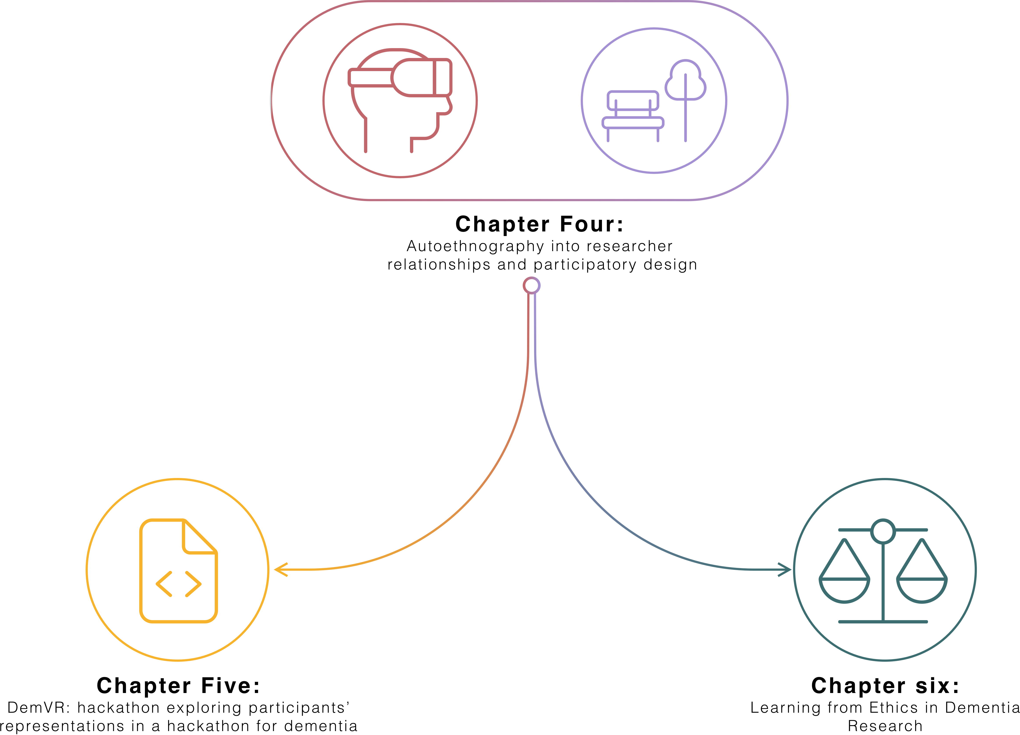

**Figure 1.13** Subsequent chapters

1. To examine the impact of research ethics on participatory approaches in dementia from a researcher’s perspective

In response to these developed themes, the following two data chapters highlighted in fig.1.13 study the themes in more detail to broaden the conversation on dementia and HCI to other stakeholders that influence the relationship between technology and people with dementia. In the next chapter, we start with the first theme that provides deep insights into the shifting representations of dementia in a hackathon that seeks to provide a creative and inclusive space for the public to engage on dementia.

31

# Chapter 2. DemVR: Public Engaged Hackathon

## Introduction

In the previous chapter, I discussed a series of studies I conducted with people with dementia with a partnering charity - Silverline Memories. Through these studies, I developed a set of VR and media experiences for families with dementia that engaged with the importance of personalisation; designing for being in the moment; placing equal importance on the different values in the ecology of care; and exploring ways for people with dementia to be actively involved in the decision process in media experiences, and research. Through an autoethnographic approach, I reflect on the complexities I encountered in representing and involving people with dementia in the participatory process I undertook. The reflections raise issues centring on the ethical challenges researchers face when planning and conducting dementia HCI research and uncertainty in how designers and developers can appropriate such participatory approaches to encourage the involvement of people with dementia.

In this chapter, I build on understanding how designers and developers may approach sensitive topics in HCI while encouraging public engagement, which facilitates opportunities for collaborative learning and awareness around the topic of interest. One such space that brings together the public to develop new paths to research, ideate and test software or products are hackathons. Typically, hackathons have been known to target technical students who are willing to offer their time and technical skills, in exchange for the opportunity to network with companies and learn new soft skills and new insights into areas they may have yet explored (Olesen et al., 2021). In recent years, various domains have adopted hackathons to prioritise to respond to issues beyond the software or hardware skillsets of attendees. For instance, ‘civic hackathons’ (Johnson and Robinson, 2014) have aimed to improve citizen-government relationships through transparency and open data and events focused on ’social good’ (Ferrario et al., 2014). Within HCI, hackathon research has demonstrated useful cases for participation, learning, building, and connecting people in communities of practice (Birbeck et al., 2017; Falk Olesen and Halskov, 2020; Hou and Wang, 2017; Johnson and Robinson, 2014) . However, such events pose challenges of longevity (Birbeck et al., 2017), compensation (Endrissat, 2018), accessibility (Hope et al., 2019), and representation of the area for which attendees are designing (Toombs, 2017).

33

## DemVR: Public Engaged Hackathon

To explore public engagement with the topic of dementia, I ran a two-day hackathon called DemVR, which aimed to provide a space for participants to design novel use cases of shared Virtual Reality (VR) experiences for people with dementia and their care partners. Much of dementia research emphasises the importance of relationships and sensitive design to support close and personal interactions. However, this approach requires long term engagement between researchers and participants that is often a small representative of individuals who are part of those communities that the researcher reached out to. With the hopes of increasing accessibility for people with dementia, I ran the hackathon in two stages. The first was a pre-hackathon event, running over six weeks, where attendees, people with dementia and their care partners, took part in short consultation via an online platform, Ideaboard, to share possible VR ideas. Following this engagement, I organised a two-day hackathon that invited designers, technologists, and other makers to further develop their ideas with domain experts and people with dementia. While the event gained reasonable interest from designers, developers and students, it significantly under-represented people with dementia and their care partners. The failure in representing people with dementia had multiple knock-on effects on teams’ outputs that I describe in the findings. Building from these insights, the chapter ends with reflecting on the hackathon structure. Using dementia as a case example here, proposes alternative approaches for collaborative design events, community building through design, and reification in design.

The study covered in this chapter is currently being peer-reviewed in the TOCHI journal. The paper is co-authored by Dr. Sarah Foley, Dr. Daniel Lambton-Howard, Dr. Kyle Montague, Dr. Laura Booi, Sandra Hastings, Prof. David Kirk, and Dr. Kellie Morrissey. I was responsible for concept, study design, data collection, data analysis and writing of the paper. Co-authors supported the facilitation of the hackathon, and Dr. Kellie Morrissey, Dr. Sarah Foley and Dr. David Kirk provided feedback on the paper’s writing and contribution.

## Related work

To provide context for the sensibilities informing the design of DemVR, I discuss the current approaches in designing for and with people with dementia and conclude the section by consider- ing the challenges and opportunities of including such populations in public design events such as hackathons.

### Learning about dementia through design

Dementia is a neurodegenerative condition causing changes to cognitive ability and increasing reliance on social and physical care; bringing with it experiences of stigmatisation and subsequent social isolation (Herrmann et al., 2018). Moving from an early, medicalised understanding of dementia as a process of decline and memory loss, recent social justice and rights-based responses

34

## 2.2 Related work

to the experience of dementia have resulted in a more holistic understanding of the condition (Shakespeare et al., 2019). This evolving understanding of dementia is mirrored in social and technological responses in research, which moved from early assistive technologies focusing on bridging a ‘cognitive gap’ (Mulvenna et al., 2010), to experience-centred design that fosters creative expressions of personhood (Morrissey et al., 2017b), to more recent work on supporting wider social engagement with people with dementia (Foley et al., 2019b; Lazar and Dixon, 2019; Welsh et al., 2018). Through the progression of understanding best practices for designing with and for people with dementia, HCI researchers have developed a series of approaches which centre relational interactions, as opposed to engaging this population solely at the end of the design process, e.g., by inviting participants for ‘user testing’ or ‘user evaluations’ (Brankaert et al., 2019; Schorch et al., 2016; Vines et al., 2013b). However, by providing a more relational approach to our work, the researcher and participant are faced with different challenges. For instance, longer-term commitment to projects to support trust-worthy relationships between the researcher and participants (Hendriks et al., 2014); complex ethical considerations (Garschall et al., 2016); and the responsibility to take a caring and compassionate procedure to the research study (Balaam et al., 2019).

In response to the increase in multidisciplinary teams (often consisting of designers, de- velopers, and researchers in the field) researchers have developed several toolkits and guides (Astell et al., 2019; Broderick, 2020; Jais et al., 2018) in an attempt to best guide the ways we involve and work with people with dementia. For the majority, they have been provocative and useful toolkits that provide researchers the knowledge and insight into the best ways to involve people with dementia in the design process. A group of researchers and people with dementia have designed a series of design activities to support the design processes and include people with dementia within the project. These design activities are the following: visual diaries, persona’s, scenarios and visual cards (Wang et al., 2021). In contrast, other toolkits such as the Compassionate Design Toolkit by LAUGH provides an approach to show designers how they may design bespoke design for people with dementia by including their interests, lift history and opening experience to the senses (Treadaway et al., 2016).

Amongst the guides and toolkits are several activities that aim to evoke empathy towards the population for whom the designer will be designing. For example, the development of a set of personas of people living with Alzheimer’s (Jais et al., 2018), and VR simulations to aid in understanding what it may be like to be a care partner or someone with dementia (Hirt and Beer, 2020). While these activities are beneficial in prompting learning and informing user scenarios for the technology at hand (Vines et al., 2015), researchers must be wary that activities such as personas may reduce flexibility and creativity by attempting to fit the technology to a set of “caricatures” (Redström, 2006), rather than exploring the ambiguous nature of how people may use the technology. Furthermore, reducing care partner training down to a simulation may undermine the complexity needed to deliver person-centred dementia care. Therefore, while these design activities can offer initial insights into the people we are designing for, researchers

35

## DemVR: Public Engaged Hackathon

should continue to question and explore the challenges and impact the approaches may have for when we are designing within sensitive settings.

Concerned by similar implications arising from such design thinking activities (Bennett and Rosner, 2019), researchers have considered novel approaches to undergraduate education to provide designers and developers with the skillset to make more sensitive design choices. In the context of dementia and HCI, this has led to inviting students to collaborate in co-design methods with care home residents by developing life story work [38] and storytelling projects (Hannan et al., 2019). Hendriks et al. (2018) further supports the importance of designers and students building a relationship with the people we are designing for and with. The authors argue design decisions *“emerge from the relationships designers build” (pg. 3)*(Hendriks et al., 2018). However, while opportunities to work in more non-traditional settings such as care homes may be possible through university classes, these are often limited to a small, selected group of students or courses focusing on healthcare and psychology (Kinnunen et al., 2018), meaning those who are taught technical or design disciplines through university miss out on opportunities to gain experience with the vulnerable populations that they may end up building for. Finally, developing these types of understandings through intergenerational interactions has often relied on organisations or care homes to provide a community of older adults or people with dementia, both increasing the workload of already pressured social care organizations, and limiting the potential of involving communities or individuals who are not part of those selected organisations. One alternative may be to support collaboration and engagement between the general public and people with dementia through online spaces, as we discuss below.

### Dementia and public engagement

Much of the research encouraging social interaction with people with dementia is highly rela- tional, emphasising the importance of relationships and the potential for design technology to support close and personal interactions. In order to consider different stakeholder values, Maiden et al. (2013) facilitated a set of co-design activities to facilitate the connection between the carer and person with dementia. They resulted in a set of improvements for the aspect of care that revolves around communication, collaboration and interaction. By designing mobile applications to be used by the carers, researchers in this study explored ways carers could log and reflect on their interactions with people with dementia to prompt future improvements in methods for delivering person-centred care. This highlights that personalisation of technology in care homes is essential to help support residents with or without dementia and enrich their individual care strategies. However, this approach requires continued engagement and relies on the support and time from care partners, volunteers, and the person with dementia. In contrast to this, Lazar and Dixon (2019) work on dementia activism online demonstrates the willingness of some people with dementia to share their experiences to change public attitudes and present ’real and raw’ accounts of life with the condition. Participants’ motivation to share their experiences of living

36

## Related work

with dementia seems to be twofold: writing allows reclamation of social identity through sharing their thoughts and feelings, and second, sharing their experiences helps not only family members, but also the public to look past the diagnosis of dementia by demonstrating life continues to be rich and meaningful post-diagnosis (Ryan et al., 2009).

For example, Talbot et al. (2020) analysis on people with dementia using Twitter describes their use of the platform provides opportunities to raise awareness, fundraise, challenge stigma and to share their experiences of living with dementia. Sharing lived experiences can also be seen in the recent proliferation of blogs, presentations, and personal books advocating (Bryden, 2020; Christine Bryden, 2005; Swaffer, 2014) for changes in media and public portrayals of dementia which might in turn counteract dominant misconceptions about, and stereotypes of, the condition. However, careful consideration must be attended to the way technology is appropriated as Lindqvist et al. (2018) argues technology can *“be hindering and evoke stress or, in contrast, bring about feelings of control”* . While this creates an opportunity for public engagement, the extent to which the ‘public’ are engaging with these narratives is underexamined, begging the question: how can these experiences be better positioned for societal change-making? Moreover, such advocacy work, despite its benefits, is often associated with strain (D’Cruz and Banerjee, 2020), through the “*psycho-emotional consequences of taking action”* (Bartlett, 2014) where advocates present themselves in an opposing dominant public view. For instance, Christine Bryden, a pioneering dementia advocate, has had practitioners request *“brain scans in her PowerPoint presentations”* (Swaffer, 2016) to question her diagnosis of dementia as her public-campaigning opposes the normative expectations of what someone with dementia ‘should’ be like. In these instances, exploring ways to balance between empathy and maintaining an individual’s privacy and dignity is required.

With this in mind, embedding public engagement into design work with vulnerable groups such as people with dementia requires careful consideration. One challenge lies in how we engage with such complex (and often stigmatised) topics sensitively while encouraging public engagement, which in turn allows a greater extension of awareness and understanding around the topic of interest. For instance, many expert researchers have years of experience working with people with dementia, and are aware of both the importance of attuning to person-centred approaches (Fazio et al., 2018) and language, but also of the damage negative and stereotypical ideas of dementia can have when used to emphasise a deficit or inaccurate image of life with dementia (Young et al., 2019). Moreover, Niederdeppe et al. (2008) highlights the formidable communication challenges faced when inviting a broader public to input on a sensitive topic due to unknown biases, priorities, and cultural norms, which may risk having stereotypes aired publicly or even perpetuated.

37

## DemVR: Public Engaged Hackathon

### Design events and public engagement

Public design events such as hackathons (Olesen et al., 2021), design sprints and workshops, involving as they do interdisciplinary teams interested in innovation, have been said to *’offer new opportunities and challenges for cooperative work by affording explicit, predictable, time- bounded spaces for interdependent work and access to new audiences of collaborators’* (Filippova et al., 2017). Originating within the tech industry as competitive over-night coding events (Jones et al., 2015), hackathons are events where designers, developers collaborate over an intensive short period of time (typically a weekend), on software or design projects (Nandi and Mandernach, 2016). Typically, hackathons have been organised and sponsored by businesses or universities to provide undergraduates the opportunity to learn and practice new skills, and potentially building connections between the attendee and organisation recruiters or employees. Hackathons are often coupled with rewards and prize money for the winning team as enticement to spend time building a demo and/or presentation (Jones et al., 2015).

In recent years, various domains have adopted hackathons to prioritise to respond to issues beyond the software or hardware skillsets of attendees. For instance, ‘civic hackathons’ (Johnson and Robinson, 2014) have aimed to improve citizen-government relationships through trans- parency and open data and events focused on ’social good’ (Ferrario et al., 2014). Within HCI, hackathon research has demonstrated useful cases for participation, learning, building, and con- necting people in communities of practice (Birbeck et al., 2017; Falk Olesen and Halskov, 2020; Hou and Wang, 2017; Johnson and Robinson, 2014) . However, such events pose challenges of longevity (Birbeck et al., 2017), compensation (Endrissat, 2018), accessibility (Hope et al., 2019), and representation of the area for which attendees are designing (Toombs, 2017). As hackathons have continued to be explored in HCI, researchers have re-structured and tailored the format to tackle the challenges described above. For example, Hope et al. (2019) leverage feminist and intersectional lenses to suggest pathways to building more inclusive and accessible events.

Similarly, Birbeck et al. (2017) employed an inclusive approach to their hackathon for mental health, inviting facilitators and presenters with experience of self-harm to centre the voices of the people impacted by the hackathon topic. Echoing this, in a recent review of the past ten years of hackathon research, Falk Olesen and Halskov (2020) highlight there is always a topical drive that is typically related to an ongoing real-world problem or engaging a particular community. Despite their benefits, hackathon formats can also raise tensions in certain circumstances: Taylor and Clarke (2018) note issues in *“explaining what a hackathon is and what it will involve”*, particularly when the audience background is mixed. The authors also recorded instances where participants’, mentors’ and teams’ interests and values clashed, leading to uncomfortable moments; however, in the same event, ‘feedback gave developers a heightened awareness of the sensitivity of their design, which was hailed as one of the weekend’s main successes”.

38

## Event context

Beyond these structural factors, facilitators of design events for public and civic issues are challenged with introducing often sensitive topics (such as the experience of living with dementia), while also encouraging creative and technical responses from participants in a short time frame. While these spaces are encouraging for student makers or as community- building events, the hackathon space expects participants to get ’up to speed’ with contemporary knowledge about the condition, group or topic while simultaneously requiring participants to design and build novel and innovative technological innovations outputs. This has been the case with hackathons such as *“Make the Breast Pump not suck”* (Hope et al., 2019) event, which considered the user experience of breast pumps, to more recent hackathons tackling the unmet needs during the COVID-19 pandemic (Bolton et al., 2020). It could be argued that, when the focus of the hackathon is on health and/or wellbeing, such open design events require the careful scoping of presentations, workshops, lived experiences, documentaries, interviews (Paganini and Gama, 2020), and inspiration packs (Birbeck et al., 2017) to upskill participants who may be drawn by the promise of prizes or creatively fruitful weekends, but who may hold outdated or stereotypical attitudes towards the topic out of a lack of experience. Providing engagement through interactions and design tools is particularly important where participation is open to the public where participants may lack lived experience. For example, Self Harmony Hackathon by Birbeck et al. (2017) consisted of 45 participants with only eight participants with lived experiences of self-harm. It is therefore not a surprise that some design responses may be unsuitable, or potentially feed into stigmatising ideas of the group or topic at the centre of the design event if resources and engagement with the lived experience is neglected (Toros et al., 2020).

Given the potential challenges of the use of such public design events, but also the increasing prevalence of such modes of public engagement (Endrissat, 2018; Paganini and Gama, 2020; Yuan and Gasco-Hernandez, 2021), it is particularly timely to begin to unpack exactly how the work of designing for marginalised populations within such settings may be better supported. This study progresses this growing area of research which has emphasised the importance to restructure hackathons to accustom marginalised populations, and the ways in which we provide and support education to those without lived experiences. With this in mind, the following section describes our approach to tackle the potential barriers of using such public design events with people with dementia. We return to these challenges and implications for the role of design and HCI in public engagement in our discussion.

## Event context

In 2019, I set out to organise a hackathon called DemVR, both to generate a set of bespoke VR environments for those living with dementia, as well as to consider how developers/designers (with expertise in media or VR) and people living with dementia may collaborate. Inspired by prior work involving lived experiences in hackathons (Birbeck et al., 2017), the hackathon

39

## DemVR: Public Engaged Hackathon

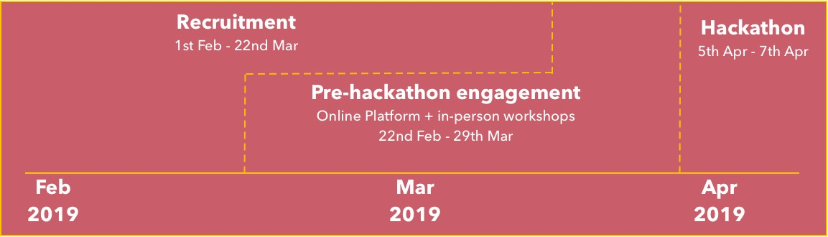

**Figure 2.1** Timeline of the event

was split into two engagement phases see Fig.2.1. The first was a six-week pre-hackathon phase: this consisted of the deployment of an online platform (called Ideaboard) to support designers/developers in pitching their potential hackathon ideas and receiving feedback from people living with dementia and care partners. The second phase was the two-day hackathon event itself, where participants formed teams to compete for £1,000 & £500 prizes by creating prototypes of VR experiences for people living with dementia and their care partners. To accommodate funding for venue hire, branding, food and travel, I partnered up with several organisations in Newcastle who assisted in the funding and providing expert knowledge on dementia, VR, and running tech-focused events. For instance, continuing my relationship with Silvelrine Memories provided the hackathon with dementia expertise, while connecting with Sunderland Software City provided funding for venue hire. In the following sub-sections, we describe the event according to the timeline of the hackathon: a) recruitment; b) pre-hackathon - online platform, in-person workshops, team formation event; and c) the two-day hackathon.

### Recruitment

My initial recruitment process targeted designers and developers through university networks, VR/AR labs across the UK, as well as publishing blog pieces on popular VR websites to invite creators to take part in the two-day event. Upon registering for the event on our website1, participants were sent an email inviting them to sign up for Ideaboard and submit their idea, I attempted to recruit people living with dementia and their care partners in multiple ways. The first, was through Silverline Memories who I talk in detail about in chapter 1. Secondly, given Twitter is a popular social media platform for dementia network and advocates (Talbot et al., 2020), I ran a Twitter account posting tweets to encourage people living with dementia and their care partners to sign-up. In these instances, while I invited people with dementia and care partners to the hackathon, the priority was signing them up to the online platform or take part in the in-person workshops as the pre-engagement phase supported longer-term engagement. However, as I mentioned in this chapter, our recruitment process to involve people living with dementia and care partners failed with only one care partner signing up to our platform.

1[www.demvr.uk](http://www.demvr.uk/)

40

## 2.3 Event context

Within our hackathon participant recruitment, the majority of attendees had to some degree experience with technical, design and/or research skills. While we did invite care partners, social workers and practitioners, the high-level expectation of building demos or lo-fi prototypes for virtual reality experiences could have intimidated those with less technical backgrounds from participating resulting in a *“limiting difference among participants”* (Irani, 2015). Additionally, the technology-oriented event may have contributed to the lack of interest from people with dementia and care partners. For instance, Hwang et al. (2020) recommend researchers should provide a longer-term learning and facilitating process with people with dementia to promote inclusion and learnability. While we discuss meeting people with dementia where they are in detail in our discussion as a reflection on our lack of engagement through online platforms, appropriation of hackathon knowledge including insights into VR in the recruitment stage could have been more carefully considered. Furthermore, the authors highlight if the learning process for engagement evokes *“frustration, anxiety, or sense of vulnerability (pg.46:26)(**Hwang et al.**,* *2020**)*, then the person with dementia may resist the interest or engagement with that particular technology. Despite our efforts to invite people with dementia from our partner charity who had previous interests and knowledge into VR from prior studies seen in 1, neglecting a set of resources for the recruitment stage to upskill people with dementia, care partners and the public onto the topic of designing VR experiences likely contributed to an unawareness or confidence to share experiences online and during the two-day event. We return to these challenges in our discussion.

Twelve participants (2 women, 10 men) actively signed up to the online platform. During set up, to get the conversation rolling, I added three initial example ideas focused on shared family VR environments, personalising the VR headset, and a VR experience that blends the real world and virtual into one. Out of the twelve participants, eight submitted ideas. Of the twelve participants, nine attended the hackathon (see table 2.1), with two of them submitting an idea but not attending the hackathon. One participant, a care partner named Denis, was unable to attend the hackathon but actively joined discussions on six of the submitted ideas. Additionally, while we set-up two in-person workshops described in 2.3.2, the workshops received no sign-ups resulting in no additional feedback for teams from people living with dementia or their care partners. In the following sections, I dive into this further considering why this may have been the case.

For the hackathon, I had 40 participants (18 women, 22 men) attend. In our pre-hackathon team formation stage, I had an additional team of four that dropped out due to intellectual property concerns. This resulted in nine teams. Individual demographics of participants within their associated teams are summarised in table 2.1. Although no participants had the experience of being a care partner or living with dementia, participants identified their experience with dementia during the sign-up process from the following:

* + - * **Experienced**: worked in the area of dementia in a research/industry/care setting/charity.

41

## DemVR: Public Engaged Hackathon

* **Knowledgeable**: Has had a family member or friend living with dementia but not neces- sarily cared for them.
* **Limited**: Have read people’s experiences or recent research in the area of dementia.
* **None**: Know very little about the topic

Expert speakers were also invited to discuss topics on design, dementia advocacy, and experiences of living with dementia. An additional three dementia & HCI researchers, a gerontologist, and the CEO of Silverline Memories, assisted with hackathon facilitation. The facilitators’ role lent their experience by sitting down with individual teams throughout the two days to talk through the teams’ ideas and thought processes. Our judges consisted of a dementia HCI research, the CEO of Silverline Memories, a VR expert, and an accessibility HCI researcher to judge the team’s final VR ideas.

### Pre-hackathon engagement

I planned and arranged a six-week consultation period, to be carried out via 1) an online participatory platform, and 2) in-person workshops with people living with dementia, and their care partners. Additionally, I provided a team formation day prior the two-day hackathon to ensure participants. The pre-hackathon stage provided the optional opportunity for future hackathon participants to submit initial thoughts and ideas where experts would provide feedback to give participants insight into the wants, desires, and experiences of people with dementia and their care partners.

### Online platform (Ideaboard)

The participatory platform, Ideaboard3, was conceptually developed in-house at Open Lab from prior participatory platforms in working in Digital Civics and social care - for instance, one inspiration was App Movement (Garbett et al., 2016), a platform that enables users to *"collaborate, design, and deploy community commissioned mobile applications"*. Ideaboard similarly offers creative tools and workspaces to support the creation of ideas and collaboration. Here I describe the process users undertake to add ideas to the platform. Our Ideaboard process was split into three components:

1. On Ideaboard, participants were invited to share preliminary ideas that they could develop during the in-person hackathon. Once their idea was uploaded, participants could then explore and comment on other submitted ideas (see Fig.2.2a).

3[www.Ideaboard.co.uk](http://www.Ideaboard.co.uk/)

42

## 2.3 Event context

|  |  |  |  |  |  |
| --- | --- | --- | --- | --- | --- |
| **Team** | **No. members** | **Age range** | **Background** | **Experience with dementia** | **No.**  **Ideaboard**2 |
| Garden Life | 7 | 16-25 | Comp-sci | Limited (1) / | 3 |
|  |  |  | undergrads | None (6) |  |
|  |  |  | (7) |  |  |
| Chatter | 2 | 26-45 | History | Experienced | 0 |
| Bench |  |  | researcher (1) | (1) / Limited |  |
|  |  |  | / HCI | (1) |  |
|  |  |  | research |  |  |
|  |  |  | developer (1) |  |  |
| Augmented | 6 | 16-25 | Comp-sci | Limited (2) / | 1 |
| World |  |  | undergrads | None (4) |  |
|  |  |  | (6) |  |  |
| VRHallucinate | 6 | 16-35 | Psychology | Limited (1) / | 0 |
|  |  |  | researcher (2) | None (5) |  |
|  |  |  | / Developer |  |  |
|  |  |  | (3) / |  |  |
|  |  |  | Designers (1) |  |  |
| LookingVRBack | 4 | 25-45 | Marketing (1) | Experienced | 2 |
|  |  |  | / Biomedical | (1) / None (3) |  |
|  |  |  | researcher (1) |  |  |
|  |  |  | / Comp-sci |  |  |
|  |  |  | undergrad (2) |  |  |
| Mindful | 2 | 16-25 | Comp-sci | Passing (2) | 0 |
| Forest |  |  | undergrad (2) |  |  |
| Sensory Tide | 6 | 26-45 | HCI | Experienced | 3 |
|  |  |  | researcher (3) | (2) / Passing |  |
|  |  |  | / Developer | (1) / None (2) |  |
|  |  |  | (1) / |  |  |
|  |  |  | Filmmaker |  |  |
|  |  |  | (2) |  |  |
| World Share | 3 | 16-25 | Filmmaker | Passing (1) / | 0 |
|  |  |  | (3) | None (2) |  |
| VRmotion | 4 | 16-25 | HCI | Experienced | 0 |
|  |  |  | researcher (1) | (1) / Limited |  |
|  |  |  | / Developer | (1) / None (2) |  |
|  |  |  | (1) / Designer |  |  |
|  |  |  | (2) |  |  |

**Table 2.1** DemVR participant table

43

## DemVR: Public Engaged Hackathon

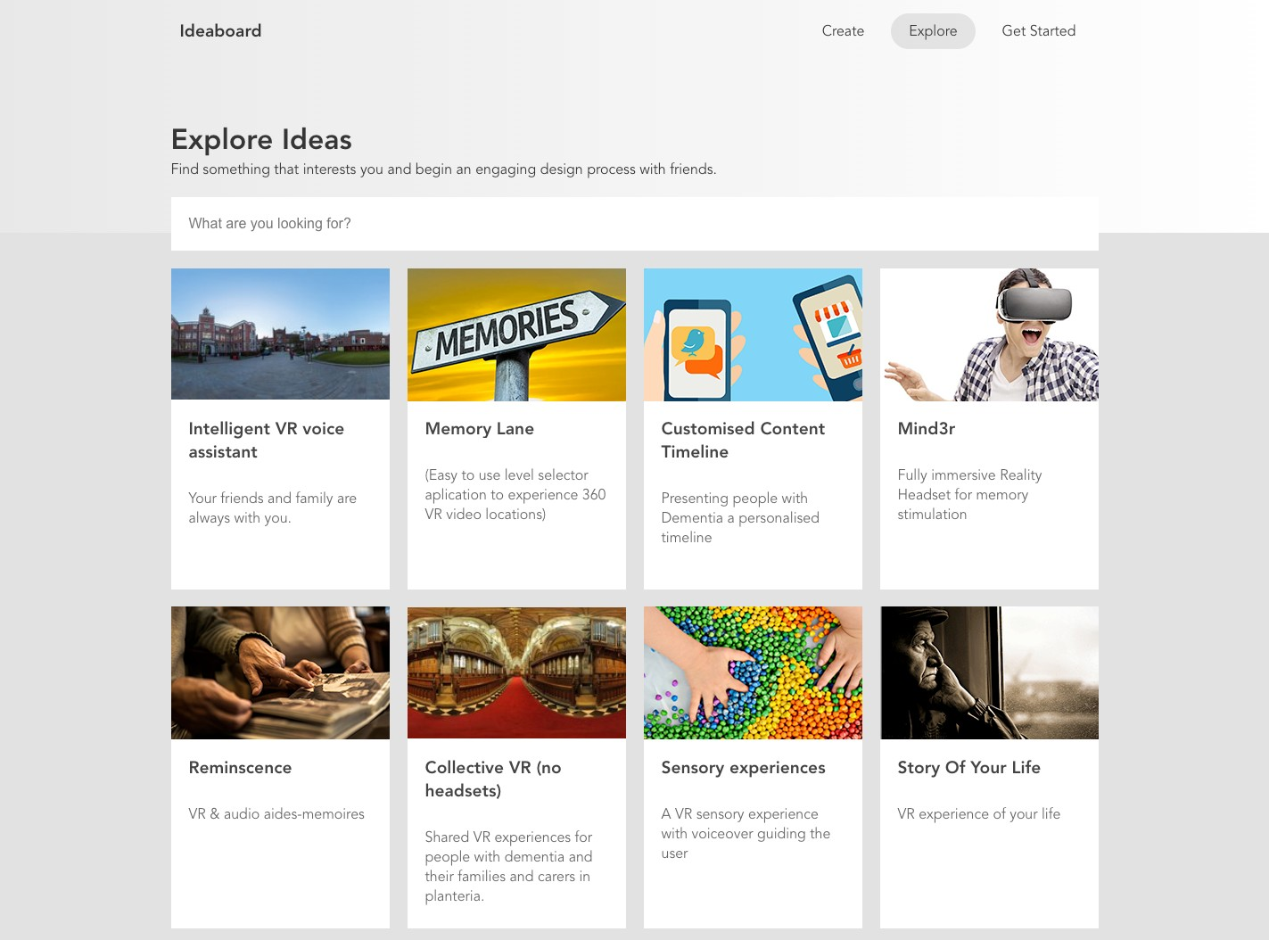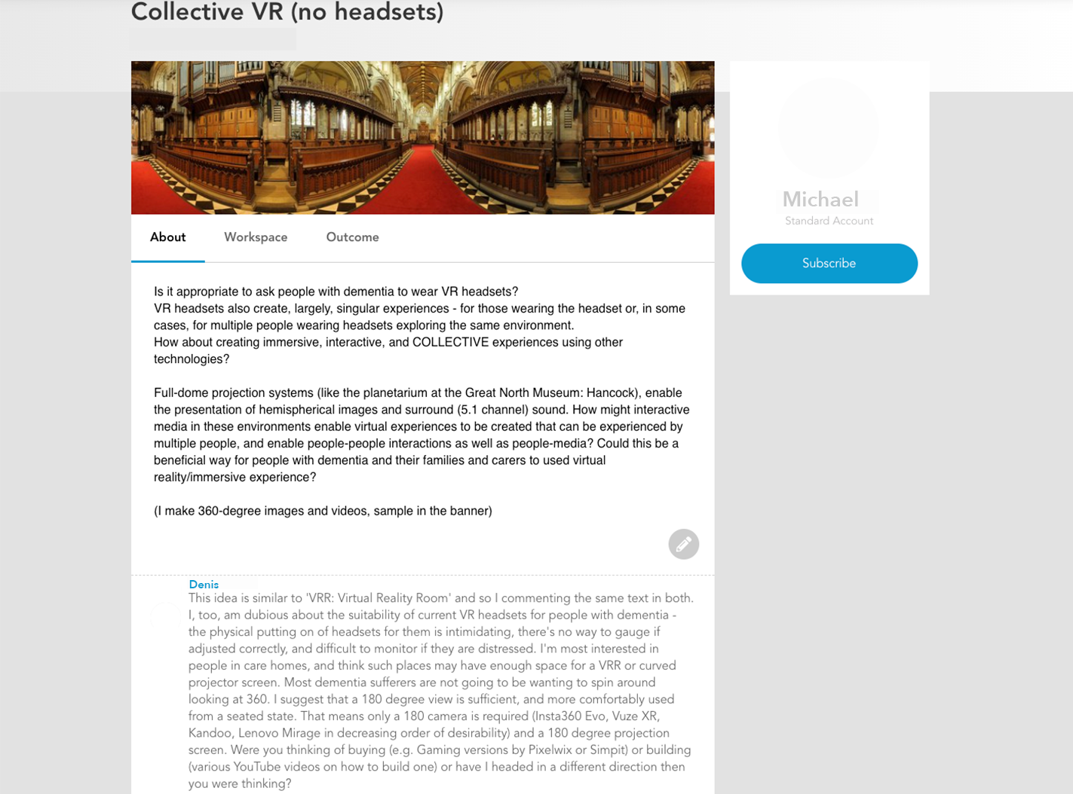

* 1. Explore Ideaboard ideas **(b)** Example of ’idea’ features

**Figure 2.2** Ideaboard features

1. Once participants had submitted their ideas, we invited people with dementia and their care partners to share insights and critique the submitted ideas before the hackathon through an open forum. We hoped that this would allow people who might be unavailable for the hackathon to take part in design ideation and help to shape emerging ideas which might be taken further in the in-person sessions.
2. Hackathon participants could then respond to the expert feedback and begin an open dialogue with other participants, care partners and people with dementia. From here, teams have more in-depth and developed ideas that consider the experiences of care partners and/or people with dementia that they could continue to develop and ideate on throughout the two-day hackathon.

### In-person workshops

To further support participation beyond the online platform (Piper et al., 2016), I set up two in-person workshop sessions inviting members of a local dementia café. Working closely with the dementia café on prior VR projects, I expected to recruit several people with dementia and care partners with established experience of VR. Within the six-week consultation period, the two in-person workshops were organised in the final two-weeks to ensure the I could print off any submitted Ideaboard ideas to share with participants. This workshop was intended to support participants to engage in a set of design activities to illustrate their desired VR shared experiences or build upon the existing eleven ideas posted on Ideaboard. Based on comments and ideas produced in these workshops by care partners and people with dementia, I would then add any additional ideas to Ideaboard or add any comments made about existing ideas to the relevant Ideaboard idea. I hoped that this process would allow the designers/developers to have additional time to reflect on comments from people with dementia and their care partners. As stated in the recruitment, the attempts to involve people with dementia and their care partners was significantly limited to one care partner’s involvement which engaged through the online

44

## 2.3 Event context

platform. For both in-person workshops, we had no sign-ups meaning we had to cancel the workshops. I refer to this in more detail through the findings and discussion.

### Team formation

I also set up a 2-hour pre-hackathon team formation event on the Friday of the hackathon event to ensure participants had organised themselves into teams. During the team formation event, I printed the eleven ideas published on Ideaboard. O placed them on individual tables with sticky notes to express an interest in the idea or find other participants who may also be interested in developing the ideas further. Since submitting an idea on Ideaboard was optional, five teams came prepared with ideas. As a result, only four of the eleven Ideaboard posts were taken into the hackathon. In table 3, I present the origin point of teams’ initial ideas. While only four Ideaboard posts were adapted and built upon through the hackathon, the other five teams’ either came with a bespoke idea they kept to themselves or proposed an idea at the start of day one. During the hackathon, all teams adapted their original ideas by reflecting on dementia through a series of resources (that I discuss below) and used the time to build and design a technical prototype of their VR experience.

### Hackathon

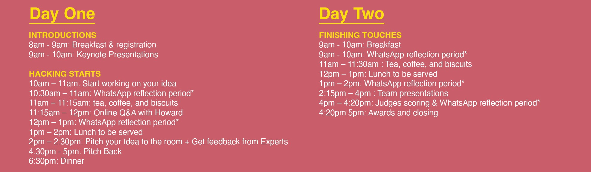

**Figure 2.3** DemVR hackathon event schedule

The hackathon too place across one weekend (April 5th - 7th 2019), at a local museum in Newcastle. The venue is centred within the city centre near the University campus and co-exists alongside a Natural History Museum that attendees had access to throughout the two-days that provided space away from ‘hacking’. To accompany the large number of teams and space required for VR demos, each team received a demo space, rounded table, and an array of crafting materials. For additional details of the schedule, check out our online appendix. In terms of equipment, teams had access to eight Oculus Go’s, four Oculus Rifts, one HTC Vive, and two VR-ready PC rigs. Teams were encouraged to bring their laptops and VR kit if they wished, and to notify the facilitators before the event if they need any additional technologies.

45

## DemVR: Public Engaged Hackathon

To encourage participants to ask for expertise feedback or general queries, each team were provided with a WhatsApp group consisting of 1-2 facilitators who could respond over text, or to be asked to join the team in person. In practice, these online chats provided quick and easy links to papers or method approaches that were related to the topic at hand. Furthermore, we used these groups chats as an opportunity to a) ask participants to respond to reflective questions such as "how have your thoughts about dementia and/or virtual reality changed from the beginning of day one?" and “describe your reaction to Howard’s Q&A”, and b) to see the teams’ design processes throughout the two days. For instance, team Sensory Tide shared several pictures of team members traveling to a local beach to collect videos and shells to be used in their finalised idea.

### Day One

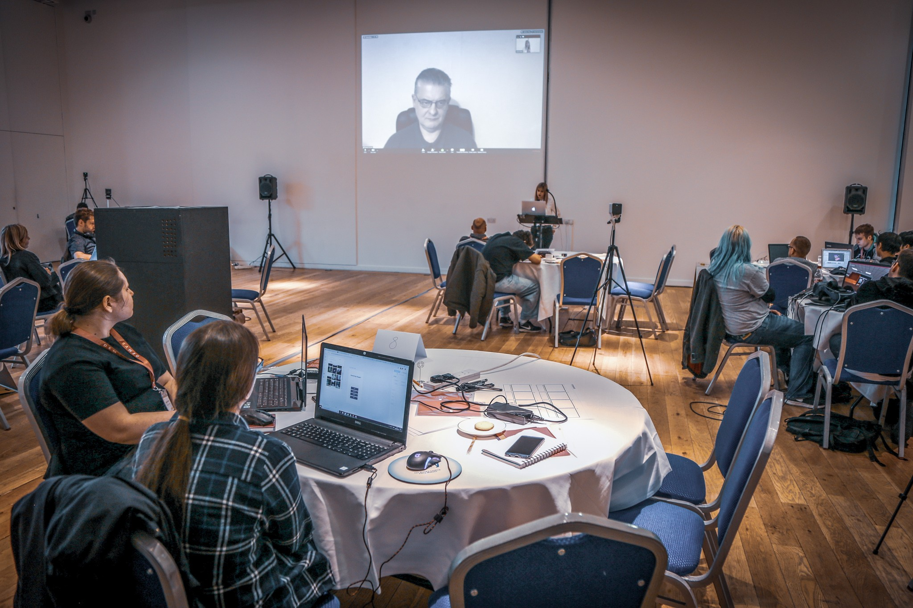

**Figure 2.4** Howard’s Zoom Q&A

The first morning of the event consisted of presentations on dementia, participatory research, and virtual reality by invited speakers. The invited speakers also enacted as facilitators that provided hackathon participants insight into the several facilitators backgrounds. During mid-day, we organised an online Q&A with Howard, a dementia advocate who shared his experiences living with dementia that lasted 15 minutes. In the Q&A, Howard was asked about his challenges of being diagnosed, the type of technologies and experiences he would find useful, and the social complexities he is currently facing given the stigma of dementia. While the Q&A was open for questions from the participants, the conversation was led by one of the keynote facilitators who has a strong relationship with Howard (see fig.2.4.

Teams could then ask for additional help or critique from the available facilitators via in- person or reaching out to the facilitators in the individually set up WhatsApp team groups. In

46

## 2.3 Event context

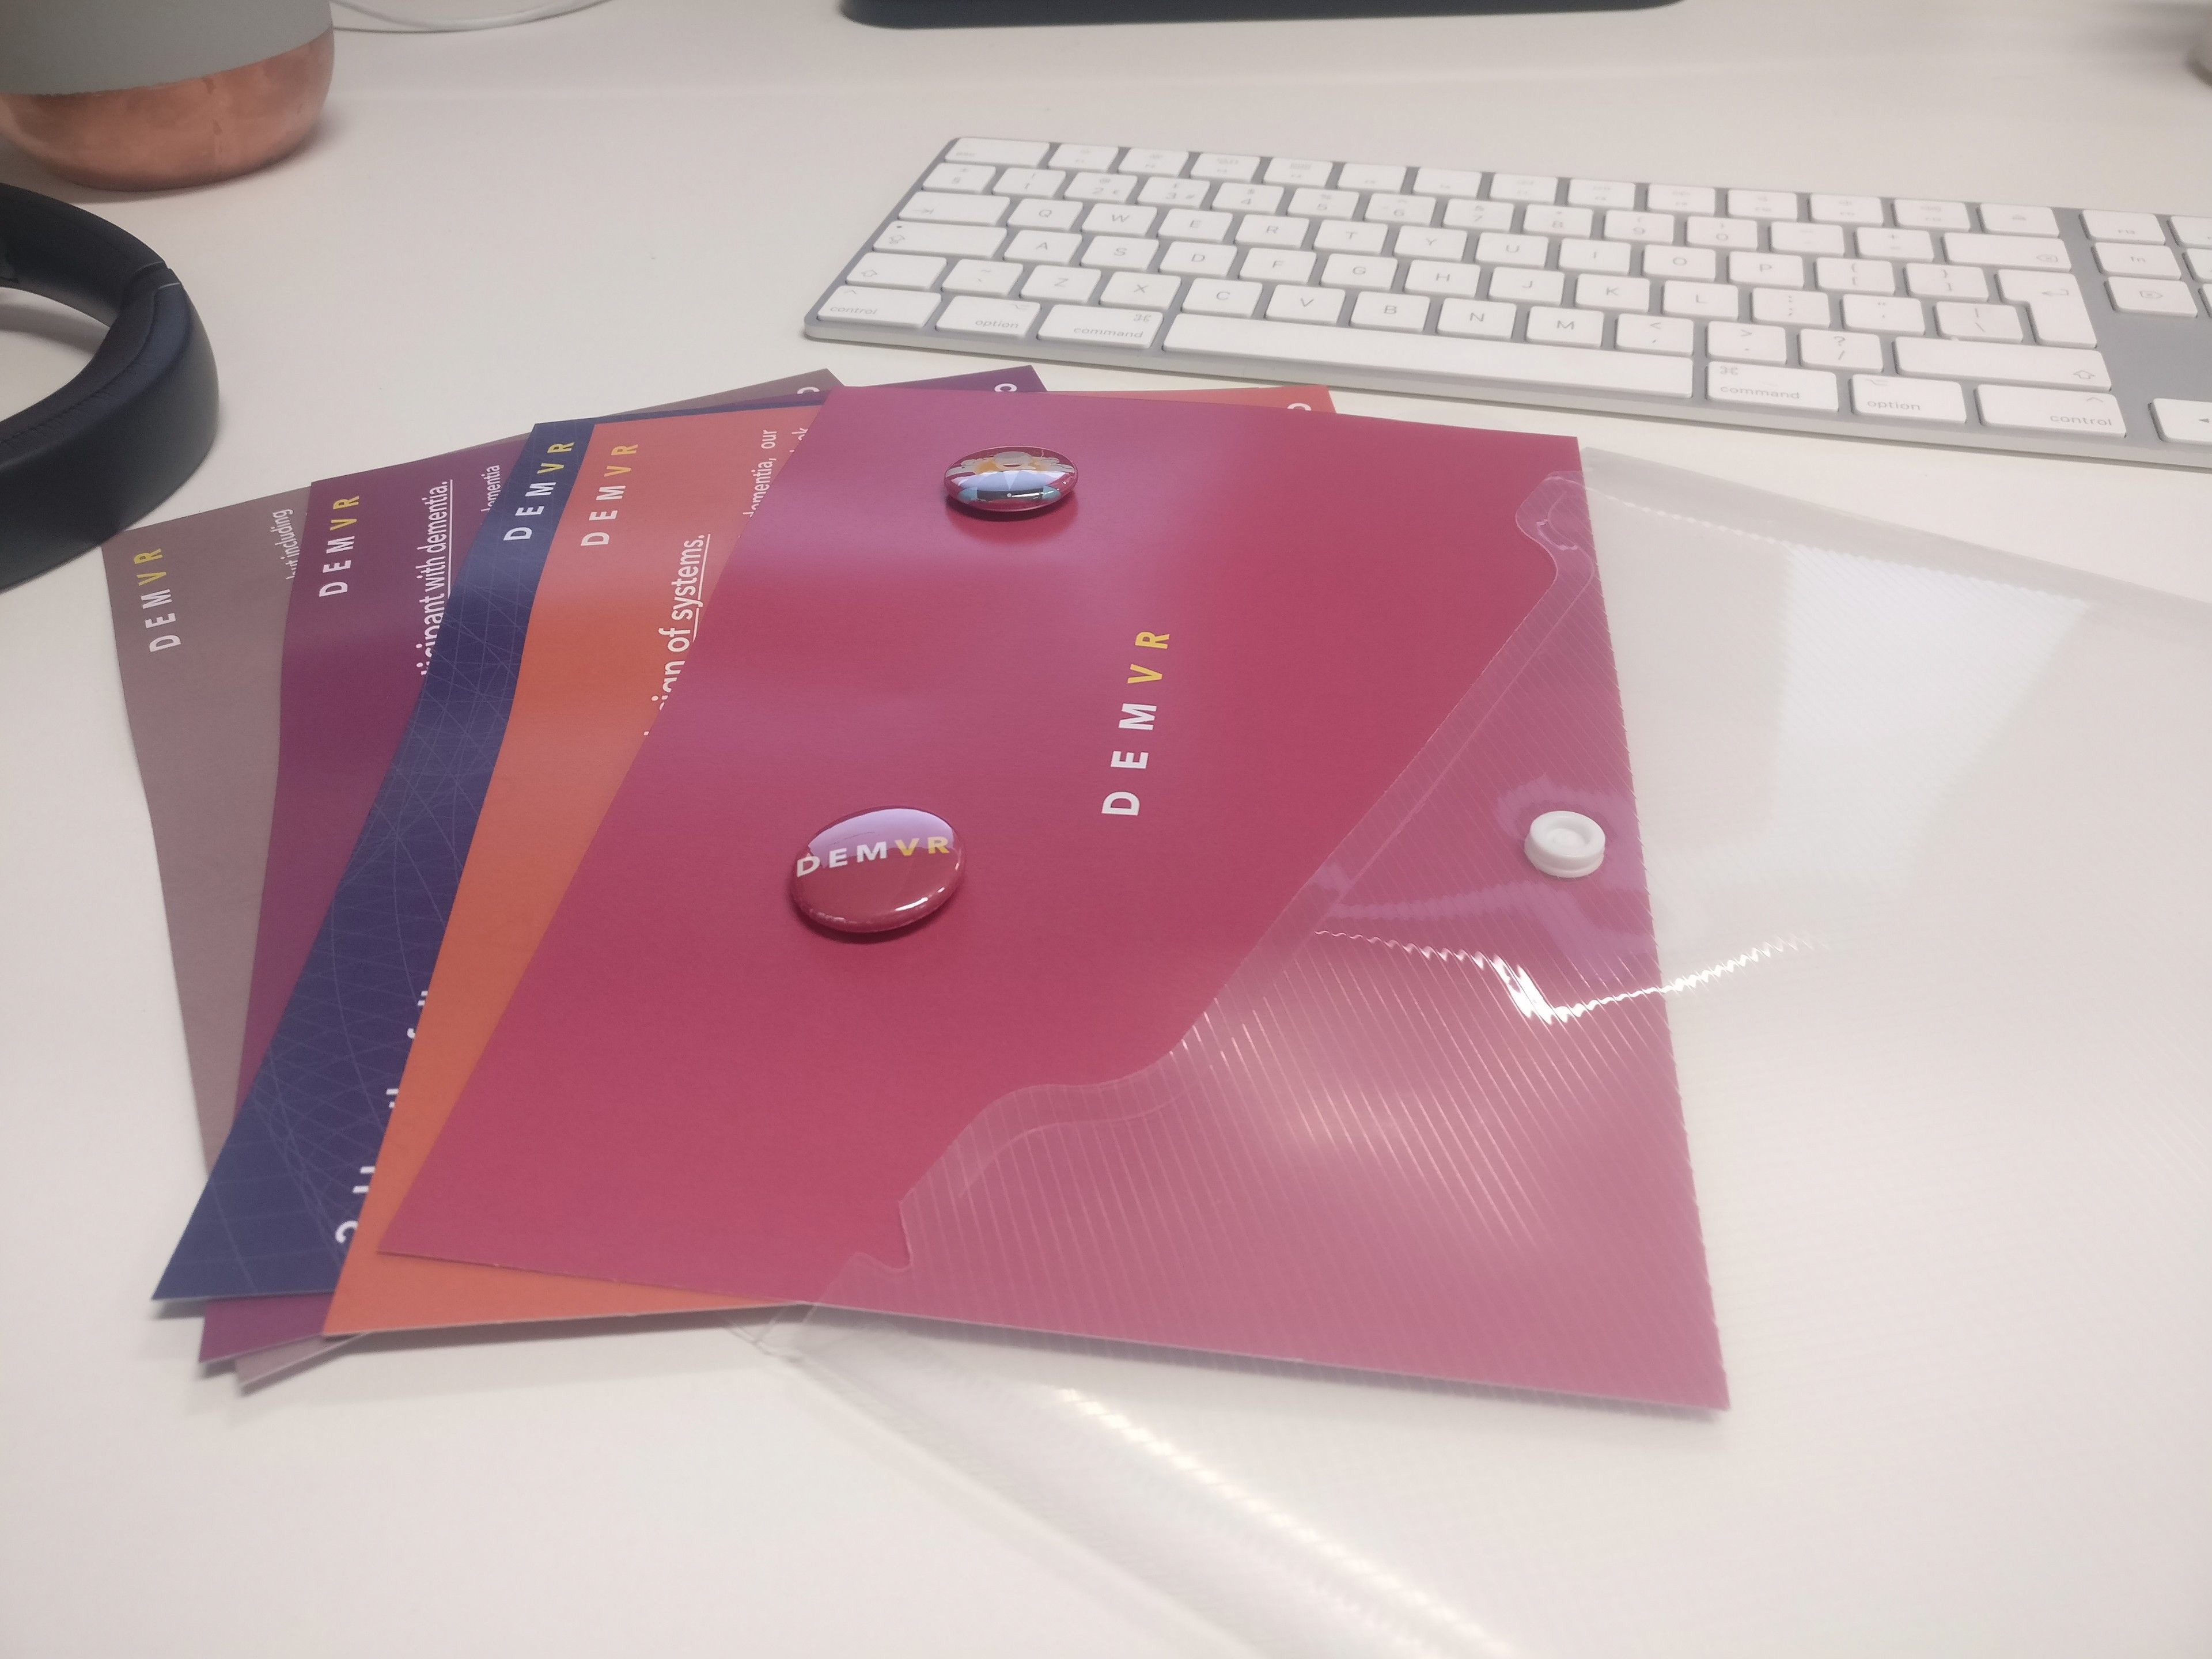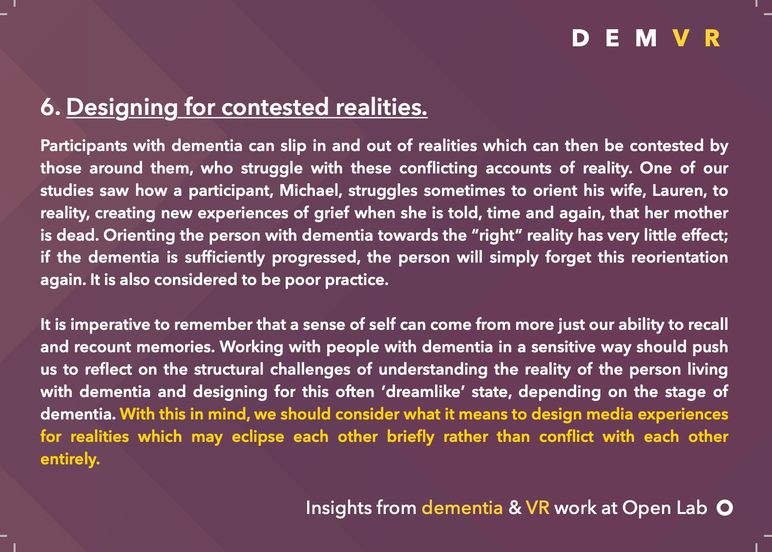

**Figure 2.5** Inspiration packs

practice, these online chats with facilitators provided quick and easy links to papers or method approaches that were related to the topic at hand. Furthermore, we used these groups chats as an opportunity to a) ask participants to respond to reflective questions such as "how have your thoughts about dementia and/or virtual reality changed from the beginning of day one?" and “describe your reaction to Howard’s Q&A”, and b) invited to detail their project’s progression through submitting comments, audio recordings and videos through a dedicated Team WhatsApp group chat, which formed the basis of data collected during the event. For instance, team Sensory Tide shared several pictures of team members traveling to a local beach to collect videos and shells to be used in their finalised idea.

Teams were given inspiration packs (see figure 2.5): these consisted of materials that summarized key insights from previously published work on VR and dementia from (Hodge et al., 2018). In addition to the physical inspiration packs, we set up an online shared document that would continue to grow as a resource through the duration of the event. In the end, this consisted of academic papers; speaker slides; dementia guides such as DEEP language and NHS (UK National Health Service) guides; a set of design method processes such as scenarios, bodystorming, and 5 Whys; and tips and tricks for what to include in final presentations. In our findings, the DEEP language guide is drawn on several times and is worth describing further. The DEEP language guide is a three-page document designed by 20 people living with dementia. The key takeaways of the document are a set of standards for dementia terms such as ’with’ or living well’ with dementia. During the afternoon, all teams pitched their idea to the rest of the room that provided an open forum between facilitators and participants to provide additional feedback for the set of ideas. For the rest of the weekend, the teams worked on their ideas with periods built in for breaks and socialisation.

### Day Two

On the Sunday morning, teams had the entirety of the day to finalise their ideas and presentations and have opportunity to ask facilitators for any feedback on their presentations and demo. For the majority, facilitators assisted in helping the teams add finishing touches to their demo’s

47

## DemVR: Public Engaged Hackathon

and providing feedback for their presentations. To maintain consistency throughout the team presentations, we provided a template with conversation topics such as: tagline; who is your user audience; what is your motivation and problem; what was your approach to inform your design challenge; what are the future considerations; and reflection on the hackathon. The event culminated in a final ten-minute presentation and five-minute demo at the end of day two in which the teams demonstrated their work to the judges. The four judges had the opportunity to explore the demo along with ask any further questions about the teams finalised idea. Each team’s finalised concepts were rated on the following:

* novelty of design concept: how original are the ideas? Are they backed up with appropriate research? How provocative (yet sensitive) or otherwise promising are they?
* clarity of team’s vision: How persuasive are the presented arguments?
* sensitivity to the challenge: Specificity to issues central to dementia/care; how well were experts’ suggestions taken on board; are there any potential negative consequences?
* potential for real-world impact: given appropriate backing or resource, would this concept make a difference?
* strength of VR/AR: How far along did the idea development get? Did the teams make good use of the technology at hand?

At the end of the day, the judges announced the 1st and 2nd place winners who would receive

£1000 and £500, and the event ended with a brief overview of the hackathon by the first author.

### Participants’ final ideas

From the final nine ideas, each team developed a prototype of their final idea alongside their ten minute presentation. In this subsection, I briefly breakdown each teams’ proposed ideas and their final ideas:

### Garden Life (seven undergraduate computing students

**Proposed Idea:** Garden Life’s proposed idea originated from Ideaboard where their idea would be to *"create a journey through the story of your life using media that links memories with locations."*

**Final Idea:** In the teams’ final idea, they created a VR garden and dog companion for those living in isolation without access to either in real life. The team had considered ways for sharing experiences by carers assisting the growth of a virtual garden through the extension of a tablet

48

## Event context

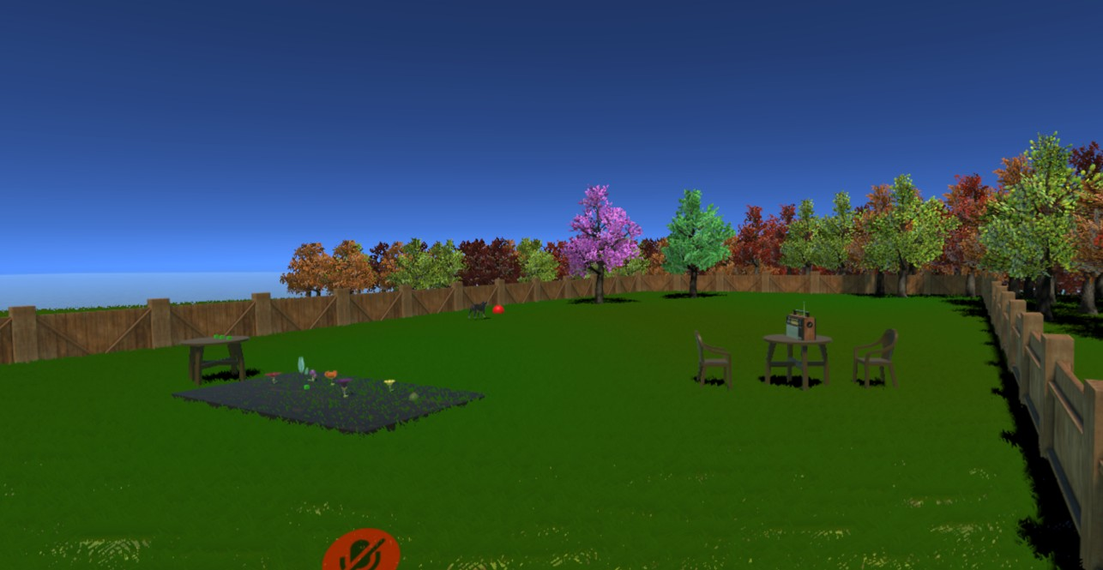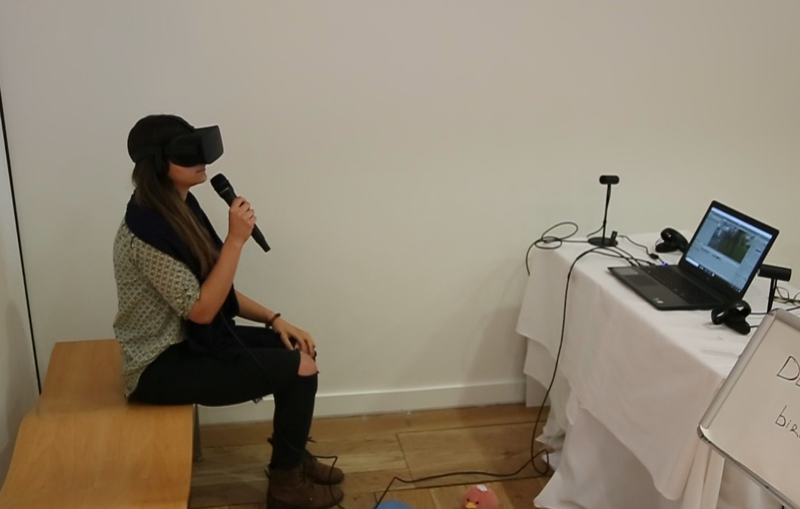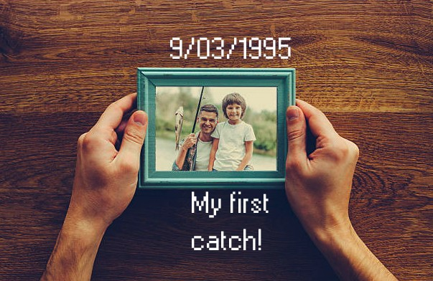

* 1. Garden Life **(b)** Chatter Bench **(c)** Augmented World

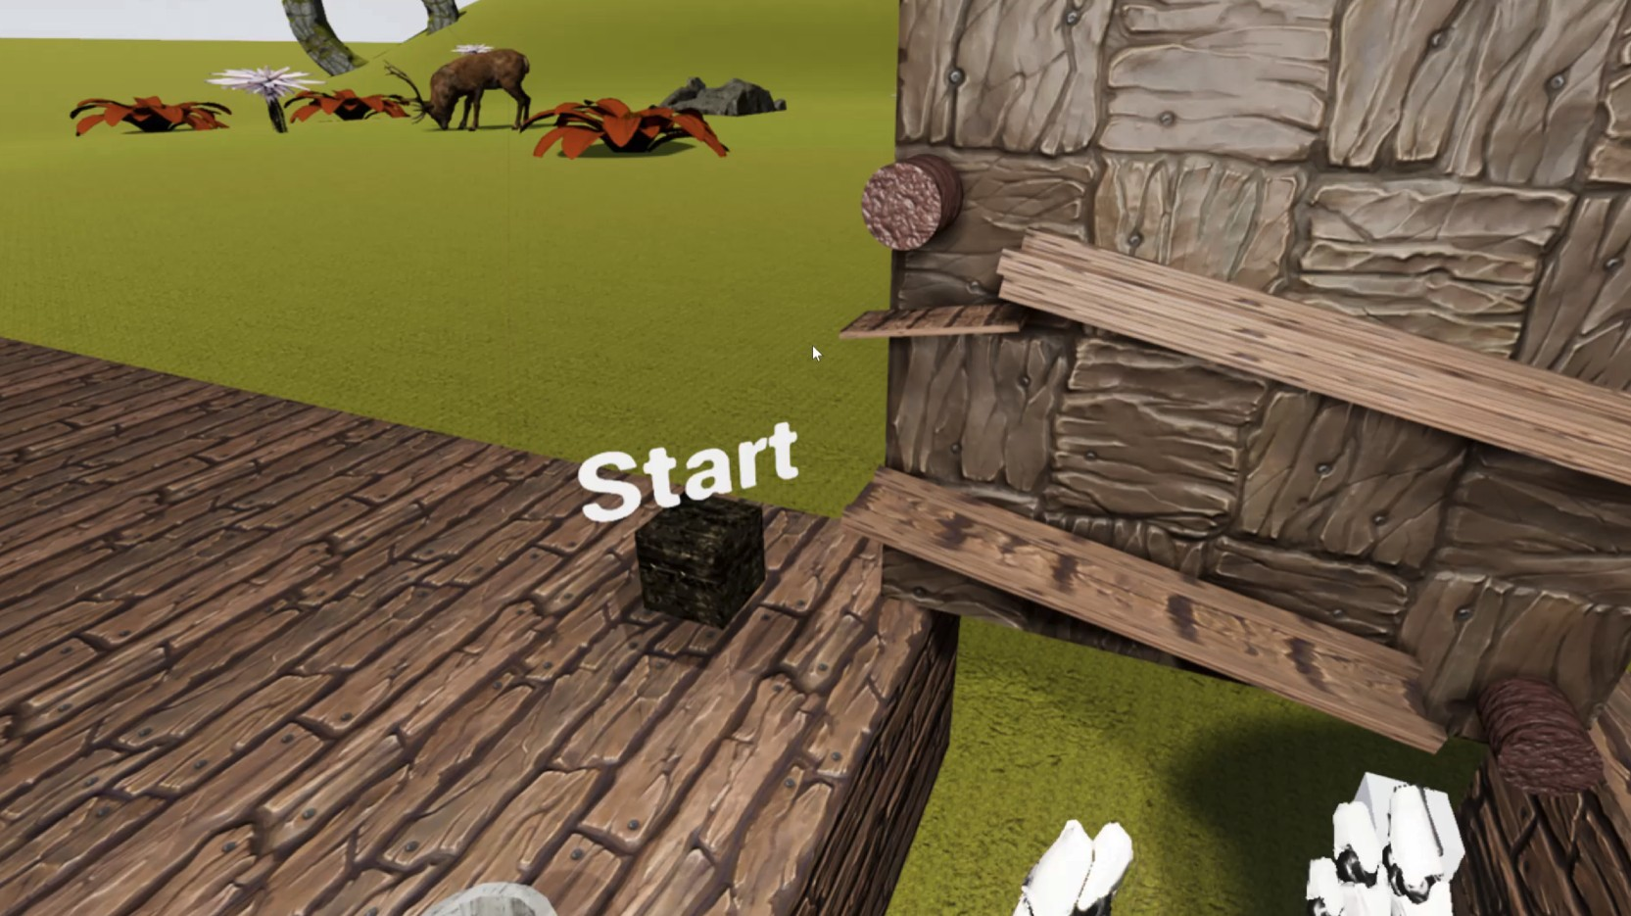  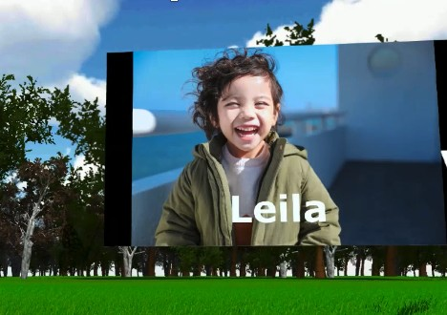

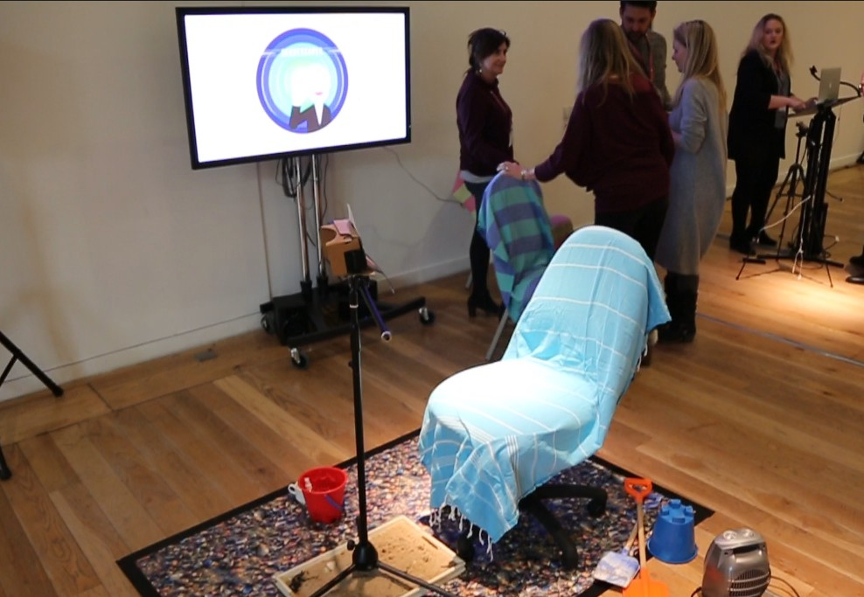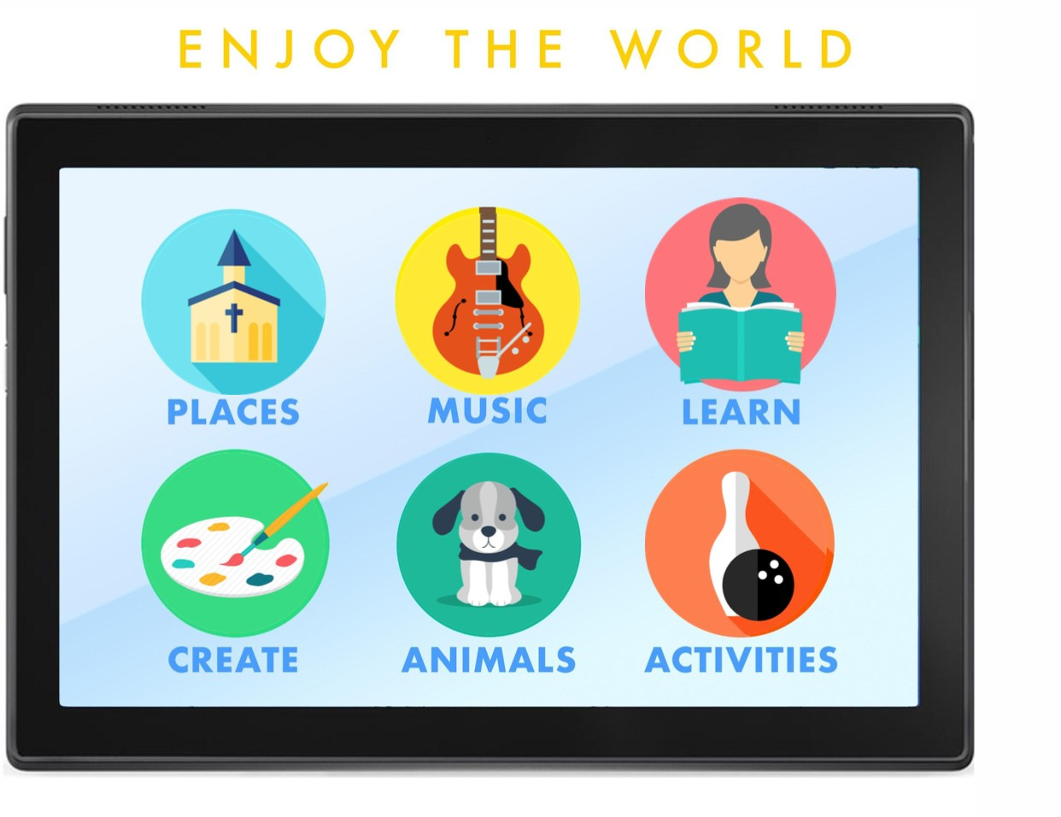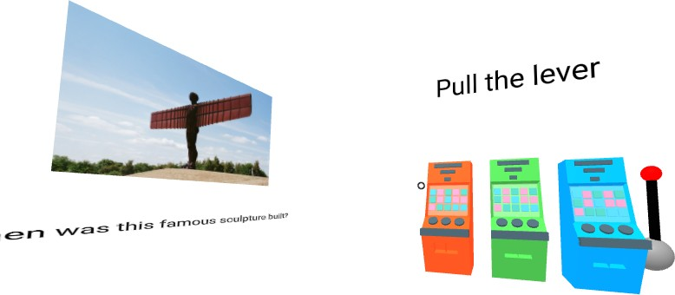**(d)** VRHallucinate **(e)** Looking VR Back **(f)** Mindful Forest

**(g)** Sensory Tide **(h)** WorldShare **(i)** VRMotion

**Figure 2.6** DemVR final prototype ideas

while the person living with dementia used VR. Furthermore, the team added multiplayer aspects to the experience allowing family and friends to virtually join the user in their own personalised garden with their virtual dog.

### Chatter Bench (two designer / researchers) - Won 2nd Prize

**Proposed idea:** A chat-based VR experience that will consider the importance of sensitivity and aesthetic design. This idea was not developed on Ideaboard, but came from conversations between the two team members.

**Final Idea:** In teams’ final idea, they developed a shared VR experience in Unity game engine where two users could ’sit’ and talk on a virtual bench. Either the care partner, or person living with dementia could select from an array of different 360-degree environments where the two users could talk into a microphone and hear one another.

49

## DemVR: Public Engaged Hackathon

### Augmented World (six undergraduate computing students

**Proposed Idea:** A bespoke chronological AR timeline connected to experiences of the users past and family. The proposed idea was developed on Ideaboard by two of the six members who originally focused their idea on themes of reminiscence.

**Final Idea:** An AR app that ’enhances’ environmental objects to facilitate meaningful social interaction by connecting virtual objects to overlay on the real-life object. For example, a user can scan a picture of their family in the app which will then overlay virtual text or videos onto the picture.

### VRHallucinate (six members from developer, researcher, and UX backgrounds

**Proposed Idea:** As the team joined the event late and missed the pre-engagement phase, the team decided to develop a gamified experience to visualise hallucination-like effects to raise awareness of potential cognitive deficits that one may get with a diagnosis of dementia.

**Final Idea:** Similar to their proposed idea, they designed the hallucination game but targeted elements of ways to educate family, friends and the public surrounding the potential challenges of living with dementia.

### Looking VR Back (four members from marketing, development, biomedical backgrounds

**Proposed Idea:** Using sounds, scents, and colours as a way to support reminiscence - this was proposed on Ideaboard by the same team.

**Final Idea:** Same idea but used a personalised example relating to Newcastle football game in 1969 as a way to take people living with dementia back to the particular experience through scents, sounds and 60-70’s VR room aesthetic.

### Mindful Forest (two undergraduate computing students

**Proposed Idea:** A fantasy shared experience where families can add videos to trigger past memories. This idea was developed at the event as the team did not engage with Ideaboard.

**Final Idea:** A forest-like environment with gentle music and scenery. Families and friends can add videos to help with memory stimulation.

50

## Methodology

### Sensory Tide (six members from developer, researcher, and film backgrounds) - Won 1st Prize

**Proposed Idea:** The team combined several participants during the team formation, where multiple Ideaboard ideas came together. At the initial stage of developing their idea, the team had ideas of: replacing VR headsets with full-dome projections, themes of focusing on designing for the moment, as oppose to improving cognitive deficits, and designing reminiscence tools to increase Independence doing tasks.

**Final Idea:** The team developed an adapted version of a headset to resemble a beach telescope that was easily accessible. Additionally, the team created the VR beach experience to support multi-sensory needs for example, the user could smell seaweed in the room, a heated fan attached to the wall and sand under the feed of the user.

### World Share (three filmmakers

**Proposed Idea:** Developed at the event, the team’s initial idea was a tablet-based app to allow people living with dementia to ’travel’ across the world and take part in tours and explore other scenic outdoor locations.

**Final Idea:** The final idea consisting of the following: a tablet that acts as a controller for interaction, and a headset to be used by the person living with dementia. The person with dementia would then request an event or a family recorded experience which the care partner would navigate to on the tablet and send the video/experience to the VR headset.

### VRMotion (for members from developer and researcher backgrounds)

**Proposed Idea:** Influenced by their prior work in research, the team’s initial idea was care home oriented where the VR experience would be a celebration of abilities of the individual instead of trying to bridge the abilities they have lost.

**Final Idea:** Building from their proposed idea, they developed a shared virtual world where people with dementia can take part in group activities such as songs to sing along, guess the place, and solve the riddle - that was inspired by the work of Foley et al. (Foley et al., 2019c)

## Methodology

In the following section, we describe our positionality, ethics, data collection and analysis process and provide a summarized table of the proposed vs. final team ideas.

51

## DemVR: Public Engaged Hackathon

### Positionality

Following the event, I began to process and reflect on how the event went and what the contribu- tion was to HCI research. From early on, it was apparent that while the nine teams had created bespoke shared VR experienced prototypes, I felt that the lack of involvement of people living with dementia was significantly reflected in teams’ presentations, raising concerns as to how designers/developers may design for dementia without these lived experiences front and centre in their design processes. Given this, it is worth writing that my positionality as a dementia researcher was an integral influence in the hackathon’s facilitation and subsequent evaluation of the event (Bourke, 2014). During the study’s framing and running of the event, I selected particular researchers who take a similar approach to dementia through using a person-centered design approach. While this was intentional as I wanted to explore ways to scale person-centered approaches, the orientation towards how I view dementia influenced the hackathon’s framing by emphasising participants to take a more creative and well-being approach to their design instead of problematising someone’s cognitive deficits. Furthermore, I hand-picked the facilitators who also take a more relationship and meaningful interaction to their work instead that of a biomedical one. By carefully selecting particular facilitators and presenters, it is likely that this impacted the teams’ final prototypes and potentially limited the potential of teams to develop more biomedical led design approaches.

Given the clear challenges I faced in representation of people with dementia and their care partners, I saw this as an opportunity to provide guidance for future researchers on the potential knock-on effects that may occur when designing for a group or person are overlooked. Motivated by the questions posed by the literature mentioned above and our internal reflections on the facilitating and developing of our hackathon event, I present the following research questions, which guided our analysis:

* + - * **Research Question One:** What type of motivations and ‘on-site’ learning may occur when learning about dementia within a hackathon setting?
      * **Research Question Two:** What design approaches do designers and developers prioritise when designing for people with dementia?
      * **Research Question Three:**What challenges may arise when shaping a VR experience for people with dementia and care partners when solely relying on the designer/developer’s own experience (or lack thereof)?

### Ethics

Ethical approval was granted by Newcastle University. Upon signing up, each participant was provided with an information and consent form describing the event and pre-hackathon stage.

52

## Methodology

Any participants who then signed up to use our online platform was given additional information about the project. Participants who registered for the hackathon signed a consent form about the hackathon weekend when they came to pick up their lanyard and sign in for the opening day of the hackathon. Participants’ and team names have been anonymised for privacy.

### Data and Analysis

In the study, I gathered data from three different source: 1) Text data of the Ideaboard ideas (I), including additional comments from participants on the ideas; 2) Keynote, Q&A and teams’ presentations from the event (P) and; 3) Each team WhatsApp group’s text, images and audio, which were extracted using the built-in Google Drive feature. WhatsApp audio recordings were also transcribed and anonymised by UKTranscription (W). To provide an additional context, I made a set of observational field notes (F) throughout the event highlighting conversations I had with teams and facilitators. The initials (I, P, W, or F) indicate the source of the data in the findings.

|  |  |  |  |  |
| --- | --- | --- | --- | --- |
| **Stakeholders** | **Ideaboard (I)** | **WhatsApp (W)** | **Presentations (P)** | **Field notes (F)** |
| Hackathon participants | 11 submitted ideas | 25 minutes audio recordings  + average 25 texts per team | 117 minutes | N/A |
| People with dementia and care partners | One care partner replied to eight submitted ideas | N/A | 15 minutes Q&A | N/A |
| Facilitators | N/A | Average 6 texts replying to each team | 40 minutes | 11,355 words |

**Table 2.3** Data collection

My analytic approach followed a Thematic Analysis (TA) set out by Braun and Clarke (2006, 2020). Working from multiple data sources, I ordered the individual sets of data across a timeline to make sense of interactions between data sets. This approach helped to decide if it was possible that a certain event, such as a keynote or the Q&A, had influenced a team’s design approach, though our qualitative approach is careful in not claiming causality. Second, the I structured a set of team narratives consisting of the different data sources described above. Structuring the data this way helped to describe the chronological development of each individuals’ teams from design ideation through to presenting their final idea and post-hackathon reflections. Once the data was framed chronologically, I began to conduct open coding. I then meet bi-weekly with Dr Kellie Morrissey, Dr Sarah Foley, and Dr Dave Kirk to construct themes and reflect on the

53

## DemVR: Public Engaged Hackathon

patterns evident across the data. Finally, the I constructed the named themes, which are presented in the following section.

## Findings

This section presents a series of findings that centre around two overarching themes describing insights into participants interactions and design considerations through the event. The first theme examines participants’ approaches to engagement and design: this explores their motivations for taking part in the event, as well as analysing how participants attempted to incorporate their new understandings of dementia into their design. The second theme, reworking participants’ conceptualizations for design, describes the challenges of assimilating these sensitivities into design outcomes, given the absence of crucial stakeholders.

### Participants’ approaches to engagement and design

As mentioned in our literature review, participation in design events is significantly labour- intensive and time-consuming, yet they remain a popular route for learning and developing new paths to research. Further, hackathons provide attendees an opportunity to learn new soft skills and new insights into areas they may have yet explored (Medina Angarita and Nolte, 2020). The following subthemes describe what motivated participants to spend their weekend ‘hacking’ away and how incremental, ‘on-site’ learning about dementia impacted their design approaches throughout the weekend.

### Motivations behind participation

Participants’ motivations for taking part in the event ranged from their own personal experiences of loved ones with dementia, seeking a chance to win the cash prize, sharing their voice, and learning about the area of dementia & HCI. For those with personal experiences, their motivation was typically driven by family members having dementia or having worked in the area of dementia. For example, in team World Share presentation, they described conversations with their Grandmother about his Grandfather where *“he may not remember going to the beach that day but he’s happy, and it’s about the day-to-day quality of life, which is something we’re looking to do with [our idea]” (P)*. Likewise, team Chatter Bench described family connections influencing their involvement where they *“called [his] mum [to talk about his] grandparents who were living with dementia in a home before they died. . . this informed what was important [to them joining the event]” (P)*. For others who had experience in the field from a research perspective, their reasoning for taking part was rooted in learning how VR could be a beneficial technology within this space. For instance, one member from VRMotion works on *“intergenerational*

54

## Findings

*interactions in dementia care” (P)* and came to the event to *“learn how VR and dementia can be linked together” (W)*. Undergraduate teams echoed similar comments where VRHallucinate could learn about *“how technology can help dementia” (W)*, or GardenLife asking, *“What can I do to help people with dementia?” (F)*.

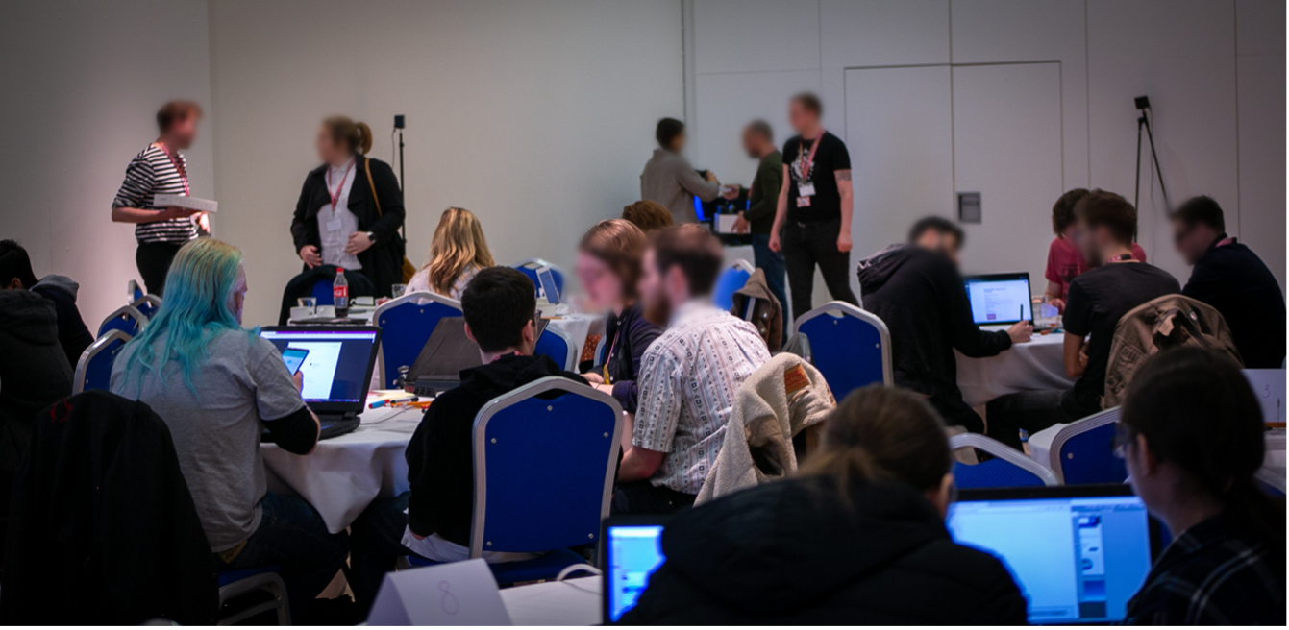

**Figure 2.7** Day one of DemVR

At the end of the event, GardenLife expressed their hopes that *“events such as this and research continuing to deepen our understanding of these issues will help to alleviate the stigma that caused [negative representations] to happen" (W)* presents a series of motivations that participants are keen to learn and educate themselves on sensitive issues. Perhaps unsurprisingly, a sense of competition and prize money were significant motivators for several teams. The first author’s field notes described *“how they [teams] would come up to [first researcher] and say they’re going to win the prize money as their idea is the best” (F)*. While this made for particularly enthusiastic participants, in many ways, it could also be seen to hinder collaboration between teams. Moreover, it was also a potential contributor to why there was little uptake from our participants for using the online platform, which would have made participants’ budding ideas public knowledge.

During our team formation, the first author was getting to know one of the six members who later made-up team Sensory Tide, when they had mentioned how three of the team members had *“got together and had a few meetings, but [their] idea is top secret. [they’re] not gonna share it till we have to” (F)*. Teams’ secrecy in their ideas constrained their willingness to share their ideas publicly before the two-day hackathon in fear others would copy or otherwise be influenced. Similarly, the team that dropped out during team formation had similar concerns of revealing their idea to the extent of questioning *“who owns the intellectual property” (F)* of the idea.

To provide engagement for people with dementia and care partners, we set up our ‘pre- engagement phase’ that included an online platform, and in-person workshops. As we described in our recruitment, only one of the twelve participants who signed-up to our online platform (Ideaboard) was not a designer/developer. Our one care partner – Denis, was motivated to share

55

## DemVR: Public Engaged Hackathon

his experiences of his father’s dementia hoping outputs of the event would provide *“published prototypes [he] can use [with his father]” (I)*. As Denis continued to comment on the Ideaboard ideas, he would express limitations in people’s ideas saying: *“my father is too old to use social media” (I)*, or *“my father wouldn’t understand how to navigate in VR” (I)*. In these examples, Denis was advocating on his father’s behalf to make sure his father’s differences may be considered in future VR outputs. Although Denis felt comfortable to share his experiences, several participants without experience of dementia sent emails asking for advice on their ideas before they submitted as they were worried, they would be *“embarrassing [them]self”* from their lack of knowledge around dementia.

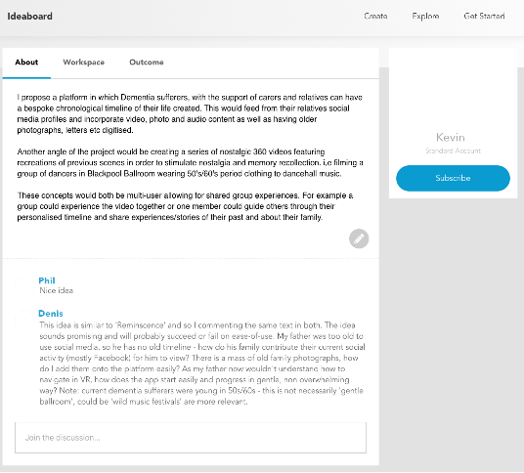

**Figure 2.8** Denis commenting on shared ideas on Ideaboard

While they expressed, they’d *“really love to be involved and help to make a difference”*, the sensitive nature of the topic at hand made some participants question their ideas and hope that they *“hadn’t got the wrong end of the stick”*. Similarly, the first author’s field notes indicate that “*participants seemed anxious or uncertain if they’d be saying the right thing [online] which might be why they didn’t engage” (F)*. Although several teams felt uncertain to share their ideas or take part in the online platform, participants were still motivated to take the time and conduct research before the event, whether that was GardenLife *“reading VR and dementia papers” (W)*, or how Augmented World had sought guidance from a Dementia Advice Centre about VR as a potential viable technology for people with dementia. Additionally, our planned in-person workshops co-organized with a local dementia café raised concerns for participation when *“no-one signed up to our workshops... CEO of the café just notified me and asked if we should cancel the [the*

56

## 2.5 Findings

*workshops]” (F)*. From the first authors field notes, at the time, they felt *“perhaps members [of the café] are no longer interested in VR work anymore”*. However, even if so, the research team received nine emails after the event from companies/individuals asking if any ideas had gone into *“production”* or any of *“the outputs from the event are in digital form”*.

Many of these companies specialised in providing *“care across a number of homes”* but reached out looking for cheaper solutions. Participation was scarce in the pre-engagement phase which initially presented that *“perhaps people are no longer interested in VR?” (F)*, and while this may have been the case for our workshops (that we discuss in our discussion), Denis’ motivation and companies interested in what the event had created suggests maybe the lack of support to learn dementia prior event hindered participants motivation to engage online. This theme describes the motivating factors influencing participants to take part in the hackathon. While there are examples of personal and educational motivations behind taking part, this themes also raises concerns about the type of incentives expected in a typical hackathon event. For example, though prize money motivates taking apart, it hinders the sharing of resources and knowledge between teams as this may affect the competition outcome. However, although our event may not have gained as many participants as it did without prize money, there are some instances of teams’ going out of their way to initiate conversations with care partners or sharing their personal experiences in the hope to have a say on the hackathon’s VR outputs, indicating that at least some of our participants’ motivations were pro-social in nature.

### Participant implementation of these new understandings

In our pre-hackathon stage, the submitted ideas formed an initial picture of how prospective participants viewed dementia – for instance, through their idea helping to *"making them [people with dementia] feel more independent"*, or to *"help calm the mind[s]"* of people with dementia *(I)*. Although multiple participants used terminology no longer accepted in best practice in dementia, such as *"sufferers"*, and *"patients" (I)*, the design ideas uploaded suggest these terms are not intended to stigmatize. For example, a participant from team World Share suggested ways for VR to *"guide sufferers through daily basics" (I)* in order to reduce the effects of memory loss by having VR technology allow them to repeat tasks such as *"basic cooking, making a cup of tea" (I)*. Although these terms were being used early in the two-day hackathon as well, through engaging in conversations with facilitators, and through introducing resources such as the DEEP Guide (Diaries, 2020), participants changed their language and used more respectful, person-centered terms. In the same vein, many early iterations of participants’ ideas promoted ’treatment’, ’fixing the disease’ and ways for technology to improve a person’s memory or other deficits (Hendriks et al., 2018). Throughout the event, several teams, particularly those made up of undergraduates, expressed their interest in learning from academic papers. For example, Mindful Forest described *“a research paper about this care home in Sweden, that took outpatients in the forest and found*

57

## DemVR: Public Engaged Hackathon

*patients communicated more and remembered more about it” (P)*. This paper inspired them to create a forest environment for their final design.



**Figure 2.9** MindfulForest influences from Sweden dementia forest research

While facilitators assisted in suggesting particular papers or articles, it led to GardenLife initially designing for ways to link memories to locations, to develop and ideate on social complexities of feeling *“silly” or “scared” of using VR – and to find a solution of “easing [the user] into the experience” (P)*. Through initial facilitation, conversations, presentations and inspiration packs, World Share described their interest in understanding the *“the challenges, accessibility, interactivity, and limitations around dementia care the people around people with dementia” (W)*.

Additionally, teams’ design decisions were influenced by conversations with stakeholders before and during our hackathon, such as Howard’s Q&A, discussions on Ideaboard, or reaching out to caregivers outside the event’s network of people. For example, Augmented World designed for AR rather than VR based on advice from a Dementia Advice Centre, which suggested: *“VR might be quite frightening. . . and with it being a bigger adjustment mentally with them living in a reality they don’t know what is real or not” (P)*. Similarly, Michael – a team member from Sensory Tide - engaged with Denis via Ideaboard to gain a richer understanding of dementia from a care partner’s perspective. Denis highlighted ethical and financial concerns for Michael’s proposed idea on Ideaboard: this was to create *“full-dome projections” (I)* as an alternative to *“wear[ing] VR headsets” (I)*. The care partner and the designer engaged in conversation on the platform and raised concerns about projection domes’ practicality for care homes. The care partner pointed they are *“$13,000 as base price” (I)*. The team shifted their course from here, and their final idea was by developing light-weight DIY solutions through the use of Google Cardboard. During Howard’s Q&A, VRHallucinate started to link prior knowledge of hallucination research and aligned it with Howard’s shared experience of hallucinations he has been having recently. While the team initially identified similarities between their understanding and Howard’s stories, when he opened up about how his friends *“disappeared, and only three people still keep in touch” (P)*, the team altered their idea, shaping it instead about being how VR could *“teach [people with dementia and their care partners] to experience these visual*

58

## 2.5 Findings

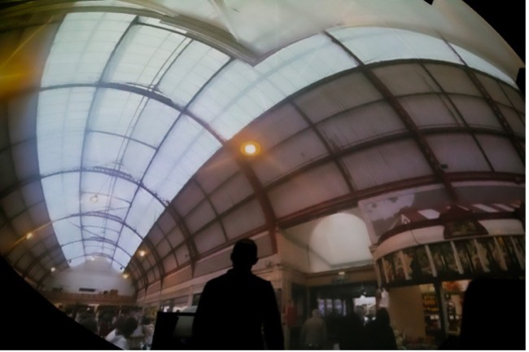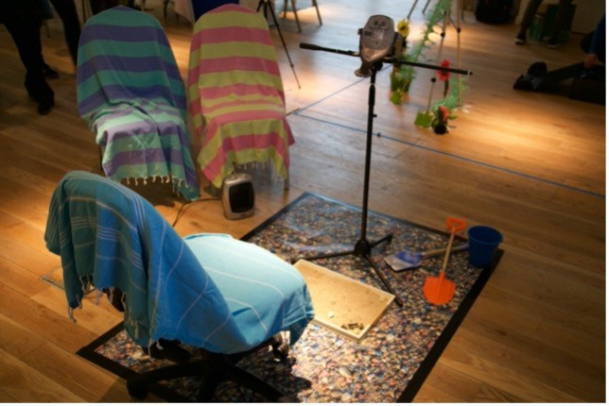

**Figure 2.10** Change in Sensory Tide’s VR technology

*uncertainties and inconsistencies, by playing a problem-solving game that will manipulate and change as you play to signify a change in hallucinations” (W)*.

While participants demonstrated new understandings of dementia and how they may design for this care context, adopting this critical approach in their design proved challenging for the teams. In fact, the only teams who demonstrated this critical sensibility are the ones populated by experienced dementia researchers. The two winners of the hackathon - ChatterBench, Sensory Tides and team VRmotion could pull from their successes and failures in the area and critique their ongoing design decisions. For example, Sensory Tides took inspiration from the many language guides around dementia and considered what that would mean for the term ‘Virtual Reality” (see table 3 for final idea). Aware of the social complexities that people with dementia may face with defining their reality and the concerns that earlier academic work had with the terminology surrounding Virtual Reality, the team designed for continued reassurance through the technology instead. Instead of the term VR, they describe their experience as a “magical viewfinder” (P) along with giving calm and helpful suggestions of how users may use it: either by leading the experience through the viewfinder or “lean[ing] back away from the headset and join everyone else relaxing on the [virtual] beach” (P).

Similarly, Chatter Bench and VRmotion began to question some of the more ethical and social challenges of designing within this space. The teams questioned, “How are you going to fit [the experience] into the [care home’s] schedule?” (P), or VRmotion considering “who controls [the experience], why would the person with dementia control it?...How would a facilitator involve themselves into the experience?” (P). In the teams’ final presentations, Chatter Bench raised concerns that their idea may add “strain on the family and resources” (P) in order to create the 360-degree worlds that people with dementia and care partners may want to share together – to the point that Chatter Bench presented future ideas of more social and community-led curation methods to generate a variety of environments in the “hope it will scale” (P). Although the event provided participants with curated research papers, ‘snippets’ of the lived experiences of people with dementia, and resources such as the DEEP Guide, these reflections can only offer examples of best practice rather than develop genuine understanding and relationships that may mirror the type of experiences the researchers suggested they had. The extent to which we can support participants to both learn about a complex issue and apply this new knowledge to design within

59

## DemVR: Public Engaged Hackathon

the traditional hackathon structure warrants further consideration. We return to this reflection in the discussion.

### Reworking participants’ conceptualisations for design

Through the event, I had hoped to engage with people with dementia and care partners in order for developers/designers to have the opportunity to gain insight into what priorities or interests they should keep in mind when designing their shared VR experiences. However, as I have described in the chapter, I did not manage to involve care partners and people with dementia in the ways that I had hoped. As a response, the following subthemes describe the subsequent consequences of a lack of engagement with lived experience, where teams had to adopt different approaches to design for an absent user. Furthermore, I discuss the outcomes of designing for users who are not present, highlighting how designers returned to established ideas of deficit models of dementia.

### Constructing the absent user

Teams’ ideas shifted over the course of the event as their interactions with facilitators, inspiration packs, and Howard unfolded; we noted that participants often focused on particular comments made by speakers who discussed their experiences with people with dementia. The interplay between the stories, resources and conversations scaffolding the event helped to create an initial understanding of what it might be like to live with, and design for, dementia. However, by having a lack of people with dementia and care partners at the event or through engagement on the online platform, a number of teams pictured the person they are designing for on Howard’s experiences of dementia that he shared in his 15-minute Q&A. For those teams, Howard became a pivotal resource, and a somewhat static personality they were designing ‘for’. The ways in which teams reacted to Howard’s experiences varied. Team Garden Life changed their design approach in response to Howard’s hobbies and interests: their initial idea centered around "a journey through the story of your life using different media that links memories with locations’.” They stated that “The experience can be customized by family, so that the focus is on either neurological rehabilitation or reminiscence" (I).

In response to Howard’s Q&A, the team developed a virtual reality ‘garden’, with a feature that allowed the user to interact with a virtual dog. In the WhatsApp group chat, the team state that they "found it interesting [Howard] has a pet dog" (W). This led to the team reflecting on how people living in a care home may not get that opportunity, but that "having an animal to care for seems to help people in a lot of ways’ (W)’; and the team felt a virtual dog could help with loneliness. As the team developed the garden environment further, they built customisability options: “you can change its breed, colour and name of the animal" (W). Similarly, while

60

## 2.5 Findings

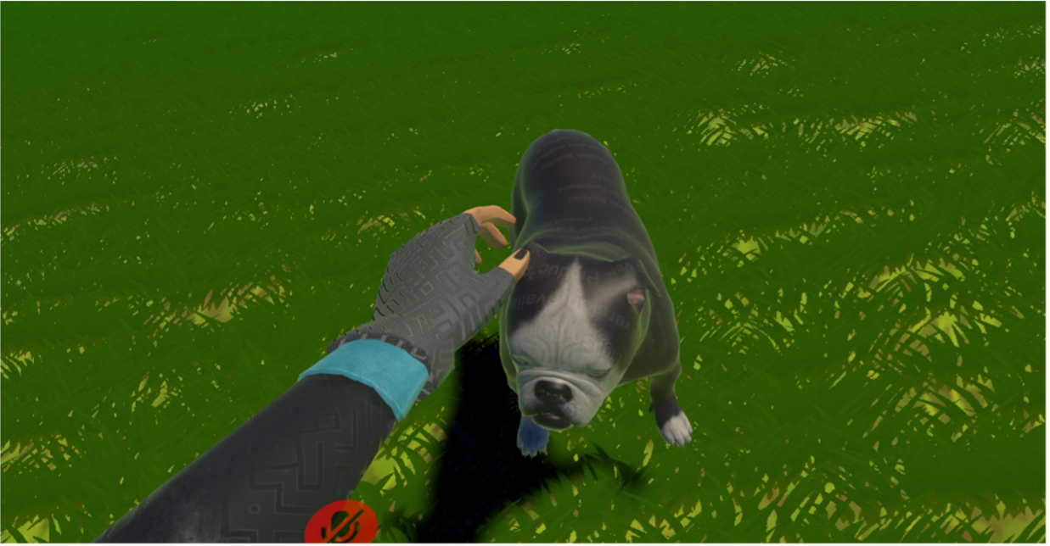

**Figure 2.11** Garden Life VR dog companion

Mindful Forest didn’t focus entirely on Howard’s experience, Howard’s experiences provided an opportunity to expand their current understandings of dementia as they “realized [they] actually don’t know as much [about dementia]” (W). In response, the team’s final idea featured “family members adding various pictures from holidays when they were young, so it would help in remembering if they forgot about their grandson or grand-daughter” (P). While the team prioritized their experiences of dementia where “I still remember the day when my Grandma no longer recognized me” (P), the team were inspired to enhance their social features after being “surprised that all of Howard’s friends left”. While basing design decisions on personal stories, or on Howard’s is not necessarily harmful, the lack of interaction with a variety of people with dementia limited the space for creativity and exploration, and instead presented Howard’s or participants personal experiences as a ‘one size fits all’ persona for dementia. Further, our event overlooked involvement of care partners, health care providers and friends who may be involved in the ecology of care which limited teams such as Chatter Bench describing they ‘have no understanding of how a nursing home really works”.

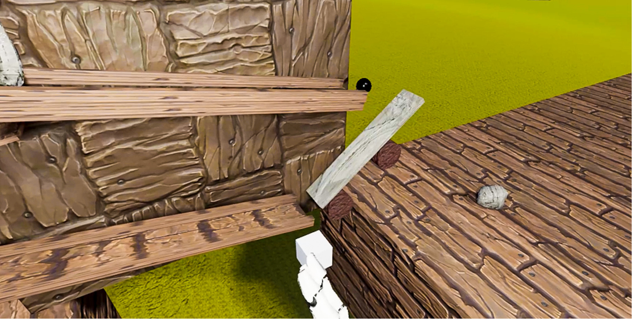

**Figure 2.12** VRHallucinate educational game on hallucinations

61

## DemVR: Public Engaged Hackathon

For the most part, teams’ initial ideas as outlined in the methodology are centered around cognitive training and reminiscence, except for three teams – VRMotion, Sensory Tide and Chatter Bench. Perhaps coincidentally, these three teams had at least one researcher with a background in working with people with dementia who could not only draw on their prior experiences, but also had extra insight into current research in HCI and dementia care. The three team’s shared design focus of *"being in the moment"*, or *"celebrating what abilities are left"* are not particularly novel contributions to dementia research, but they speak to the participant’s knowledge of the best practice in care. With that said, even though Sensory Tide and Chatter Bench won the final prizes, they still struggled to construct an understanding of who the user might be. During their final presentation, Sensory Tide presented a set of personas that often abstracted the user and were prone to stereotypes such as: *“Mary: can often get confused or lost if left alone” (P)* and *“Ben: has anxiety and depression as a result of his diagnosis (P)*.

Although personas can be useful for designers to connect with the people they are designing for, it shows that even the winning teams were limited to representing the person with dementia as a set of stereotypes based on their diagnosis. Although Sensory Tide used the personas to *“help us decide who we are actually designing for”*, for reasons similar to Chatter Bench, they found it *“hard to figure out what to design because [they] can’t ask the user” (W)*. This observation goes a way towards highlighting the value teams placed on engaging with end-users in the research, and highlights what is at the centre of this finding: the perceived importance of engagement between designers and stakeholders. In our final sub-theme, we describe the continued effect that the lack of stakeholder involvement had to designer’s creativity as they prioritized risk aversion as opposed to exploring a range of possibilities that people with dementia may want to experience.

### The trade-off between autonomy and safety

Some teams raised concerns regarding how best to represent an appropriate environment virtually for users with dementia. This often resulted in taking an inherently ‘safe’ design approach in order to reduce any ’negative’ or ’confusing’ experiences, thereby ensuring neutral or positive emotions. For example, team Chatter Bench were conflicted in *"how [to] represent the person living with dementia [in VR]" (W)*. The team’s idea is a ‘VR skype call’ where both participants would be present in a 360-degree video on a bench in a park. Members of this team were attuned to the technical aspects of design, having worked in VR over the past five years, where the concern of the illusion of embodiment and the representation of the user’s body has been regularly discussed (Nakamura, 2019). For example, when discussing the possibilities of designing avatars for the VR environment, they worried that, *"the other [avatars in the environment] will look like a scary apparition or, you know some floating smiley head" (W)*. To tackle this concern, the team removed the virtual avatars and transmitted only the online voices between the two users. The team suggests their decision was to some extent a trade-off: when you are already *"placing a headset on somebody with dementia”* (and therefore causing some discomfort in all likelihood),

62

## Findings

*“you don’t want to take it to a further extreme when you’re showing, magic hands popping around or magic heads" (W)*.

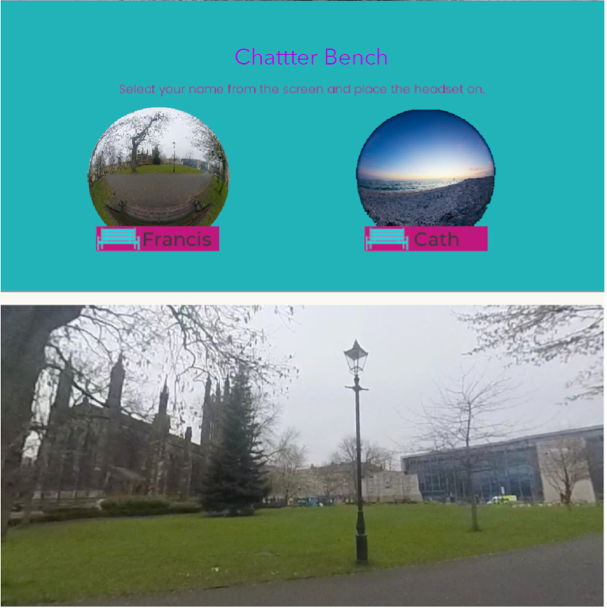

**Figure 2.13** Chatter Bench shared VR locations

Despite ‘magic hands’ and ‘floating heads’ being common way to represent the user in VR, the team remained skeptical of this approach due to the common conception of people with dementia as unable to decipher what is ‘real’, and what is not, in both real life and in VR. Similarly, team Mindful Forest, state that they originally *"planned to add fantasy elements to our idea. But due to learning about other symptoms like hallucinations, we, therefore, had to change it to be more realistic, because we don’t want to cause any problems for people with dementia" (W).* Both teams were focused on the person’s safety, deciding that this was more important than designing for autonomy or ideas of abstract aesthetic engagement. In both instances, designers took the decision-making process out of the user’s hands by removing fantasy elements or bodily representation in VR to prevent harm. While user’s safety is a priority in any form of design process, removing the option of switching features off or on can be argued to restrict the expression of individual differences and limits the potential autonomy a person with dementia may have over the experience.

Many teams whose ideas sought to involve care partners, families or friends would often make design decisions that shifted the responsibilities of setting up the technology to the caring

63

## DemVR: Public Engaged Hackathon

role. Again, while this may be useful or even preferential for some, it may also result in a loss of agency for the person with dementia. For instance, team Chatter Bench stated that if their VR experience was implemented into a care home, then scheduling of the VR ’Skype calls’ need to consider *"fitting into the schedule of the care partner as well" (W)*. The team realized that a diagnosis of dementia often brings along with it a shifting of responsibilities, with these being placed instead upon others such as their care partner, potentially further eroding the autonomy of the person with dementia and contributing to caregiver burden.

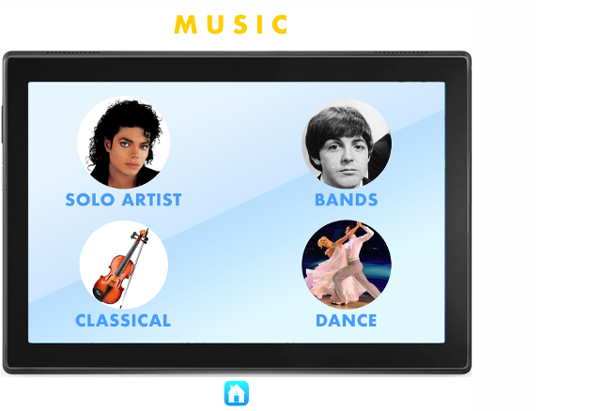

**Figure 2.14** World Share’s UI interactions

Alternatively, team World Share focused on their interactive app consisting of events, family and friends’ recordings to be as customisable as possible to *"approach the widest possible audience" (P)*. World Share’s approach wanted the user to have as much ownership and agency when using their VR system as they argued *"just because you have dementia, does not mean you don’t want to learn. You want to be able to explore these things" (P)*. Although this idea encourages customisability to tailor the system to the user, it could also be argued that placing all the decision-making processes on the individual may also hinder or overwhelm the user through exploring the system. In sum, the majority of teams found it challenging to design VR as a shared experience particularly when trying to place responsibility on who drives the experience – the person with dementia, or the care partner. However, while they still found it challenging to navigate the space of shared VR experiences, Sensory Tide designed their VR experience with reference to experiences both of families living with, and those with dementia. In this instance, as the person with dementia controls the movement of the VR headset, this drives the experience for not only themselves, but projects what they are seeing into the outside space of the room for the family to see.

Similarly, VRMotion designed a series of VR activities such as “songs to sing along to, guess the place, solve the riddle or even share jokes”, and considered the collaborative decision-making needed to ensure continued participation within the care home. This is done through giving the staff member the responsibility as a facilitator to “pull a lever on a [VR] slot machine, which

64

## Discussion

will show a random task. [Then] people with dementia and the facilitator will work together to complete the task”. These examples highlight difficulties that may occur when designing for decision-making, where the two extremes are to either place all the responsibility onto the care partner through risk-averse approaches or giving full responsibility to the person with dementia to aid their autonomy. However, in some cases, such as VRMotion, they considered ways to maintain reciprocal interdependent relationships where the person with dementia is part of the decision-making process resulting in a more collaborative experience through not only the experience, but the set-up and responsibility of actions.

## Discussion

The analysis presents the nature of participation from team members, and the impact of structural factors of the event on design outcomes. I explore the different reasons participants were motivated to participate in the hackathon. Motivation for involvement ranged from personal experiences to learning, albeit collaboration between teams being hindered by competition. I also compare participants’ ways of incorporating their new understanding of dementia into their design ideas to highlight critical differences between those with and without extensive experiences of dementia. Finally, as an outcome of the lack of engagement of people with dementia and care partners in the event, the second theme describes how teams attempted to design for the absent user through different means, showing that teams often prioritised safety over autonomy when uncertain if VR features may cause psychosocial risks. Overall, these findings raise some important considerations for design events such as best understanding participant involvement, designing for the ‘absent user’, and redefining what collaboration may be between different communities, which I further discuss in the next section. Considering the analytic findings and existing literature on reification in design, collaborative design events, community building, and meeting participants where they are, I provide a series of considerations that suggest researchers and designers to consider ways to mitigate stereotypes, improve recruitment processes, and future approaches to re-design hackathons.

### reification, experience & designing with and for stereotypes

The transformation of complex individuals, groups, communities, processes, and systems into manageable constructs to inform design has long been noted in HCI. Such conceptualizations are often referred to as creating or using boundary objects – that are *“entities that enhance the capacity of an idea, theory or practice to translate across culturally defined boundaries” (pg. 71)*(Fox, 2011), which are adaptable across application areas, but which are also solid enough to represent one ‘thing’ or meaning across these areas too. The participants, working with an idea of their own end users as ‘sufferers’, or as those dealing with instrumental cognitive problems wholly aside from the felt experience of their own dementia, were working with a boundary

65

## DemVR: Public Engaged Hackathon

object – the *“Person With Dementia”* - which was manageable for a weekend’s design work, but may have shut down possibilities for greater creativity and wider representation. While I suggest people with dementia should always be involved in conversations in design settings, given the challenges encountered by participants when reliant on a set of resources to construct their person with dementia, I suggest three considerations to **mitigate stereotypes** for researchers and designers:

### Not everything needs to be a solution

Living with dementia can lead to varying cognitive abilities which can make daily tasks chal- lenging and potentially further heightened by design choices within the environment or by the way people act towards someone with dementia. Engineering and design disciplines are often focused towards problem-solving methodologies. This may account for why our hackathon resulted in a high number of solution approaches to tackle challenges that people with dementia may face. For instance, Garden Life *‘found it interesting that [Howard] has a pet dog’*, and so go about inscribing this already existing reality into a technological solution – they create a VR dog interaction where the user *‘can change its breed, colour and name’*. This is an almost exact translation of a reality offered to the participants as an example, but while the team acknowledge that ‘having an animal to care for seems to help people in a lot of ways’, they are unable to delve further due to the absence of other people with dementia present, a lack of personal experience, and overall, a lack of time.

This virtual representation of an enriching human-animal relationship is in stark contrast to existing research on technological approaches to designing animal companionship for older people by Lazar et al. (2016). In this study, older people express a need for comfort and companionship through *‘cuddling and petting live pets’* and wanting a pet that was *‘warm, soft’*; which promotes social opportunities for getting out and about; and a reciprocal relationship. This isn’t to say that Garden Life’s idea was unsuitable, or that VR experiences cannot at all provide these sorts of qualities; but that our participants were disadvantaged by time and by lack of engagement with ‘real’ participants – and as such, were able to provide only a shallow exemplar which might have been much richer. It is also worth considering general depictions and understandings of ageing and dementia as a ‘problem’ facing society, which can also influence design.

Pullin argues that not all design challenges in disability are *“best described as problems to be solved”* (pg. 41) (Pullin, 2009). Further, for issues that are not easily defined as problems, we risk under examining issues that could provide important changes for the people we are design with and for. Although our conventionally-structured hackathon can be seen partially responsible for influencing a problem-to-solution approach (Hope et al., 2019), design approaches such as personas and scenarios are rather static and often designed to elucidate problems that designers

66

## 2.6 Discussion

and developers may want to tackle (Cutting and Hedenborg, 2019). One alternative designer’s may consider is expanding persona-like approaches to be more reflexive and experimental through their design workflows. For example, (Leong et al., 2021) describes open-ended personas that were designed with the intention to have more interactive and embodied purposes. In this way, a 2D written persona is developed to have material imagination through tangible belongings such as desks, calendars, books, and photos of the persona. In this way, the designer is introduced to new interpretations and define their own unique meanings towards the experiential persona. Therefore, while traditional methods that were implemented in our event limited designer’s experimental and openness, we encourage designers to take these traditional design approaches to understand our participants and reimagine ways to support a full range of embodied experiences.

### Looking beyond one’s abilities

When we design for people with dementia and others in marginalised populations, we often place emphasis on abilities and the ways technology may provide improvement in abilities. For instance, reminiscence therapy for memory problems (Astell et al., 2010), exergames for motor deficits (Unbehaun et al., 2018), and tracking products for ‘wandering’ (Kearns et al., 2007). While this work is beneficial, focusing on people’s ability runs risk of overlooking diversity among people who share the same deficits. Within our hackathon, focusing on the cognitive deficits that come with a diagnosis of dementia, led to some participants’ solutions being risk averse. This is described in the final sub-theme, where the autonomy of the user was pitched against the potential risk of infringing upon their safety or their comfort: Chatter Bench were worried about the ‘strangeness’ of bodily representation in VR; while Mindful Forest decided against the addition of any fantasy elements to their design response for fear of triggering hallucinations. While the safety and comfort of our participants should be paramount in our minds as we design new technological responses, a heightened focus on risk might quash creativity, remove any room for individual differences in user experience, and further limit the expressive and aesthetic potential of the technology itself.

It has been noted in applied psychological research that the presence of risk limits participants’ creativity when critiquing, problem finding, and see new patterns (Amabile et al., 1990); but in design, following these risk-averse approaches may lead to the cyclical perpetuation of stereotypes in design features and interactions. By presuming that people with dementia are unable to handle features such as ‘floating smiley heads’, or ‘fantasy elements’, we run the risk of restricting the range of possibilities for users who don’t feel represented by this range of interaction; further to this, we may influence future designers to work solely within the range we’ve defined. While features such as fantasy elements, or floating heads may increase anxiety, or heightening confusion within the VR experience, restricting design based on potential shared deficits has numerous knock-on effects – for one thing, the same practice often leads to excess disability in residential dementia care (Keady et al., 2007).

67

## DemVR: Public Engaged Hackathon

It is of course true that many people with dementia will find their abilities deteriorate to a point at which they are unable to make decisions for themselves, where they may engage in dangerous, aggressive or self-destructive behaviour, or where they may cease to communicate entirely (Baumgart et al., 2015). It’s also true that many people with dementia deal with problems with cognition and perception which may make new experiences stressful or otherwise challenging (West et al., 2017). However, many people with dementia are also able to sing, dance, act, clown, play games, write, engage in their own families and communities, and even continue meaningful work; they may engage in such activities on a continual basis, but perhaps also on a fragmented basis (Landmark et al., 2021).

### Disseminating research outputs

Disseminating our research in less ‘static’ ways to offer participants new explorations into ethical and embodied topics of dementia is an opportunity to further mitigate designing for stereotypes. In the last several years, we have seen a gradual shift in disseminating dementia work, such as the theatre play Cracked that responds to promoting inclusivity and engagement to tackle stigma (Kontos et al., 2018). This recent work resonates with the ongoing drive towards using film for public health and cultural awareness in educational programmes to elucidate in-class discussions (Botchway et al., 2017). To have improved the dissemination of our event, I could have done this in several ways. The first would have been to provide each team with workbooks (Mucha et al., 2020) to fill in over the event. While I documented the design processes through WhatsApp group chats, audio recordings, and field notes, they are challenging to disseminate.

They require significant context to understand the individual pieces of data. Instead, providing workbooks that structured documentation could have provided the opportunity to publish design processes (if teams chose to) online to disseminate the team’s shifting representations of dementia. Second, hiring designers, filmmakers to develop a set of resources inspired by the team’s final ideas that could have been shared online, particularly with the organisations and individuals who reached out post-hackathon. Therefore, to get the public to engage with the more sensitive and complex topics, taking an alternate approach to presenting our work such as through theatre, zines, and other creative arts methods may result in a set of work that provokes similar understandings that researchers aim to gain from working alongside people with dementia.

### Facing actual reality: Unplatforming and participant disinterest

Previously, I focused on how participants’ conceptualisations of people with dementia led them to make assumptions about the population, which may have restricted their creativity and perpetuated stereotypes. However, what’s also clear about this project is that our configuration of the hackathon gave rise to certain challenges. Prime among these was the extent to which people

68

## 2.6 Discussion

with dementia were meaningfully engaged in the event itself. As noted above, I tried to involve people with dementia (and their care partners) in three ways: 1) through planning workshops through a community partner with whom we’ve worked several times, 2) as full participants during the day itself, and 3) as participants on our online platform, Ideaboard.

The former two routes failed, as no person signed up through our community partner; the latter route saw some engagement, but ultimately much less than we had hoped. Late in the planning process, we invited Howard to share his experiences and engage in a Q&A with our participants, in order to ensure that our attendees had an opportunity to engage with at least one person living with the condition around which the event was centred. We also ensured that participants were provided with information materials drawn from best practice guidelines on working and designing for people with dementia.

Despite growing research has indicated, that older adults capably make rich use of technolo- gies such as e-mail and Youtube (Sayago and Blat, 2010; Sayago et al., 2011), Hwang et al. (2020) work with people with dementia and care partners found “that technological support needs may vary over the appropriation process” and will often require the support from care partners who are also aware of the changing cognitive perceptions of the person with dementia overtime.

Although Ideaboard was not created solely for older users (whom we envisaged as the people living with or caring for dementia who might be interested in our hackathon), it was configured with them in mind, and it is true that more familiar technologies might have been used in soliciting the views and opinions of participants with experiences of dementia. Aware of the ramifications of an online only interaction through Ideaboard, we did seek to carry out a series of workshops in our pre-hackathon engagement stage with a local partner. However, during the recruitment stage, no members signed up to any of the workshops. In the following sub-sections, we provide a set of future considerations for **recruiting** and involving marginalised populations in future work:

### Meeting your participants where they are

Instead of designing additional online platforms, we suggest asking participants what platforms they would like to use for engagement. Not only does this reduce development costs, but this also provides the opportunity to understand the communication processes your participants are familiar with. One approach we might have adopted would be an ‘Unplatformed’ approach to the design of the pre-hackathon experience and recruitment stage. Unplatformed design is a model for the appropriation of social media technologies, that pays particular attention to the implications of the individual features of social media in respect to coordinating participation in specific contexts (Lambton-Howard et al., 2020). We might have reduced barriers to engagement and ensured better representation of the views of our participants by coordinating participation

69

## DemVR: Public Engaged Hackathon

on the technologies that they were already comfortable with (e.g., Twitter, Facebook, and other media platforms). Although we knew that some members of the community whom we would have liked to have reached used these platforms, we were seeking an additional ‘string to our bow’ by piloting the use of the Ideaboard platform. Nevertheless, in this case, it hindered rather than increased participation.

However, it should also be noted that utilizing solely digital methods to facilitate recruitment and engagement could be limiting for some participants facing significant marginalization. For instance, (Lazar and Dixon, 2019) describe how even inclusive initiatives centred around the involvement of people with dementia may silence voices that offer less "polished stories" or those who are nonverbal. Dai and Moffatt (2020) describe that while online interactions provide an enjoyable and beneficial interaction for the person with dementia, it contributes to a burden and the need for the car partner to provide *“responsive, continuous, and knowledgeable support|” (pg. 46:24)(**Hwang et al.**,* *2020**)*.

Moreover, we should consider ways to invite and involve participants in the research processes and recruitment stages to help ensure agendas and processes to engagement are more closely aligned with the participants. To this extent, participant-led research may offer understandings into new, more impactful ways our research be of benefit to communities beyond academic publications. Alongside, researchers should continue to provide additional context for their recruitment methods when working in sensitive settings to generate a set of knowledge on the challenges and possibilities of participant engagement in this area of work

### Fostering participation through relationships and topic training

During the recruitment stage for inviting people with dementia, I leaned on the expectation that the CEO would describe hackathon and VR topic to members of the dementia café that I had already worked with in the past. However, in this way, without building training and learning, the lack of investment by people with dementia may echo Hwang et al. (2020) reflections of if technology *“evokes frustration, anxiety, or sense of vulnerability” (pg. 46:26)*, then resistance to the new technology and idea may increase. In this way, we are guilty of many of the shortcomings levied against researchers who claim participatory work yet don’t involve their participants from the ground up, and don’t schedule in regular check-ins to ensure interests and priorities haven’t shifted. Recent work in public engagement has indicated that, for health research to be truly collaborative, participants must be engaged from the ground-up in setting agendas and priorities. Although I had a long-standing engagement with our charity partner, I overlooked that their priorities might have changed.

Although VR enticed developers and designers to take part in designing for a new and upcoming piece of technology, supporting communication and training before the pre-hackathon stage for people with dementia, developers and designers may have provided confidence and

70

## 2.6 Discussion

interest for the differing communities. For instance, while the findings describe Augmented World reaching out to care partners through a Dementia Advice Centre, other teams expressed an uncertainty in their knowledge on the topic. While we provided guides and resources to support their understanding of dementia, facilitating early engagement between designers, developers and people with dementia in dementia cafés and alternative locations may have provided more meaningful interactions and relationships to form over the period of creating the VR experiences that echoes Hendriks et al. (2018) argument of the importance of relational approaches to inform design decisions. While future work should consider how to educate and support training for the public to reach out to other communities, and to up-skill participants towards understanding the research topic, this may come with additional challenges surrounding motivation and value of participants’ time. While I describe motivation in more detail below, spending vast amounts of time in support and training without clear indication of community outcomes may hinder interest from communities that are already heavily exploited for their free-labour and insights Medina Angarita and Nolte (2020).

### Supporting the ecology of care within the research topic

As previously mentioned, although the hackathon was centred on shared experiences for people with dementia, the topic lacked any primary focus on care partners, families, and friends – those who make up the ecology of care for the person with dementia. In hindsight, undermining care partners desires and interests may have contributed to the struggle in recruitment. Piper et al. (2016) describes four forms of work that care partners may perform in an online activity such as: social media apps, responding to emails and online browsing. From the four forms, they are processes to assist in the use of technology that provides continuous adaption based on the needs of the person with dementia. The four forms of work are the following: 1) guiding: providing teaching, assistance in online activities; 2) stimulating: through informational, social, and emotional means such as encouragement of exergames; 3) connecting: setting up video, assisting in replying to forum messages, emails; and 4) protecting: to ensure people with dementia avoid phishing attempts, scams, and fake friend requests. Given all the support care partners provide for the person with dementia to stay connected and educated regarding technology, it is no surprise that several studies describe care partners want to promote their agendas and perspectives in the domain of technology and dementia.

Furthermore, apart from the winning team, Sensory Tides – who designed an experience that could be shared with care partners and provided the space for necessary support for the person with dementia, little attention was given to the values, expectations and needs of care partners. While this was the fault of ours of only prioritising people with dementia within the topic, future work of technologies should continue to consider ways to prioritise both the desires and interests of the person with dementia and their ecology of care. Progressing in this area will mean careful

71

## DemVR: Public Engaged Hackathon

co-design consideration that pays attention to the eclipsing desires and interests of those with dementia and their care partners.

### Towards a new economy of collaboration for design events

Falk Olesen and Halskov (2020) write, in a review of 381 publications referring to hackathons held during this time, that three main motivations for such events are 1) structuring learning,

2) structuring processes, and 3) enabling participation. The authors also differentiate between research with, and research on hackathons, and outline a series of benefits and challenges for both: some of which have already been discussed in our account of our hackathon. One which deserves some consideration due to its frequency in other papers (Birbeck et al., 2017; Johnson and Robinson, 2014) is that hackathons have *‘limited sustainability and implementation of hackathon outcomes’*. This paucity of workable outcomes is in stark contrast to the resources that are often ploughed into hackathons – for example, our hackathon, which drew on public funds and involved the labour of several highly skilled individuals over several months, cost

£5,000 to hold. While Falk Olesen and Halskov (2020) note that such events target *‘real-world’ problems, ‘facilitate new research projects and publications’, and help to ‘[imagine] citizenship in new ways’*, they also note that ‘*it can be difficult for peer researchers to evaluate and build upon hackathon outcomes if the circumstances in which the outcomes were created are not well-documented.’*

When such events are predicated on ‘making things better’ for marginalized communities with no clear pathway to actually do this; with limited participation and high barriers of engagement for these communities; with budget and university pathways to compensate the designers and developers but not the population themselves; when these events overwhelmingly focus on the problems, discrimination and indignities faced by people undergoing significant challenges: then marginalised people become the currency with which we trade. Before we describe our vision beyond hackathons where we describe companion communities, within this section, we describe a series of suggestive changes for hackathons to provide more meaningful engagement for the public including those who may be underrepresented within our work. While not limited to, we consider the following considerations to **improve hackathons**:

### Appropriate incentives for all

Within our hackathon, the competition money provided a clear involvement incentive for design- ers and developers. Within our findings, teams expressed a gradual change in their motivation once they had more experience with dementia (Gama, 2017). For instance, VRHallucinate were motivated by the stark contrast of Howard’s experiences where the team thought a diagnosis of dementia would bring support from *“friends and [relationships] would be a lot closer. . . instead,*

72

## Discussion

*there is a lot of loneliness surrounding it”*. Similarly, (Foley et al., 2020) work on student engage- ment with residents at a care home, describes students “sense of purpose and the determination” where their role became a more supportive through the building of relationships by getting to know the residents.

As teams sympathised and had their perceptions opened to the challenges and possibilities of living with dementia, Garden Life’s motivations were driven by a desire to continue to *“deepen [an] understanding of these issues” in hope to “help to alleviate the stigma”* that contributes to the misrepresentations of dementia. Furthermore, while we described the prize money hindered the sharing of resources and knowledge between teams during our event, the two winning teams did use that money for initial exploratory studies whether that was in a dementia care home, or for Chatter Bench who attuned their prototype technology within a heritage setting (Tsenova et al., 2020). While prize money was a contributor to participate in the weekend, multiple teams indicated pro-social motivations all while been providing a unique collaborative space for learning and exploring the potential use cases of VR and dementia. In such a way, further consideration into longer term relationships and learning may provide reciprocal incentives.

However, while our hackathon provided incentive for designers and developers, it lacked insight into the type of incentives for people with dementia and care partners. When applying for a grant, or designing a study, an analysis of the cost-benefit, ideally with community partners, may provide insight into the studies contributed value to the community. Reflecting on the lack of output our hackathon provided, preparing our event with the community may have offered us additional insights into understanding the topics of interest and the type of technologies that may be of use. Further, working with the community may have provided other alternatives for a hackathon. While we intended to understand hackathons in the dementia context, the funding provided this opportunity could have been used to support engagement between schools and care homes or contribute to funding to maintain dementia communities that are perhaps doing more for dementia than a public hackathon.

### Technology vs non-technical solutions

One of our key insights into this event is how restrictive our VR-topic was for innovation and creativity. By providing a space for only VR and AR experiences to be explored, other areas of interest to the public remained underexamined or brought up in interest. While our VR hackathon stemmed from local authority interest across several years, the same technology contradicts prior work that acknowledges the willingness and interest to learn about new technologies (Astell et al., 2019). Lorenz et al. (2019) describe that technology must be cheap, widely accessible and be easily adapted and tailored to fit the ever-changing needs of someone living with dementia. By inviting community partners and the public to provide input into areas of interest, we may have provided the following: a) understanding into the type of technology the community uses,

73

## DemVR: Public Engaged Hackathon

and b) gained the interest of the public who have experiences and insights into the cheaper and more accessible technologies – resulting in a greater interest in public engagement across the hackathon.

However, through our event there is value in understanding the appropriateness of Virtual Reality. While we did not test the experiences with people with dementia, prior VR work in dementia / aging has demonstrated the potential psychosocial risks vs. the meaningful engagements that VR provide individuals through personalisation, reminiscence, and sharing experiences. Instead, our focus on VR lended itself towards learning about the potential pitfalls and mitigations that designers and developers present when designing VR experiences for people with dementia.

With this in mind, while we do not suggest HCI researchers to stop exploring novel technolo- gies and building nuanced studies that may result in ‘failures’ – particularly in instances that we can learn from and examine the technologies appropriateness, we suggest researchers to broaden their public engagement events to provide spaces for creativity and exploration where we can learn how *“technologies are used, adopted, and repurposed in ways neither totally determined by the technology itself nor by the context in which it is used” (pg. 2273)(**Baumer and Silberman**,* *2011**)*. Furthermore, opening public engagement to technical and non-technical solutions may provide HCI researchers a deeper understanding into concurrent non-technical solutions that makes the technical solution obsolete.

### Drawn-out phases for hackathons

Within DemVR, it was our intention to provide a set of phases that would provide a longer and drawn-out process to provide people with dementia and care partners to engage with the event. Primarily, this was done through our pre-hackathon phase consisting of our online platform, and in-person workshops. Originally, we envisioned these engagements to provide an opportunity for designers and developers to gain expert feedback and potentially collaborate with care partners and people with dementia. Instead, as we describe in our paper, we only had one care partner engage with the ideas on Ideaboard and only 12 of the 40 participants who attended the hackathon. Furthermore, only one designer communicated back and forth with the care partner in the Ideaboard online forum section while others never replied to the care partner’s queries. While we still believe that hackathons may benefit participation stages to reduce burden and workload from the public, researchers should explore more relational and facilitated approaches to this area of work.

For instance, hackathons that are centred on a particular marginalised population may provide the space to be a learning context for not only designers and developers, but also a space for those marginalised to take part in a learning context. Rosenberg and Nygård (2012) recommend that to support people with dementia in learning was through belonging to a learning context.

74

## Conclusion

In this way, hackathons may provide a facilitation between designer and developer teams and a family living with dementia over a longer duration of time that provides quick iterative changes across a number of weeks. Within the differing phases, designers/developers may work together with families to decide on a problem to tackle over the hackathon, provide testing of prototypes and enable families to contribute their views and expressions of what type of technology they desire. Drawn out hackathons may mirror positives seen in Game Jams where month-long cycles allow for *“playtesting and refinement that short jams are not able to support”* (Faas et al., 2019). In this way, the technology built in a hackathon does not end post-weekend, but instead, leans towards hackathons being a longer-term project that is done in the publics spare time where commitment to the project is driven by the relationships and learning between the communities. Therefore, we suggest researchers who are designing future hackathons to consider ways they may connect designers, developers and those within marginalised populations to tackle the challenges we faced with limited output, and uncertainty on incentives for public engagement.

## Conclusion

This chapter presents a detailed account of DemVR, a hackathon aimed to design novel VR shared experiences in dementia supportive contexts. The event was split into two stages. First, a six-week engagement phase to support participants in proposing and refining initial ideas online, and second, a two-day hackathon inviting designers and domain experts to further develop their ideas. While the event gained reasonable interest from designers, developers, and students throughout both phases, the representation of people with dementia and their care partners was limited. I examine the structure of the event and the role this played in our struggle to involve people with dementia and their care partners.

The data analysis presents insights into participants motivations, the type of new under- standings participants presented, and a series of moments where teams prioritised user’s safety over their autonomy. Aware of our limitations of engaging with people with dementia and the challenges designers faced when constructing their ’absent user’, our discussion provides a set of reflections and considerations for design events. For instance, the discussion describes alternative approaches for collaborative design events through participant research-led agenda and recruit- ing and communicating with participants through the platforms they use, whether in-person meetings or bespoke platforms they have come accustomed to. Finally, while I acknowledge that hackathons do play an important role in educating the public and can provide new opportunities for research and networking, future research should continue to examine the role of community building to bring different communities to ’partner-up’ in hopes to share skills and knowledge to reduce stigma and provide opportunities of co-developing technical DIY products that are tailored to the person with dementia and care partner’s needs.

75

## DemVR: Public Engaged Hackathon

In the next chapter, I tackle the second theme of interest that I highlight in chapter three’s summary: "b) To examine the impact of research ethics on participatory approaches in dementia from a researcher’s perspective." Since I have explored the complexities that arise when repre- senting and involving people with dementia in public events, now I present a chapter that invites 22 HCI dementia researchers to share their experiences into the kinds of ethical foci required when doing design research with people with dementia.

76

# Chapter 3. Learning from Ethics in Dementia Research

## Introduction

In this chapter, I present insights into the ethical experiences and practices in the field of HCI and dementia, where I interviewed 22 researchers from diverse countries, institutions, and disciplines. As the previous chapters have explored the involvement of people with dementia, students (de- signers/developers), this chapter examines the insights strictly from the researchers perspective of their own cultivated practices. While exploring researchers concerns of participatory approaches in this line of work resonated in chapter four, many conversations I had with dementia researchers at HCI conferences sparked interest in collaborating on this particular project.

A version of this chapter was published at CHI’20 (Hodge et al., 2020) with collaboration from Dr. Sarah Foley, Dr. Rens Brankaert, Dr. Gail Kenning, Dr. Amanda Lazar, Dr. Jennifer Boger, and Dr. Kellie Morrissey. In this study, I was responsible for methodology, data collection, data analysis, leading the study, and writing the paper. While I directed the study, the paper is highly collaborative and it must be acknowledged that many of the authors influenced the ideas and arguments of the paper. With this in mind, I revisited the study and expanded the discussion section to a) fit with the thesis themes, and b) to ensure the contribution in the thesis is firmly my own.

As discussed in the previous chapters, I became aware of the many difficulties of working with everyday experiences in dementia - particularly navigating ethical review boards and stakeholder relationships. From here, over 2019, I began to have conversations with researchers (those who are authors of the paper) on their experiences of working in institutional ethics and understanding the ways to work with people with dementia. From early on, it was apparent that we had only engaged with these type of conversations through venues such as Town Halls (Bruckman et al., 2017; Frauenberger et al., 2017; Munteanu et al., 2019) and conference workshops at ACMvenues (Lazar et al., 2018; Waycott et al., 2015) and felt that coming together as a community of practice, could provide deeper insights into the complexities that are involved when conducting ethical and engaging research with people with dementia. Furthermore, several of the authors (myself included) ran a workshop centering on inclusivity, personalisation, and scalability (Brankaert et al., 2019). We ran this workshop at DIS’19 and I led some early converastions on writing a paper on ethics and dementia 3.1.

77

## Learning from Ethics in Dementia Research

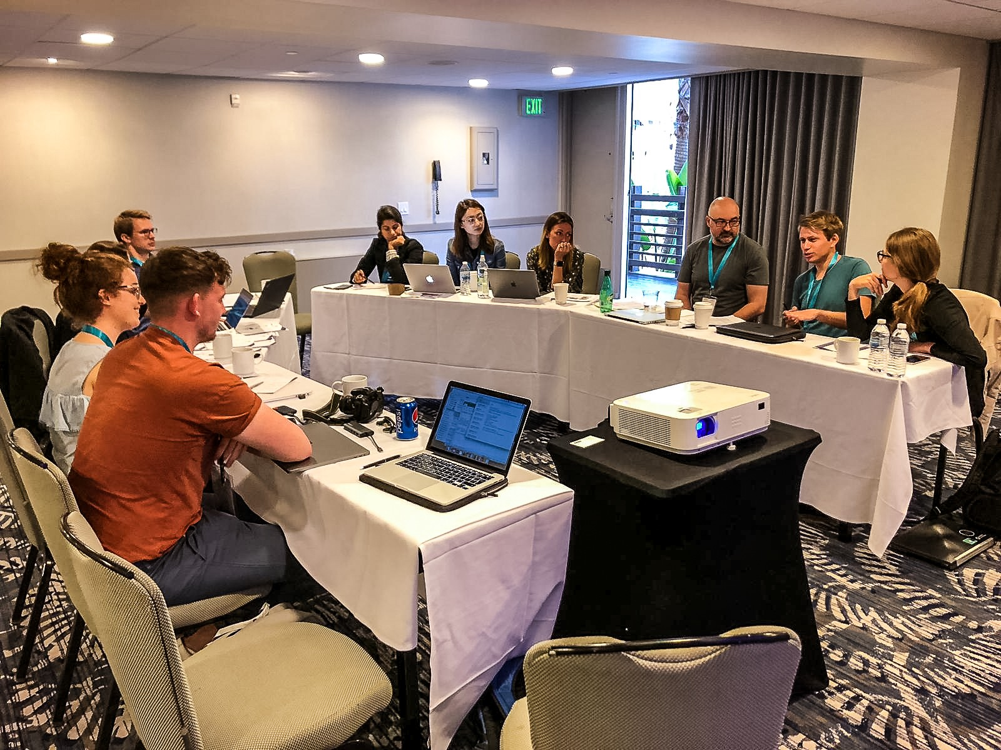

**Figure 3.1** Workshop at DIS’19

A particular interest has arisen in working with participants in sensitive contexts, due to the unique challenges that arise due to what it means to participate when capacity is difficult to ascertain (Foley et al., 2019c; Lazar, 2014), in verbal processes for people who are often not verbal (John Killick Claire Craig, 2012; Knapp et al., 2013; Kontos and Grigorovich, 2018), and recognition of participants involvement throughout the study (Lindsay et al., 2012; Morrissey and McCarthy, 2015; Wallace et al., 2012). To date, these conversations have helped share experiences that are often based on a single research project. Yet we are missing an understanding of how researchers in a diverse array of contexts handle ethical decisions. As an example of a topic that emerged in this study through considering different viewpoints, Ethical Review Boards (ERBs) are in place to ensure research is following standard ethical principles, with the aim of protecting the participants, researchers and research institutions (Flicker et al., 2007). Despite playing a key role and coming up repeatedly in town halls in terms of questioning how the HCI community can think about ethics given the variation (or lack) of ERBs in the international context, there has been little research to date that examine the impact of ERBs on research in HCI. With this in mind, this chapter takes design ethics in dementia and HCI research as a study to reflect as a community of practice and to elucidate broader concerns about ethics in HCI research.

78

## 3.2 Related work

* 1. **Related work**

The following sections summarise working practices around ethics in HCI and the nature of the complexities that can arise from working with technology and design in dementia research and, more broadly, in sensitive contexts.

### Design & ethics in HCI

HCI and design researchers have long recognised the role of building relationships between the designer and the user that facilitates viewing and understanding the user is more than a test subject (Wright and McCarthy, 2008). Many approaches follow a similar pursuit, such as experience centred design (Morrissey et al., 2017b), feminist HCI (Bardzell and Bardzell, 2011), value-sensitive design (Friedman, 1996), and participatory design (Bannon et al., 2018). Over the past decade, researchers have leveraged these participatory design methods to engage with those considered marginalised. However, as researchers have adapted ethnographic research, design probes, and co-design to fit the needs of their user populations, these practice-based methods present considerable challenges for researchers navigating through emotionally and contextually complicated researcher settings (Vines et al., 2013a).

In most cases, navigating the preparation of such a study requires researchers to receive ethical approval from institutional ethical review boards who define ethical practices through a set of institutional ethical procedures. In the UK, these bodies are known as ‘Ethical Review Boards’ (ERBs) that are present across all universities and are put in place to ensure research follows sound ethical principles and puts the welfare of participants at the forefront of the research (Pachana et al., 2014). While most, if not all, often reflect the philosophical basis of morality, ERBs are significantly shaped by their culture and society, resulting in a vastly different set of expertise and approaches to reviewing research ethics (Flicker et al., 2007).

While these ethical guidelines set a course for research that seeks to ensure that both the participant and research institute are informed and protected, many prominent interdisciplinary research approaches, such as participatory design and qualitative work with vulnerable popu- lations in HCI, can be considered ethically questionable ERBs. Bell and Elliott (2014) argues that many ERBs’ approaches to ethics align more with biomedical and experimental scientific methods, which fail to reflect the multiple ways of generating knowledge that encompass the third wave of HCI (Bødker, 2006; Lazar et al., 2017a). Willig (2013) suggests that for qualitative researchers, *"ethical issues arise from the very beginning of the research, they stay with us throughout our interactions with our research participants, and they continue to be relevant throughout the process of dissemination of the research findings"*, and call for a prolonged and adaptable approach to ethical research design.

79

## Learning from Ethics in Dementia Research

For most research, these guidelines may be relatively straightforward. However, the introduc- tion of technology may bring additional complexities concerning privacy and data storage; health and educational support (Gray and Boling, 2016); technology longevity (Foley et al., 2019c), and technology responsibility (Ferrario et al., 2014). These challenges have been navigated and discussed in detail through ACM Town Halls and conference workshops (Frauenberger et al., 2017; Munteanu et al., 2019; Waycott et al., 2015). Researchers have been invited to reflect and consider the ethical challenges they face within this space. While recent work in HCI has begun to examine the role of ethics in HCI research - particularly studies that work within sensitive settings, there is a need to come together as a community of practice to identify institutional and relational ethical challenges - in this instance, the context of dementia. As this thesis focuses on dementia, the following literature briefly introduces the current state of ethics in dementia and HCI research.

### Ethics in context: Dementia and HCI

As described throughout this thesis, a diagnosis of dementia comes with varying cognitive changes (Hampson and Morris, 2016). With dementia, the decline may change social functioning, judgement, problem-solving and may require care or other support to engage in social or complex activities. Given the vast complexities that a diagnosis presents, many of these can be seen as ethical concerns, making it a difficult space for both research and care practices. Person- centered approaches to dementia care have called attention to how we communicate with people with dementia (Oyebode and Shickle, 2005), debated the need for ongoing consent processes (Dewing, 2007), questioned the contested use of lies and deception in care (Elvish et al., 2010) and promoted the need to attune to embodied, non-verbal communication (Group et al., 2019; Twigg and Buse, 2013) as key considerations in ensuring the person with dementia is respected and engaged within their own care. These practices, largely initiated within nursing and social care, have implications for research and design which seeks to work with and for people living with dementia, avoiding practices that devalue or disregard the experience of the person living with dementia. Design and technology solutions that focus on cognitive decline, monitoring and management may perpetuate stereotypes and contribute further to the stigmatisation of dementia (Low and Purwaningrum, 2020). In contrast, HCI research that extends from person-centred approaches to dementia is a growing body of work that relies on relational processes as the basis of design. This has resulted in the introduction of technologies that evoke emotion (Dixon and Lazar, 2020; Houben et al., 2019; Wallace et al., 2012) , engage in creativity (Lindsay et al., 2012; Morrissey et al., 2016) and support inclusion (Foley et al., 2019c; Treadaway and Kenning, 2016; Welsh et al., 2018).

Participatory and co-design projects have innovated some of the methodological approaches to design, which are necessary to support people living with dementia to engage meaningfully in co-design processes (Branco et al., 2017). This includes engaging in longer-term projects

80

## Related work

(Hendriks et al., 2014), working within the family ecology of care (Keady et al., 2007), and navigating gate-keeping within institutions (Sanghera and Thapar-Björkert, 2008). The care and ethical consideration needed to include the voices of people living with dementia in HCI research has resulted in a strong relational basis for design practice (Bartlett, 2014; Kontos and Grigorovich, 2018). The established state-of the art based within this work has moved away from the biomedical deficit model of dementia, resulting in several underlying person-based values in design practice. This includes: treating the person living with dementia as an individual in context; including the person living with dementia in research processes that are explicitly aiming to improve their quality of life; acknowledging that dementia is a complex experience that often also includes social complexity (Keyes et al., 2019), ageing and multi-morbidities (Buse and Twigg, 2016), which require attuning to in design and research responses. It can be argued that these design decisions offer particular ethical stances that appear essential to both the success of HCI projects in this context, and ensure the researcher-participant relationship is navigated with mutual respect and care (Foley et al., 2019b). Making these ethical decision- making processes more visible within our empirical work has the potential to critically inform the current institutional and relational ethical framing in which we currently work (Oyebode and Shickle, 2005), and make more apparent considerations needed to ensure meaningful and engaged research with vulnerable user groups is central to the design of technologies and systems.

However, even as these views of dementia evolve in research and practice, research shows that work in sensitive settings such as dementia can raise concern from Ethical Review Boards (ERBs). Pachana et al. (2014) further highlight that committees may be *“subject to the same biases and stereotypes present in the general population”*. ERBs unaware of such biases may focus on the aims of protection instead of the approval of research that attends to topics such as agency and ensures meaningful participation. Further complexity arises since ERB decisions vary even within the same country or region (Edwards et al., 2004). This is because the decisions and reasonings are made at a university level and influenced by cultural and local norms and customs. Thus, the disciplinary changes in working with populations such as dementia are not necessarily matched at the level of those who make decisions about what research is and is not allowed when carrying out participatory work with participants who are considered ‘vulnerable’, this tension is a key focus that we attend to in this study.

To understand ethical experiences and practices in the field of HCI and dementia, I inter- viewed 22 researchers from diverse countries, institutions, and disciplines. Our analysis uncovers tensions arising from institutional ethical practices in socially oriented research. While ERBs vary significantly in their cultural and disciplinary approaches to dementia research, the findings reveal the tensions that arise in participatory research due to ERBs’ tending to focus on protecting participants, which raises concerns with acknowledging participants and building relationships. Through the interviews, researchers reflected on how ERBs could be more reflexive bodies, where researchers can seek support, guidance, and collaboration from experts. Researchers also shared insights from their own cultivated practices from establishing clear expectations for

81

## Learning from Ethics in Dementia Research

participants, knowing when and how to involve participants in the research, and appropriately acknowledging their contributions to our work. The chapter progresses from these rich findings from a growing body of work in HCI and dementia towards establishing a new set of fluid ethical practices to direct work in this ever-increasing area of socially-oriented HCI research.

## Methodology

Interested in the tacit and unstated practices that researchers employed in working with people with dementia and their carers, I undertook a reflective qualitative approach to carrying out this empiracal research. I invited 22 self-identified researchers and/or designers to one-to-one questions to elucidate wider concerns about ethics in HCI research. The following study tackles *What are the ethical implications for people with dementia to participate in HCI research?*

### Participants and recruitment

I recruited 22 self-identified designers and/or researchers (12 women, 10 men). Each partic- ipant reported significant experience in working with people with dementia in the design of technologies and services. Participants demographics are summarised in table 3.1. I approached recruitment through purposive sampling methods which moves away from random form of sampling, but rather adopts a process to *"select respondents that are most likely to yield appro- priate and useful information*(pg.317)(Kelly et al., 2010). To begin with, I selected presenters, exhibitors and attendees from Dementia Lab conferences (2016-2019) - this is an international conference featuring design and HCI work with people with dementia (Brankaert and IJssel- steijn, 2019). Once participants from Dementia Lab expressed interested, I employed snowball sampling, which asks current participants to recommend potential participants of interest who have similar experiences to design, HCI and dementia (Noy, 2008). In the demographic table, participants were asked to self identify their career stages as: early - junior researcher/lecturer, mid - senior researcher/lecturer and senior - professor.

### Ethics

Newcastle University granted ethical approval for this study. Each participant was emailed an overview of what would be expected from the interview and the study, and provided with consent form and information sheets. Due to the sensitivity of the topics discussed in the interview, all participants have been anonymised for privacy purposes.

82

## Methodology

|  |  |  |  |  |
| --- | --- | --- | --- | --- |
| **Name** | **Discipline** | **Career Stage** | **Gender** | **Place of Practice** |
| Emily | Design | Mid | F | UK |
| Verna | HCI | Early | F | Singapore |
| Neville | Design | Early | M | The Netherlands |
| Louise | Psychology | Early | F | Ireland |
| Sofià | Design | Early | F | The Netherlands |
| Isla | Psychology | Early | F | Ireland |
| Martin | Computer Science | Student | M | United Kingdom |
| Niamh | Speech & Language | Early | F | United Kingdom |
| Kevin | Computer Science | Senior | M | United Kingdom |
| Lucas | Computer Science | Mid | M | United Kingdom |
| Micheal | Psychology | Senior | M | Ireland |
| Jessica | Informatics | Early | F | USA |
| Daisy | Design | Mid | F | United Kingdom |
| Beth | Social Science | Early | F | United Kingdom |
| Enzio | Design | Early | M | Belgium |
| Mary | Design | Early | F | Belgium |
| Holly | Design | Student | F | The Netherlands |
| Dion | Design | Student | M | The Netherlands |
| Thomas | Computer Science | Junior Developer | M | Sweden |
| Jarod | Computer Science | Junior Developer | M | United Kingdom |
| Lisa | Computer Science | Mid | F | Canada |
| Katie | HCI | Mid | F | Australia |

**Table 3.1** Participant demographics

83

## Learning from Ethics in Dementia Research

### Data collection

Mindful that the interviews would be touching on sensitive topics, I adopted the reflexive position of ’connected knowing’, which involves empathy, and perspective-taking to understand the other’s perspective that further recognises disagreement or disparity (Belenky et al., 1986). With this in mind, while I conducted the majority of the interviews, specific interviews where the participant had a prior relationship with other authors of the study led the interview to provide a more comfortable space for sharing personal stories on dementia. For all interviews, I developed a semi-structured interview schedule (see appendix A.6), which consisted of open-ended questions and prompts on: 1) experience in dementia research, 2) power relationships, 3) experiences with institutional ethics processes, 4) HCI ethics, 5) building relationships with people with dementia,

6) dissemination of knowledge, 7) exit strategies, and 8) how we define impact. Interviews lasted from 45 minutes to 70 minutes. Interviews were carried out in person where possible, but were otherwise carried out over video calls. All the interviews were audio-recorded and transcribed in full.

### Data and analysis

Data collection consisted of 1100 minutes (average 50 minutes per interview) stretching across 22 interviews. With the large dataset, Dr. Kellie Morrissey and Dr. Sarah Foley supported initial coding by coding half of the data to compare to my coding of the 22 interviews to avoid bias (Berends and Johnston, 2005). Throughout the project, I led weekly meetings with the authors to reflect on what I saw in the data, agree on codes, subcategories and the building of themes. My analytical approach followed Braun and Clarke (2006, 2020) Thematic Analysis (TA). This process followed a seven step process. First, I prepared the transcripts. Second, myself and the other two coders familiarised ourselves with the data and referring to the research questions. Third, I began to generate labels to identify relevant data - for example, *explaining the use of data’* , *’learning by observing’*, and *’novelty not always necessary’*. For consistency and avoid bias, I then compared my coding with the other two authors to ensure sufficient concordance. In the fourth and fifth steps, I invited authors to take part in a Skype call to organise codes into potential themes to gain multiple perspectives and have opportunities to address disagreements and reflect on the themes that had been generated throughout the analysis. In the sixth step, I began to frame the themes around the research question and defined and named the themes. Finally, the seventh step is the developing and writing of the analysis that is presenting in the following section below.

84

## Findings

* 1. **Findings**

The findings centre around two more prominent, overarching themes that describe researchers’ reflections on ethical dilemmas and emergent practices in their research within the subthemes. The first theme considers the tension between guidelines and situated practice that highlights institutional protection and ways (or the lack of) to acknowledge the person with dementia. The second theme, emotion and everyday experiences, explores the relationships researchers co-create with participants and how researchers initiate and maintain relational approaches. Throughout the findings, I refer to the participants as researchers, as they all engage in research to one degree or another.

### Guidelines vs situated practice

Researching under a culture of ethical ‘protectionism’ caused significant tension when working in socially-oriented research, which the participants described as requiring significantly more flexibility. To this point, the following subthemes describe the ethical challenges researchers face, including a sense of over-protection of participants, a lack of practical guidance from ethical review boards as to how to navigate ongoing ethical challenges through the research, and the effect misrepresentation of dementia has in the public eye.

### The unacknowledged subjectivity of ERBs

Researchers highlighted a range of different experiences with ERBs that were tied to their geographical, cultural, and institutional contexts. Holly expressed in the Netherlands that person- centred care is recognised as standard practice providing a *“easy process”* as the research is not taking a *“medical direction”*. Holly continued to explain finding value in describing to ERBs why *“we do person centered research”* which provided the ERB with deeper insights into dementia and provided valuable understandings for her approval application. Additionally, in the UK, Daisy describes her university ethics committee as consisting of researchers *“with a track record of working with people who lack capacity”*. Furthermore, this provides a diverse and inclusive lens to provide a *“good framework for the ethical consideration of involving [people who are considered maganlised] and people who lack capacity”*.

On the other hand, Verna’s ERB in Singapore considers, as a matter of course, *“technology that’s implemented into a care home to be a medical device”*. Because of this, the technology and the ethical review it is connected to is evaluated much more stringently. Verna further highlights struggles about whether *“engagement activities for people living with dementia [can be considered] a medical device”*. As soon as the research is being done in a hospital setting, the ERB considered it to be a medical device - *“That’s like calling a ball used in therapy a medical*

85

## Learning from Ethics in Dementia Research

*device”*. This miscategorisation of aesthetic or pleasurable experiences as an intervention in health or wellbeing places importance on technology as having to “make the person better” in a biomedical method.

In contrast to Daisy’s success with a working relationship with UK Ethics committee’s, Beth’s experience with UK institutional ethics has been challenged where she *“felt [their] knowledge and expertise was being called into question by people that were either non-experts in the field, or that it wasn’t appropriate for them to be reviewing it”*. As such, Beth’s experiences highlight issues of where decision-making processes are made by committee members who have potential biases and stereotypes of people with dementia resulting in an inaccurate view on the study proposal. Likewise, the makeup of an ERB can also lead to a biomedical view. Michael says he found significant difficulties getting ethics approved, as his relevant Clinical Research Committee, was *“run by mostly medics”*. Though ERBs try to have people with experience in particular areas, due to the specialisation of research, it is not always possible to have a committee with expertise in dementia from both a person-centered and design angle. Niamh, part of the ethics committee at her university, explains that *“you do not know who is going to get your proposal”*. Perhaps because of the breadth of expertise on the committee, decisions may lack ’discernment’, as ERBs are perceived as taking a *“one size fits all ethics... to be obstructive”*.

Isla reflects on ‘one size fits all ethics’ when working on an application to recruit from NHS (National Health Service, UK) care homes to take part in a low-risk, qualitative design study exploring the support of intergenerational contact between young people and people living with dementia through technology. She explains that her proposal got *“bounced to the NHS ethics”* and after a considerable amount of time approval was refused. The medical ethics committee could not see the *“benefits of involvement”*, but instead focused on the risks concomitant with cognitive decline, and the need for protection above inclusion. Researchers noted that their own experience in the area was not considered in reviews. Thomas expressed that while he thinks ERBs see *“the benefit in [the research]”*, that ‘trust is lacking’ towards the researcher.

Verna describes her collaboration with care homes as being about partnerships built from trust. Similarly, Kevin proposes that ethical review forms should create a collaborative bond between the researcher and the ethics committee. Enzio suggested that ethical approval forms should give the committee information to reassure them that the researcher has the support and knows what they are doing such as: *“Is there a senior researcher? Who is the junior researcher? What’s the experience?”* Overall, our participants sought a reciprocal relationship with their ERBs. They could seek support, advice, and collaborate discursively, rather than be judged for their ethical practices or denied approval entirely after a significant amount of time and effort has been expended. Similarly, our participants also sought an equal relationship with their participants.

86

## 3.4 Findings

### Recognition of participants’ contribution

Researchers placed importance on acknowledging their participants’ contributions. In his design research, Dion mentioned a lack of recognition from other researchers that caused a domino effect, putting participants off from taking part: *“I noticed there was this kind of, almost fatigue [from the carers], that they have seen all these researchers come by, especially many students who make these prototypes. They test it, it is all nice...but then they disappear. There is nothing that remains.”* When Dion explained his research to the participants, the participants said *“Why do we need this? Why can’t there be something that stays?”* This illustrates the importance of clearly articulating what participants should expect throughout the study and acknowledging their participation in an appropriate and meaningful way.

Katie and other’s emphasised designing research to be *“engaging, enjoyable and rewarding”* for the participants as a way to a) recognise the *“time they are giving up”* and b) to provide a *“space for creativity and sharing”*. Beth reflects on one participant who said:

*“you know, this has been so amazing [to be part of the research] because actually, we never got any information when we got the diagnosis and we have no one to talk to, nowhere to go, and it has been so lovely just having a conversation”.*

As such, while Beth describes that for many who have felt shut out from a diagnosis, that research offers an opportunity for people with dementia to talk to experts who may know where to find resources and offer alternative directions for the person with dementia to find ways to take part int he community. Similarly, Martin comments on how participants would express to be “*part of future studies”* and that they were *“extremely thankful to be listened to and to be listened to again”*. Where many people with dementia often express difficulties in participating in society post-diagnosis (Bartlett, 2014), the researcher’s illustrate the importance of recognising people with dementia’s participation in research.

Typically, researchers will often pay their participants with vouchers for their time. However, Thomas stated that in care homes, money *“doesn’t really work in this setting. . . money does not hold too much value there”*. If the traditional approach to compensation does not work in this setting, we must consider other ways to compensate people with dementia for their participation. One approach is to offer participants the technology that we build. In our conversation with Niamh, she discussed a different approach to disseminate research to be useful for the participants: *“So, we co-designed a toolkit with them and left them with the toolkits and left research materials, and things, when we went over. . . they were really taking time out of their- you know, some of them were travelling up to three hours just to get there. Three hours, three hours back, just to come early to come and do these things.”*

87

## Learning from Ethics in Dementia Research

Though this approach works well with some research, other HCI projects focus on initial exploration, where prototypes are not fit to withstand long time use without continuous check- ups and fixes. Echoing this, Isla shared concerns *“of anxiety and failure”* if the technology would break, and conflict towards the technology *“may break in a year or two.”* Another way researchers give back and recognise participants’ contributions is through ceremonies or events to commemorate and celebrate participation. Through our interviews, Louise and Daisy reflected on using the term ‘celebration’ and the act of giving as a way to value their participants work through the study. Daisy sees the celebration as *“a way of celebrating the lives of the participants that have helped develop whatever you’ve found”*. Louise reflects on creating personalised gifts and celebrating research with those involved through her PhD study: *“For them, maybe I just came in, but for me, it was a very meaningful relationship. I probably just didn’t want it to end, to be honest.”* Researchers need to celebrate a finished project not only for the participants but for themselves, highlighting the personal impact of this kind of research. Regardless of how we acknowledge contribution, we should recognise participants as individuals who have contributed to the research and that their knowledge, experience, and time are valuable and valued.

### Protection vs acknowledgement

Keeping participants anonymous is the standard ethical practice (Novak, 2014). Researchers use pseudonyms and blur faces in photographs to ensure data collected cannot be traced back to the original participants. Throughout the interviews, researchers expressed an understanding of safety and respect to the participants when anonymising data. However, Kevin noted that this approach seems to be more about "making sure we stay within the university’s insurance" and less about *"avoiding harm to participants"*. Similarly, Beth describes universities avoiding harm that caused additional frustrations for the research team. For instance, the team "had to ensure [transcription] was only dealt with by the research team", and the *"video recording of participants"* caused a *"massive problem"* with the ethics committee despite the necessities of researching *"body language in dementia"*.

Daisy mentions that anonymisation works when participants *"might not want their [real] name [used]"*, but when participants want to be recognised for their contributions, challenges can arise. Several researchers commented on their challenges when participants want to be acknowledged as co-creators. Lucas reflected on previous work where he had participants ask *"We have done this work. . . Can we have some credit for it? Can our names appear in the research?"*. But as it stands, *"they can’t, because [the] ethics board says it must be anonymised."* Researchers, especially in social science, endeavour to have participants real names ethically passed by the review board. Daisy highlights further tensions because of this tendency towards protection that universities exhibit when it comes to research with dementia: institution protection can further add to the feeling of "*dementia rob[bing] people of their dignity, their individuality and their lived life."* Through Daisy’s awareness of working with people living with dementia,

88

## 3.4 Findings

she believes that *"to make them then anonymous or a number is robbing them of their dignity."* Dion considers appropriate ways to acknowledge the person living with dementia’s contribution through a photo shoot for a care organisation magazine:

*"[the photographer] came by to take some pictures and ask for permissions, and I was with the participant, interacting, but it was a bit fake, of course."*

Dion reflects on this moment, saying the participant *"was enjoying it"*, and was *"laughing"* during the activity. The participants were particularly *"proud that she could be on the pictures, and in the magazine’s article"*. A growing number of publications include people with dementia as authors to recognise their contributions.

Enzio named a UK institution that hired participants as research collaborators and, through this, ensured they were given authorship of subsequent publications: *"I think this in-between solution is great. If you have a participant who is joining you for some time, [hiring] would be great to do. Then they are equal to you as an author of work or papers.*" Jessica also mentions Dementia Enquirers *"who have a project where people with dementia are coming up [with research studies] and that have [their own] ethics [guidelines]."* Recognising participants by opening up authorship ensures participants are influencing the research agenda, in contrast to the current standard practice of anonymisation of participants. However, the ACM code of authorship states that authors must *"have participated in drafting and/or revision of the manuscript"* ( , 2019). We, therefore, need to question whether the ACM model should shift towards a contributorship model, in which contributions towards the project are credited rather than academic writing.

### Emotion and everyday experiences

Through our interviews, researchers described various views on their work’s ideal and realistic impact. In this theme, we unpack the subjective role of time in research impact and the importance of building and continuing relationships that hold meaning as part of the research.

### Research pace and relationships

Researchers noted the tensions arising when the timeline of a research project does not align with researchers’ best practices. There are differing views on what should be emphasised: one perspective espouses allowing relationships to develop slowly over time, while the other emphasises the value of a swift design process where visible progress is made in step with technology development. From our interviews, it was common to hear how important it was to researchers to create relationships throughout the research. Niamh mentioned times where she questioned *"I wonder if this is the right time for you (the participant)"*. At odds with timelines

89

## Learning from Ethics in Dementia Research

that rush data collection for a deadline, several researchers emphasised a more relational approach that takes time and care throughout the entirety of the study, up to its ending.

Michael comments on how researchers should be considering continuity and not be *"dropping in and out of care homes or people’s lives for two or three months to get data to write a paper"*. He explains that it is unreasonable *"to jump into people’s lives. . . and come back and expect them to be open-armed and welcoming us again three months later"*. In situations where this is not feasible as part of the research, Dion would often *"go and meet the participants"* at the residential between studies to maintain a relationship with the care staff and residents. Similarly, Isla suggests, *"go and have a coffee or work to their schedule, I guess. They are the most important part of our research."*

Consequently, the researchers expressed that through building stretched out processes, Isla argues we provide the time to *"think about sustainability, scalability... and be mindful and treat every single person as a person and not racing to the finish line"*. A knock-on effect that researchers highlighted was the building of relationships outside the research scope. For instance, Louise described *"personal relationships"* shaped by spending time with residents where they *"could be so open"* and would be *"delighted to have someone to listen to them"*. Daisy described how she felt the relationships we make in research never *"stop and [we] never let go"*. Daisy continued to describe the development of *"good relationships"* that would "tend to continue informally" and that while they would *"contact very rarely"*, those relationships that are formed over a long period *"don’t stop existing"*.

While some researchers express the need to take more time in the research process and the potential outcomes of long-term relationships forming outside the research, Lucas mentioned that design iteration is *"too slow of a process"*. While he agrees relationships should take as much time as they need to develop, it should speed up once the study moves to iteration and design. Lucas continues to describe the need to move towards a *"more hackathon pace"* where iteration and changes to prototypes are a "daily or weekly basis". By leveraging *"wizard of OZ"* and *"lo-fi prototyping"*, people with dementia and designers can focus on the *"interactions rather than designing the final systems"*. In a similar vein, Kevin emphasises the challenges technology brings when *"technology just ages really quickly"*, which requires fast iteration processes to provide *"top of the range technology in the area"*.

Returning to Lucas, he describes frustration participants may experience if they are expecting something to be built:

*"meeting and chatting with someone for a couple of hours each week can feel like not much is happening. Especially if you come back and that thing you said you would do hasn’t been altered, and maybe it has to be discussed again next week".*

90

## 3.4 Findings

Once design iteration starts, researchers should engage and involve people living with dementia in the study as much as possible and through design responses which *"show people that you are taking feedback seriously*". In particular, when designing with people living with dementia, there is a distinct progression in the diagnosis over time. If we prolong the research study, *"what [the person with dementia] needed at the start . . . might be different from what they wanted at the end of it"*. Researchers should consider how to pace the trajectory of a project, including explicitly planning for the time it takes to grow and support meaningful relationships with research participants. This is especially important with people living with dementia, as understanding each individual’s communication abilities can support better engagement in research as well as better research outcomes.

### Understanding impact

Bringing technology into research offers opportunities for meaningful engagement and ethical challenges relating to the robustness and longevity of technology when the project ends. In our interviews, researchers offered different perspectives on what is most important: the technology itself working, or the meaning and the relationships that they engender. Dion notes that it is *“difficult to do these long-term solutions”*, and while it is easy to say *“We need to leave something behind”*, the technology still needs *“technical support.. because they break down every week or so.”* Isla reflects on a colleague who had difficulties maintaining technology after the study had ended. The researcher *“guaranteed [the device] to last for the year of the study.. and will fix it [throughout the year]”*. While the researcher appropriately managed expectations of the study with participants, “*one of the participants hung on to the technology for years and found it was helping [her quality of life]”*. As it broke, the participant asked for help to fix it, but “the research was gone. The funding was gone.” As researchers, Isla suggests we have a responsibility to anticipate and be *“upfront and say there is a natural lifespan to some of these technologies”*. One direction researchers take is by thinking about longevity in ways other than the lifespan of the technology itself. Thomas highlights how the value in participants taking part in the research is the opportunity to have a say *“on the new social direction of that [community]*”.

In her research, Emily expresses building a sense of media’s lifespan or other possible tech- nologies. The couple she worked with, *“had pictures of things they made together [throughout the research]...and that meant a lot.”* By placing her participants as the focal point who drove the research, it became a significant event for them. Emily remarks that technology *“doesn’t have to be cutting edge to be meaningful, and to do something poetic and powerful”.* In this way, it’s clear that researchers should consider that technology alone does not hold any value; it’s the relationships and experiences it creates. However, there can be an expectation of, and value, associated with longevity. Martin shared a story about his Grandad designing gifts for his Grandma:

91

## Learning from Ethics in Dementia Research

*“My Grandma looked after my grandpa through his dementia until he sadly passed away. During those years, he expressed himself creatively and would create gifts for my grandma. One Christmas, he created a beautiful Nativity scene. On the backdrop was LED lights that resembled the stars and was powered by a battery. On the back of the nativity scene, my grandpa wrote: “My love lasts as long as the battery”.*

Every year, Martin’s Grandma brings out the scene for a few days and places the very same battery that she has had for over 20 years to see if it still works (*“to this day, it still does”*). Kevin expressed ethical value in working with businesses to help maintain a product after the end of a project. Kevin says *“grants only ever get you so far. . . [researchers] have got to come up with a value proposition”*. Researchers can find ways to *“reinvest [money into the product] and keep the stuff going”* by bringing in businesses. Having businesses continue supporting systems and technology after the end of a study can ethically support the participants who have been part of the research and are using the technology that may have improved their quality of life. Within these more extensive projects, more comprehensive sets of skills were implicated, involving complexities on their own. Kevin iterates by working with *“business people, venture capitalists”*, his study has the opportunity to find the best way for technology to get to the market, where, ostensibly, it will find further impact. Kevin further expresses that research should aim to *“build robust software that can result in spin-offs or commercial partnerships to get to the next stage”*. However, this can be a contested space with participants, particularly carers, concerning how long it takes for design products to arrive on the market. This further highlights the need for setting clear expectations for participants and being responsive to the many reasons as to why they agree to partake in the design research process.

### Ecology of self(care)

Our interviews saw several researchers talking about their emotions and how they influenced their experiences in their projects. Our interview with Enzio indicated that *“building relationships between researchers and participants help to appropriate the technology around the person living with dementia and their ecology of care”*. Working primarily with students, their emotions influenced the way they formed relationships and engaged with the research. Seeing his students sensitively attending to lived experience, Enzio realised that *“this would not have happened if they just made something for a generic person with dementia without having this personal relationship”*.

Louise, who works on a study in a care home, reflected on learning from a caregivers experience. Over five years, Louise talks about one participant who “*used to be engaged”*. Over time, as *“her dementia progressed”*, that participant became *“very shy”*. That change in personality and expression gave Louise *“the best sense of what it might be like to watch a loved one in that process and try to bring them back.”* While focused on a caregiver’s lived experience,

92

## Findings

it changed Louise’s view of *“being quite critical”* of people trying to ‘bring back’ their loved one’s memory. Having spent more time on the project, Louise had a more in-depth understanding of *“how it can be really difficult”* to see someone go through a diagnosis of dementia. Louise’s experience of ‘unexpected’ emotion is reflected as emotionally significant. As researchers, we have *“the luxury”* to reflect on the lived experiences we are a part of. Having space and time to reflect allows researchers to understand the emotional nature of the work we are doing; Of course, working in dementia care comes with complexities in that participants may pass away, or that their dementia will likely progress. Katie expresses that this can represent *“big emotional stress for researchers”*. Dion highlights the ethical and moral complexities of *“hav[ing] observational data”* from a participant who had passed away before any publication.

Similar to many other academics, Dion echoed the struggles of what to do in this situation: *“Do you use the data or not? How do you mention this in a paper? Those are things that I don’t know how to handle actually. I found it very difficult. What do you do with it?”* In this instance, Dion particularly struggles between his emotions influencing his choice on whether his work be published. However, it is likely that simply not talking about the work will not divert the conflicted emotions stemming from having carried out the research in question (Wacquant, 2015). If we are moving towards reflexive practises in HCI, these seemingly personal experiences from researchers should be integrated into the empirical nature of our work (Morrissey et al., 2017b). However, self-care is similarly important: Mary recommends to “be true to your personality and feelings” and to make *“time to talk about the experience, even if this [has] no specific function in the research”*. Researchers should take time to reflect and discuss the experiences they have had through their research; in doing this, they may lay down healthier, more open and more empathetic practices for researchers who may follow in their shoes.

Through my analysis, I unpacked tensions that arise using institutional ethical practices in socially oriented research. With the importance of creating meaningful relationships, our analysis highlights the importance of recognising participants, valuing their time, and the continued ethical challenges of acknowledging people living with dementia in research. ERBs continue to over-protect participants, causing researchers difficulties of involving participants throughout a research study, including not being acknowledged for their contributions. While we are working in ‘sensitive settings’, this does not change our morality or our capacity to empathise and sympathise with other humans. Isla remarks, *“we should be as present as possible...the more open and almost kind and loving you can be towards someone, the better, without compromising your self-care”*. Bringing this element to the forefront of ethical design practices may be essential in moving this research space forward.

93

## Learning from Ethics in Dementia Research

## Discussion

The findings indicate that ethical tensions arise when researchers find themselves conflicted between the ethical guidelines they need to comply to and the specifics of the research, such as participant characteristics, relationships that have developed over the course of the study, the role technology has taken in the participants’ lives, and the researchers’ own definition and understanding of what it means to have long lasting impact (Mattsson and Kemmis, 2007). I described how researchers ethically navigate the contrast between ethics in theory and practice, ultimately requiring an ‘in the moment’ investment in the integrity of the relationship with both participants and backing institutions. Below, we discuss how our findings add to and contrast with previous work in this field and suggest future directions for HCI researchers. Participants discussed challenges in maintaining boundaries in participant-researcher relationships. Working within an experience-centred design framework, Balaam et al. (2019) note the need for designers and researchers to be more accepting of how we engage and manage emotion in the work. Through engaging with emotion, we must consider boundaries as subjectively based on contextual knowledge of the research relationships. From the reflections presented in the findings, it is evident that emotion is an integral part of much socially-oriented HCI research, and thus must also be taken into account in considering ethics. With this in mind, the following three subsections suggest a set of future directions guided by the researchers’ reflections on working with people with dementia.

### What can researcher’s and ERB’s do?

From the findings, the researchers desired reflexivity in the ethical review process, where re- searchers can seek support, advice, and collaborate discursively. Researchers have much to communicate back to ERBs in terms of how to ensure the inclusion of vulnerable populations, which past research has argued is an ethical and moral design outcome to strive for (Scanlon, 1998).By clarifying expectations for participants, and knowing when and how to involve partici- pants in the research, we can support better engagement in research as well as better research outcomes. However,the emotionally engaging nature of this work and empathetic response evident in the findings suggests the importance of supporting care practices - self-care and otherwise - as part of the research design. In table 3.2, I have presented a series of suggestions for ERBs and researchers to improve the relationship and processes that often structure our work.

### Designing for peer-led research

Researchers felt that the institutional ethical application process needs to be developed further - particularly where it does not acknowledge how valuable expert knowledge from the user domain can be. This poses the question: *How can research design be rooted in participant-led agendas?*

94

## Discussion

|  |  |
| --- | --- |
| **Recommendations for academic ERBs** | **Recommendations for researchers** |
| Create relationships with community advisory groups to gain insight into population needs (also see next discussion subsection). | Develop specialised educational programmes that can be shared to ERBs and other researchers in the field. The programmes could consist of examples of consent/information forms, internal ethics procedures, websites/organisations that may provide support. |
| Introduce staged review processes to provide feedback and understanding for researchers to provide clarity to any ERBs potential concerns. | Link-up community experts with ERBs to pro- vide additional insight into an area that the ERB may be lacking expertise. |
| Consider workshops / on-call queries to provide education to researchers and the community. | Volunteer to work for your ERB to make neces- sary changes from the inside. |
| Be open to learn new insights into the different everyday ethical practices researchers may re- quire to use for the community they are working with. | Educate the community about ERB processes and the benefits of research, and ensure the com- munity receives actionable insights that could be implemented into their practice. |
| Consider procedures and processes that take into account the researchers’ wellbeing. | Discuss compensation and acknowledgement to your participants to ensure they are recognised for their contribution to the research. |

**Table 3.2** Recommendations for ERBs and researchers for ethical research

From the findings, all researchers expressed the value in working with people with dementia for their experience and knowledge in the same way you would work with developers to learn about developer workflows. In all the examples within the findings, researchers highlighted various forms of compensation from monetary value, gift-giving, pleasant research activities, and contributing to the authorship of an academic publication. However, as Martin described, *"many of these compensations still [present] problems of addressing power imbalanced between the research and the participants"*. With this in mind, as researchers, we must consider ways to use academic resources to centre the community to address the issues that HCI research can assist with.

For instance, Reuter et al. (2019) work, which made use of the university resources that are often rich in (e.g., technical competence, A/V equipment) to innovate within a radio programme for older people, leading them to encourage researchers ‘to consider participatory action research as a method of assistance in itself, complemented by technical innovation to facilitate processes in this space. Building on her work, Reuter continued to centre the radio programmes needs by supporting grant and internal university funding as a procedure to ensure that the institution and the radio programme maintain a relationship once the researchers step away from the project (Reuter et al., 2021).

95

## Learning from Ethics in Dementia Research

Additionally, to provide more ethical research studies and to engage with communities from the start of the research journey, in our findings, Jessica discussed, engaging with advocates outside of HCI, such as the Dementia Enquirers Davies et al. (2021) , ensures that research agendas are more closely aligned with the needs of the population, thus *“helping improve the quality, relevance and ethical conduct of dementia research”*. Although these particular networks may not be found in every community, they have been a growing area of interest in the dementia community who advocate for: *"Nothing about us, without us"* Spiel et al. (2020) - in the research, policy and technology domains. These communities have started to apply for funding, design various documents of how to research with people with dementia, and curate ethical review guidance within their network. As researchers and as an institution, we should involve these communities to be part of the ethical review boards, not only to contextualise a deeper understanding of what work is sensitive and what is not, but also articulates the interests and priorities of the individuals the research will impact. As I have briefly highlighted in the previous discussion point, ERBs and researchers must consider how to improve the relationships institutions have with the communities they will ultimately impact their research. While I suggest researchers should start by opening conversations up with their individual ethical review processes; we must also consider the type of tools that may promote discussions and inclusion of community members, researchers and ethical review board members to begin to shape new research processes that prioritise the needs of the community.

### Designing for impact

Throughout the findings, the matter of impact was a widely contentious issue causing a lot of disagreement and meaning of what it means to have impact within your research. To cluster peoples views of impact into two themes, researchers saw differing values in a) exploratory work, and b) building robust products with collaborations. In this section, I will describe the value in both and conclude with ways for researchers to continue to explore the values of impact of their work.

The researchers I interviewed who had done ethnographic studies that required long-term relationships to be built between the researcher and participants had similar views of impact being about the taking part and representation of individuals within the research. For instance, in the findings, Emily saw the impact in the design process of involving people with dementia where it was less about the final product, but rather the research is a significant event. Similarly, Foley et al. (2019a) describe that the recognition that being part of the research had a significant impact on people with dementia as they *"often express the desire or need to be part of a social environment, to engage in collaborative action, and the co-creation of experience."* With many social ramifications often associated with a diagnosis of dementia, it is no surprise that being represented and involved in the research process impacts the participants. This also resonates

96

## 3.5 Discussion

with my writing in chapter four, where I discussed my participants expressing interest in being involved in future works despite the disinterest in the VR experiences I built for them.

Several researchers mentioned the importance of generating design implications that call for action to motivate other designers and activists to continue to explore the area of interest. This echoes Colusso et al. (2017) who highlights the framing of academic resources is necessary for adoption by both academics and practitioners. Researchers demonstrated a clear indication of the value in early discovery work, and the importance of work that is not market-led oriented allows for creative thinking to unleash its potential into new areas of understanding that we may not uncover when building long-lasting projects. The importance of early discovery work resonates in Ashutosh Jogalekar article who writes:

*"[C]uriosity-driven basic research has paid the highest dividends in terms of practi- cal inventions and advances. Tinkering, somewhat aimless but enthusiastic explo- ration of biological and physical systems and following one’s nose have been the ingredients for some of the key inventions that have transformed our lives. Radar, computers, drugs, detergents, plastics and microwave ovens were all made possible not because someone sat down and tried to discover them but because they arose as fortuitous consequences of elemental, pure research."* (Jogalekar, 2012)

However, researchers also expressed frustrations with implementing technology in early stages where they lack robustness or longevity. For example, Louise discussed her frustrations about not leaving technology behind after a study. In exploratory work, there is not enough time to develop robust products that can continue to stay with the participants. With not enough time, participants’ frustrations with the technology may never be fixed. Lucas further remarks on this: he sees participants’ irritation when a bug is not fixed as participants may feel their efforts were unacknowledged. This echoes Vines et al. (2017), who describes ethical difficulties in using Google Glass, a large corporation supported technology that still had bugs typically found in prototypes. This created frustrations with the participants ranging from poor battery life to Google sporadically updating the system despite participants’ wishes to the contrary.

The second area of interest is that impact relied on whether participants continued using their technologies and in developing successful industrial spin-offs to sustain their research. Kevin suggested that researchers should consider business link-ins when writing grants and that “it is all about partnerships.” Involving businesses into the start of research can still position participants at the forefront of the research, and allow value in creating technology that may outlast the study’s timeline. This can also fall into similar problems when funding ends. Returning to Vines et al. (2017), two years after the Google Glass project, Google *“stalled their support”, and any prospect of future development “into a product [was] diminished”*. In this way, even when working with large and well-funded businesses, support may only continue if it seems profitable. A recent CSCW workshop discusses the appropriate relationship between research and industry

97

## Learning from Ethics in Dementia Research

in terms of industry funding (Group et al., 2019): I encourage the continuation and expansion of this dialogue to discuss other facets of collaborations, such as those that emerged in this work.

## Summary

In this chapter, I introduced a study of 22 researchers working in dementia design research that raises numerous ethical complexities such as consent, participation recognition, self-care, and researcher relationships. Many of the insights resonate with my own experiences described in chapter 1. However, coming together as a community of practice, this chapter provides a series of directions applicable in all HCI research that seeks to work with marginalised populations. From here, the study entails the different expectations that are required for people with dementia and researchers - particularly when considering their wellbeing.

In the next chapter, I carried out a study to envision a participatory toolkit between designers, developers, and people with dementia would look like that tackles the complexities described in Chapter 2 - DemVR and Chapter 3 - learning from ethics in dementia research. Through iterative design workshops and interviews with people with dementia, designers and developers, I explore the type of resources developers and designers need to design with people with dementia and investigate how people with dementia envision their potential participation within a toolkit.

98

# Chapter 4. Dialogical Dementia Design (D3) Toolkit

## Introduction

As stated in the concluding comments in chapter four, I set out to explore the following themes:

* + 1. Explore the role of participation between people with dementia, developers and designers in public engagement
    2. To examine the impact of research ethics on participatory approaches in dementia from a researcher’s perspective

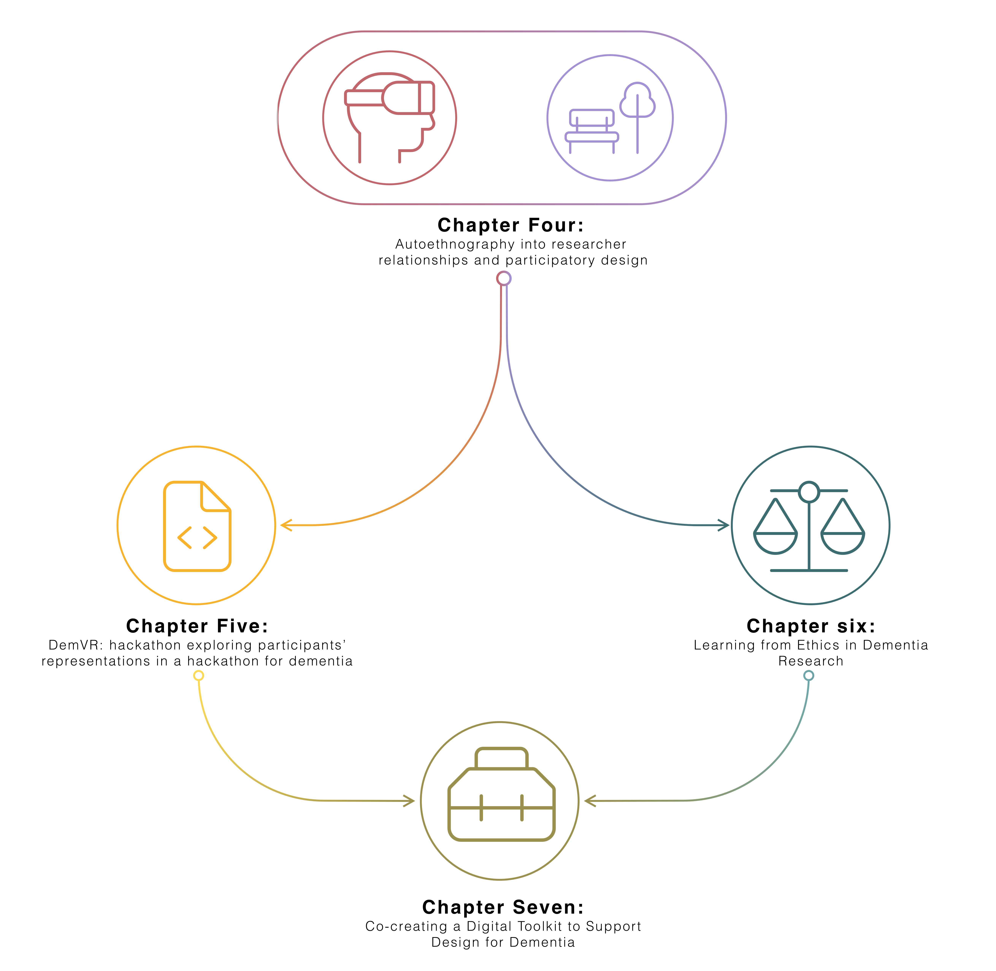

**Figure 4.1** Data chapter overview

To tackle these two themes, I organised a hackathon called DemVR to consider how de- velopers/designers and interviewed 22 HCI researchers with dementia experience to examine the complexity of navigating both “everyday” and more formal, institutional ethics in dementia research. Through these two studies, while I have outlined a series of key considerations into my research questions (that I will explore in more detail in the final chapter), the studies have raised

99

## Dialogical Dementia Design (D3) Toolkit

numerous questions centred on the ethics of recognising people with dementia in research; the challenges of communication between designers/developers and people with dementia; and how collaboration should be curated for the different groups of people with diverse sets of skills and backgrounds.

With this in mind, this chapter presents a study working with seven designers, four developers, and five people with dementia who I invited to participate in a three-stage iterative process to explore the type of resources developers and designers need to design with people with dementia and investigate how people with dementia envision their potential participation within a toolkit. Following stages one and two, I used a process of affinity diagramming to help surface a set of design priorities to guide the design for a final dementia design toolkit prototype - which I called the Dialogical Dementia Design (D3) Toolkit. Following our toolkit design, I conducted a final workshop inviting participants to reflect on the prototype toolkit to provide further insights into how designers, developers and people with dementia may contribute, use, and envisage how toolkit components might facilitate co-creation between different groups. Through our inclusive methodology, this paper offers three novel contributions:

* A rich description of a prototype Dementia Toolkit to support designers and developers in co-designing with people with dementia.
* A series of design insights to support toolkit development, including barriers to co-creation, incentives for sustainable participation, and sharing the ’design’ role.
* A series of directions for HCI and dementia research highlighting how we might balance participants’ privacy, safety, and recognition; priorities to contribute and grow a community- owned toolkit; and the accountability and responsibility that designers and developers carry when designing in such sensitive and ever-changing situations.

The study covered in this chapter is currently in submission to TOCHI. The study was co-authored by Dr. Kellie Morrissey, and Dr. David Kirk.

## Related work

To help ground our work, below I summarise current approaches in HCI to participatory research with marginalised communities, explore priorities and engagement requirements when designing with people with dementia, and review the type of resources and toolkits that have been designed as creativity support for designers and developers.

100

## 4.2 Related work

### Representing the experiences and views of marginalised communities in HCI

Co-design and participatory design traditions have historically engaged with marginalised communities in order to highlight the agendas and individual needs of members on topics such as rights, benefits, resources, and identity (Devito et al., 2019; Fraser, 2000; Porter et al., 2017; Scheuerman et al., 2018). This work has resulted in design practices that examine the acknowledgement of emotion in our research (Balaam et al., 2019); give careful attention to researcher-participant relationships (Clarke et al., 2013); and create safe spaces to support the sharing of sensitive topics (Lazar and Dixon, 2019; Scheuerman et al., 2018; Talhouk et al., 2016a). Following this work, the acknowledgement and sensitivity required for participants depends on their desires, needs as a community, and the community’s history that we are building on. Prior work has innovated many of our methodological approaches to better fit our participants: for instance, careful navigation of gatekeeping (Sanghera and Thapar-Björkert, 2008), awareness of biases and stereotypes (Marsden and Haag, 2016), and providing slower, longer-term projects to provide the time to build trust and a relationship between the researcher and participants (Foley et al., 2019b). Beyond designing for individual needs and desires, working specifically with LGBTQIA*groups (Byron, 2019), refugee and immigrant populations (Talhouk et al., 2016b), those with mental illnesses (Birbeck et al., 2017), older people (Reuter et al., 2019), and reproductive rights advocates (Michie et al., 2018) has contributed to a more inclusive design that invites *“new ways of doing, making and inhabiting the situation of our world today” (pg.65) (**Rosner**,* *2018**)*.

This project focused in particular on designing for and with people with dementia, where dementia is a neurodegenerative condition that sees the deterioration of cognitive abilities, often leading to an increased dependence on care, and which can lead to societal stereotyping and stigmatisation (Benbow and Jolley, 2012; Kontos and Grigorovich, 2018). Early HCI and dementia work has evolved our understanding of dementia by focusing on the ways in which we involve people with dementia in processes of technology design (Lindsay et al., 2012; Suijkerbuijk et al., 2019; Vines et al., 2013a; Wallace et al., 2012). For instance, Wallace et al. (2013) use a tailored approach that centred the importance of personhood by paying attention to a person’s individual and unique experiences of dementia to design bespoke digital artifacts for the participants. Similarly, Lindsay et al. (2012) describes the need for more interpretative data approaches for those at later stages of dementia, which in turn, may require longer-term projects and relationships to form throughout a study. This early work stresses the required need to adapt co-design and participatory approaches to accommodate the differing communication needs of people with dementia, ensuring they are respected rather than infantilised (Morrissey et al., 2016; Muriana and Hornung, 2016).

More recent work has seen a critical turn to understanding personhood even in the presence of later stages of dementia, where non-verbal and ambiguous interactions may be more present (Dupuis et al., 2016). Treadaway and Kenning (2016) emphasise that recognition and appreciation

101

## Dialogical Dementia Design (D3) Toolkit

are crucial even when leaning on tacit, creative activities to support non-verbal interactions. This critical turn is further supported in work by Morrissey et al. (2017b), taking an experience- centred approach that shifts the way we see people with dementia-related cognitive deficits as contributing to design choices. While prior work may focus on alleviating a person’s cognitive deficit, the critical perspective widens our approach to inclusivity, by celebrating what a person has to offer through more creative and engaging approaches, where those living with a broad spectrum of dementia-related changes can also participate (Lazar et al., 2017a).

To help foster empathy with, and understanding of, a person with dementia’s experience, there has been a push from dementia activists towards using online interactions and bespoke forums and Twitter to raise awareness and further challenge the stigma surrounding dementia (Talbot et al., 2020). Dai and Moffatt (2020) recent work on social sharing through community-based programs describes how future platforms involving people with dementia need to allow flexibility for *"dynamic roles"* where individuals can flip between *"storytellings, listeners, contributors" as the "activities [on the platform] evolve" (pg.10)*. Likewise, Johnson et al. (2019) argue that these roles may need support from *"various stakeholders in participating without burdening" (pg.127)* people with dementia. The further involvement of gatekeeping stakeholders may provide useful moderation and provide safety and familiarity on online spaces that can feature bad actors who target the vulnerability of people with dementia.

This move to online-mediated change-making mirrors a trend in work on participatory platforms and digital civics that has begun examining and developing tools to promote change and support marginalised voices (Corbett and Le Dantec, 2018). For instance, Puussaar et al. (2018a) developed a visual map-based querying tool to provide the public to interpret and understand open-source datasets that are typically incomprehensible by non-professionals. Asad and Le Dantec (2017) work on similar civic platforms describes that there is an *"obligation [for] designers and researchers to ensure our work aligns with existing efforts in our respective research communities" (pg. 6314)*. In Foley et al. (2020) work on student engagement within dementia care, the authors describe that over time, students started to take *"responsibility for the development of the relationships"* while the person with dementia was *"viewed as experts, with knowledge and stories to share beyond their role as a patient in care" (pg.9)*. However, to support collaboration and engagement between those who are being designed for, and those who are doing the designing, we need further consideration into the articulated needs and desires of such platform users - particularly those within socially complex contexts.

### Resources for designers and developers doing participatory HCI work

Much research in HCI has been devoted to the development of toolkits and other creativity support mechanisms, which have variously been used to support design research, creativity, and technological development and implementation (Broderick, 2020; Ledo et al., 2018). Ledo et al.

102

## Related work

(2018) write that toolkits within HCI provide: a) simplifying and fast-track creation, b) assistance in problem-solving processes, c) help to engage new audiences d) help to adapt tools within users workflows and e) support replication to enable scaling. Designers and developers use toolkits to manage collaborative design and *"understand the design situation and the problem at hand and to explore and experiment with potential solutions." (pg.21)(**Dalsgaard**,* *2017**)*. For instance, Chen et al. (2020) introduce a toolkit for turning conference papers into actionable guidelines and design tips through the curation activity of undergraduate researchers, who review papers and summarise the key findings down into a series of guidelines. Likewise, Tiles, a card-based toolkit for iteratively designing Internet of Things ideas, provides a framework for playful and quick interaction between a small group to support conversation and creative thinking on given design goals and context (Mora et al., 2017).

Card sets and games are often employed in such toolkits, particularly as they allow collabo- ration between multiple stakeholders or members of a team (Culén and van der Velden, 2015; Friedman and Hendry, 2012).Peters et al. (2020) review of analogue tools note the popularity of card games, as they are helpful to organise ideas, structure activities, spark creativity and heighten playfulness and collaboration. Similarly, Caraban et al. (2020) work in developing ’Nudge Deck’ supported participants to break their design challenge down into more minor problems and in turn lay out directions for their design. However, the use of design toolkits can face challenges where other cultural contexts and settings interact (Peters et al., 2020) , such as when values, goals and technologies displayed on cards may have little to no meaning within the setting. While one approach is to make toolkits more abstract and open to be applicable for different settings, Peters et al. (2020) suggest tools be more *"consciously culturally-tailored" (pg.20)* . This may require involving audiences in the creation and customisation of the tool. Similarly attending to the practical use of such kits, in a recent review of open-source fairness toolkits, Lee and Singh raise a valuable concern, stating creators of such toolkits should *“remain vigilant to ensure their adoption is aligned to the over-arching goal: to ensure our algorithms reflect our ethical values of non-discrimination of fairness” (pg.12)* (Lee and Singh, 2021). In cases like these, the provision of tools that may be freely used and reshaped by a user community requires further thought about the roles of moderation or expertise, particularly when toolkits may be intended for use or application in marginalised settings. This open-source framing also, interestingly, opens up the possibility that toolkits might move from being static resources (even so far as being printed, boxed and shipped), to being something that evolves and develops over time (a fluid and unfinalisable design tool).

It is clear that creating specialised toolkits for use in particular settings or contexts requires specialist input to ensure the content is appropriate (Alshehri et al., 2020; Meissner et al., 2018). For example, Craig et al. (2021) developed an ethical roadmap for designing at the end-of-life; this roadmap comprised components such as value cards, ‘informedness’ of consent questions, provocations, and value cards to support developers and designers to reflect on and question their approaches to this very contested area of work. To curate the cards and content for the ethical

103

## Dialogical Dementia Design (D3) Toolkit

roadmap, the authors worked with a diverse team of experts in end-of-life matters, digital media, and physical object design, as well as with participants whose experiences in bereavement spoke to the toolkit’s use. In a similar study, Shinohara et al. (2020) describe a series of design cycles requiring various stakeholders to develop a set of method cards for social accessibility. While Shinohara emphasises the toolkit should not replace students directly speaking to users, they explain that the toolkit provides *“information about how to interact with expert users” and that this “helped students to know how to start conversations and guide them toward productive discussions” (pg.17:29)*.

Moreover, during the COVID-19 pandemic, an open-sourced collaborative toolkit known as Covid Creatives Toolkit was curated to support practitioners who needed to migrate their practice to digital spaces quickly (Braybrooke, 2020). Initial co-creators of the toolkit quickly realised the resources they offered were leaning towards North American perspectives and needs; they quickly counteracted this by providing an open resource to be maintained by patrons worldwide. This supportive, shared curation for and between diverse backgrounds echoes Lee and Singh (2021) key finding: that toolkits need to “adapt and integrate to *“plug and play” with the [developers] existing workflow”*. Within this prior work, while toolkits do not replace engaging with the community, they offer expert knowledge for those outside the community to engage and learn about important history and understandings that may be required prior to engagement. Additionally, the breadth of iteration and expert knowledge invested in this work highlights the importance of involving users to contribute to toolkit resources to provide relevant and important information.

In reviewing the above, I see that many of toolkits have been developed in response to a given problem or design challenge - whether that has been engagement with a particular community, or to provide insight and knowledge on a complex or novel topic. Prior work has highlighted that the content of such toolkits requires careful consideration, and often a set of expert curators to ensure content is ethical and sensitively designed. However, returning to our dementia literature, such work involving people with dementia requires adaptability to ensure inclusive and meaningful engagement. Furthermore, while there are many different types of toolkits that we look to for inspiration for applications within dementia, we must ensure that the toolkits will adapt and fit into the user’s workflow. In turn, this raises the question of what sorts of toolkit interactions we should provide to designers and developers that allow them to collaboratively design with people with dementia. The following section beings to unpack how I approached this challenge.

## Methodology

Interested in what creativity support designers and developers need to design, for dementia and how people with dementia can be involved in that same process, I invited 11 developers and

104

## Methodology

designers and five people with dementia for a series of workshops and interviews. The following research questions guided the study:

* **Research Question One**: What do designers and developers want and need to know to ethically and sensitively design for dementia?
* **Research Question Two**: How can toolkits and other creativity support toolkits foster dialogical engagement between people with dementia and designers and developers?
* **Research Question Three**: What challenges may arise when shaping a digital toolkit that provides co-creation and curation between designers, developers, and people with dementia?

### Participants & Online Setting Developers and designers

Participants were 11 self-identified designers/developers (four women, seven men). I approached recruitment through purposive sampling, ‘*a form of non-probability sampling in which decisions concerning the individuals to be included in the sample are taken by the researcher’*, based upon ‘*criteria which may include specialist knowledge of the research issue’* (pg.5)(Rai and Thapa, 2015). I recruited through networks which were likely to provide this specialist knowledge, with myself contacting prospective participants from software engineering network in Newcastle; and Dr Kellie Morrissey recruiting through student and graduate network through a local School of Design. Although I believed these to be appropriate groups for the purpose of this research, potential imitations of this approach are detailed in my discussion.

### People with dementia

I recruited five people with dementia (one woman, four men) by reaching out to dementia advocacy groups online as well as several dementia networks, asking them to share study information in their weekly newsletters. While I did not receive any interest from network members, three members of the 3 Nations Dementia Working Group committee agreed to participate in the study. With schedule conflicts, not all participants could participate in all three interviews – table 4.2 highlights the interviews in which they participated.

### Ethics

Newcastle University Ethical Review Board approved this study. Each participant was emailed an overview of the study and provided with information and consent forms. For the participants

105

**Dialogical Dementia Design (D3) Toolkit**

|  |  |  |  |  |  |
| --- | --- | --- | --- | --- | --- |
| **Name** | **Age** | **Gender** | **Ethnicity** | **Highest** | **Professional** |
|  |  |  |  | **qualification** | **background** |

**Designers**

|  |  |  |  |  |  |
| --- | --- | --- | --- | --- | --- |
| **Conor** | 21 | M | White Irish | Final year undergraduate | Product Designer |
| **Mary** | 22 | F | White Irish | Undergraduate | Designer |
| **Kathleen** | 20 | F | White Irish | Final year undergraduate | Product Designer |
| **Sean** | 28 | M | White Irish | Postgraduate | Designer |
| **David** | 44 | M | White Irish | Undergraduate | Product Designer |
| **Husainah** | 20 | F | Irish Moroccan | Final year undergraduate | Product Designer |
| **John** | 22 | M | White Irish | Undergraduate | Designer |

**Developers**

|  |  |  |  |  |  |
| --- | --- | --- | --- | --- | --- |
| **Becky** | 53 | F | White British | Postgraduate | Research Software Engineer |
| **Henry** | 25 | M | White British | Undergraduate | Software Engineer |
| **Jay** | 29 | M | White Northern Irish | PhD | Research Software Engineer |
| **James** | 25 | M | White British | Postgraduate | Software Developer |

**Table 4.1** Designer and developer demographics

with dementia, the I carried out capacity assessment, detailed in the Mental Capacity Act 2005 (Oyebode and Shickle, 2005) to verify participants were capable of participating in the study. Following the assessment, each participant provided recorded verbal consent. Each participant was offered to be identified by their real forename or else to be pseudonymised if they preferred. Each participant was offered a £30 voucher (or equivalent) for their contribution.

106

## 4.3 Methodology

|  |  |  |  |  |  |  |
| --- | --- | --- | --- | --- | --- | --- |
| **Name** | **Age** | **Gender** | **Ethnicity** | **Professional Back- ground** | **Stage of dementia** | **Interview involve- ment** |
| **Howard** | 58 | M | White British | Healthcare | Early to middle | 1,2,3 |
| **Nigel** | 67 | M | White British | Human rights lawyer | Early onset | 2,3 |
| **Julie** | 58 | F | White English | Nurse / social worker | Middle | 1 |
| **Masood** | 64 | M | Asian British | Accountant | Early to middle | 2,3 |
| **Jim** | 72 | M | Canadian | Marketer, communi- cator | Middle to late | 1,2,3 |

**Table 4.2** People with dementia demographic

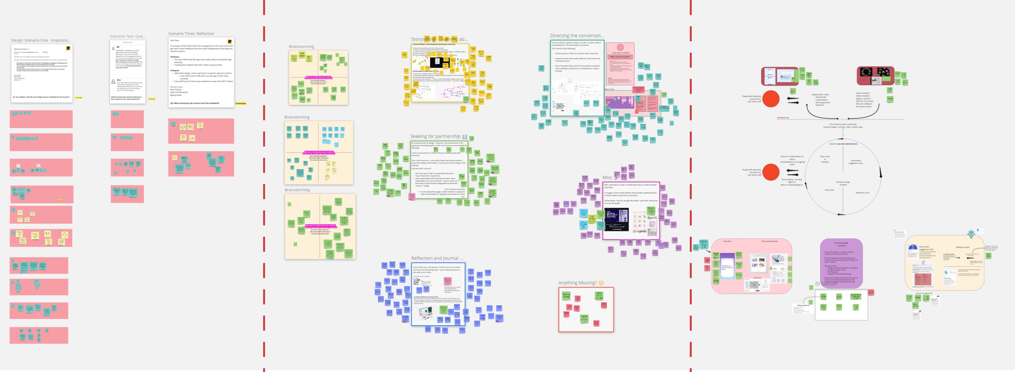

**Figure 4.2** Stage one, two, and three Miro boards (from left to right)

### Data collection

Group workshops with designers and developers and one-to-one interviews with people with dementia were split across three stages of data collection. Stage one and two focused on gathering data to incrementally develop the dementia design toolkit. For the third stage, I presented the toolkit to participants to gather feedback and critique in its roughly ‘final’ stage. Interviews were carried out over Zoom as the preferred choice for participants with dementia. For the workshops, designers and developers joined a scheduled Microsoft Teams’ meeting, with additional activities occurring on a shared online whiteboard space (a [Miro board](https://miro.com/)).

107

## Dialogical Dementia Design (D3) Toolkit

### Stage one

In the first workshop, I explored the type of resources that designers and developers use in the creation of new physical and digital artefacts. In discussing toolkits, I conducted an initial walk through of three popular examples – Tiles: IoT (Mora et al., 2017), IDEO Method Toolkit (Fraga Viera et al., 2020), and Ethical Explorer Pack (NETWORK, 2021). Participants then read and responded to design fictions about the work of newly recruited designers/developers for a bespoke care home technology company. The scenarios were intended to provoke questions around early phases of design and development, sensitive conversations within teams, and reflecting on mistakes. The workshop concluded by having a group conversation on *“what type of toolkit/resources would work for the design fiction team?”*. Interviews with people with dementia in stage one used open-ended questions and prompts to explore: 1) important topics in dementia, 2) experiences with working with designers/developers, 3) involvement of people with dementia, 4) public engagement with dementia, 5) storytelling in dementia, and 6) dissemination of dementia knowledge for learning. From the initial workshops and interviews, I began to cluster the conversations using affinity diagramming – a well-recognised early-stage design process for organising ideas and opinions into groups based on their relationship to one another (Lucero, 2015).

### Stage Two

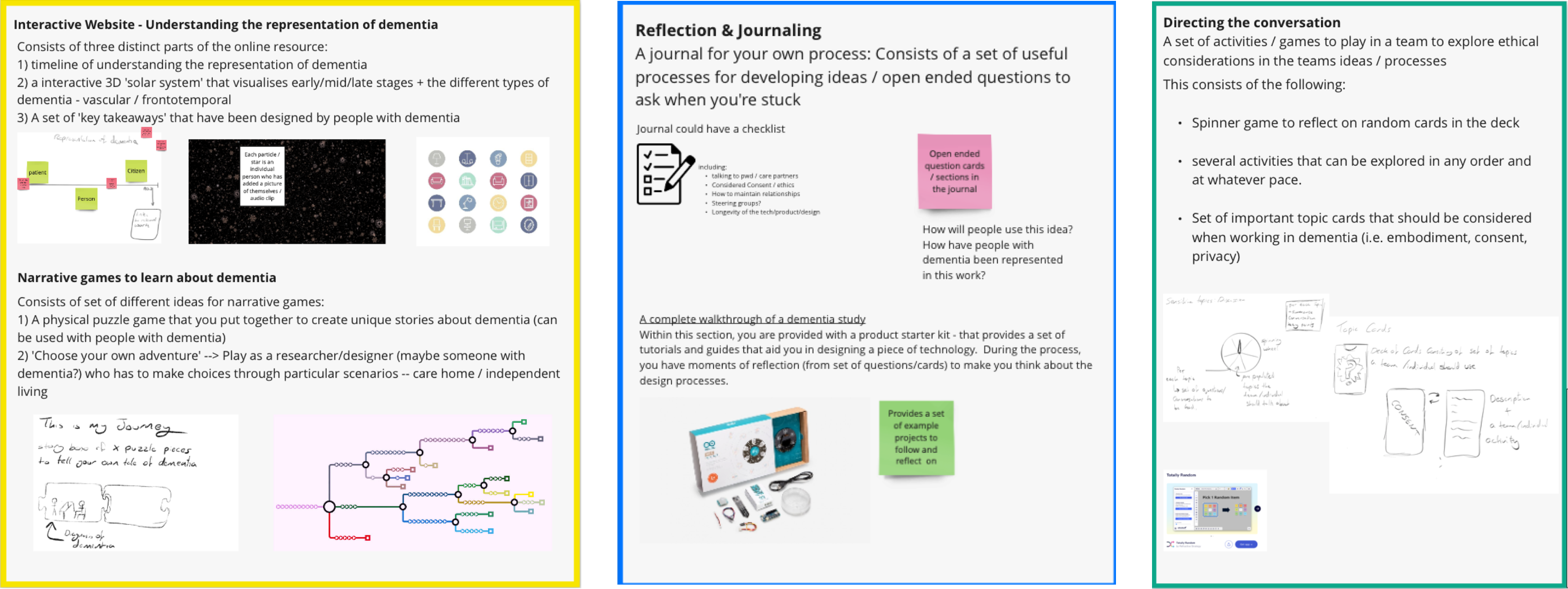

**Figure 4.3** Stage Two Category Examples: storytelling about dementia, reflection, and journaling, and directing the conversation (left-right)

In stage two, research engagements explored ten ideas which emerged via the process of affinity diagramming. The ten ideas were categorised into the following categories: 1) storytelling and learning about dementia, 2) seeking partnership, 3) reflection & journaling, 4) directing the conversation, and 5) community-driven toolkits. During the workshop and interviews, the first author walked through each category and facilitated conversations around topics, preferences, and participants’ workflows. Concerns regarding dementia representation within the toolkit and

108

## 4.3 Methodology

the involvement of people with dementia were discussed in interviews with people with dementia. Returning to our affinity diagram, I then added our stage two data to the diagram and grouped all the data into a more articulated set of design rationales, described in detail in section 4.4.

### Stage Three

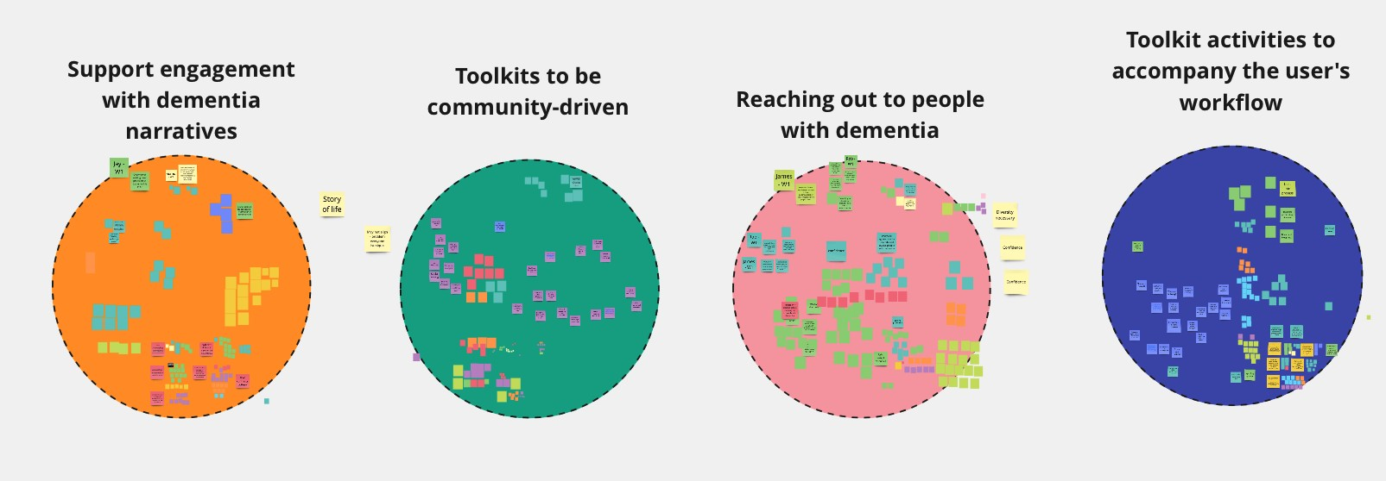

**Figure 4.4** Final Affinity Diagram for our design rationale

Finally, in stage three, I presented a prototyped (via on-screen mock-ups) toolkit consisting of resources to assist participants in the design of technologies for and with people with dementia. In this engagement, I presented the individual components of the toolkit (described in section 5) with prompts to elicit further discussion, i.e., *“what type of privacy concerns should this component consider?”*, and *“how could you see this component benefitting you in ideating new design responses?”*.

### Data and Analysis

I gathered data in the following ways: a) Microsoft Team’s built-in recording and transcription tool for workshops with designers and developers, and b) Google Pixel on-device Audio Recorder that supports offline text to speech for translation for interview with people with dementia. I then revised both the video and audio recordings’ auto-transcriptions for any misinterpretations by the auto-transcription models (Bokhove and Downey, 2018). Data collection consisted of eight designer and four developer workshops, and 11 interviews with people with dementia. Breakdown of data can be seen below in table 4.3. For signposting where quotes come from, our findings use the abbreviation seen in table 4.3.

My analytical approach followed a Thematic Analysis (TA) in line with the instructions set out by Braun and Clarke (2006, 2020). This process consists of seven steps. The first step is to prepare transcripts. Second, I familiarised themselves with the data by reading and interpreting the data while referring to the research questions. Following, I ordered the data from stage three onto a Miro Board to make sense of the similar conversations between the different groups. This

109

## Dialogical Dementia Design (D3) Toolkit

|  |  |  |  |  |
| --- | --- | --- | --- | --- |
| **Participants & abbreviation** | **Stage one** | **Stage two** | **Stage three** | **Total** |
| People with dementia interviews *(inter- view{1,2,3})* | 227 minutes | 317 minutes | 309 minutes | **853 minutes** |
| Designer workshops *(W{1,2,3} -*  *Designer)* | 170 minutes | 175 minutes | 173 minutes | **518 minutes** |
| Developer workshops *(W{1,2,3} –*  *Developer)* | 62 minutes | 123 minutes | 56 minutes | **241 minutes** |

**Table 4.3** Data Collection (audio)

helped to explore what topics resonated between the groups, and what topics were unique to the individual groups. Third, I moved onto the coding process to identify all relevant data by reviewing each quote, tagging, and highlighting anything of interest. In the fourth and fifth steps, the I organised codes into potential linking themes across the participants. By the sixth step, the I had weekly meetings with my supervisors to discuss if initial themes fit the original research questions and constructed and defined and named the themes. Finally, the seventh step is developing and writing the analysis presented in section 4.6.

## Developing a design rationale for dementia design toolkit

This section, drawing from data in stages one and two, details the results from our initial affinity diagramming process which helped to shape an early design rationale and inform initial toolkit components.

### Empathy and appreciation for a diversity of experiences

Designers and developers expressed interest in reading and listening narrative about dementia as a way of learning and contributed ideas about how a toolkit may incorporate this – for instance, Kathleen suggested a *“VR simulation of a walk through a day in the life of dementia” (W2 – Designer)*. However, Jim, who is living with dementia, argued that such a simulation may give a *“warped sense of dementia” (interview1)*. This criticism helped to decide that simulations like these may not be appropriate for our toolkit; instead, designer Sean spoke about a wish to learn about *“spectrum of dementia to know how to design for different stages” (W2 - Designer)*. This aligned with Howard (participant with dementia), who affirmed that *“everybody’s experience [of*

110

## 4.4 Developing a design rationale for dementia design toolkit

*dementia] are different” (interview1)*. Julie, also living with dementia, argued that designers and developers must be aware of the differing experiences of ‘living well’ and the often life-changing difficulties that come along with dementia. Working from this data in a process of affinity diagramming, I note the following design needs:

* + - * A way to quickly grasp the changing nature through exploring stories clustered by theme or diagnosis.
      * For stories of dementia to portray ‘living well’ as well as challenges of dementia through a range of media formats.

### Putting dementia into dialogue with design

From our workshops, participants generally believed that people with dementia should somehow be involved in the design process if they were to later become users of a design artefact. Howard argued that *"people with dementia should be involved from the very beginning [of the project]" (interview1)*, with Julie agreeing that it’s "*best way to learn about dementia" (interview1)*. However, designers and developers described *“a lack of confidence to talk to people with dementia” (W2 – Conor/Designer)*. While communicative abilities can change as dementia progresses, Julie describes being mindful that talking to people with dementia is simply *“being human. . . just be yourself. Speak to us like humans" (interview2)*. The designers and developers suggested the toolkit could provide a set of resources to *"feel reassured... and have a confidence booster" (W2 – David/Designer)* when reaching out to people with dementia. Participants suggested that these resources could be guidelines or *"prep cards" (W2 - Henry/Developer)* developed by researchers and people with dementia to help to *"normalise and provide some ‘dementia 101’ to establish the basics" (interview1 - Jim)*. Participants also raised the idea of having a database of people with dementia who are happy to be contacted about involvement in design studies. Husainah wished to *"[know] a bit of information on the person in the shared network" (W2 - Designer)*, which in turn would help to a) know if they are interested in your design artefact/process and b) help with *"starting a conversation on interests or who they are" (W2 - Designer)*. Reinforcing a general wish to learn from people with dementia, Kathleen also suggested that *"designers [could] submit questions [to the resource] that people with dementia would answer" (W2 - Designer)*, and Howard suggested *"sending videos to [dementia] groups, which would facilitate the recordings or written replies which may help to include those who can’t use technology" (Interview2)*. Again, working from this data in a process of affinity diagramming, I note the following design needs:

* + - * The sensitive and ongoing creation of resources to proactively prepare designers and developers to contact people with dementia in a way which recognizes the changing nature of dementia.

111

## Dialogical Dementia Design (D3) Toolkit

* A way for safe and comfortable dialogical interactions to be invited, and then occur, between designers, developers, and people with dementia.
* A forum or process for designers and developers to propose questions for people with dementia to answer.

### Integrating with existing workflows

Participants were curious about how creativity resources might be incorporated into their existing workflows. Kathleen indicated resources *"would be helpful during the ideation and research stage" (W1- Designer)*, while Husainah stated that resources *"should not be too restrictive" because "designers design in different ways" (W1 - Designer)*. All designers and developers generally preferred to move away from material toolkits, preferring *"apps or a website to replace physical [activities]”*. Another universal preference was for a series of checklists to provide helpful scaffolding processes or tips when designing for dementia. David said that such checklists *"make sure not to leave out the important topics" (W2 - Designer)* and provide confidence in *"knowing the checklist suggestions are guidance from experts [in the field] who know what requirements you may want to consider" (W2 - Designer)*. In the developer workshops, Henry described the difficulties of getting a team to *"reflect on and document decisions made within the team" (W1 - Developer)*. Still, he acknowledged that a set of *"blueprints"* or *"checklists"* may make it easier to *"get teams to talk about sensitive topics" (W1 – Developer)*. While critical thinking questions were well received by designers, developers Henry and Jay raised concerns that team activities are *"too time-consuming" (W2 - Developer)*, and in particular, pausing a workflow to engage in a structured card activity may be disruptive. Inspired by the data, I moved forward to try to incorporate the following design needs:

* + - * Toolkits must fit into the designer or developer’s workflow
      * Toolkit resources should aim to provide reflection and critical thinking
      * Resources must be able to be digital rather than physical (at least in this instantiation)
      * Design tools could vary across stages of the design/development process

### A collaborative and unfinalisable toolkit

Developers expressed an interest in contributing on an ongoing basis to the set of resources if it was an open-source project; and people with dementia similarly described a wish to contribute regularly, with Nigel stating that he could offer insights within such an arrangement, resulting in *“a bubble of people bouncing ideas off each other” (interview2)*. Julie’s interview supported this – she envisioned how people with dementia might highlight issues with *“technical terms,*

112

## 4.5 Dialogical Dementia Design (D3) Toolkit

*abbreviations” (interview1)* or *“alter stigma, stereotype related content”*. Howard cautioned however that such involvement of people with dementia would require significant attention to accessibility to not feel *“disempowered to engage with the material if [you] have to be assisted by others” (interview2)*. All participants supported a general view that moderation and guidance in maintaining relevant and quality content is required. Husainah argues that, although sharing resources is useful, *"custom made resources are more helpful as they are less overwhelming” (W2 – Designer)* and raises an essential concern that community shared resources can often become overwhelming and lack structure if no moderation structure is in place. Jay suggested a structure for narrowing down content with concentrated framing similar to *"Github Awesome Lists” (W2 – Developer)* (Sorhus, 2021). Additionally, blueprints for resource components, which aim to plan and scaffold content material, could offer a structured process for community contribution. Our data within this category points to the follow design priorities:

* + - * Put in place a structure which allows a toolkit to be updated by a community of designers, developers, and people with dementia
      * Design processes that scaffold and structure the creation of community-added content in order to maintain consistency through moderation and blueprints
      * Consider how such contributing processes could be made accessible and transparent to ensure the comfortable engagement of people with dementia

## Dialogical Dementia Design (D3) Toolkit

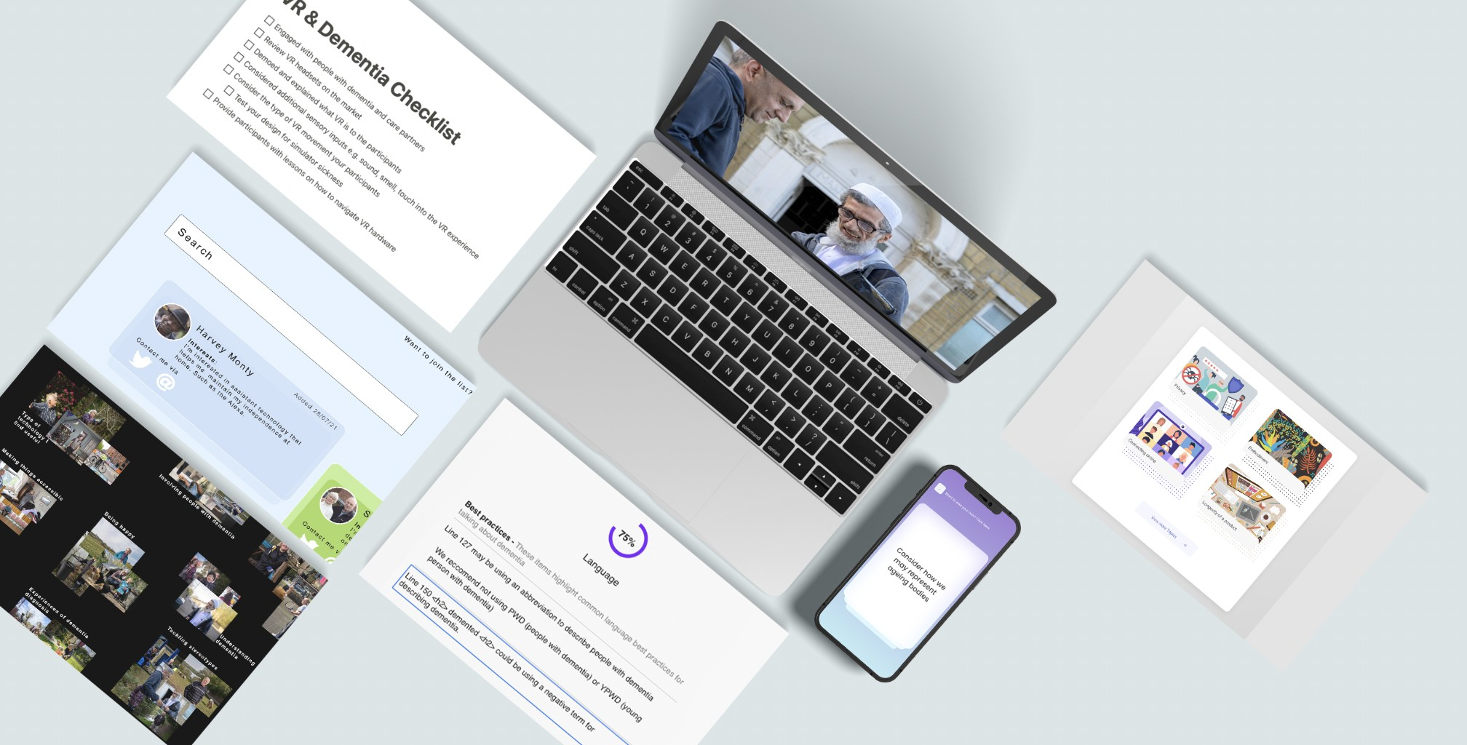

**Figure 4.5** Different components that create D3 Toolkit

Based on the data collection and affinity diagramming, I created a detailed mock-up prototype of what a dialogical dementia design toolkit may look and feel like and the processes it might

113

## Dialogical Dementia Design (D3) Toolkit

support, based on participants’ wishes and preferences. In this section, I describe the individual components of the Dialogical Dementia Design (D3) toolkit. The toolkit is a set of resources to help designers and developers in the ideation, inspiration, and implementation phases of their work with people with dementia. Furthermore, it offers several pipelines for people with dementia to contribute to the individual resources, further described in the individual component descriptions. The phases are as follows:

* **Inspiration phase**: Based on our participants’ descriptions of their work patterns, here the inspiration phase is about gaining a fuller understanding about the topic at hand. Our toolkit provides three inspiration components to assist in learning about, and reaching out to, people with dementia, while supporting organised design thought and documentation processes. These three components are:
  + **Our Shared Story** – A website for publicly-shared stories from people with dementia grouped into topics and themes to illustrate the diversity of experiences within dementia, as well as their ever-changing nature.
  + **Dementia Friends** – A web page consisting of profiles of people with dementia who are interested in research involvement.
  + **Foresight Checklist** – A shared set of community-created checklists to provide suggestions and steps for designers and developers who are navigating the complexity of technology and dementia.
* **Ideation phase**: Our resources in this phase focus on providing users with ways to generate ideas or identify design opportunities that they may initially discounted over. These components are the following:
  + **Flow Cards** – A set of quick idea cards that orient users towards often-ignored capabilities or communication modalities in dementia; these would be organised via a web-app, for designers or developers to use when they hit a creative block. For example, *“pay attention to non-verbal interactions”*.
  + **Guiding Topic Cards** – series of detailed cards focused on relevant topics in technol- ogy and co-design with people with dementia. For instance, designers and developers may need to know about legal and care frameworks for ascertaining capacity for consent; or take account of privacy requirements for designing technology with people with dementia.
* **Implementation phase**: This phase supports the later stages of artefact/system develop- ment, providing feedback and suggestions based on community-contributed ‘best prac- tices’:

114

## 4.5 Dialogical Dementia Design (D3) Toolkit

* + **Suggestive Guidance pack** – A automated tool to be run on a website or other system/artefact to provide guidance by comparing text, images, and other media to dementia best practices.

The following sections describe a breakdown of each component and how collaboration between designers, developers and people with dementia may look when using our toolkit.

### Inspiration phase Our Shared Story

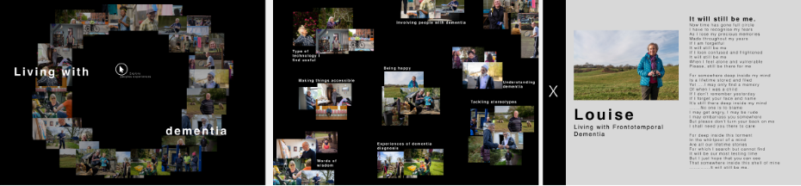

**Figure 4.6** Navigating Our Shared Story page

Our Shared Story allows people with dementia could share their diverse and often in-flux stories via audio, video, or text. Through this medium, the tool will tag and map the experiences of individual people together to support designers and developers in a) exploring diverse participants’ experiences of similar challenges or opportunities, and b) to map the trajectories of dementia to understand the different challenges people may have at different stages of the condition. Provoking insight into the changing nature of dementia, the website provides the user with suggested stories related to the previous story they were reading, which may for instance relating to topics and diagnoses; or else more granular experiences. Such a tool will allow for a variety of experiences to be expressed in their individuality (rather than aggregating them quantitatively), welcoming narratives of dementia which are focused around ‘living well’ but also allowing participants to discuss their challenges. Within this framework, participants can propose questions for other community members to answer, thus supporting the ongoing creation of new narrative threads.

### Dementia Friends

Participants expressed concern about not knowing where to start in reaching out to people with dementia, despite participants living with dementia in general welcoming engagement with designers and developers. Dementia Friends is a portal where people with dementia are asked to share their name, interest, and contact details (Twitter, Facebook, Email) via a form that connects

115

## Dialogical Dementia Design (D3) Toolkit

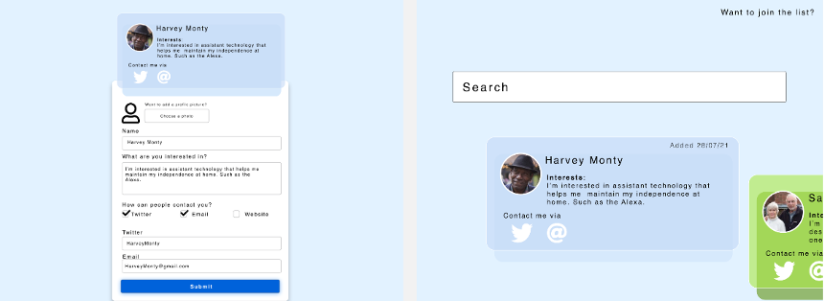

**Figure 4.7** Platform for ’Dementia Friends’

to a database. Upon submission, designers and developers will then be able to search (based on the interests) and contact the different signed-up members to find potential participants for their research. Furthermore, signed-up members are provided with yearly on-going consent check-ins to remind them of this resource, and ask if they would like to continue to be part of the database.

### Foresight Checklist

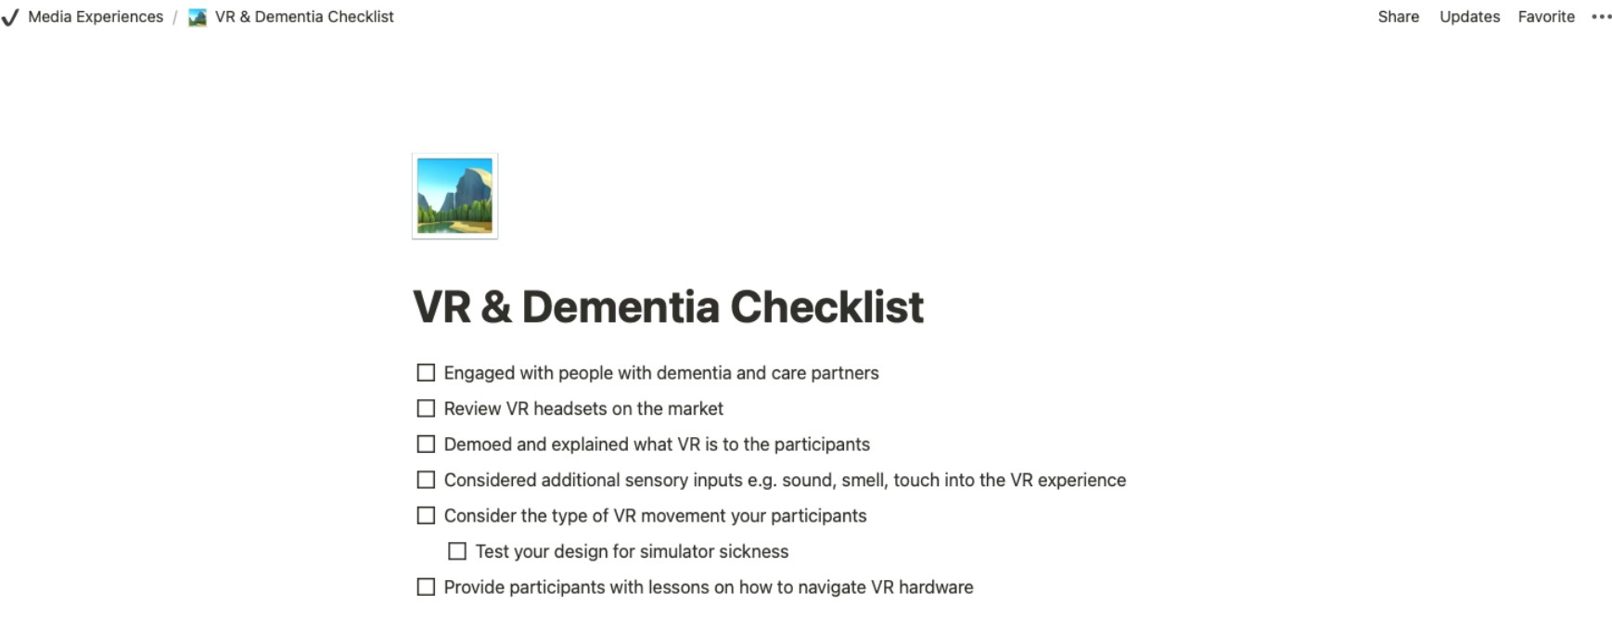

**Figure 4.8** Foresight checklist example on VR and dementia

Participants sought tools to help them ‘check’ their work to ensure it is incorporating best practice guidelines within the particular area. Within this section of the website, the public may share their suggested checklists for each new project, based on prior work. For instance, a researcher who has previously worked in VR and dementia may submit a set of suggestions that they found helpful (seen in figure 4.8).

116

## 4.5 Dialogical Dementia Design (D3) Toolkit

### Ideation phase Flow cards

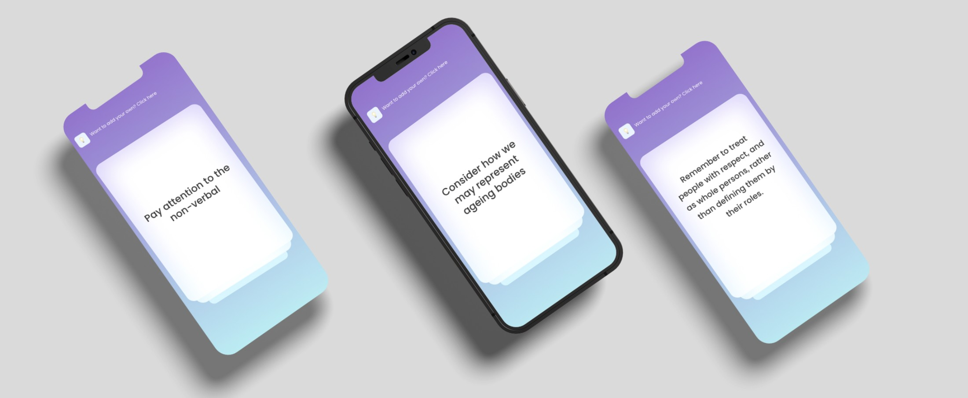

**Figure 4.9** Flow cards

Our Flow cards aim to promote creativity during a creative block in the process. As a starting point, I envision these cards as consisting of 100 questions formulated by researchers and people with dementia, such as *“pay attention to the non-verbal”*, *“explore how you can support an individual’s choice”*, and *“consider how we represent ageing bodies”*. Users will find the cards on a webapp and will swipe or tap the screen to explore the different cards that are randomly sorted. Users will also be able to offer additions to these pre-made questions.

### Guiding topic cards

Participants wanted tailored yet concise knowledge around technology and dementia provided by those with expert experience. In our toolkit, we envision this content as a set of individual topic cards that designers and developers could use to reflect on when working. For example, a guiding topic card may provide information on cognitive changes in dementia when designing interfaces or avoiding perceptual problems in dementia when creating digital assets. To maintain consistency and quality of the cards, I also envision the provision a blueprint that users must follow when creating a new topic card, which must contain:

* + - * **Information about the topic**: paragraph describing the topic in relation to dementia.
      * **Aim for / Avoid**: a set of dos and don’ts for that topic. For example, in the privacy example above: Aim for – tracking apps to be turned off by default and Avoid – hiding GPS trackers without the user’s knowledge.

117

## Dialogical Dementia Design (D3) Toolkit

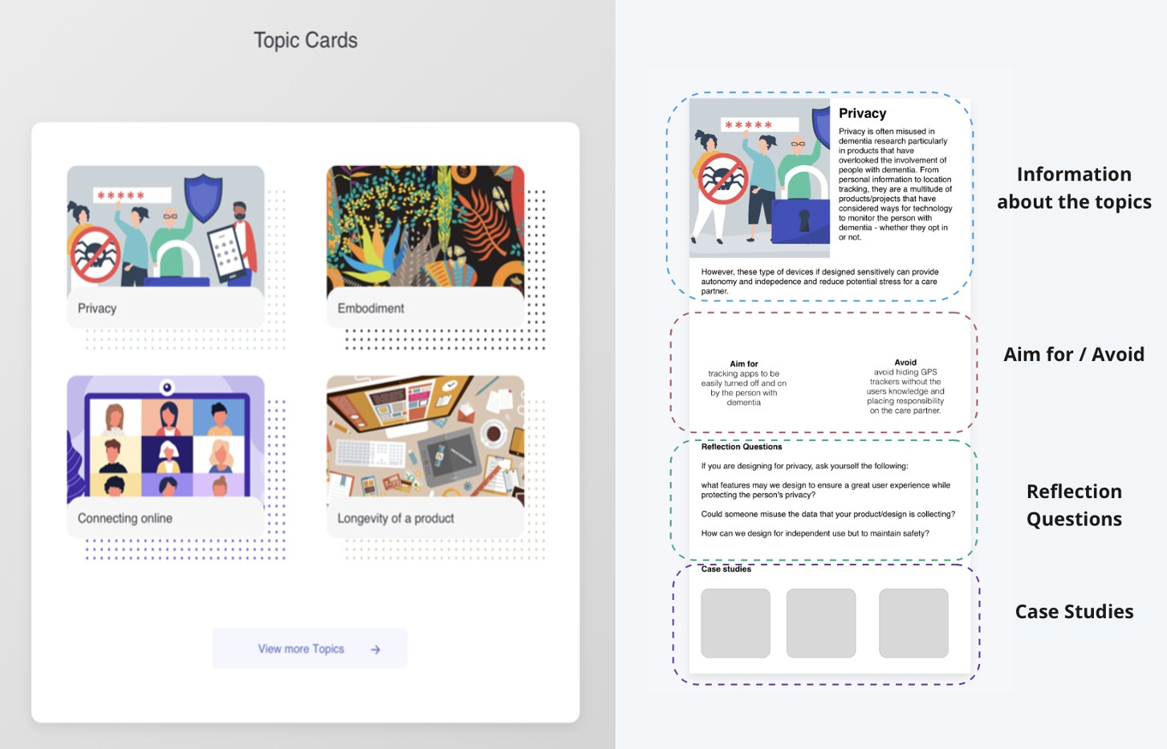

**Figure 4.10** Guiding topic cards (blueprint design on the right)

* **Reflection questions**: Questions for designers and developers to reflect upon in refining their design concepts. For instance, *“How can we design for independent use while balancing maintain safety?”*
* **Case studies**: A section for the curator to add additional links to relevant articles or projects. For example, in the perceptual problems example above, a case study may focus on non-repeating patterns in fabric and textile development.

### Implementation phase Suggestive guidance pack

As discussed above, significant discussion centred on how toolkit resources and activities might fit into participants’ workflows, and we began to think about other tools they stated they currently use, such as Google’s automated tool for improving the quality of websites, Lighthouse, which highlights the accessibility and performance of a website (Chrome, 2021). Mirroring this, I suggest a set of automated reflection tools for sensitive design. For instance, one tool included in our dementia toolkit may compares your website with ’best practices for talking about dementia’

* seen in figure 4.11. The tool will highlight negative labelling such as ’demented’ or ’sufferer’, and then suggest potential fixes and alternatives, in turn offering an opportunity for reflection for the user. The tool can also check photos through image classification which fail to live up to best practice (e.g., photos which do not show faces of people with dementia, or focus instead on

118

## 4.6 Reflections on D3 Toolkit

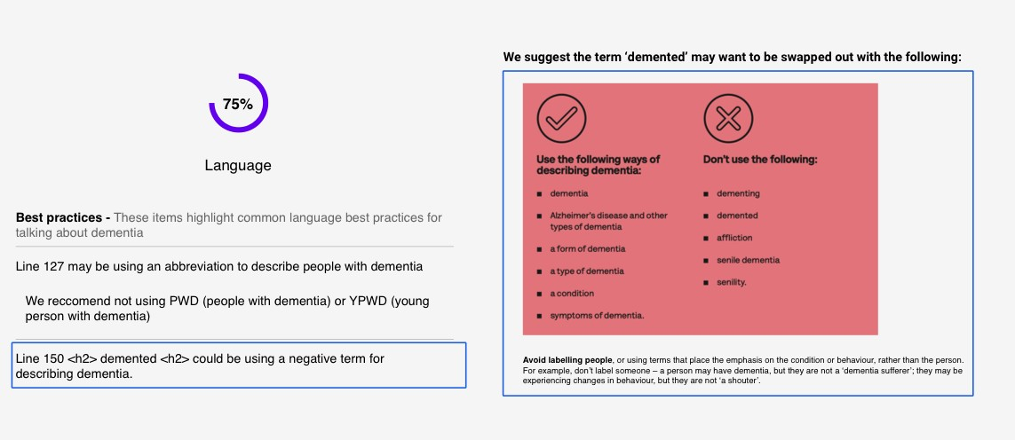

**Figure 4.11** Suggestive guidance pack to reflect on best practices

hands (Low and Purwaningrum, 2020)), and in turn can suggest age-positive libraries to replace negative stereotypical images, such as Age-positive image library by Centre for Ageing Better (Better, 2021).

## Reflections on D3 Toolkit

The previous sections describe the first two stages of the study which aimed to develop a set of design directions for a dementia design toolkit. In response to these, I developed the D3 toolkit: responding to participants’ expressed needs and wants, it emphasises critical thinking activities as well as tools to support dialogical interactions between designers/developers and people with dementia. In this section, I contribute a thematic analysis of data collected in stage three to summarise and analyse participants’ reactions to the toolkit, as well as any remaining issues. The resulting analysis outlines a) Barriers to co-creation with people with dementia, b) Sharing the designer role, and c) Incentives for sustainable participation. Taken together, these themes highlight the sociotechnical conditions required for meaningful and engaged co-creation to happen between designers/developers and people with dementia.

### Barriers to online co-creation with people with dementia

As mentioned above, part of our designed toolkit provided: a) information about dementia and best practices in designing for and with people with dementia, and b) a database or network for designers and developers to directly contact people with dementia interested in participation in design research. This development was overwhelmingly appreciated by our participants, and, commenting on the reflective topic cards component, designer Husainah reflected that the resource helped her to:

119

## Dialogical Dementia Design (D3) Toolkit

*" [make sure] I’m respectful... making sure, I’m not demeaning or rude by knowing the type of [words] I shouldn’t be saying". (W3 - Designer)*

Husainah’s concerns about starting a conversation on the wrong foot were echoed by other participants who also initially asked, *"what should I bring up in a conversation, or how do I word something in a way that doesn’t assume they are capable or unable to do something" (W2 - Conor/Designer)*. Here, Conor’s concerns centre around the importance of getting to know your conversation partner, as well as the difficulties inherent to doing this in dementia.

However, while the addition of features like interest lists in our **Dementia Friends compo- nent** was positively received (including by those with dementia - Jim saw it as a way to help *"nudge, or offer a suggestion to the designer" (Interview3)*), our suggestion of creating a database of the contact information of people with dementia raised several concerns regarding safety and privacy. For instance, Jim questioned if *"people would feel vulnerable putting their email address [on the database]" (Interview3)*; this was further highlighted by Howard, who worried that scammers or other bad actors may go *"to the website, and look for the vulnerable" (Interview3)*. While I intended to connect people with dementia directly to developers and designers to offset the challenges brought about by gatekeeping, it became clear that further attention on users’ safety is necessitated. Nigel argues for gatekeeping - *"when you are giving access to people who are ’vulnerable’, you have to gatekeep to some extent" (Interview3)*. In suggesting changes, Nigel shared his experiences with other organisations where contact access is *"held by one individual. If I need someone’s email, that individual will make the connection between me and the person" (Interview3)*. Alternatively, Kathleen suggested that *"researchers or designers post what they are doing" (W3 – Designer)* on the platform to garner interest, and another participant suggested making designers/developers *"go through a verification process...to weed out the bad actors" (W3 – Jay/Developer)*. Placing the onus of verification on the company, or designer/developer, would reduce complexity and danger for the person with dementia, who can either reach out themselves or be reached by trusted/verified users, or, at the very least, those who are accountable for their actions.

Furthermore, from our interviews, people with dementia noted the importance of ongoing, or process, consent. Masood reflected that, *"with this dementia, it’s a gradual process of change" (Interview3)*; participants felt that this change that in turn should be mirrored in the consent phase. James noted that having a *"continuous opt-in/out basis means [the person with dementia] can consult their involvement with friends, care partners" (W3 - Developer)* and if necessary *"nominate a family member or friend to be their point of contact" (W3 – Husainah/Designer)*. Howard suggested the toolkit might send out yearly *"renewing consent emails”* that *"remind the person what they signed up for, and if they wish to continue to be part of the [toolkit website] for the next 12 months" (Interview3)*. In this way, the involvement of people with dementia and the continued engagement can be respected through providing supported decision-making.

120

## 4.6 Reflections on D3 Toolkit

In this theme, I described a few challenges that may occur in online co-creation between developers/designers and people with dementia. Several participants felt uncertain regarding what to say to someone with dementia, and worried about using outdated or demeaning terminology. However, stemming from this, participants raised concerns surround the privacy of personal data, and complexities regarding ongoing consent. With this in mind, the extent to how we can support safe but meaningful interactions in future toolkits warrants further consideration. Relatedly, in our next theme, I discuss the varying accountabilities that stakeholders may held to when contributing and collaborating with such a toolkit.

### Sharing the designer role

The **Our Shared Story** toolkit component aims to provide designers/developers with real-life dementia narratives in order to help them learn about people’s experiences in a context that also emphasises understanding the changing nature of dementia as well as the diversity of experiences within. Within this component, people with dementia share their lived experiences through different media formats, which are then tagged and grouped together for ease of navigation and exploration. Masood felt that this component supported an essential part of the learning process for designers and developers as *"one of the biggest issues is that people with dementia are not listened to" (Interview3)*.

Interestingly, however, a recurring request in the final workshop was to know more about assistive technologies. For instance, Jay mentioned that it would be helpful to know "*what type of technologies" people with dementia already used to "support aspects of their dementia" (W3*

*- Developer)*. Similarly, Nigel expressed an interest in knowing *"what technologies are on the market" (Interview3)*. This reflects a duality where on one hand, people with dementia want to know the kind of technologies that may help them, and on the other, designers/developers are curious about what people with dementia are currently using. This prompted some consideration around creating and providing a curated list of assistive technologies; however, it was also an opportunity to consider the type of DIY solutions that people with dementia have crafted to meet their needs. In the workshop, we discussed how this could occur alongside inviting designers and developers to provide additional knowledge and other hacks or products that could viably solve the issue the person with dementia is tackling. For example, Nigel ensures the safety of himself through linking to his stepbrother by using an *“app that is attached to my front door. . . if I don’t lock my door at 10:30, my step-brother gets an email” (Interview3)*. Jim also highlighted that, while he has not made many creative solutions for his everyday challenges, he does describe having a *“microwave set-up” whenever “[his] wife is not around and is uncomfortable using the stove” (Interview3)*. These examples see participants sharing solutions that are far from ‘dementia products’ but provide them with an easier way to live a comfortable and independent life.

121

## Dialogical Dementia Design (D3) Toolkit

Participants also discussed accountability for components of the toolkit across the several workshops and interviews. For those living with dementia, it was apparent that they felt a duty or importance in providing their unique stories to the **Our Shared Story** component and to contribute to informational content. For instance, Howard described that *"while the* ***Flow Cards*** *component isn’t something [he’d] use, asking [those with] lived experience to see [if the cards] are still relevant" (interview3)* is a way to involve people with dementia in the design process of the toolkit. Howard went on further to suggest, *"if you have 100 questions, and have 20 people [with dementia] signed up to the website, every year or so, you could send each one five prompts to see if they think it is still relevant" (interview3*). Henry described ways of people with dementia being involved in the **Suggestive Guidance Pack** by editing *“an external library or documentation” (W3 – Developer)* that then is referenced through the front-end of the tool when highlighting best practice errors. Furthermore, James suggests that, by allowing the community to contribute to the resources, *"the [toolkit] may grow organically based on feedback" (W3 - Developer)*.

However, while people with dementia emphasised their wish to represent themselves and to add content, Jim reiterated that designers/developers and *“. . . organisations should be accountable” (Interview3)* beyond simply using the toolkit – they should indeed be actively reflecting and taking a critical approach to their design work. However, to ensure designers and developers are free to approach their work in this way, toolkit components must first fit into the user’s workflow. This will help to make sure that processes *"don’t take any more time up - when I don’t have time for the work I already do" (W3 – Henry/Developer)*. Participants with dementia also indicated that toolkit components should offer provocations that challenge potential preconceptions of design/development teams. For instance, David found the **Suggestive Guidance Pack** component to be an opportunity to make sure a group or *"team, are on the same page... where people may slip up on words that they shouldn’t use" (W3 - Designer)*. At the same time, Husainah explained the tool would help where *"developers and designers don’t necessarily come across all the do’s and don’ts of these sort of sensitive topics"* and by *"telling [the user] the problem, and providing a solution" (W3 - Designer)*. Nigel further echoed support for these tools as he found it would be a helpful learning tool for people *"to get use to the correct taxonomy when they are talking to people with dementia" (Interview3)*.

Finally, Sean suggested if tools that highlight scores based on best practice could be used to *"restrict websites to be put up online if they didn’t hit the score mark" (W3 - Designer)*. While this would not be possible, it mirrors Jim’s suggestion for *"inclusive or dementia-friendly website stamps" (Interview3)* that could be awarded to websites achieving best practice in dementia representation. Similarly, in the developer workshop, Henry suggested that organisations might use the **Foresight Checklist** as a set of checks for a given feature where *“the [developer] has to get like ‘75%’ [pass rate] otherwise they can’t push [the code to the main branch]”. (W3 – Developer)*. Henry’s suggestion here mirrors Sean’s to begin to uncover a shared responsibility regarding ill-prepared features.

122

## Reflections on D3 Toolkit

I have presented the dialogical debate surrounding accountability in ethical design decisions and implementation. For instance, while people with dementia may play a significant role in structuring and formatting content about dementia within the toolkit, developers/designers and organisations have a responsibility to take accountability for the type of products and media they may publish within this domain. Our final theme describes the type of incentives that people with dementia and designers/developers may require for continued collaborating and co-creation of a toolkit.

### Incentives for sustainable participation

People with dementia involved in this study expressed a desire to be acknowledged for their contribution to design work. Discussing his previous experiences with academic institutions and organisations, Masood stated:

*"Sometimes you feel like guinea pigs, and at the end of the day, the [organisation/researcher] are saying we have this research and here’s what we have found... but we haven’t been appreci- ated for the time we spent with them". (Interview3)*

In this interview, Masood emphasised this acknowledgement is not simply about compen- sation through payment. While compensation can be an incentive to take part, the participants with dementia in this study, at the very least, told us that they share their stories and advocate to *"dispel stigma” (Nigel – Interview3)* and to *“raise awareness" (Jim – Interview3)*. While the advocates said this is not about payment, being *“acknowledged for your work goes a long way” (Masood - Interview3)*.

Returning to payment through incentive, typically in research, researchers will often pay participants vouchers for their time (Hodge et al., 2020). However, since this toolkit is imagined to be a growing ecosystem supported by public engagement, payment through vouchers may not be possible. In considering this problem, during a conversation about Dementia Friends component, Jay suggested how businesses could pay a monthly fee to support the toolkit and usage to then:

*"be able to pay the people they were contacting... that way [people with dementia] are being paid for their time and ideas. So they should be reimbursed as you would in research projects." (W3 - Developer)*

By placing the emphasis on companies or organisation in funding the toolkit, this suggestion may help to incentivise participation by collaborators’ receiving a fee which acknowledges their engagement as co-researchers and co-designers. For Jim, this framing of telling a story in order to turn it into an actionable item that could be ‘worked on’ was key: *"I see no incentive to just share my story about my day for the sake of it... If I’m going to share my story, It needs to*

123

## Dialogical Dementia Design (D3) Toolkit

*be framed around ’tell me about your day, and how do you make it work for you... maybe we ([designers]) can help you". (Interview3)*

Here, Jim is describing a trade-off: the opportunity to potentially attain a solution or new knowledge that may help make his life more comfortable. His description indicates that dialogical nature of co-designing: designers/developers may provide a solution, or at the very least, a response – while the person with dementia is offering time and experience of their diagnosis.

Designers and developers located their interest in the toolkit as being rooted in *"under- stand[ing] what [people with dementia] are going through so I [do not] make assumptions (W3 – Kathleen/Designer)* and *"reflect[ing] on areas of dementia I may not have considered" (W3 – David/Designer)*. However, several participants wanted to contribute because their skillset could help others. Husainah suggested that some designers might freely *"give their time and expertise to help find solutions" to quickly provide a more effective solution, as long as it’s constrained to "a small weekend project" or "providing information about a product that already helps with that issue" (W3 - Designer).*

However, other participants’ experiences indicate this may not be possible. Henry confessed that he knew he *"should be more reflective in [his] work"*, but this becomes a lower priority when *"trying to get the job done in time" (W3 – Developer)*. Similarly, James notes barriers present in carrying out such reflective work while in private sector employment as *"they’re going to over budget, or miss deadlines" (W3 – Developer)*. These examples highlight the different, often competing priorities that occur when considering how community-owned resources might continue to grow in a generative but appropriate way.

In summary, our analysis describes three themes that begin to indicate the remaining work that must be done in seeking to design for and with people with dementia. In our discussion, I draw these themes together with extant literature to begin to draw directions for future community- focused dementia and design work.

## Discussion

Our development of the D3 toolkit and further user-focused analysis of the same has presented us both with hope that such a tool or process may be useful, as well as barriers we may likely encounter in facilitating a shared workspace for different communities. I have explored differing incentives between designers/developers and people with dementia, and drawn attention to how we might accommodate their competing priorities, as well as comparing participants’ ways of responsibly engaging with and using the toolkit components. Finally, workshop discussions highlight important considerations for supporting safe but meaningful interactions in future toolkits in similar but not identical contexts. I now turn in our discussion to reflect on three future directions for HCI work, considered against a background of existing literature on re-

124

## Discussion

sponsible design, representation of people with dementia online, and incentives and priorities in contributing to a community-owned toolkit.

### Future directions for co-design toolkits between designers, developers, and people with dementia

***Learning responsible design through our toolkit***

As mentioned in my findings, several participants described how toolkit components might provide reflections and potential hurdles that they might encounter when designing with/for people with dementia. For instance, the **Foresight Checklist** component was well received as designers/developers felt a published checklist from prior research could offer a responsible and considerate, as well as evidence-based, approach. This echoes work by Gray et al, who describe the value in encouraging designers to share and reflect on failures and constraints of their prior work:

*“Rigorously presented design precedent with its rich retelling of the design process, breaks down stereotypically mechanistic views of design processes and encourages designers to actively talk about their work (**Boling and Gray**,* *2015**;* *Smith**,* *2010**). Without robust investments in sharing design precedent within a field, designs are easily disconnected from their designers and the design processes that led to them (or forgotten altogether), and the social effects of those designs can easily become disassociated from the designer, or ignored entirely.” (pg. 993) (**Gray and Boling**,* *2016**)*

By expanding our **Foresight Checklist** further, we could provide the means for researchers to document their designs (and share this documentation) more thoroughly, thereby collectively learning from challenges or mistakes made within our work. In a similar manner, research such as Vines et al., has described the ethical complexities and challenges made within a study of using Google Glass with people with Parkinson’s (Vines et al., 2017), presenting an honest account of decisions made which later turned out to harm their participants. Similar writing on emotion work in experience-centred design (Balaam et al., 2019) makes visible the ‘messy’ emotion work of design researchers working actively in marginalised settings. By presenting our mistakes, difficulties, and successes to the communities we work in, we can begin to understand our design and development practice better by ensuring we are responsible for not making the same mistakes that other designer/developers have done in the past. Such a process may also help make clear to our participants the emotional labour undertaken by researchers who seek to intervene in such contexts.

125

## Dialogical Dementia Design (D3) Toolkit

Through our study, toolkit components have been designed to support reflection and critical thinking about dementia, rather than lapsing into tired societal stereotypes. While designing toolkits to fit a user’s workflow was a significant consideration, designers’ and developers’ accountability in using those resources also needs additional attention. Frauenberger et al. propose a series of guides for designers where accountability through internal reflection, critique and through debate with other members of the team (Frauenberger et al., 2015). However, in my findings, developers James and Henry raise concerns about the incentives (or disincentives) that designers/developers and organisations have in allowing sufficient time and space in designing an ethical and sensitive product. One approach discussed in our workshops, is making accessibility and inclusivity standards visible in our products. For instance, allowing the public to use the Suggestive Guidance Pack to review websites and products online will make accountability more transparent and put pressure on organisations to adopt best practice. This mirrors the current work in Explainable AI where researchers have emphasised the need for interactive explanations for user to explore the behaviour of the AI system and understand its capabilities (Abdul et al., 2018).

Furthermore, Providing ease in interpretation and providing the potential of the public to highlight poor practice resembles the work of Puussar et al. in providing non-professionals with accessible data tools (Puussaar et al., 2018b). The provision of context-rich, easily-interpretable workspaces like this may help to enrich the dialogical encounters between designers, develop- ers, people with dementia and the public. To strengthen public awareness and accountability, **researchers should therefore continue to examine technical and no-technical approaches required for developers/designers to internalise and support societal change through the products and knowledge they publish and produce they engage in**.

### Balancing privacy, safety, and recognition

It is apparent from the above work that additional considerations for our D3 toolkit design must centre on understanding how we balance participants’ safety and privacy while still recognising people with dementia’s contribution to the work. Within our analysis, people with dementia described sometimes feeling a lack of appreciation and recognition for their contribution, as well as fears around what contributing online may bring for their own safety. In Johnson et al.’s recent analysis of an online forum for people with dementia, authors describe a series of challenges individuals may face when engaging online – for instance, posts that take advantage of their vulnerability through promoting the *"buy[ing] [of] questionable products or otherwise place people with dementia at risk"* (pg. 127) (Johnson et al., 2020). These challenges heighten hesitancy in older adults (in general), and people with dementia (in particular) in adopting online technologies. It adds to pressure to hide a diagnosis, ultimately meaning that people with dementia may not want to share their vulnerabilities and challenges. The hesitancy for adopting technology is similarly seen where safety is placed over autonomy. While safety is a priority,

126

## Discussion

Quan-Haase and Ho describe older adult participants’ strategy towards safety was for complete avoidance of platforms altogether in fear of: “I don’t want anybody having my information ‘cause I don’t feel everything is so secure” (pg. 1095) (Quan-Haase and Ho, 2020).

One ‘safer’ approach to ensuring the safety of people with dementia’s online contributions is suggested by Lazar and Dixon. They state that *“the role of the moderator [is] essential to ensuring a sense of safety and trust in the platform” (pg. 85:9)* (Lazar and Dixon, 2019). As our toolkit is envisioned as a community-led project, volunteer moderators may be integral in pro- viding trust, curation and continued engagement between designers/developers and people with dementia. Moderators can become a personally empowering and beneficial way of supporting group members, however, in our toolkit, this may at least initially require moderation of diverse experts with backgrounds in design, development and dementia; or a concerted effort to upskill a wider community in the same. There is precedence for such an arrangement: Kendall et al. suggests having steering committees containing various stakeholders who then organise, guide and structure interactions within a website (Kendall et al., 2008). Coulson and Shaw describe the importance of understanding the skills and necessary resources in effectively undertaking a moderation role (Coulson and Shaw, 2013). Drawing from this literature, I expect that such an envisioned future may require training and developing long-term relationships between a group of developers, designers, and people with dementia in order to recognise the necessary shared work of collaborating online on design research support.

Future toolkits and resources that emphasise the voices of people with dementia must de- sign for a nuanced and often progressive non-linear condition. Rather than see safety and privacy as limitations for people with dementia’s involvement, **we must investigate how we may better support decision-making online through ongoing consent, support interdepen- dent relationships, and identify what privacy means to people with dementia**. Instead of restricting the sharing of identifiable information that many people online willingly share, we should determine what type of instructions, education, or infrastructure may be required for the person with dementia to represent themselves online.

### Priorities in growing a community-owned toolkit

Through our design of D3 Toolkit, I emphasised how designers/developers and people with dementia might contribute and continue to grow the toolkit once it is made available. In contrast, previous toolkits have often been designed for a particular use and remain static in content (although some recent examples provide the ability to update text content, or offer templates for inventing your own deck of cards (Garcia-Lopez et al., 2019; Mora et al., 2017)). In addition, Biskjaer et al. describes how particularly valuable design process interactions are generated when designers and developers *“design the design process”* (Mose Biskjaer et al., 2017) themselves - this provides more tailored processes that fit their workflows. At the same time, this may provide

127

## Dialogical Dementia Design (D3) Toolkit

challenges where other designers or developers just starting in the field find it difficult to adapt the process into their own design process. To provide future community-owned toolkits where designers/developers provide such tailored components, we should consider how we in turn scaffold a process for people to search through, and trial, the various tools to understand the offerings. This may aid their selection of appropriate toolkit components (Lee and Singh, 2021). Here there may be an interesting opportunity for intelligent tools to guide and develop bespoke configurations of a toolkit with multiple components - helping users to create tailor-made, adaptable processes that fit their needs.

In a similar fashion, one challenge raised by several participants was trusting the content that the community has curated. Husainah, in the second design workshop, described seeking out *"custom made resources help as they are less overwhelming and are designed by experts."* While that may be the case, such online co-creation raises similar challenges to, for instance, Wikipedia, where user-generated content is regularly questioned for its accuracy and reliability (Kittur et al., 2008). One approach researchers have suggested is to provide users with transparency regarding the history of online contributors (Heuer and Breiter, 2018). Although this may produce an overall trust in the content that has been provided, openly sharing a list of contributors with dementia may present similar challenges of privacy and security that I have described in our previous sections. One other option is to gain external credibility through the involvement of key experts from dementia groups that concurrently exist – indeed, I worked with one for this study. Furthermore, involving people with dementia as drivers of content calls attention to how they can meaningfully contribute to the toolkit in ways which suit multiple communication styles and needs that may be in-flux within a changing condition.

While our findings have discussed use of Github Awesome Lists for shared resources, Github may not be the appropriate platform for involving people with dementia. Prior work has highlighted the engagement through posting on forums (Johnson et al., 2019; Lazar et al., 2017b); in this way, providing input mechanisms that allow people with dementia to curate parts of the website through already-used platforms – for instance, publishing a post on Facebook or Twitter (Talbot et al., 2020) – may support the ‘flow’ of the toolkit into the day-to-day online interactions of people with dementia. Moreover, echoing Howard’s suggestion to reach out to dementia networks to involve those who lack access to technology, future work should seek to find ways to involve the voices and involvement of people with dementia who are further marginalized by digital divides (Harrington, 2020).

Finally, as researchers, **we should consider how people’s incentives and priorities in contributing to a community-led toolkit work to best allow collaboration between differing communities**. Borges and Nóbrega highlight how individuals’ incentive to contribute to Wiki could be raised by augmenting a user’s reputation – i.e., rewarding contribution via user scores and being awarded more responsibility within the community platform (Borges and da Nóbrega, 2008). Alternatively, incentive could be provided by emphasising the common purpose, and

128

## Chapter summary

meaningful benefits of sharing and contributing to the community-owned toolkit. For instance, Colusso et al. describes the importance of research being translated into important and digestible content for practitioners to improve their designs. Through this work, the authors describe a series of innovative tools to promote dialogue via ‘Ask Me Anything’ sessions on Reddit, or providing automated bots to make community members aware of academic research (Colusso et al., 2017). In these instances, incentive is driven by learning more about an area and to promote the potential collaboration between different members of communities. Once relationships have formed, and there is a mutual understanding of what one another can offer, there is considerable design space for mutuality in the co-creation of new technologies and systems.

### Limitations of the work

It is worthwhile to highlight the limitations of this study. Within my participant recruitment, all designers are either current design students or recent graduates, though all have at least one year of real-world design experience through paid placement. The potential impacts of this limitation may have contributed to slight inaccuracies in the type of workflow expectations that designers may engage in over time. For future work, I suggest exploring the provision of toolkits within longitudinal studies of designers’ practices. Finally, the study took place during COVID-19, and in-person participation was not possible for fear of spreading COVID. While video calling platforms have become important in connecting people together, there are those excluded by either not having access to technology or who cannot engage virtually (Masoud et al., 2021). With this in mind, this study does not fully represent those at later stages of dementia, particularly those without the ability to contribute online. However, as we return to in-person meetings and meet-ups, researchers should question how we may involve those marginalised further by COVID, and how we may better support their involvement in the near future (Braybrooke et al., 2021).

## Chapter summary

In this chapter, I have presented the design of the Dialogical Dementia Design (D3) toolkit, a set of resources to support co-designing with people with dementia. The process consisted of three phases, phase one and two consisted of initial exploration of resources needed by developers and designers when designing with people with dementia, as well as investigating how people with dementia may support the toolkit; and phase three consisted of reviewing the design of the D3 toolkit that responds to the design rationale developed by the stage one and two data. This toolkit comprised several components that offered opportunities to learn and engage in sensitive ways with people with dementia. Analysis of participant reactions to the designed prototype raises questions around the challenges of co-creation through safety and privacy, the sharing of the ‘designer’ role between the different stakeholders, and finally, the type of incentives required for

129

## Dialogical Dementia Design (D3) Toolkit

participation and engagement in curating a toolkit. Against a background of extant literature on dementia and collaboration, our discussion provides a series of directions for HCI and dementia research, highlighting how we might balance participants’ privacy, safety, and due recognition; priorities in growing a community-owned toolkit; and the accountability and responsibility that designers and developers carry in adapting their working practices for designing within sensitive areas.

In the following chapter, I bring together all the studies undertaken in this thesis into a closing discussion, where I synthesise the findings in line with the research aim and questions. The discussion describes the role of participation in dementia and HCI, where collaboration must be broadened to consider stakeholders who may support technology decision-making, such as designers and developers. The chapter’s contribution highlights future work on involving people with dementia in the entirety of research, supporting collaboration between diverse groups, and disseminating knowledge on inclusive research and design practices.

130

# Appendix A. Documents

## Information Sheets

## Consent Sheets

* Probably don’t need exmaples of each consent / information sheet from each studies. Probably just take the one I used for the media experiences project?

## Thematic Analysis Example

* Take this from NVivo - print out the codebook

## DemVR Schedule

DemVR schedule - of the two days

## DemVR Recruitment Advertisement

* the different advertisement we used / flyers / posters / website

## Ethics Semi-structured interview

The following questions were used for the 22 interviews with HCI researchers seen in chapter 3.

## What work have you done in a dementia context?

* + - 1. Can you elaborate on our expertise and experience?

## What do you think about the role of the individual researcher vs. the institutional responses to protecting researchers

131

## Documents

1. Can you tell me a bit about your interactions with ethical review processes at your institution?
2. Do you think that they are effective at protecting participants? Researchers?
3. How do you think they change when you talk about technology as being a part of your work?

## How do you think implementing technology into technology has added to the ethical complexities of working with people living with dementia?

* + - 1. Do you think that seeking to innovate technologically has made working with people with dementia more ethically complex? If so, how?
      2. How do you think such work is perceived by the media? The larger research commu- nity?
      3. Do you think people with dementia and their carers/families want technology in their lives?

## Have you felt a power imbalance of sorts between you as the researcher or significant role changes between the carer and the person with dementia?

* + - 1. Can you tell me a bit about the sorts of relationships you’ve had in dementia contexts?
      2. (if there are many) What do you feel was the most interesting or striking relationship?
      3. In particular, I’m interested in a sense of power balance or imbalance, or instances where your role changed.

## Have you had instances where you’ve become part of a community/friends with your participants? Do you feel there is a line? Are the steps you’d suggest to other re- searchers to follow or have in the back of their heads?

* + - 1. Have you had instances where you’ve become part of a community or friends with your participants?
      2. Do you feel there is a line that should or shouldn’t be crossed?
      3. Are the steps you’d suggest to other researchers to follow or have in the back of their heads if this is something that’s happening for them?

## How can we make sure our efforts have longevity?

* + - 1. Do you feel like your research, or HCI research into dementia in general, has longevity?
      2. What are some ways we can extend our longevity?
      3. Are there instances where longevity isn’t as important as we might think?

## Questioning reliability of technology vs short and fast iteration of technology

132

## A.7 Affinity Diagramming

* + - 1. How highly do you value the reliability of the technologies you create?
      2. Do you feel like agile design environments or processes are suitable to the creation of technologies for people with dementia?
      3. Can you describe some of the design processes you’ve undertaken with people with dementia in the past, from a methods point of view?

## Designing for an exit strategy. It needs to be more than just a debrief document.

* + - 1. Negotiating a process of leaving can be difficult when you’ve come to form attach- ments to your participants. Can you tell me a bit about how you’ve left research contexts in the past?
      2. What about leaving technologies or designs behind? What sort of responsibilities do we have then?

## Anonymisation is a key premise of how we conduct ethical research to protect the privacy and integrity of those we’re working with. While we typically default to this, do you think thats a good idea? Are we hindering acknowledgment of those we’re working with and not crediting their creative and intellectual work.

* + - 1. How do you feel about anonymisation in design research with dementia?
      2. Is it always a good thing, or is it more ethical to identify participants’ achievements and labour?
      3. What would an updated best practice look like here?

## How useful are examination boards? How much do they know about the research they are overseeing and do they see the clear benefits of the research we’re doing?

* + - 1. Can you tell me about your experiences with ethical review boards?
      2. How much do you feel they know about the research they are passing judgement on?
      3. Do they always see the benefits of our research?
      4. When we are working in an ethically dynamic environment to what extent are ethical review boards aware of the changing environment or restrict ground breaking research in this area?

## At what point should we publish? Should we place quality over quantity in publica- tions? How can we challenge the problems of expectations from participants from previous work?

* 1. **Affinity Diagramming**
* Miro images of the affinity diagramming in the toolkit paper

133

## Documents

## Workshop materials

* Pull in images of the different workout materials from the workshops I made

134

# References

, A. (2019). Criteria for Authorship.

Abdul, A., Vermeulen, J., Wang, D., Lim, B. Y., and Kankanhalli, M. (2018). Trends and trajectories for explainable, accountable and intelligible systems: An hci research agenda. In *Proceedings of the 2018 CHI conference on human factors in computing systems*, pages 1–18.

Abu-Lughod, L. (1990). Can There Be A Feminist Ethnography? *Women & Per- formance: a journal of feminist theory*, 5(1):7–27. Publisher: Routledge _eprint: https://doi.org/10.1080/07407709008571138.

Akindes, F. Y. (2001). Pahala’s last (bon) dance: The dead are not dead. *Qualitative inquiry*, 7(1):21–34. Publisher: Sage Publications Sage CA: Thousand Oaks, CA.

Alger, M. (2015). Visual design methods for virtual reality. *Ravensbourne.* [*http://aperturesciencellc.*](http://aperturesciencellc/) *com/vr/VisualDesignMethodsforVR_MikeAlger. pdf*.

Alshehri, T., Kirkham, R., and Olivier, P. (2020). Scenario co-creation cards: A culturally sensitive tool for eliciting values. In *Proceedings of the 2020 CHI Conference on Human Factors in Computing Systems*, pages 1–14.

Amabile, T. M., Goldfarb, P., and Brackfleld, S. C. (1990). Social influences on creativity: Evaluation, coaction, and surveillance. *Creativity Research Journal*, 3(1):6–21. Publisher: Routledge _eprint: https://doi.org/10.1080/10400419009534330.

Asad, M. and Le Dantec, C. A. (2017). Tap the "Make This Public" Button: A Design-Based Inquiry into Issue Advocacy and Digital Civics. In *Proceedings of the 2017 CHI Conference on Human Factors in Computing Systems*, CHI ’17, pages 6304–6316, New York, NY, USA. Association for Computing Machinery.

Astell, A., Smith, S., and Joddrell, P. (2019). *Using Technology in Dementia Care: A Guide to Technology Solutions for Everyday Living*. Jessica Kingsley Publishers. Google-Books-ID: qaqFDwAAQBAJ.

Astell, A. J., Ellis, M. P., Alm, N., Dye, R., and Gowans, G. (2010). Stimulating people with dementia to reminisce using personal and generic photographs. *International Journal of Computers in Healthcare*, 1(2):177.

Balaam, M., Comber, R., Clarke, R. E., Windlin, C., Ståhl, A., Höök, K., and Fitzpatrick, G. (2019). Emotion Work in Experience-Centered Design. In *Proceedings of the 2019 CHI Conference on Human Factors in Computing Systems*, CHI ’19, pages 602:1–602:12, New York, NY, USA. ACM. event-place: Glasgow, Scotland Uk.

Balaam, M., Comber, R., Jenkins, E., Sutton, S., and Garbett, A. (2015). FeedFinder: A Location- Mapping Mobile Application for Breastfeeding Women. In *Proceedings of the 33rd Annual ACM Conference on Human Factors in Computing Systems*, CHI ’15, pages 1709–1718, Seoul, Republic of Korea. Association for Computing Machinery.

135

## References

Bannon, L., Bardzell, J., and Bødker, S. (2018). Introduction: Reimagining participatory design—emerging voices.

Bardzell, S. and Bardzell, J. (2011). Towards a Feminist HCI Methodology: Social Science, Feminism, and HCI. In *Proceedings of the SIGCHI Conference on Human Factors in Comput- ing Systems*, CHI ’11, pages 675–684, New York, NY, USA. ACM. event-place: Vancouver, BC, Canada.

Bartlett, R. (2014). Citizenship in action: the lived experiences of citizens with dementia who campaign for social change. *Disability & Society*, 29(8):1291–1304. Publisher: Routledge

_eprint: https://doi.org/10.1080/09687599.2014.924905.

Baumer, E. P. and Silberman, M. S. (2011). When the implication is not to design (technology). In *Proceedings of the SIGCHI Conference on Human Factors in Computing Systems*, pages 2271–2274.

Baumgart, M., Snyder, H. M., Carrillo, M. C., Fazio, S., Kim, H., and Johns, H. (2015). Summary of the evidence on modifiable risk factors for cognitive decline and dementia: A population-based perspective. *Alzheimer’s & Dementia*, 11(6):718–726.

Belenky, M. F., Clinchy, B. M., Goldberger, N. R., and Tarule, J. M. (1986). *Women’s ways of knowing: The development of self, voice, and mind*. Women’s ways of knowing: The development of self, voice, and mind. Basic Books, New York, NY, US.

Bell, K. and Elliott, D. (2014). Censorship in the name of ethics: critical public health research in the age of human subjects regulation. *Critical Public Health*, 24(4):385–391.

Benbow, S. M. and Jolley, D. (2012). Dementia: stigma and its effects. *Neurodegenerative Disease Management*, 2(2):165–172. Publisher: Future Medicine.

Bennett, B., McDonald, F., Beattie, E., Carney, T., Freckelton, I., White, B., and Willmott, L. (2017). Assistive technologies for people with dementia: ethical considerations. *Bulletin of the World Health Organization*, 95(11):749–755.

Bennett, C. L. and Rosner, D. K. (2019). The Promise of Empathy: Design, Disability, and Knowing the "Other". In *Proceedings of the 2019 CHI Conference on Human Factors in Computing Systems*, CHI ’19, pages 1–13, New York, NY, USA. Association for Computing Machinery.

Berends, L. and Johnston, J. (2005). Using multiple coders to enhance qualitative analysis: The case of interviews with consumers of drug treatment. *Addiction Research & Theory*, 13(4):373–381.

Better, A. (2021). Age-positive image library launched to tackle negative stereotypes of later life

| Centre for Ageing Better.

Bharucha, A. J., Anand, V., Forlizzi, J., Dew, M. A., Reynolds III, C. F., Stevens, S., and Wactlar, H. (2009). Intelligent assistive technology applications to dementia care: current capabilities, limitations, and future challenges. *The American journal of geriatric psychiatry*, 17(2):88–104.

Birbeck, N., Lawson, S., Morrissey, K., Rapley, T., and Olivier, P. (2017). Self Harmony: Rethinking Hackathons to Design and Critique Digital Technologies for Those Affected by Self-Harm. In *Proceedings of the 2017 CHI Conference on Human Factors in Comput- ing Systems*, CHI ’17, pages 146–157, New York, NY, USA. Association for Computing Machinery.

Bokhove, C. and Downey, C. (2018). Automated generation of ‘good enough’transcripts as a first step to transcription of audio-recorded data. *Methodological innovations*, 11(2):2059799118790743.

136

## References

Boling, E. and Gray, C. M. (2015). Designerly tools, sketching, and instructional designers and the guarantors of design. In *The design of learning experience*, pages 109–126. Springer.

Bolton, W. S., Ng, S., Lam, A., Kinch, J., Parchment, V., Foster, W. P., Zimmermann, M. R., Teh,

J. Q., Simpson, A., Sharma, K., Kerstein, R., Burke, J., Chapman, S. J., Culmer, P. R., and Jayne, D. G. (2020). Virtual hackathon to tackle COVID-19 unmet needs. *BMJ Innovations*, page bmjinnov. Publisher: BMJ Specialist Journals Section: Early-stage innovation report.

Bond, J. (1992). The medicalization of dementia. *Journal of Aging Studies*, 6(4):397–403.

Borges, A. d. S. and da Nóbrega, G. M. (2008). Towards encouraging contribution to a semantic wiki-based experience repository. In *ICEIS (2)*, pages 571–574.

Botchway, S., Bettiol, S., van Schalkwyk, M., Flodgren, G., and Hoang, U. (2017). Films for public health: developing the evidence base for films to support public health goals. *Perspectives in public health*, 137(5):260–261.

Bourke, B. (2014). Positionality: Reflecting on the Research Process. *The Qualitative Report*, 19(33):1–9. Num Pages: 1-9 Place: Fort Lauderdale, United States Publisher: The Qualitative Report.

Branco, R. M., Quental, J., and Ribeiro, Ó. (2017). Personalised participation: an approach to involve people with dementia and their families in a participatory design project. *CoDesign*, 13(2):127–143.

Brankaert, R. and IJsselsteijn, W., editors (2019). *Dementia Lab 2019. Making Design Work: Engaging with Dementia in Context: 4th Conference, D-Lab 2019, Eindhoven, The Nether- lands, October 21–22, 2019, Proceedings*. Communications in Computer and Information Science. Springer International Publishing.

Brankaert, R., Kenning, G., Welsh, D., Foley, S., Hodge, J., and Unbehaun, D. (2019). Intersec- tions in HCI, Design and Dementia: Inclusivity in Participatory Approaches. In *Companion Publication of the 2019 on Designing Interactive Systems Conference 2019 Companion*, DIS ’19 Companion, pages 357–360, New York, NY, USA. ACM. event-place: San Diego, CA, USA.

Braun, V. and Clarke, V. (2006). Using thematic analysis in psychology. *Qualitative Research in Psychology*, 3(2):77–101.

Braun, V. and Clarke, V. (2020). One size fits all? What counts as quality practice in (reflexive) thematic analysis? *Qualitative Research in Psychology*, 0(0):1–25. Publisher: Routledge

_eprint: https://doi.org/10.1080/14780887.2020.1769238.

Braybrooke, K. (2020). ’together, we dance alone’ building a collective toolkit for creatives in a pandemic. *Interactions*, 27(4):68–71.

Braybrooke, K., Janes, S., and Sato, C. (2021). Care-full design sprints, online? addressing gaps in cultural access and inclusion during covid-19 with vulnerable communities in london and tokyo. In *C&T’21: Proceedings of the 10th International Conference on Communities & Technologies-Wicked Problems in the Age of Tech*, pages 25–37.

Broderick, B. M. (2020). From theory to practice: Creating a toolkit for engaged design.

*University of Michigan School of Information*.

Brooker, D. (2003). What is person-centred care in dementia? *Reviews in Clinical Gerontology*, 13(03):215–222.

137

## References

Bruckman, A. S., Fiesler, C., Hancock, J., and Munteanu, C. (2017). CSCW Research Ethics Town Hall: Working Towards Community Norms. In *Companion of the 2017 ACM Conference on Computer Supported Cooperative Work and Social Computing*, CSCW ’17 Companion, pages 113–115, New York, NY, USA. ACM. event-place: Portland, Oregon, USA.

Bryden, C. (2015). *Before i forget: How i survived a diagnosis of younger-onset dementia*.

Penguin UK.

Bryden, C. (2020). Challenging the discourses of loss: A continuing sense of self within the lived experience of dementia. *Dementia*, 19(1):74–82. Publisher: SAGE Publications.

Buse, C. and Twigg, J. (2016). Materialising memories: Exploring the stories of people with dementia through dress. *Ageing & Society*, 36(6):1115–1135. Publisher: Cambridge University Press.

Byron, P. (2019). ‘Apps are cool but generally pretty pointless’: LGBTIQ+ young people’s mental health app ambivalence. *Media International Australia*, page 1329878X1984403.

Bødker, S. (2006). When Second Wave HCI Meets Third Wave Challenges. In *Proceedings of the 4th Nordic Conference on Human-computer Interaction: Changing Roles*, NordiCHI ’06, pages 1–8, New York, NY, USA. ACM. event-place: Oslo, Norway.

Caraban, A., Konstantinou, L., and Karapanos, E. (2020). The nudge deck: A design support tool for technology-mediated nudging. In *Proceedings of the 2020 ACM Designing Interactive Systems Conference*, pages 395–406.

Chen, X., Nayak, M., Wong, T. C., Kawas, S., and Kientz, J. A. (2020). Interaction design & children toolkit. In *Proceedings of the 2020 ACM Interaction Design and Children Conference: Extended Abstracts*, pages 256–259.

Christine Bryden (2005). *Dancing with Dementia: My Story of Living Positively with Dementia*.

Jessica Kingsley Publishers.

Chrome, G. (2021). Lighthouse Stack Packs. original-date: 2018-12-07T22:46:51Z.

Clarke, R., Wright, P., Balaam, M., and McCarthy, J. (2013). Digital portraits: photo-sharing after domestic violence. In *Proceedings of the SIGCHI Conference on Human Factors in Computing Systems*, CHI ’13, pages 2517–2526, New York, NY, USA. Association for Computing Machinery.

Colusso, L., Bennett, C. L., Hsieh, G., and Munson, S. A. (2017). Translational resources: Reducing the gap between academic research and hci practice. In *Proceedings of the 2017 Conference on Designing Interactive Systems*, pages 957–968.

Corbett, E. and Le Dantec, C. A. (2018). Exploring Trust in Digital Civics. In *Proceedings of the 2018 Designing Interactive Systems Conference*, DIS ’18, pages 9–20, Hong Kong, China. Association for Computing Machinery.

Coulson, N. S. and Shaw, R. L. (2013). Nurturing health-related online support groups: Exploring the experiences of patient moderators. *Computers in Human Behavior*, 29(4):1695–1701.

Craig, C., Wallace, J., Montague, K., Koulidou, N., Fisher, H., Carvalho, L., Groot, L., Trueman, J., Lawson, S., Morrissey, K., et al. (2021). Development of an ethical roadmap. *Design for Health*, pages 1–21.

Culén, A. L. and van der Velden, M. (2015). Making context specific card sets-a visual method- ology approach: Capturing user experiences with urban public transportation. *International Journal on Advances in Intelligent Systems*, 8(1&2):17–26.

138

## References

Cutting, K. and Hedenborg, E. (2019). Can Personas Speak? Biopolitics in Design Processes. In *Companion Publication of the 2019 on Designing Interactive Systems Conference 2019 Companion*, DIS ’19 Companion, pages 153–157, New York, NY, USA. Association for Computing Machinery.

Dai, J. and Moffatt, K. (2020). Making space for social sharing: Insights from a community- based social group for people with dementia. In *Proceedings of the 2020 CHI Conference on Human Factors in Computing Systems*, pages 1–13.

Dalsgaard, P. (2017). Instruments of inquiry: Understanding the nature and role of tools in design. *International Journal of Design*, 11(1).

Davies, T., Houston, A., Gordon, H., McLintock, M., Mitchell, W., Rook, G., and Shakespeare,

T. (2021). Dementia enquirers: pioneering approaches to dementia research in uk. *Disability & Society*, pages 1–19.

D’Cruz, M. and Banerjee, D. (2020). Caring for persons living with dementia during the covid-19 pandemic: Advocacy perspectives from india. *Frontiers in Psychiatry*, 11:1125.

Devito, M. A., Walker, A. M., Birnholtz, J., Ringland, K., Macapagal, K., Kraus, A., Munson, S., Liang, C., and Saksono, H. (2019). Social Technologies for Digital Wellbeing Among Marginalized Communities. In *Conference Companion Publication of the 2019 on Computer Supported Cooperative Work and Social Computing*, CSCW ’19, pages 449–454, New York, NY, USA. Association for Computing Machinery.

Dewing, J. (2007). Participatory research: A method for process consent with persons who have dementia. *Dementia*, 6(1):11–25.

Diaries, D. (2020). DEEP.

Dixon, E. and Lazar, A. (2020). Approach Matters: Linking Practitioner Approaches to Technol- ogy Design for People with Dementia. In *Proceedings of the 2020 CHI Conference on Human Factors in Computing Systems*, CHI ’20, pages 1–15, New York, NY, USA. Association for Computing Machinery.

Dupuis, S. L., Kontos, P., Mitchell, G., Jonas-Simpson, C., and Gray, J. (2016). Re-claiming citizenship through the arts. *Dementia (London, England)*, 15(3):358–380.

Edwards, S. J. L., Ashcroft, R., and Kirchin, S. (2004). Research ethics committees: differences and moral judgement. *Bioethics*, 18(5):408–427.

Ellis, C. (2016). Heartful Autoethnography:. *Qualitative Health Research*. Publisher: Sage PublicationsSage CA: Thousand Oaks, CA.

Elvish, R., James, I., and Milne, D. (2010). Lying in dementia care: an example of a culture that deceives in people’s best interests. *Aging & Mental Health*, 14(3):255–262.

Endrissat, N. (2018). Hackathons: A field of dreams for ‘collaborative innovation’? *Entreprendre Innover*, n° 38(3):69–75. Publisher: De Boeck Supérieur.

Faas, T., Liu, I.-c., Dombrowski, L., and Miller, A. D. (2019). Jam today, jam tomorrow: Learning in online game jams. *Proceedings of the ACM on Human-Computer Interaction*, 3(GROUP):1–27.

Falk Olesen, J. and Halskov, K. (2020). 10 Years of Research With and On Hackathons. In *Proceedings of the 2020 ACM Designing Interactive Systems Conference*, DIS ’20, pages 1073–1088, New York, NY, USA. Association for Computing Machinery.

Fazio, S., Pace, D., Flinner, J., and Kallmyer, B. (2018). The Fundamentals of Person-Centered Care for Individuals With Dementia. *The Gerontologist*, 58(suppl_1):S10–S19.

139

## References

Ferrario, M. A., Simm, W., Newman, P., Forshaw, S., and Whittle, J. (2014). Software engineering for ’social good’: integrating action research, participatory design, and agile development. In *Companion Proceedings of the 36th International Conference on Software Engineering*, ICSE Companion 2014, pages 520–523, New York, NY, USA. Association for Computing Machinery.

Filippova, A., Chapman, B., Geiger, R. S., Herbsleb, J. D., Kalyanasundaram, A., Trainer, E., Moser, A., and Stoltzfus, A. (2017). Hacking and Making at Time-Bounded Events: Current Trends and Next Steps in Research and Event Design. In *Companion of the 2017 ACM Conference on Computer Supported Cooperative Work and Social Computing*, CSCW ’17 Companion, pages 363–370, New York, NY, USA. Association for Computing Machinery.

Flicker, S., Travers, R., Guta, A., McDonald, S., and Meagher, A. (2007). Ethical Dilemmas in Community-Based Participatory Research: Recommendations for Institutional Review Boards. *Journal of Urban Health : Bulletin of the New York Academy of Medicine*, 84(4):478–493.

Foley, S., McCarthy, J., and Pantidi, N. (2019a). The Struggle for Recognition in Advanced Dementia: Implications for Experience-Centered Design. *ACM Trans. Comput.-Hum. Interact.*, 26(6):40:1–40:29.

Foley, S., Pantidi, N., and McCarthy, J. (2019b). Care and Design: An Ethnography of Mutual Recognition in the Context of Advanced Dementia. In *Proceedings of the 2019 CHI Conference on Human Factors in Computing Systems*, CHI ’19, pages 610:1–610:15, New York, NY, USA. ACM. event-place: Glasgow, Scotland Uk.

Foley, S., Pantidi, N., and McCarthy, J. (2020). Student Engagement in Sensitive Design Contexts: A Case Study in Dementia Care. In *Proceedings of the 2020 CHI Conference on Human Factors in Computing Systems*, CHI ’20, pages 1–13, New York, NY, USA. Association for Computing Machinery.

Foley, S., Welsh, D., Pantidi, N., Morrissey, K., Nappey, T., and McCarthy, J. (2019c). Printer Pals: Experience-Centered Design to Support Agency for People with Dementia. In *Proceed- ings of the 2019 CHI Conference on Human Factors in Computing Systems*, CHI ’19, pages 404:1–404:13, New York, NY, USA. ACM. event-place: Glasgow, Scotland Uk.

Fontana, A. and Smith, R. W. (1989). Alzheimer’s disease victims: The "unbecoming" of self and the normalization of competence. *Sociological Perspectives*, 32(1):35–46.

Fox, N. J. (2011). Boundary objects, social meanings and the success of new technologies.

*Sociology*, 45(1):70–85.

Fraga Viera, D., Gonzalez-González, C., Gil Iranzo, R., Paderewski, P., and Gutiérrez Vela, F. L. (2020). Inclusive design toolkit for the creation of intergenerational gamified experiences. In *Eighth International Conference on Technological Ecosystems for Enhancing Multiculturality*, pages 707–712.

Fraser, N. (2000). Rethinking recognition. *New left review*, 3:107.

Frauenberger, C., Bruckman, A. S., Munteanu, C., Densmore, M., and Waycott, J. (2017). Research Ethics in HCI: A Town Hall Meeting. In *Proceedings of the 2017 CHI Conference Extended Abstracts on Human Factors in Computing Systems*, CHI EA ’17, pages 1295–1299, New York, NY, USA. ACM. event-place: Denver, Colorado, USA.

Frauenberger, C., Good, J., Fitzpatrick, G., and Iversen, O. S. (2015). In pursuit of rigour and accountability in participatory design. *International journal of human-computer studies*, 74:93–106.

Friedman, B. (1996). Value-sensitive Design. *interactions*, 3(6):16–23.

140

## References

Friedman, B. and Hendry, D. (2012). The envisioning cards: a toolkit for catalyzing humanistic and technical imaginations. In *Proceedings of the SIGCHI conference on human factors in computing systems*, pages 1145–1148.

Gama, K. (2017). Crowdsourced software development in civic apps-motivations of civic hackathons participants. In *International Conference on Enterprise Information Systems*, volume 2, pages 550–555. SCITEPRESS.

Garbett, A., Comber, R., Jenkins, E., and Olivier, P. (2016). App Movement: A Platform for Community Commissioning of Mobile Applications. In *Proceedings of the 2016 CHI Conference on Human Factors in Computing Systems*, CHI ’16, pages 26–37, San Jose, California, USA. Association for Computing Machinery.

Garcia-Lopez, C., Tesconi, S., and Mor, E. (2019). Designing design resources: from contents to tools. In *International Conference on Human-Computer Interaction*, pages 87–100. Springer.

Garschall, M., Hamm, T., Hornung, D., Muller, C., Neureiter, K., Schorch, M., and van Velsen, L. (2016). Challenges and experiences in designing for an ageing society. reflecting on concepts of (age) ing and communication practices. *International Reports on Socio-Informatics, Volkmar Pipek and Markus Rohde (eds.). IISI-International Institute for Socio-Informatics*.

Gibson, G., Dickinson, C., Brittain, K., and Robinson, L. (2015). The everyday use of assistive technology by people with dementia and their family carers: a qualitative study. *BMC geriatrics*, 15(1):1–10.

Gottfried, H. (2016). Beyond Patriarchy? Theorising Gender and Class:. *Sociology*. Publisher: CAMBRIDGE UNIVERSITY PRESS.

Gray, C. M. and Boling, E. (2016). Inscribing ethics and values in designs for learning: a problematic. *Educational technology research and development*, 64(5):969–1001.

Group, C. P. S., Irani, L., Salehi, N., Pal, J., Monroy-Hernández, A., Churchill, E., and Narayan,

S. (2019). Patron or Poison?: Industry Funding of HCI Research. In *Conference Companion Publication of the 2019 on Computer Supported Cooperative Work and Social Computing*, CSCW ’19, pages 111–115, New York, NY, USA. ACM. event-place: Austin, TX, USA.

Hamington, M. (2019). Integrating Care Ethics and Design Thinking. *Journal of Business Ethics*, 155.

Hampson, C. and Morris, K. (2016). Dementia: Sustaining Self in the Face of Cognitive Decline.

*Geriatrics*, 1(4):25.

Hannan, J., Raber, C., Ellis, E., Beyzaei, N., Levi, D., Phinney, A., and Sakamoto, M. (2019). Zeit- geist publication: a storytelling project with residents and design students. *Design for Health*, 3(1):48–64. Publisher: Routledge _eprint: https://doi.org/10.1080/24735132.2019.1596210.

Harrington, C. N. (2020). The forgotten margins: what is community-based participatory health design telling us? *Interactions*, 27(3):24–29.

Hendriks, N., Huybrechts, L., Slegers, K., and Wilkinson, A. (2018). Valuing implicit decision- making in participatory design: A relational approach in design with people with dementia. *Design Studies*, 59:58–76.

Hendriks, N., Huybrechts, L., Wilkinson, A., and Slegers, K. (2014). Challenges in Doing Partic- ipatory Design with People with Dementia. In *Proceedings of the 13th Participatory Design Conference: Short Papers, Industry Cases, Workshop Descriptions, Doctoral Consortium Papers, and Keynote Abstracts - Volume 2*, PDC ’14, pages 33–36, New York, NY, USA. ACM. event-place: Windhoek, Namibia.

141

## References

Herrmann, L. K., Welter, E., Leverenz, J., Lerner, A. J., Udelson, N., Kanetsky, C., and Sajatovic,

M. (2018). A Systematic Review of Dementia-related Stigma Research: Can We Move the Stigma Dial? *The American Journal of Geriatric Psychiatry: Official Journal of the American Association for Geriatric Psychiatry*, 26(3):316–331.

Heuer, H. and Breiter, A. (2018). Trust in news on social media. In *Proceedings of the 10th Nordic conference on human-computer interaction*, pages 137–147.

Hirt, J. and Beer, T. (2020). Use and impact of virtual reality simulation in dementia care education: A scoping review. *Nurse Education Today*, 84:104207.

Hodge, J., Balaam, M., Hastings, S., and Morrissey, K. (2018). Exploring the Design of Tailored Virtual Reality Experiences for People with Dementia. In *Proceedings of the 2018 CHI Conference on Human Factors in Computing Systems - CHI ’18*, pages 1–13, New York, New York, USA. ACM Press.

Hodge, J., Foley, S., Brankaert, R., Kenning, G., Lazar, A., Boger, J., and Morrissey, K. (2020). Relational, Flexible, Everyday: Learning from Ethics in Dementia Research. In *Proceedings of the 2020 CHI Conference on Human Factors in Computing Systems*, CHI ’20, pages 1–16, New York, NY, USA. Association for Computing Machinery.

Hodge, J., Montague, K., Hastings, S., and Morrissey, K. (2019). Exploring Media Capture of Meaningful Experiences to Support Families Living with Dementia. In *Proceedings of the 2019 CHI Conference on Human Factors in Computing Systems*, CHI ’19, pages 423:1–423:14, New York, NY, USA. ACM. event-place: Glasgow, Scotland Uk.

Hodge, J. and Morrissey, K. (2020). Sharing a virtual world with people living with dementia.

In *HCI and Design in the Context of Dementia*, pages 237–253. Springer.

Hoffman, H. G., Doctor, J. N., Patterson, D. R., Carrougher, G. J., and Furness, T. A. (2000). Virtual reality as an adjunctive pain control during burn wound care in adolescent patients. *Pain*, 85(1):305–309.

Hope, A., D’Ignazio, C., Hoy, J., Michelson, R., Roberts, J., Krontiris, K., and Zuckerman, E. (2019). Hackathons as Participatory Design: Iterating Feminist Utopias. In *Proceedings of the 2019 CHI Conference on Human Factors in Computing Systems*, CHI ’19, pages 1–14, New York, NY, USA. Association for Computing Machinery.

Hou, Y. and Wang, D. (2017). Hacking with NPOs: Collaborative Analytics and Broker Roles in Civic Data Hackathons. *Proceedings of the ACM on Human-Computer Interaction*, 1(CSCW):53:1–53:16.

Houben, M., Brankaert, R., Bakker, S., Kenning, G., Bongers, I., and Eggen, B. (2019). Fore- grounding Everyday Sounds in Dementia. In *Proceedings of the 2019 on Designing Interactive Systems Conference*, DIS ’19, pages 71–83, New York, NY, USA. ACM. event-place: San Diego, CA, USA.

Hwang, A. S., Jackson, P., Sixsmith, A., Nygård, L., Astell, A., Truong, K. N., and Mihailidis, A. (2020). Exploring how persons with dementia and care partners collaboratively appropriate information and communication technologies. *ACM Transactions on Computer-Human Interaction (TOCHI)*, 27(6):1–38.

Irani, L. (2015). Hackathons and the Making of Entrepreneurial Citizenship. *Science, Technology, & Human Values*, 40(5):799–824. Publisher: SAGE Publications Inc.

Irwin, K. (2006). Into the Dark Heart of Ethnography: The Lived Ethics and Inequality of Intimate Field Relationships. *Qualitative Sociology*, 29:155–175.

Jais, C., Hignett, S., Estupinan, Z. G., and Hogervorst, E. (2018). *Evidence based dementia personas: Human factors design for people living with dementia*. Loughborough University.

142

## References

Jogalekar, A. (2012). The perils of translational research.

John Killick Claire Craig (2012). *Creativity and Communication in Persons With Dementia: A Practical Guide*. Jessica Kingsley, London.

Johnson, J., Black, R. W., Chen, Y., and Hayes, G. R. (2019). Older Adults with Dementia in an Online Forum: A Preliminary Analysis. In *Conference Companion Publication of the 2019 on Computer Supported Cooperative Work and Social Computing*, CSCW ’19, pages 231–235, New York, NY, USA. Association for Computing Machinery.

Johnson, J., Black, R. W., and Hayes, G. R. (2020). Roles in the discussion: An analysis of social support in an online forum for people with dementia. *Proceedings of the ACM on Human-Computer Interaction*, 4(CSCW2):1–30.

Johnson, P. and Robinson, P. (2014). Civic Hackathons: Innovation, Procurement, or Civic Engagement? *Review of Policy Research*, 31.

Jones, G. M., Semel, B., and Le, A. (2015). “There’s no rules. It’s hackathon.”: Negotiating Commitment in a Context of Volatile Sociality. *Journal of Linguistic Anthropology*, 25(3):322–

345. _eprint: https://anthrosource.onlinelibrary.wiley.com/doi/pdf/10.1111/jola.12104.

Kaomea, J. (2001). Dilemmas of an Indigenous Academic: A Native Hawaiian Story. *Contem- porary Issues in Early Childhood*, 2.

Keady, J., Woods, B., and Seddon, D. (2007). *Involving Families in Care Homes: A Relationship- Centred Approach to Dementia Care*. Jessica Kingsley Publishers. Google-Books-ID: 2PZ- zHc5icHIC.

Kearns, W., Rosenberg, D., West, L., and Applegarth, S. (2007). Attitudes and Expectations of Technologies to Manage Wandering Behavior in Persons with Dementia. *Gerontechnology*, 6(2):89–101.

Kelly, S. E., Bourgeault, I., and Dingwall, R. (2010). Qualitative interviewing techniques and styles. *The SAGE handbook of qualitative methods in health research*, pages 307–326.

Kendall, S. L., Nino, M. H., and Staley, S. M. (2008). Collaborative strategic planning: a wiki application. *Journal of Web Librarianship*, 2(1):3–23.

Keyes, S. E., Clarke, C. L., and Gibb, C. E. (2019). Living with dementia, interdependence and citizenship: narratives of everyday decision-making. *Disability & Society*, 34(2):296–319.

Kinnunen, P., Butler, M., Morgan, M., Nylen, A., Peters, A.-K., Sinclair, J., Kalvala, S., and Pesonen, E. (2018). Understanding initial undergraduate expectations and identity in computing studies. *European Journal of Engineering Education*, 43(2):201–218. Publisher: Taylor & Francis _eprint: https://doi.org/10.1080/03043797.2016.1146233.

Kittur, A., Suh, B., and Chi, E. H. (2008). Can you ever trust a wiki? impacting perceived trustworthiness in wikipedia. In *Proceedings of the 2008 ACM conference on Computer supported cooperative work*, pages 477–480.

Kitwood, T. and Bredin, K. (1992). Towards a Theory of Dementia Care: Personhood and Well-being. *Ageing & Society*, 12(3):269–287.

Knapp, M. L., Hall, J. A., and Horgan, T. G. (2013). *Nonverbal communication in human interaction*. Cengage Learning.

Kontos, P. (2005). Embodied Selfhood in Alzheimer’s Disease: Rethinking Person-Centred Care.

*Dementia: The International Journal of Social Research and Practice*, 4:553–570.

143

## References

Kontos, P. and Grigorovich, A. (2018). Integrating Citizenship, Embodiment, and Relationality: Towards a Reconceptualization of Dance and Dementia in Long-Term Care. *The Journal of Law, Medicine & Ethics*, 46(3):717–723.

Kontos, P., Grigorovich, A., Dupuis, S., Jonas-Simpson, C., Mitchell, G., and Gray, J. (2018). Raising the curtain on stigma associated with dementia: fostering a new cultural imaginary for a more inclusive society. *Critical Public Health*, pages 1–12.

Lambton-Howard, D., Olivier, P., Vlachokyriakos, V., Celina, H., and Kharrufa, A. (2020). Unplatformed Design: A Model for Appropriating Social Media Technologies for Coordinated Participation. In *Proceedings of the 2020 CHI Conference on Human Factors in Computing Systems*, CHI ’20, pages 1–13, New York, NY, USA. Association for Computing Machinery.

Landmark, A. M. D., Nilsson, E., Ekström, A., and Svennevig, J. (2021). Couples living with dementia managing conflicting knowledge claims. *Discourse Studies*, 23(2):191–212. Publisher: SAGE Publications.

Lazar, A. (2014). Using Technology to Increase Meaningful Engagement in a Memory Care Unit. In *Proceedings of the 18th International Conference on Supporting Group Work*, GROUP ’14, pages 255–257, New York, NY, USA. ACM. event-place: Sanibel Island, Florida, USA.

Lazar, A. and Dixon, E. E. (2019). Safe Enough to Share: Setting the Dementia Agenda Online.

*Proceedings of the ACM on Human-Computer Interaction*, 3(CSCW):85:1–85:23.

Lazar, A., Edasis, C., and Piper, A. M. (2017a). A Critical Lens on Dementia and Design in HCI. In *Proceedings of the 2017 CHI Conference on Human Factors in Computing Systems*, CHI ’17, pages 2175–2188, New York, NY, USA. ACM. event-place: Denver, Colorado, USA.

Lazar, A., Edasis, C., and Piper, A. M. (2017b). Supporting People with Dementia in Digital Social Sharing. In *Proceedings of the 2017 CHI Conference on Human Factors in Computing Systems*, CHI ’17, pages 2149–2162, New York, NY, USA. ACM. event-place: Denver, Colorado, USA.

Lazar, A., Thompson, H., and Demiris, G. (2014). A Systematic Review of the Use of Technology for Reminiscence Therapy. *Health Education & Behavior*, 41(1_suppl):51S–61S.

Lazar, A., Thompson, H. J., Piper, A. M., and Demiris, G. (2016). Rethinking the Design of Robotic Pets for Older Adults. In *Proceedings of the 2016 ACM Conference on Design- ing Interactive Systems*, DIS ’16, pages 1034–1046, New York, NY, USA. Association for Computing Machinery.

Lazar, A., Toombs, A. L., Morrissey, K., Kenning, G., Boger, J., and Brankaert, R. (2018). HCIxDementia Workshop: Engaging People Living with Dementia. In *Extended Abstracts of the 2018 CHI Conference on Human Factors in Computing Systems*, CHI EA ’18, pages W01:1–W01:7, New York, NY, USA. ACM. event-place: Montreal QC, Canada.

Ledo, D., Houben, S., Vermeulen, J., Marquardt, N., Oehlberg, L., and Greenberg, S. (2018). Evaluation strategies for hci toolkit research. In *Proceedings of the 2018 CHI Conference on Human Factors in Computing Systems*, pages 1–17.

Lee, M. S. A. and Singh, J. (2021). The landscape and gaps in open source fairness toolkits. In *Proceedings of the 2021 CHI Conference on Human Factors in Computing Systems*, pages 1–13.

Leong, T. W., Su, C.-S., Liang, R.-H., and Tsai, W.-C. (2021). Experiential persona: Towards supporting richer and unfinalized representations of people. In *Extended Abstracts of the 2021 CHI Conference on Human Factors in Computing Systems*, pages 1–6.

Lichtner, V. (2014). The everyday ethics of field work research with vulnerable patients. *Studies in Health Technology and Informatics*, 205:813–817. Publisher: IOS Press.

144

## References

Lindqvist, E., PerssonVasiliou, A., Hwang, A. S., Mihailidis, A., Astelle, A., Sixsmith, A., and Nygård, L. (2018). The contrasting role of technology as both supportive and hindering in the everyday lives of people with mild cognitive deficits: a focus group study. *BMC geriatrics*, 18(1):1–14.

Lindsay, S., Brittain, K., Jackson, D., Ladha, C., Ladha, K., and Olivier, P. (2012). Empathy, participatory design and people with dementia. In *Proceedings of the 2012 ACM annual conference on Human Factors in Computing Systems - CHI ’12*, page 521, New York, New York, USA. ACM Press.

Lorenz, K., Freddolino, P. P., Comas-Herrera, A., Knapp, M., and Damant, J. (2019). Technology- based tools and services for people with dementia and carers: Mapping technology onto the dementia care pathway. *Dementia*, 18(2):725–741.

Lorey, P. (2019). Fake bus stops for persons with dementia? On truth and benevolent lies in public health. *Israel Journal of Health Policy Research*, 8.

Low, L.-F. and Purwaningrum, F. (2020). Negative stereotypes, fear and social distance: a systematic review of depictions of dementia in popular culture in the context of stigma. *BMC geriatrics*, 20(1):1–16.

Lucero, A. (2015). Using affinity diagrams to evaluate interactive prototypes. In *IFIP Conference on Human-Computer Interaction*, pages 231–248. Springer.

Maiden, N., Turner, I., Zachos, K., D’Souza, S., Jones, S., Müller, L., Pannese, L., Pitts, K., Prilla, M., Pudney, K., and Rose, M. (2013). Computing technologies for reflective, creative care of people with dementia. *Communications of the ACM*, 56(11):60–67.

Marsden, N. and Haag, M. (2016). Stereotypes and Politics: Reflections on Personas. In *Proceedings of the 2016 CHI Conference on Human Factors in Computing Systems*, CHI ’16, pages 4017–4031, New York, NY, USA. Association for Computing Machinery.

Marshall, M., Kirk, D. S., and Vines, J. (2016). Accountable: Exploring the Inadequacies of Transparent Financial Practice in the Non-Profit Sector. In *Proceedings of the 2016 CHI Conference on Human Factors in Computing Systems*, CHI ’16, pages 1620–1631, San Jose, California, USA. Association for Computing Machinery.

Masoud, S. S., Meyer, K. N., Martin Sweet, L., Prado, P. J., and White, C. L. (2021). “we don’t feel so alone”: A qualitative study of virtual memory cafés to support social connectedness among individuals living with dementia and care partners during covid-19. *Frontiers in public health*, 9:497.

Mattsson, M. and Kemmis, S. (2007). Praxis-related research: serving two masters? *Pedagogy, Culture & Society*, 15(2):185–214.

McCarthy, J. and Wright, P. (2007). *Technology As Experience*. The MIT Press.

Medina Angarita, M. A. and Nolte, A. (2020). What Do We Know About Hackathon Outcomes and How to Support Them? – A Systematic Literature Review. In Nolte, A., Alvarez, C., Hishiyama, R., Chounta, I.-A., Rodríguez-Triana, M. J., and Inoue, T., editors, *Collaboration Technologies and Social Computing*, Lecture Notes in Computer Science, pages 50–64, Cham. Springer International Publishing.

Meissner, J. L., Strohmayer, A., Wright, P., and Fitzpatrick, G. (2018). A schnittmuster for crafting context-sensitive toolkits. In *Proceedings of the 2018 CHI Conference on Human Factors in Computing Systems*, pages 1–13.

Meurer, J., Müller, C., Simone, C., Wagner, I., and Wulf, V. (2018). Designing for Sustainability: Key Issues of ICT Projects for Ageing at Home. *Computer Supported Cooperative Work (CSCW)*, 27(3):495–537.

145

## References

Michie, L., Balaam, M., McCarthy, J., Osadchiy, T., and Morrissey, K. (2018). From Her Story, to Our Story: Digital Storytelling as Public Engagement around Abortion Rights Advocacy in Ireland. In *Proceedings of the 2018 CHI Conference on Human Factors in Computing Systems*, CHI ’18, pages 1–15, New York, NY, USA. Association for Computing Machinery.

Mora, S., Gianni, F., and Divitini, M. (2017). Tiles: a card-based ideation toolkit for the internet of things. In *Proceedings of the 2017 conference on designing interactive systems*, pages 587–598.

Morrissey, K., Garbett, A., Wright, P., Olivier, P., Jenkins, E. I., and Brittain, K. (2017a). Care and Connect: Exploring Dementia-Friendliness Through an Online Community Commissioning Platform. In *Proceedings of the 2017 CHI Conference on Human Factors in Computing Systems*, CHI ’17, pages 2163–2174, Denver, Colorado, USA. Association for Computing Machinery.

Morrissey, K. and McCarthy, J. (2015). Creative and Opportunistic Use of Everyday Music Technologies in a Dementia Care Unit. In *Proceedings of the 2015 ACM SIGCHI Conference on Creativity and Cognition*, C&C ’15, pages 295–298, New York, NY, USA. ACM. event- place: Glasgow, United Kingdom.

Morrissey, K., McCarthy, J., and Pantidi, N. (2017b). The Value of Experience-Centred Design Approaches in Dementia Research Contexts. In *Proceedings of the 2017 CHI Conference on Human Factors in Computing Systems*, CHI ’17, pages 1326–1338, New York, NY, USA. ACM. event-place: Denver, Colorado, USA.

Morrissey, K., Wood, G., Green, D., Pantidi, N., and McCarthy, J. (2016). ’I’m a Rambler, I’m a Gambler, I’m a Long Way from Home’: The Place of Props, Music, and Design in Dementia Care. In *Proceedings of the 2016 ACM Conference on Designing Interactive Systems*, DIS ’16, pages 1008–1020, New York, NY, USA. ACM. event-place: Brisbane, QLD, Australia.

Mose Biskjaer, M., Dalsgaard, P., and Halskov, K. (2017). Understanding creativity methods in design. In *Proceedings of the 2017 conference on designing interactive systems*, pages 839–851.

Mucha, H., Mevißen, D., Robert, S., Jacobi, R., Meyer, K., Heusler, W., and Arztmann, D. (2020). Co-design futures for ai and space: A workbook sprint. In *Extended Abstracts of the 2020 CHI Conference on Human Factors in Computing Systems*, pages 1–8.

Mulvenna, M. D., Nugent, C. D., Moelaert, F., Craig, D., Dröes, R.-M., and Bengtsson, J. E. (2010). Supporting People with Dementia Using Pervasive Healthcare Technologies. In Mul- venna, M. D. and Nugent, C. D., editors, *Supporting People with Dementia Using Pervasive Health Technologies*, Advanced Information and Knowledge Processing, pages 3–14. Springer, London.

Munteanu, C., Bruckman, A., Muller, M., Frauenberger, C., Fiesler, C., Kraut, R. E., Shilton, K., and Waycott, J. (2019). SIGCHI Research Ethics Town Hall. In *Extended Abstracts of the 2019 CHI Conference on Human Factors in Computing Systems*, CHI EA ’19, pages panel05:1–panel05:6, New York, NY, USA. ACM. event-place: Glasgow, Scotland Uk.

Muriana, L. M. and Hornung, H. (2016). Who are you? getting to know and understanding older adults with dementia in participatory design at a nursing home. In *Proceedings of the 15th Brazilian Symposium on Human Factors in Computing Systems*, pages 1–10.

Nakamura, L. (2019). Virtual Reality and the Feeling of Virtue: Women of Color Narrators, Enforced Hospitality, and the Leveraging of Empathy. In *Proceedings of the 2019 on Designing Interactive Systems Conference*, DIS ’19, page 3, San Diego, CA, USA. Association for Computing Machinery.

146

## References

Nandi, A. and Mandernach, M. (2016). Hackathons as an Informal Learning Platform. In *Proceedings of the 47th ACM Technical Symposium on Computing Science Education*, SIGCSE ’16, pages 346–351, New York, NY, USA. Association for Computing Machinery.

Naples, N. A. (2003). *Feminism and method: Ethnography, discourse analysis, and activist research*. Psychology Press.

NETWORK, O. (2021). Ethical Explorer Pack – Tools to help manage the future impact of today’s tech.

Niederdeppe, J., Bu, Q. L., Borah, P., Kindig, D. A., and Robert, S. A. (2008). Message design strategies to raise public awareness of social determinants of health and population health disparities. *The Milbank Quarterly*, 86(3):481–513.

Nolan, L., McCarron, M., McCallion, P., and Murphy-Lawless, J. (2006). Perceptions of stigma in dementia: An exploratory study. Report, Alzheimer Society of Ireland. Accepted: 2013-08-27T13:40:35Z.

Novak, A. (2014). Anonymity, Confidentiality, Privacy, and Identity: The Ties That Bind and Break in Communication Research. *Review of Communication*, 14(1):36–48.

Noy, C. (2008). Sampling Knowledge: The Hermeneutics of Snowball Sampling in Qualitative Research. *International Journal of Social Research Methodology*, 11(4):327–344.

Olesen, J. F., Kannabiran, G., and Hansen, N. B. (2021). What Do Hackathons Do?: Understand- ing Participation in Hackathons Through Program Theory Analysis. *Proceedings of CHI’21*. Publisher: Association for Computing Machinery.

Olivier, P. and Wright, P. (2015). Digital civics. *interactions*, 22:61–63.

Oyebode, F. and Shickle, D. (2005). The Mental Capacity Act 2005. *Clinical Medicine*, 6(2):2005–2006.

Pachana, N. A., Liddle, J., Peel, N. M., Beattie, E., Juang, C., and Knight, B. G. (2014). Can We Do Better? Researchers’ Experiences with Ethical Review Boards on Projects with Later Life as a Focus. *Journal of Alzheimer’s Disease*, 43(3):701–707.

Paganini, L. and Gama, K. (2020). Engaging Women’s Participation in Hackathons: A Qualitative Study with Participants of a Female-focused Hackathon. In *International Conference on Game Jams, Hackathons and Game Creation Events 2020*, ICGJ20, pages 8–15, New York, NY, USA. Association for Computing Machinery.

Peacock, S., Anderson, R., and Crivellaro, C. (2018). Streets for People: Engaging Children in Placemaking Through a Socio-technical Process. In *Proceedings of the 2018 CHI Conference on Human Factors in Computing Systems*, CHI ’18, pages 1–14, Montreal QC, Canada. Association for Computing Machinery.

Peters, D., Loke, L., and Ahmadpour, N. (2020). Toolkits, cards and games–a review of analogue tools for collaborative ideation. *CoDesign*, pages 1–25.

Piper, A. M., Cornejo, R., Hurwitz, L., and Unumb, C. (2016). Technological caregiving: Supporting online activity for adults with cognitive impairments. In *Proceedings of the 2016 CHI Conference on Human Factors in Computing Systems*, pages 5311–5323.

Porter, J. R., Sobel, K., Fox, S. E., Bennett, C. L., and Kientz, J. A. (2017). Filtered Out: Disability Disclosure Practices in Online Dating Communities. *Proceedings of the ACM on Human-Computer Interaction*, 1(CSCW):87:1–87:13.

Pullin, G. (2009). *Design meets disability*. MIT press.

147

## References

Puussaar, A., Johnson, I. G., Montague, K., James, P., and Wright, P. (2018a). Making Open Data Work for Civic Advocacy. *Proceedings of the ACM on Human-Computer Interaction*, 2(CSCW):143:1–143:20.

Puussaar, A., Johnson, I. G., Montague, K., James, P., and Wright, P. (2018b). Making open data work for civic advocacy. *Proceedings of the ACM on Human-Computer Interaction*, 2(CSCW):1–20.

Quan-Haase, A. and Ho, D. (2020). Online privacy concerns and privacy protection strategies among older adults in east york, canada. *Journal of the Association for Information Science and Technology*, 71(9):1089–1102.

Rai, N. and Thapa, B. (2015). A study on purposive sampling method in research. *Kathmandu: Kathmandu School of Law*.

Redström, J. (2006). Towards User Design? On the Shift from Object to User as the Subject of Design. *Design Studies*, 27:123–139.

Reuter, A., Bartindale, T., Morrissey, K., Scharf, T., and Liddle, J. (2019). Older Voices: Supporting Community Radio Production for Civic Participation in Later Life. In *Proceedings of the 2019 CHI Conference on Human Factors in Computing Systems*, CHI ’19, pages 1–13, New York, NY, USA. Association for Computing Machinery.

Reuter, A., Scharf, T., and Smeddinck, J. (2021). Content creation in later life: Reconsidering older adults’ digital participation and inclusion. *Proceedings of the ACM on Human-Computer Interaction*, 4(CSCW3):1–23.

Robertson, T. and Wagner, I. (2012). Ethics: Engagement, representation and politics-in-action.

In *Routledge international handbook of participatory design*, pages 84–105. Routledge.

Rose, G. (1997). Situating knowledges: positionality, reflexivities and other tactics. *Progress in Human Geography*, 21(3):305–320. Publisher: SAGE Publications Ltd.

Rosenberg, L. and Nygård, L. (2012). Persons with dementia become users of assistive technol- ogy: a study of the process. *Dementia*, 11(2):135–154.

Rosner, D. K. (2018). *Critical fabulations: Reworking the methods and margins of design*. MIT Press.

Ryan, E. B., Bannister, K. A., and Anas, A. P. (2009). The dementia narrative: Writing to reclaim social identity. *Journal of Aging Studies*, 23(3):145–157.

Sanghera, G. S. and Thapar-Björkert, S. (2008). Methodological dilemmas: gatekeepers and positionality in Bradford. *Ethnic and Racial Studies*, 31(3):543–562. Publisher: Routledge

_eprint: https://doi.org/10.1080/01419870701491952.

Sayago, S. and Blat, J. (2010). Telling the story of older people e-mailing: An ethnographical study. *International Journal of Human-Computer Studies*, 68(1):105–120.

Sayago, S., Sloan, D., and Blat, J. (2011). Everyday use of computer-mediated communication tools and its evolution over time: An ethnographical study with older people. *Interacting with Computers*, 23(5):543–554. Publisher: Oxford Academic.

Scanlon, T. (1998). *What We Owe to Each Other*. Belknap Press of Harvard University Press. Scheuerman, M. K., Branham, S. M., and Hamidi, F. (2018). Safe Spaces and Safe Places:

Unpacking Technology-Mediated Experiences of Safety and Harm with Transgender People.

*Proceedings of the ACM on Human-Computer Interaction*, 2(CSCW):155:1–155:27.

148

## References

Schorch, M., Wan, L., Randall, D. W., and Wulf, V. (2016). Designing for Those who are Overlooked: Insider Perspectives on Care Practices and Cooperative Work of Elderly Informal Caregivers. In *Proceedings of the 19th ACM Conference on Computer-Supported Cooperative Work & Social Computing*, CSCW ’16, pages 787–799, New York, NY, USA. Association for Computing Machinery.

Schultheis, M. and Rizzo, A. (2001). The application of virtual reality technology in rehabilitation.

*Rehabilitation Psychology*, 46:296–311.

Shakespeare, T., Zeilig, H., and Mittler, P. (2019). Rights in Mind: Thinking Differently About Dementia and Disability. *Dementia*, 18(3):1075–1088. Publisher: SAGE Publications.

Shinohara, K., Jacobo, N., Pratt, W., and Wobbrock, J. O. (2020). Design for social accessibility method cards: Engaging users and reflecting on social scenarios for accessible design. *ACM Transactions on Accessible Computing (TACCESS)*, 12(4):1–33.

Slater, M. (2013). The Sense Of Embodiment in VR. *Presence: Teleoperators & Virtual Environments*, 23(2):109–132.

Smith, K. (2010). Producing the rigorous design case. *International Journal of Designs for Learning*, 1(1).

Sorhus, S. (2021). sindresorhus/awesome. original-date: 2014-07-11T13:42:37Z.

Spiel, K., Gerling, K., Bennett, C. L., Brulé, E., Williams, R. M., Rode, J., and Mankoff, J. (2020). Nothing About Us Without Us: Investigating the Role of Critical Disability Studies in HCI. In *Extended Abstracts of the 2020 CHI Conference on Human Factors in Computing Systems*, CHI EA ’20, pages 1–8, New York, NY, USA. Association for Computing Machinery.

Suijkerbuijk, S., Nap, H. H., Cornelisse, L., IJsselsteijn, W. A., de Kort, Y. A., and Minkman,

M. M. (2019). Active Involvement of People with Dementia: A Systematic Review of Studies Developing Supportive Technologies. *Journal of Alzheimer’s Disease*, 69(4):1041–1065.

Swaffer, K. (2014). Dementia: Stigma, Language, and Dementia-friendly:. *Dementia*. Publisher: SAGE PublicationsSage UK: London, England.

Swaffer, K. (2016). “But you don’t look like or sound like you have dementia”.

Takai, M., Takahashi, M., Iwamitsu, Y., Ando, N., Okazaki, S., Nakajima, K., Oishi, S., and Miyaoka, H. (2009). The experience of burnout among home caregivers of patients with dementia: Relations to depression and quality of life. *Archives of Gerontology and Geriatrics*, 49(1):e1–e5.

Talbot, C. V., O’Dwyer, S. T., Clare, L., Heaton, J., and Anderson, J. (2020). How people with dementia use twitter: A qualitative analysis. *Computers in Human Behavior*, 102:112–119.

Talhouk, R., Ahmed, S. I., Wulf, V., Crivellaro, C., Vlachokyriakos, V., and Olivier, P. (2016a). Refugees and HCI SIG: The Role of HCI in Responding to the Refugee Crisis. In *Proceedings of the 2016 CHI Conference Extended Abstracts on Human Factors in Computing Systems*, CHI EA ’16, pages 1073–1076, New York, NY, USA. Association for Computing Machinery.

Talhouk, R., Mesmar, S., Thieme, A., Balaam, M., Olivier, P., Akik, C., and Ghattas, H. (2016b). Syrian Refugees and Digital Health in Lebanon: Opportunities for Improving Antenatal Health. In *Proceedings of the 2016 CHI Conference on Human Factors in Computing Systems*, CHI ’16, pages 331–342, New York, NY, USA. Association for Computing Machinery.

Taylor, J. S. (2008). On Recognition, Caring, and Dementia. *Medical Anthropology Quarterly*, 22(4):313–335.

149

## References

Taylor, N. and Clarke, L. (2018). Everybody’s Hacking: Participation and the Mainstreaming of Hackathons. In *Proceedings of the 2018 CHI Conference on Human Factors in Computing Systems*, CHI ’18, pages 1–12, New York, NY, USA. Association for Computing Machinery.

Toombs, A. L. (2017). Hackerspace Tropes, Identities, and Community Values. In *Proceedings of the 2017 Conference on Designing Interactive Systems*, DIS ’17, pages 1079–1091, New York, NY, USA. Association for Computing Machinery.

Toros, K., Kangro, K., Lepik, K.-L., Bugarszki, Z., Sindi, I., Saia, K., and Medar, M. (2020). Co-creation of social services on the example of social hackathon: The case of Estonia. *International Social Work*, page 0020872820904130. Publisher: SAGE Publications Ltd.

Treadaway, C. and Kenning, G. (2016). Sensor e-textiles: person centered co-design for people with late stage dementia. *Working with Older People*.

Treadaway, C., Kenning, G., Prytherch, D., and Fennell, J. (2016). Laugh: Designing to enhance positive emotion for people living with dementia. *Conference on Design and Emotion- Celebration and Contemplation*.

Tsenova, V., Wood, G., Dolfini, A., Tindley, A., and Kirk, D. (2020). Un-authorised view: Leveraging volunteer expertise in heritage. In *Proceedings of the 2020 CHI Conference on Human Factors in Computing Systems*, pages 1–14.

Twigg, J. and Buse, C. E. (2013). Dress, dementia and the embodiment of identity:. *Dementia*.

Unbehaun, D., Vaziri, D. D., Aal, K., Wieching, R., Tolmie, P., and Wulf, V. (2018). Exploring the potential of exergames to affect the social and daily life of people with dementia and their caregivers. In *Proceedings of the 2018 chi conference on human factors in computing systems*, pages 1–15.

Vines, J., Clarke, R., Wright, P., McCarthy, J., and Olivier, P. (2013a). Configuring participation: on how we involve people in design. In *Proceedings of the SIGCHI Conference on Human Factors in Computing Systems*, CHI ’13, pages 429–438, Paris, France. Association for Computing Machinery.

Vines, J., McNaney, R., Clarke, R., Lindsay, S., McCarthy, J., Howard, S., Romero, M., and Wallace, J. (2013b). Designing for- and with- vulnerable people. In *CHI ’13 Extended Abstracts on Human Factors in Computing Systems*, CHI EA ’13, pages 3231–3234, New York, NY, USA. Association for Computing Machinery.

Vines, J., McNaney, R., Holden, A., Poliakov, I., Wright, P., and Olivier, P. (2017). Our Year With the Glass: Expectations, Letdowns and Ethical Dilemmas of Technology Trials With Vulnerable People. *Interacting with Computers*, 29(1):27–44.

Vines, J., Pritchard, G., Wright, P., Olivier, P., and Brittain, K. (2015). An Age-Old Problem: Examining the Discourses of Ageing in HCI and Strategies for Future Research. *ACM Transactions on Computer-Human Interaction*, 22(1):2:1–2:27.

Wacquant, L. (2015). For a Sociology of Flesh and Blood. *Qualitative Sociology*, 38(1):1–11.

Wallace, J., Thieme, A., Wood, G., Schofield, G., and Olivier, P. (2012). Enabling Self, Intimacy and a Sense of Home in Dementia: An Enquiry into Design in a Hospital Setting. In *Proceedings of the SIGCHI Conference on Human Factors in Computing Systems*, CHI ’12, pages 2629–2638, New York, NY, USA. ACM. event-place: Austin, Texas, USA.

Wallace, J., Wright, P. C., McCarthy, J., Green, D. P., Thomas, J., and Olivier, P. (2013). A Design-led Inquiry into Personhood in Dementia. In *Proceedings of the SIGCHI Conference on Human Factors in Computing Systems*, CHI ’13, pages 2617–2626, New York, NY, USA. ACM. event-place: Paris, France.

150

## References

Wang, G., Albayrak, A., Hogervorst, E., and van der Cammen, T. J. (2021). Know-me: A toolkit for designing personalised dementia care. *International Journal of Environmental Research and Public Health*, 18(11):5662.

Wang, X. (2013). The construction of researcher–researched relationships in school ethnography: doing research, participating in the field and reflecting on ethical dilemmas. *International Journal of Qualitative Studies in Education*, 26(7):763–779. Publisher: Routledge _eprint: https://doi.org/10.1080/09518398.2012.666287.

Waycott, J., Davis, H., Thieme, A., Branham, S., Vines, J., and Munteanu, C. (2015). Ethical Encounters in HCI: Research in Sensitive Settings. In *Proceedings of the 33rd Annual ACM Conference Extended Abstracts on Human Factors in Computing Systems*, CHI EA ’15, pages 2369–2372, New York, NY, USA. ACM. event-place: Seoul, Republic of Korea.

Welsh, D., Morrissey, K., Foley, S., McNaney, R., Salis, C., McCarthy, J., and Vines, J. (2018). Ticket to Talk: Supporting Conversation Between Young People and People with Dementia Through Digital Media. In *Proceedings of the 2018 CHI Conference on Human Factors in Computing Systems*, CHI ’18, pages 375:1–375:14, New York, NY, USA. ACM. event-place: Montreal QC, Canada.

West, E., Stuckelberger, A., Pautex, S., Staaks, J., and Gysels, M. (2017). Operationalising ethical challenges in dementia research—a systematic review of current evidence. *Age and Ageing*, 46(4):678–687.

Willig, C. (2013). *Introducing Qualitative Research In Psychology*. McGraw-Hill Education (UK).

Wright, P. and McCarthy, J. (2008). Empathy and experience in hci. In *Proceedings of the SIGCHI conference on human factors in computing systems*, pages 637–646.

Young, J. A., Lind, C., Orange, J. B., and Savundranayagam, M. Y. (2019). Expanding current understandings of epistemic injustice and dementia: Learning from stigma theory. *Journal of Aging Studies*, 48:76–84.

Yuan, Q. and Gasco-Hernandez, M. (2021). Open innovation in the public sector: creating public value through civic hackathons. *Public Management Review*, 23(4):523–544. Publisher: Routledge _eprint: https://doi.org/10.1080/14719037.2019.1695884.

Zimmerman, J., Forlizzi, J., and Evenson, S. (2007). Research through design as a method for interaction design research in HCI. In *Proceedings of the SIGCHI conference on Human factors in computing systems - CHI ’07*, page 493, New York, New York, USA. ACM Press.

151